**Hindi Vidya Prachar Samiti’s**

**Ramniranjan Jhunjhunwala College of Arts, Science & Commerce**

**(Empowered Autonomous College)**



**Affiliated to**

**UNIVERSITY OF MUMBAI**

**DEPARTMENT OF INFORMATION TECHNOLOGY**

**2024-2025**

**M.Sc. (IT) part i SEM i**

**PAPER RJSPIT101P – Fundamental of Cloud Computing**

**Name :- Vishwakarma Shivam Suresh Sushila**

**Roll No. 6620**

**Hindi Vidya Prachar Samiti’s**

**RAMNIRANJAN JHUNJHUNWALA COLLEGE**

**Ghatkopar (W), Mumbai-400 086**

***Certificate***



**This is to certify that Mr./Ms. Vishwakarma Shivam Suresh Suhila Roll No 6620 of M.Sc.(I.T.) Part-1 class has completed the required number of experiments in the subject of Fundamental of Cloud Computing in the Department of Information Technology during the academic year 2024 - 2025 .**

**Professor In-Charge Co-ordinator of IT Department**

**Prof. Bharati Bhole**

#### **College Seal & Date Examiner**

#### **INDEX**

**Fundamental of Cloud Computing**

| **Sr No** | **Practical List** | **Date** |
| --- | --- | --- |
| 1 | **Implementing Client Server communication model using TCP.**   1. A client server-based program using TCP to find if the number entered is prime. 2. A client server TCP based chatting application 3. Write a client program to enter the number and server program to calculate the square, square root, cube and cube root of the entered number using TCP Communication | Jul 16, 2024 |
| 2 | **Implementing Client Server communication model using UDP.**   1. A client server-based program using UDP to find if the number entered is even or odd. 2. A client server-based program using UDP to find the factorial of the entered number. 3. A program to implement simple calculator operations like addition, subtraction, multiplication and division. | Jul 16, 2024 |
| 3 | **Write a program to show the object communication using RMI.**   1. RMI based application program to display current date and time. 2. RMI based application program that converts digits to words, e.g. 123 will be converted to one two three.Implementation of Client Server communication using RMI. | Jul 30, 2024 |
| 4 | Implementation of web services. | Jul 23, 2024 |
| 5 | Implementation of cluster on Windows Server. | Aug 13, 2024 |
| 6 | Developing application for Google App Engine. | Aug 6, 2024 |
| 7 | Implement virtualization using VMWare  ESXi Server and managing with vSphere Client. | Aug 6, 2024 |
| 8 | Implement simple cloud simulation in cloudsim. | Sep 3, 2024 |
| 9 | Implement virtualization using Hyper-V. | Aug 20, 2024 |

#### 

#### **Practical 1 - Implementing Client Server communication model using TCP.**

Jul 16, 2024

1. A client server-based program using TCP to find if the number entered is prime.
2. A client server TCP based chatting application
3. Write a client program to enter the number and server program to calculate the square, square root, cube and cube root of the entered number using TCP Communication

Github Repo → [FCC Practical 1 Github repo](https://github.com/shivamvishwakarma2k2/MSc-IT/tree/main/Part%201/SEM%201/FCC/Practical%201)

##### **A. A client server-based program using TCP to find if the number entered is prime.**

**TCPServerPrimeCheck.java**

import java.io.*;

import java.net.*;

class TCPServerPrimeCheck {

public static void main(String[] args) {

try {

ServerSocket ss = new ServerSocket(8001);

System.out.println("Waiting for client");

Socket s = ss.accept();

System.out.println("Connected to client");

DataInputStream in = new DataInputStream(s.getInputStream());

int x = in.readInt();

System.out.println("Number received : " + x);

DataOutputStream out = new DataOutputStream(s.getOutputStream());

if (x == 1) {

out.writeUTF(x + " is nor a Prime nor a Composite.");

System.exit(0);

} else if (x == 2 || x == 3) {

out.writeUTF(x + " is a Prime Number.");

System.exit(0);

}

for (int i = 2; i <= x / 2; i++) {

if (x % i != 0) {

out.writeUTF(x + " is a Prime number.");

} else {

out.writeUTF(x + " is a Composite number.");

}

}

ss.close();

s.close();

in.close();

out.close();

} catch (IOException e) {

System.out.println(e.toString());

} catch (Exception e) {

System.out.println(e.toString());

}

}

}

**TCPClientPrimeCheck.java**

import java.io.*;

import java.net.*;

class TCPClientPrimeCheck {

public static void main(String[] args) {

try {

Socket s = new Socket("LocalHost", 8001);

System.out.println("Connected to Server.");

BufferedReader bf = new BufferedReader(new InputStreamReader(System.in));

System.out.print("Enter a number : ");

int a = Integer.parseInt(bf.readLine());

DataOutputStream out = new DataOutputStream(s.getOutputStream());

out.writeInt(a);

DataInputStream in = new DataInputStream(s.getInputStream());

System.out.println("Response : " + in.readUTF());

s.close();

in.close();

out.close();

bf.close();

} catch (IOException e) {

System.out.println(e.toString());

} catch (Exception e) {

System.out.println(e.toString());

}

}

}

**Output**

Command to execute → **javac -source 1.8 -target 1.8 Class.java**

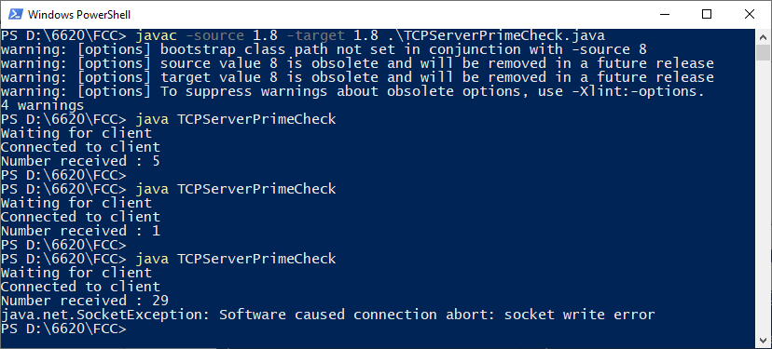

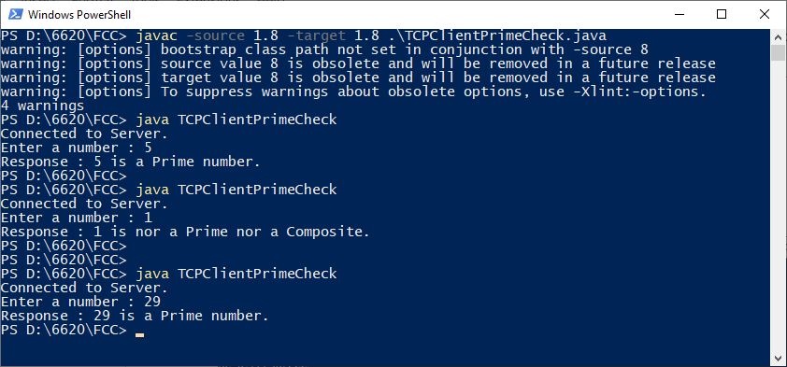

##### **B. A client server TCP based chatting application**

**TcpChatServer.java**

import java.io.*;

import java.net.*;

public class TcpChatServer {

public static void main(String[] args) {

try {

ServerSocket ss = new ServerSocket(8000);

System.out.println("Waiting for client to connect....");

Socket s = ss.accept();

System.out.println("Connected to client successfully");

BufferedReader br = new BufferedReader(new InputStreamReader(System.in));

DataOutputStream out = new DataOutputStream(s.getOutputStream());

DataInputStream in = new DataInputStream(s.getInputStream());

String receive, send;

while ((receive = in.readLine()) != null) {

if (receive.toLowerCase().equals("stop")) {

System.out.println("--- Chat Ended from Client Side ---");

break;

}

System.out.println("client : " + receive);

System.out.print("server : ");

send = br.readLine();

out.writeBytes(send + "\n");

}

ss.close();

s.close();

br.close();

in.close();

out.close();

} catch (Exception e) {

e.toString();

}

}

}

**TcpChatClient.java**

import java.io.*;

import java.net.*;

public class TcpChatClient {

public static void main(String[] args) {

try {

Socket s = new Socket("Localhost", 8000);

System.out.println("Connected to server successfully");

BufferedReader br = new BufferedReader(new InputStreamReader(System.in));

DataOutputStream out = new DataOutputStream(s.getOutputStream());

DataInputStream in = new DataInputStream(s.getInputStream());

System.out.println("--- To stop chatting enter STOP ---");

System.out.print("client : ");

String msg;

while ((msg = br.readLine()) != null) {

out.writeBytes(msg + "\n");

if (msg.toLowerCase().equals("stop")) {

System.out.println("--- Chat ended ---");

break;

}

System.out.println("server : " + in.readLine());

System.out.print("client : ");

}

s.close();

br.close();

in.close();

out.close();

} catch (Exception e) {

e.toString();

}

}

}

**Output**

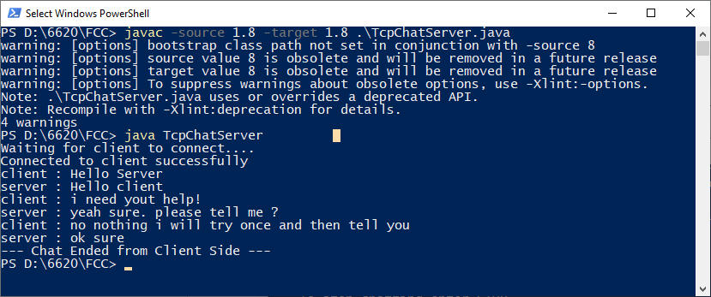

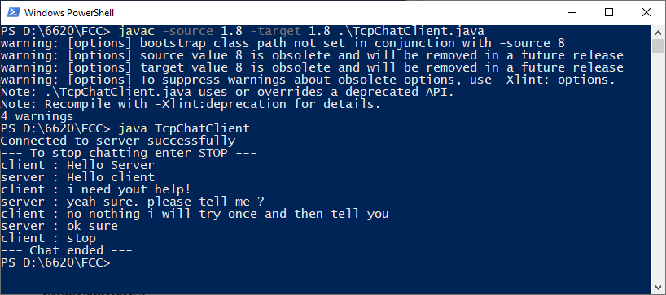

##### **C. Write a client program to enter the number and server program to calculate the square, square root, cube and cube root of the entered number using TCP Communication**

**TcpServerSquareCube.java**

import java.io.*;

import java.net.*;

public class TcpServerSquareCube {

public static void main(String[] args) {

try {

ServerSocket ss = new ServerSocket(8000);

System.out.println("Waiting for client to connect...");

Socket s = ss.accept();

System.out.println("Client connected.");

BufferedReader in = new BufferedReader(new InputStreamReader(s.getInputStream()));

DataOutputStream out = new DataOutputStream(s.getOutputStream());

String receive;

while ((receive = in.readLine()) != null) {

try {

double number = Double.parseDouble(receive);

double square = number * number;

double squareRoot = Math.sqrt(number);

double cube = number * number * number;

double cubeRoot = Math.cbrt(number);

String response = "Square: " + square + ", Square Root: " + squareRoot

+ ", Cube: " + cube + ", Cube Root: " + cubeRoot;

out.writeBytes(response + "\n");

} catch (NumberFormatException e) {

out.writeBytes("Invalid input. Please enter a valid number.\n");

}

}

in.close();

out.close();

s.close();

ss.close();

} catch (IOException e) {

e.toString();

} catch (Exception e) {

e.toString();

}

}

}

**TcpClientSquareCube.java**

import java.io.*;

import java.net.*;

public class TcpClientSquareCube {

public static void main(String[] args) {

try {

Socket s = new Socket("localhost", 8000);

BufferedReader br = new BufferedReader(new InputStreamReader(System.in));

DataOutputStream out = new DataOutputStream(s.getOutputStream());

BufferedReader in = new BufferedReader(new InputStreamReader(s.getInputStream()));

String numberStr;

while (true) {

System.out.print("Enter a number (or 'STOP' to quit): ");

numberStr = br.readLine();

out.writeBytes(numberStr + "\n");

if (numberStr.equalsIgnoreCase("STOP")) {

break;

}

String serverResponse = in.readLine();

System.out.println("Server response: " + serverResponse);

}

br.close();

out.close();

in.close();

s.close();

} catch (IOException e) {

e.toString();

}

catch (Exception e) {

e.toString();

}

}

}

**Output**

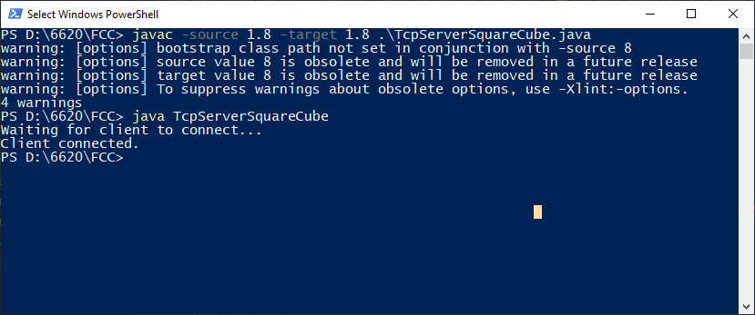

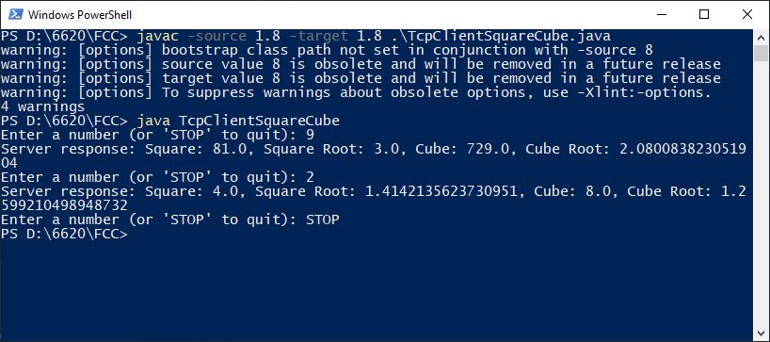

#### **Practical 2 - Implementing Client Server communication model using UDP.**

Jul 16, 2024

1. A client server-based program using UDP to find if the number entered is even or odd.
2. A client server-based program using UDP to find the factorial of the entered number.
3. A program to implement simple calculator operations like addition, subtraction, multiplication and division.

Github Repo → [FCC Practical 2 Github repo](https://github.com/shivamvishwakarma2k2/MSc-IT/tree/main/Part%201/SEM%201/FCC/Practical%202)

##### **A. A client server-based program using UDP to find if the number entered is even or odd.**

**UdpServerEvenOdd.java**

import java.net.*;

public class UdpServerEvenOdd {

public static void main(String args[]) {

try {

DatagramSocket ds = new DatagramSocket(2000);

byte b[] = new byte[1024];

DatagramPacket dp = new DatagramPacket(b, b.length);

ds.receive(dp);

String str = new String(dp.getData(), 0, dp.getLength());

System.out.println("Number received : " + str);

int a = Integer.parseInt(str);

String result = new String();

if (a % 2 == 0) {

result = "Number is EVEN";

} else {

result = "Number is ODD";

}

byte b1[] = new byte[1024];

b1 = result.getBytes();

DatagramPacket dp1 = new DatagramPacket(b1, b1.length, InetAddress.getLocalHost(), 1000);

ds.send(dp1);

System.out.println("Response sended");

ds.close();

} catch (Exception e) {

e.toString();

}

}

}

**UdpClientEvenOdd.java**

import java.io.*;

import java.net.*;

public class UdpClientEvenOdd {

public static void main(String args[]) {

try {

DatagramSocket ds = new DatagramSocket(1000);

BufferedReader br = new BufferedReader(new InputStreamReader(System.in));

System.out.print("Enter a number : ");

String num = br.readLine();

byte b[] = new byte[1024];

b = num.getBytes();

DatagramPacket dp = new DatagramPacket(b, b.length, InetAddress.getLocalHost(), 2000);

ds.send(dp);

byte b1[] = new byte[1024];

DatagramPacket dp1 = new DatagramPacket(b1, b1.length);

ds.receive(dp1);

String str = new String(dp1.getData(), 0, dp1.getLength());

System.out.println(str);

ds.close();

br.close();

} catch (Exception e) {

e.toString();

}

}

}

**Output**

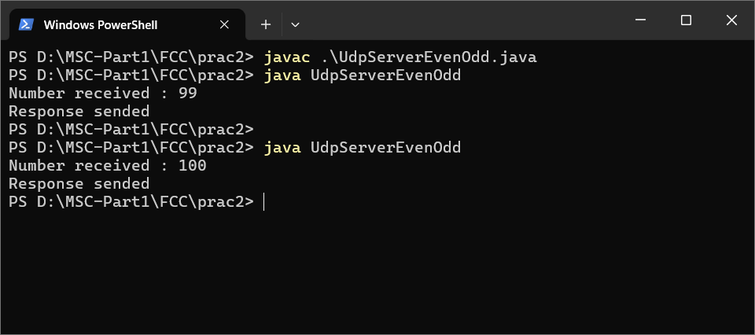

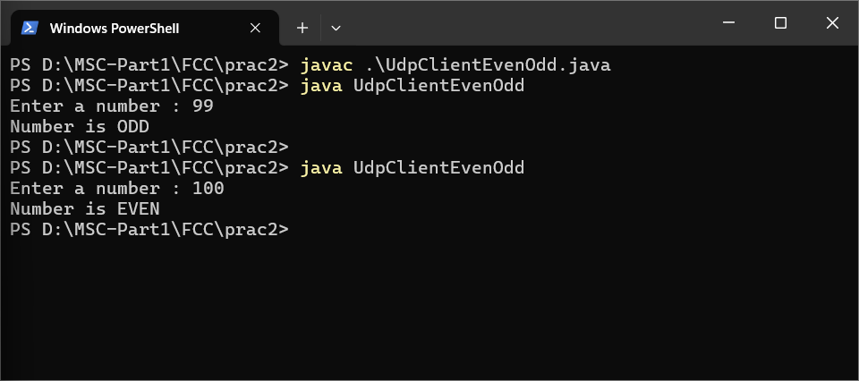

##### **B. A client server-based program using UDP to find the factorial of the entered number.**

**UdpFactorialServer.java**

import java.net.*;

import java.net.*;

public class UdpFactorialServer {

public static int fact(int n) {

if (n == 1) {

return 1;

}

return n * fact(n - 1);

}

public static void main(String args[]) {

try {

DatagramSocket ds = new DatagramSocket(2000);

byte b[] = new byte[1024];

DatagramPacket dp = new DatagramPacket(b, b.length);

ds.receive(dp);

String str = new String(dp.getData(), 0, dp.getLength());

System.out.println("Number received : " + str);

int a = Integer.parseInt(str);

int result = fact(a);

String resultStr = Integer.toString(result);

byte b1[] = resultStr.getBytes();

DatagramPacket dp1 = new DatagramPacket(b1, b1.length, dp.getAddress(), dp.getPort());

ds.send(dp1);

System.out.println("Response sent");

ds.close();

} catch (Exception e) {

e.printStackTrace();

}

}

}

**UdpFactorialClient.java**

import java.io.*;

import java.net.*;

public class UdpFactorialClient {

public static void main(String args[]) {

try {

DatagramSocket ds = new DatagramSocket(1000);

BufferedReader br = new BufferedReader(new InputStreamReader(System.in));

System.out.print("Enter a number : ");

String num = br.readLine();

byte b[] = new byte[1024];

b = num.getBytes();

DatagramPacket dp = new DatagramPacket(b, b.length, InetAddress.getLocalHost(), 2000);

ds.send(dp);

byte b1[] = new byte[1024];

DatagramPacket dp1 = new DatagramPacket(b1, b1.length);

ds.receive(dp1);

String str = new String(dp1.getData(), 0, dp1.getLength());

System.out.println("Factorial : " + str);

ds.close();

br.close();

} catch (Exception e) {

e.toString();

}

}

}

**Output**

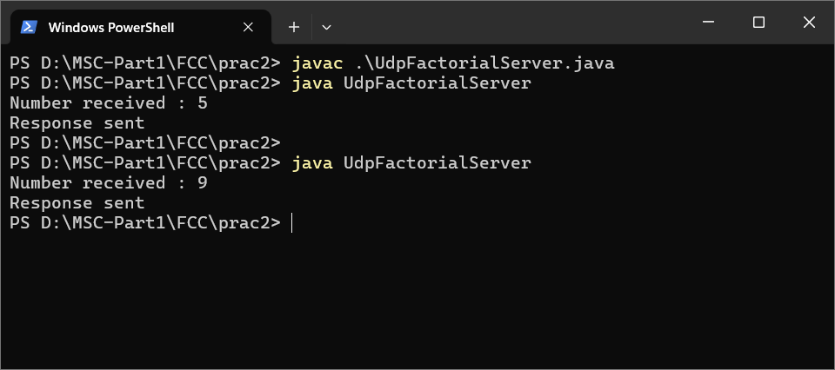

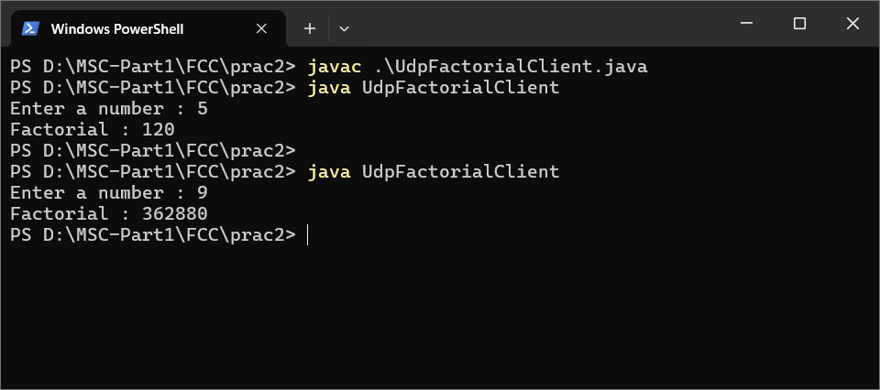

##### **C. A program to implement simple calculator operations like addition, subtraction, multiplication and division.**

**UdpCalServer.java**

import java.net.*;

import java.net.*;

import java.util.*;

public class UdpCalServer {

DatagramSocket ds;

DatagramPacket dp;

String str, methodName, result;

int val1, val2;

UdpCalServer() {

try {

ds = new DatagramSocket(1200);

byte b[] = new byte[4096];

while (true) {

dp = new DatagramPacket(b, b.length);

ds.receive(dp);

str = new String(dp.getData(), 0, dp.getLength());

if (str.equalsIgnoreCase("q")) {

System.exit(1);

} else {

StringTokenizer st = new StringTokenizer(str, " ");

int i = 0;

while (st.hasMoreTokens())

{

String token = st.nextToken();

methodName = token;

val1 = Integer.parseInt(st.nextToken());

val2 = Integer.parseInt(st.nextToken());

}

}

System.out.println(str);

InetAddress ia = InetAddress.getLocalHost();

if (methodName.equalsIgnoreCase("add")) {

result = "" + add(val1, val2);

} else if (methodName.equalsIgnoreCase("sub")) {

result = "" + sub(val1, val2);

} else if (methodName.equalsIgnoreCase("mul")) {

result = "" + mul(val1, val2);

} else if (methodName.equalsIgnoreCase("div")) {

result = "" + div(val1, val2);

}

byte b1[] = result.getBytes();

DatagramSocket ds1 = new DatagramSocket();

DatagramPacket dp1 = new DatagramPacket(b1, b1.length, InetAddress.getLocalHost(), 1300);

System.out.println("result : " + result + "\n");

ds1.send(dp1);

}

} catch (Exception e) {

e.printStackTrace();

}

}

public int add(int val1, int val2) {

return val1 + val2;

}

public int sub(int val3, int val4) {

return val3 - val4;

}

public int mul(int val3, int val4) {

return val3 * val4;

}

public int div(int val3, int val4) {

return val3 / val4;

}

public static void main(String[] args) {

new UdpCalServer();

}

}

**UdpCalClient.java**

import java.io.*;

import java.net.*;

public class UdpCalClient {

UdpCalClient() {

try {

InetAddress ia = InetAddress.getLocalHost();

DatagramSocket ds = new DatagramSocket();

DatagramSocket ds1 = new DatagramSocket(1300);

System.out.println("Enter method name and parameter like add");

while (true) {

BufferedReader br = new BufferedReader(new InputStreamReader(System.in));

String str = br.readLine();

byte b[] = str.getBytes();

DatagramPacket dp = new DatagramPacket(b, b.length, ia, 1200);

ds.send(dp);

dp = new DatagramPacket(b, b.length);

ds1.receive(dp);

String s = new String(dp.getData(), 0, dp.getLength());

System.out.println("\nResult = " + s + "\n");

}

} catch (Exception e) {

e.toString();

}

}

public static void main(String[] args) {

new UdpCalClient();

}

}

**Output**

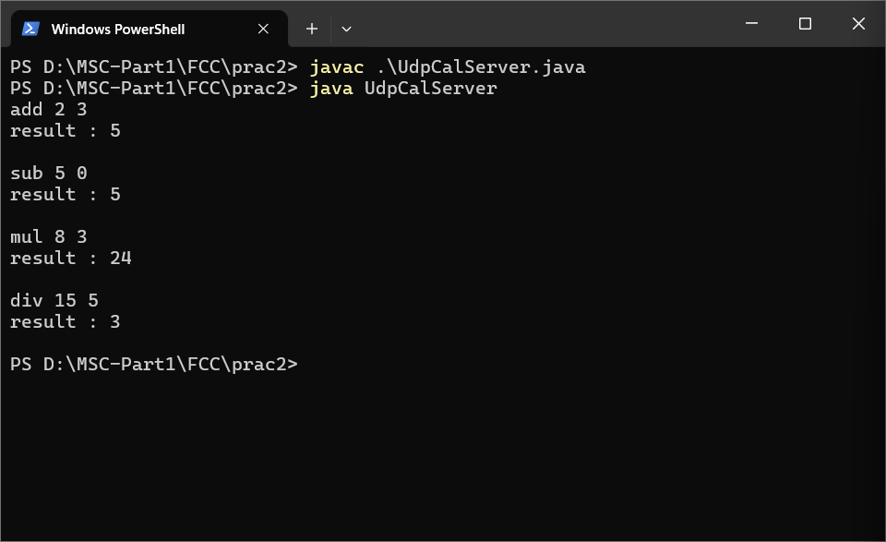

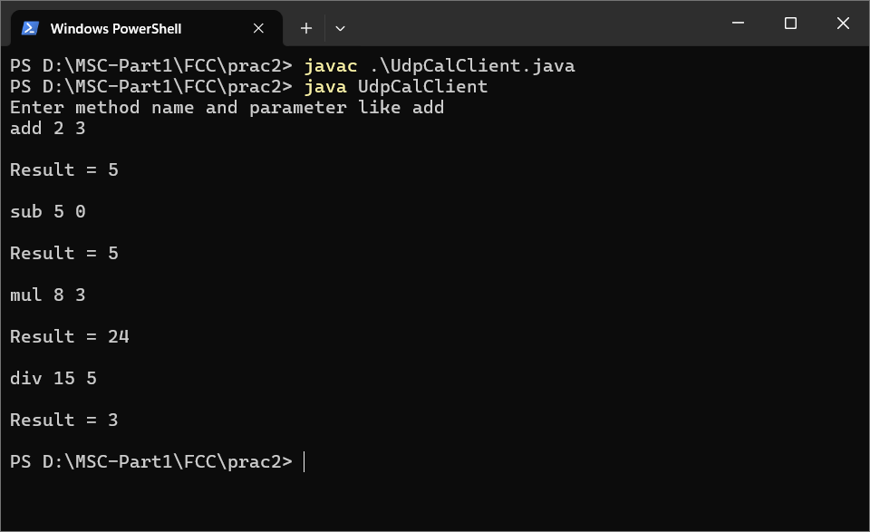

#### **Practical 3 - Write a program to show the object communication using RMI.**

Jul 30, 2024

1. RMI based application program to display current date and time.
2. RMI based application program that converts digits to words, e.g. 123 will be converted to one two three.Implementation of Client Server communication using RMI.

**Requirements** : Java version - jdk 11

Github Repo → [FCC Practical 3 Github repo](https://github.com/shivamvishwakarma2k2/MSc-IT/tree/main/Part%201/SEM%201/FCC/Practical%203)

**What is RMI ?**

* The RMI (Remote Method Invocation) is an API that provides a mechanism to create distributed applications in java. The RMI allows an object to invoke methods on an object running in another JVM.
* The RMI provides remote communication between the applications using two objects stub and skeleton.
* The stub is an object, acts as a gateway for the client side. All the outgoing requests are routed through it. It resides at the client side and represents the remote object.
* The skeleton is an object, acts as a gateway for the server side object. All the incoming requests are routed through it.

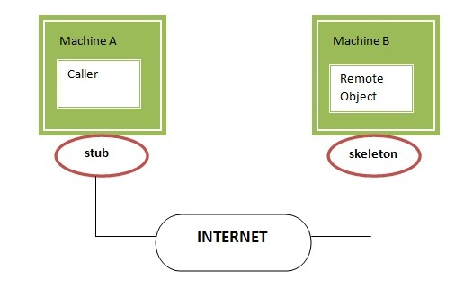

**Steps to write the RMI program.**

1. Create the remote interface
2. Provide the implementation of the remote interface
3. Compile the implementation class and create the stub and skeleton objects using the rmic tool
4. Start the registry service by rmiregistry tool
5. Create and start the remote application
6. Create and start the client application

##### **A. RMI based application program to display current date and time.**

**DateTimeInterface.java**

import java.rmi.*;

public interface DateTimeInterface extends Remote{

public String showCurrentDateTime() throws Exception;

}

**DateTimeServer.java**

import java.rmi.*;

import java.rmi.server.*;

import java.util.*;

public class DateTimeServer extends UnicastRemoteObject implements DateTimeInterface {

public DateTimeServer() throws Exception {

}

@Override

public String showCurrentDateTime() throws Exception {

Date currentDateTime = new Date();

return currentDateTime.toString();

}

public static void main(String[] args) throws Exception {

DateTimeServer server = new DateTimeServer();

Naming.bind("DTserver", server);

System.out.println("Object registered");

}

}

**DateTimeClient.java**

import java.rmi.*;

public class DateTimeClient {

public static void main(String[] args) throws Exception {

DateTimeInterface date = (DateTimeInterface) Naming.lookup("DTserver");

String currentDate = date.showCurrentDateTime();

System.out.println(currentDate);

}

}

**Output**

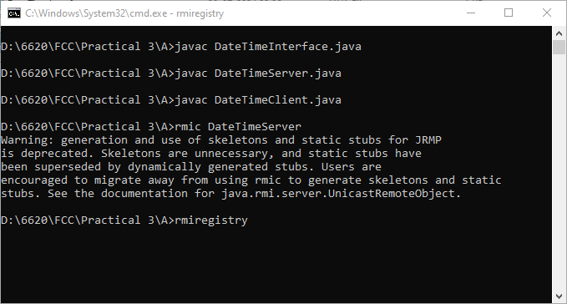

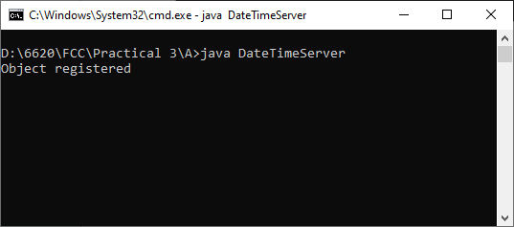

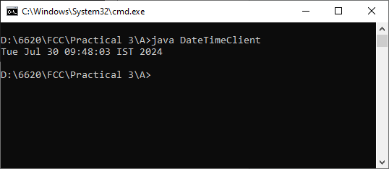

##### **B. RMI based application program that converts digits to words, e.g. 123 will be converted to one two three.Implementation of Client Server communication using RMI**

**InterfaceConvert.java**

import java.rmi.*;

public interface InterfaceConvert extends Remote {

public String convertDigit(String no) throws Exception;

}

**ServerConvert.java**

import java.rmi.*;

import java.rmi.server.*;

public class ServerConvert extends UnicastRemoteObject implements

InterfaceConvert {

public ServerConvert() throws Exception {

}

public String convertDigit(String no) throws Exception {

String str = "";

for (int i = 0; i < no.length(); i++) {

int p = no.charAt(i);

if (p == 48) {

str += "zero ";

}

if (p == 49) {

str += "one ";

}

if (p == 50) {

str += "two ";

}

if (p == 51) {

str += "three ";

}

if (p == 52) {

str += "four ";

}

if (p == 53) {

str += "five ";

}

if (p == 54) {

str += "six ";

}

if (p == 55) {

str += "seven ";

}

if (p == 56) {

str += "eight ";

}

if (p == 57) {

str += "nine ";

}

}

return str;

}

public static void main(String args[]) throws Exception {

ServerConvert s1 = new ServerConvert();

Naming.bind("Wrd", s1);

System.out.println("Object registered....");

}

}

**ClientConvert.java**

import java.rmi.*;

import java.io.*;

public class ClientConvert {

public static void main(String args[]) throws Exception {

InterfaceConvert h1 = (InterfaceConvert) Naming.lookup("Wrd");

BufferedReader br = new BufferedReader(new InputStreamReader(System.in));

System.out.println("Enter a number :\t");

String no = br.readLine();

String ans = h1.convertDigit(no);

System.out.println("The word representation of the entered digit is : " + ans);

}

}

**Output**

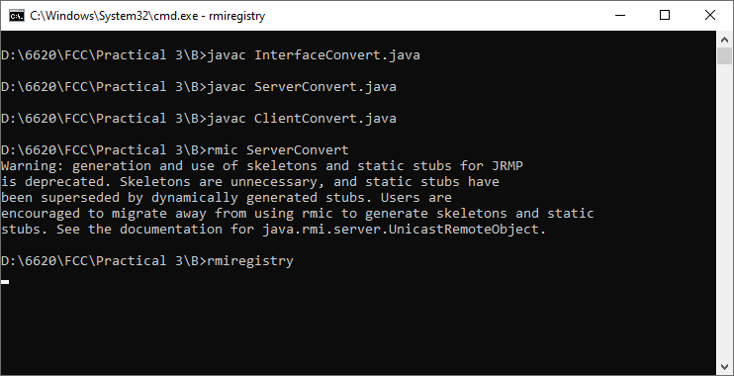

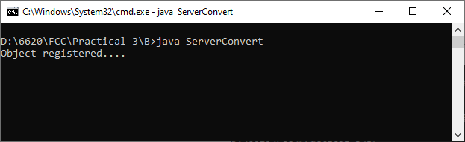

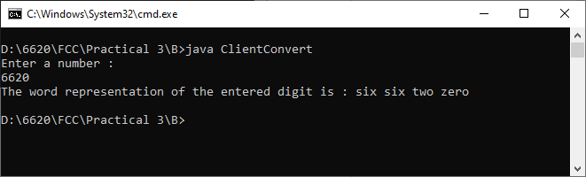

#### **Practical 4 - Implementation of web services.**

Jul 23, 2024

**Requirements**

* Netbeans 8.0.2
* Java version - jdk 8 or jdk 1.8

Github Repo → [FCC Practical 4 Github repo](https://github.com/shivamvishwakarma2k2/MSc-IT/tree/main/Part%201/SEM%201/FCC/Practical%204%20(WS%20%2B%20Clients))

**1. Creating a Web Service**

1. **Choosing a Container**

New Project → Select Java Web → Select Web Application

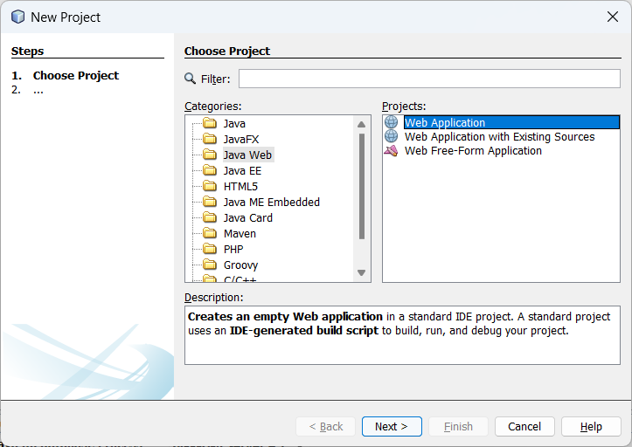

Name the project “Practical 4” → Select a location for the project → Click Next

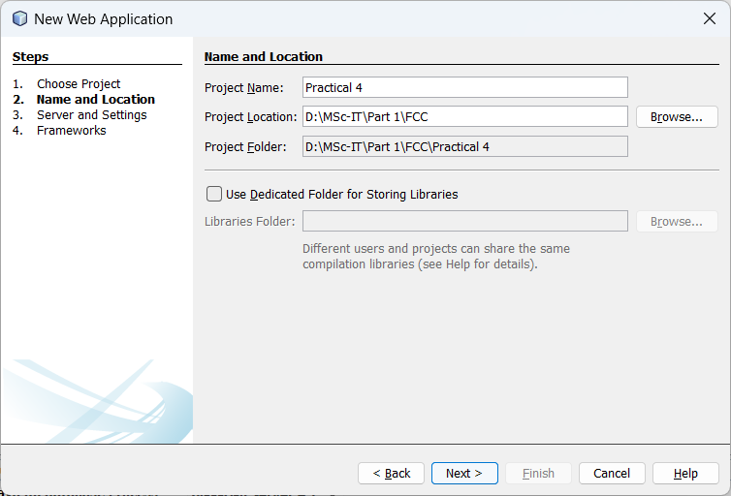

Select your server and Java EE version and click Finish.

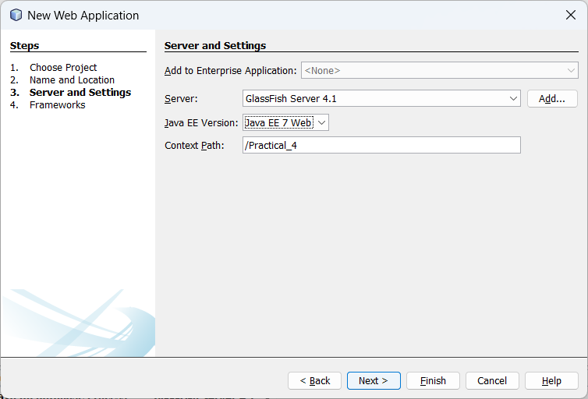

1. **Creating a Web Service from a Java Class**

Right-click the Practical 4 (project) node → choose New → Web Service

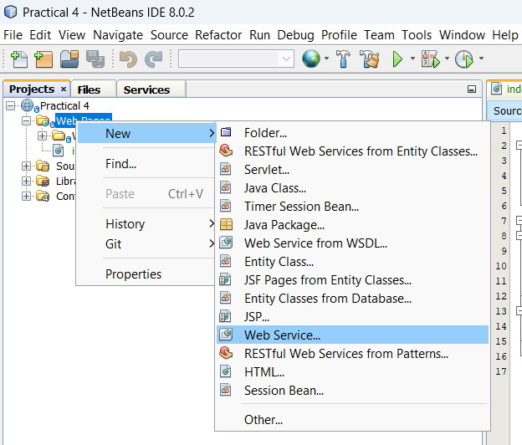

Name the web service “CalculatorWS” and type “org.me.calculator” in Package.

Leave Create Web Service from Scratch selected.

If you are creating a Java EE 6 project on GlassFish or WebLogic,

select Implement Web Service as a Stateless Session Bean

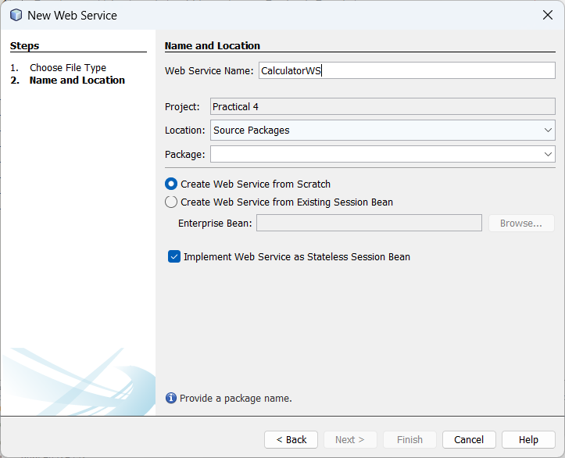

Click Finish. The Projects window displays the structure of the new web service and the source code is shown in the editor area.

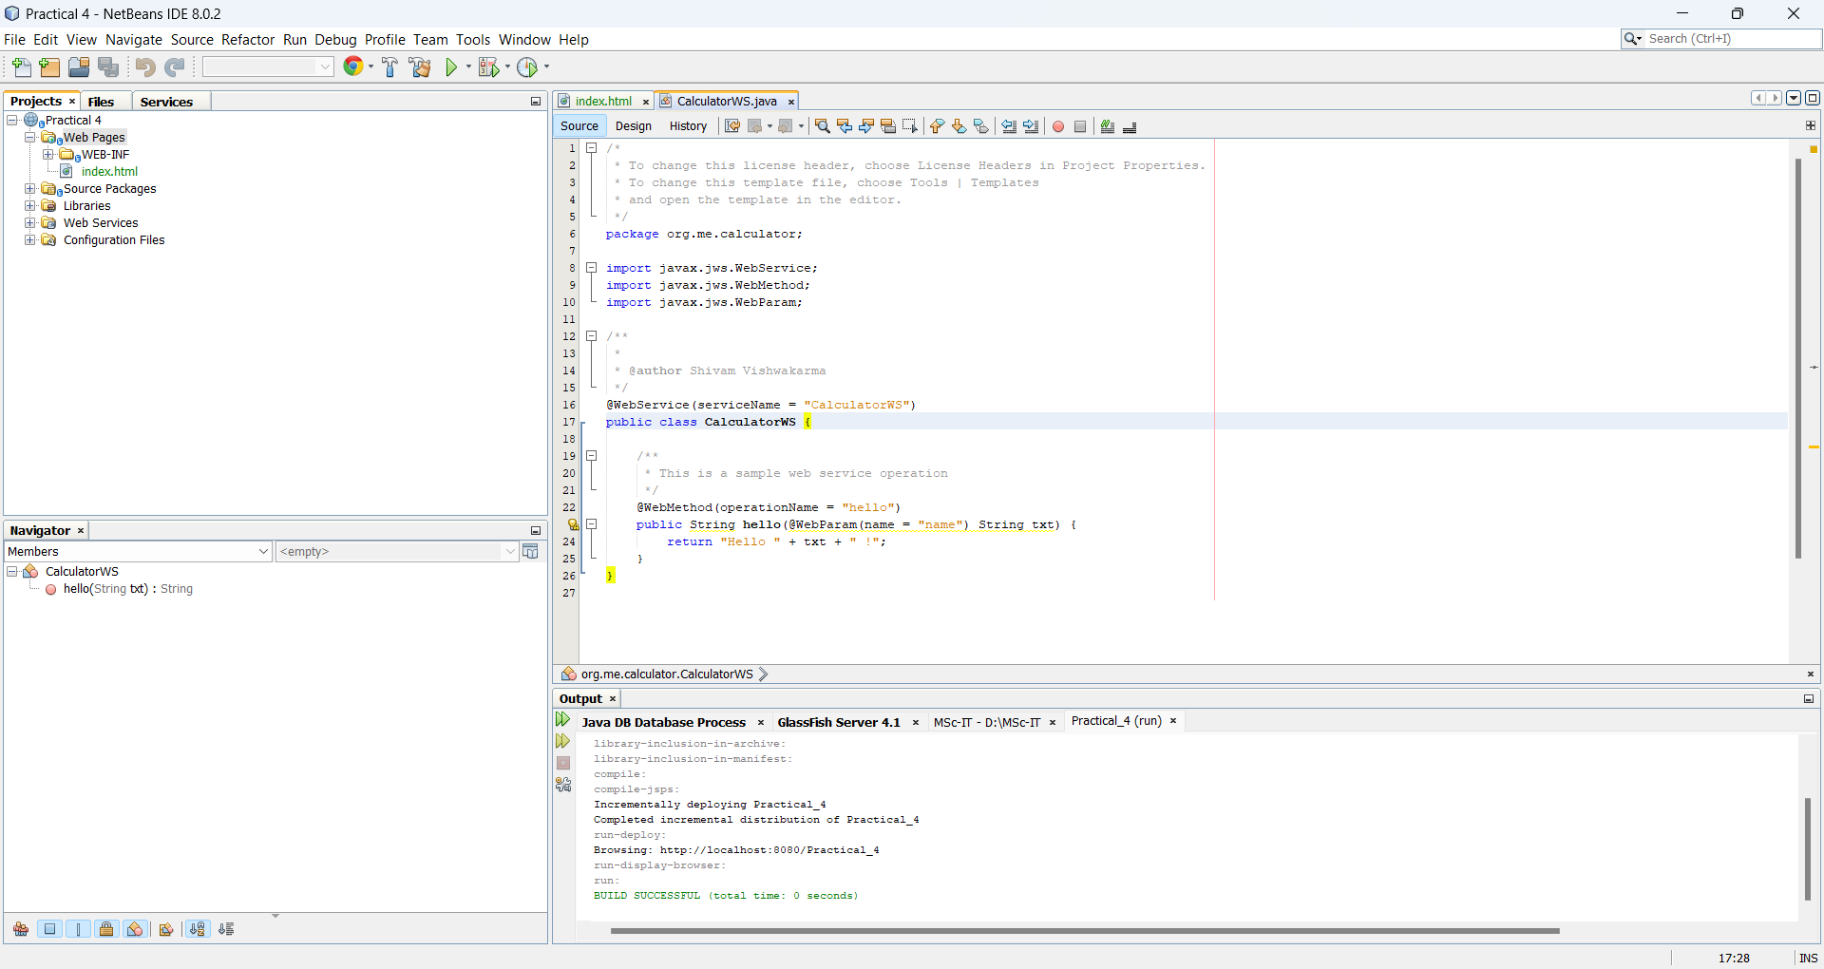

**2. Adding an Operation to the Web Service**

The goal is to add to the web service an operation that adds two numbers received from user. The NetBeans IDE provides a dialog for adding an operation to a web service. You can open this dialog either in the web service visual designer or in the web service context menu.

1. **To add an operation to the web service**

Change to the Design view in the editor.

Click Add Operation in either the visual designer or the context menu. The Add Operation dialog opens

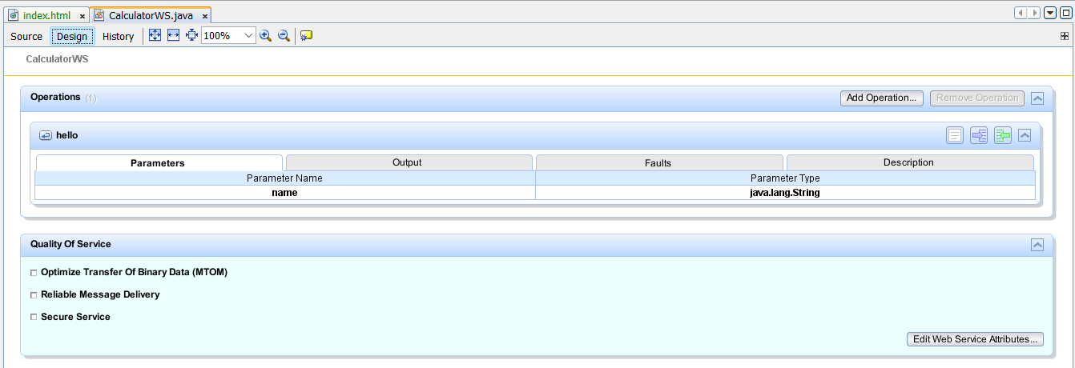

In the upper part of the Add Operation dialog box, type add in Name and type int in the Return Type drop-down list.

In the lower part of the Add Operation dialog box, click Add and create a parameter of type int named n1 and n2.

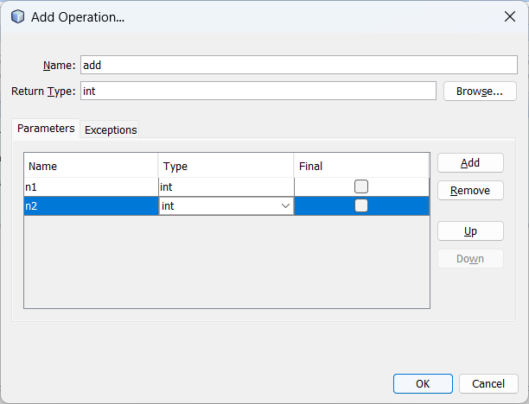

Click OK at the bottom of the Add Operation dialog box. You return to the editor.

The visual designer now displays the following:

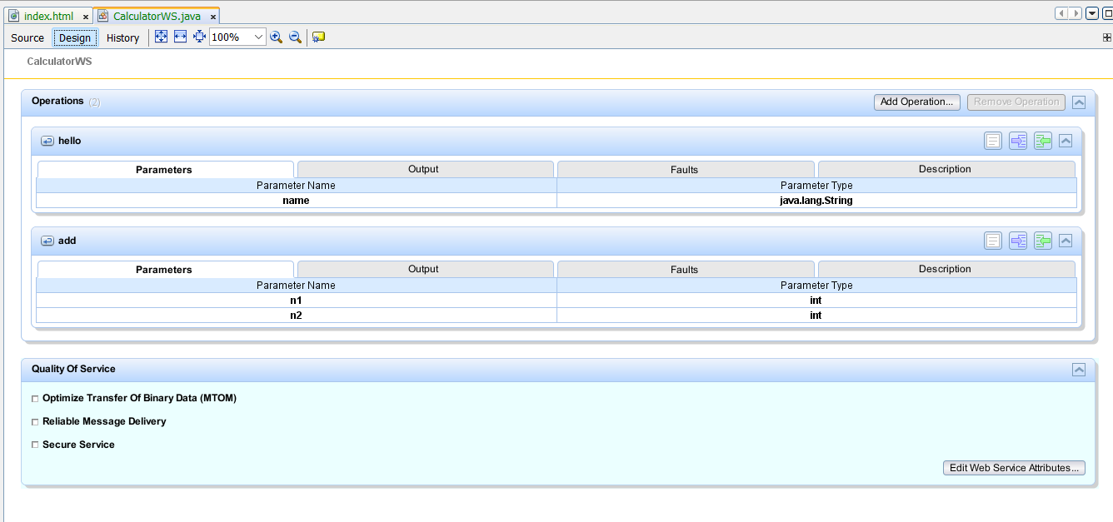

Click Source. And code the following.

**CalculatorWS.java**

/*

* To change this license header, choose License Headers in Project Properties.

* To change this template file, choose Tools | Templates

* and open the template in the editor.

*/

package org.me.calculator;

import javax.jws.WebService;

import javax.jws.WebMethod;

import javax.jws.WebParam;

/**

*

* @author Shivam Vishwakarma

*/

@WebService(serviceName = "CalculatorWS")

public class CalculatorWS {

/**

* This is a sample web service operation

*/

@WebMethod(operationName = "hello")

public String hello(@WebParam(name = "name") String txt) {

return "Hello " + txt + " !";

}

**/\*\***

**\* Web service operation**

**\*/**

**@WebMethod(operationName = "add")**

**public int add(@WebParam(name = "n1") int n1, @WebParam(name = "n2") int n2) {**

**//TODO write your implementation code here:**

**return n1 + n2;**

**}**

}

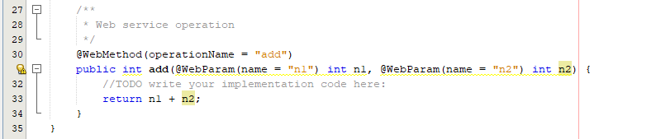

STOP the port using cmd

**netstat -aon | find ":8080" | find "LISTENING"**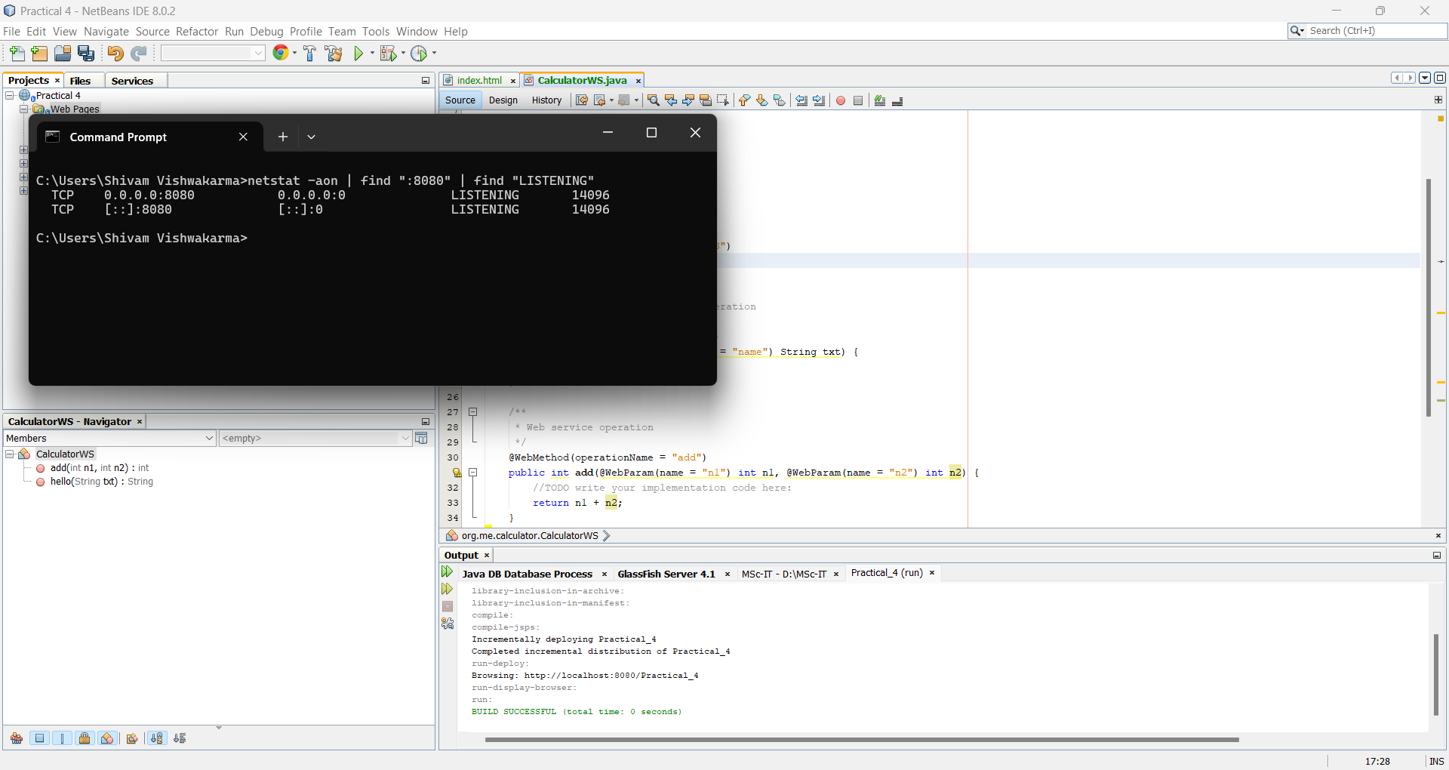

**3. Deploying and Testing the Web Service**

After you deploy a web service to a server, you can use the IDE to open the server's test client, if the server has a test client. The GlassFish and WebLogic servers provide test clients.

1. **To test successful deployment to a GlassFish or WebLogic server:**

Right-click the project and choose Deploy. The IDE starts the application server, builds the application, and deploys the application to the server

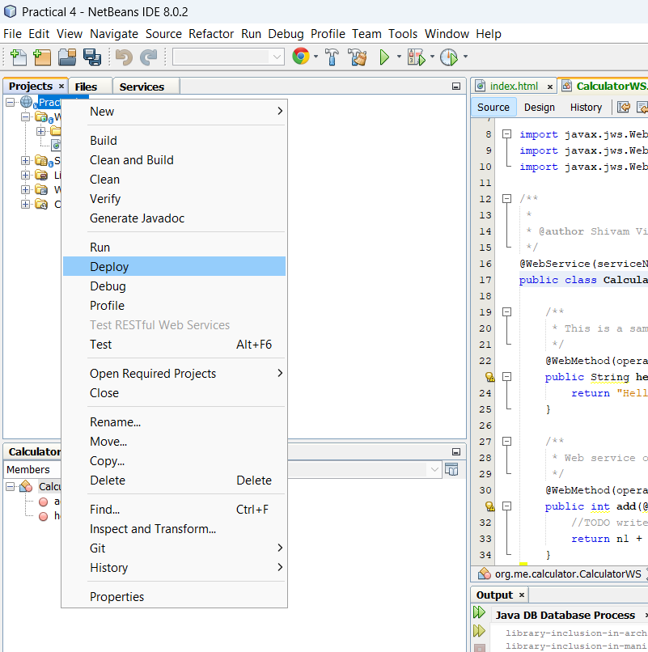

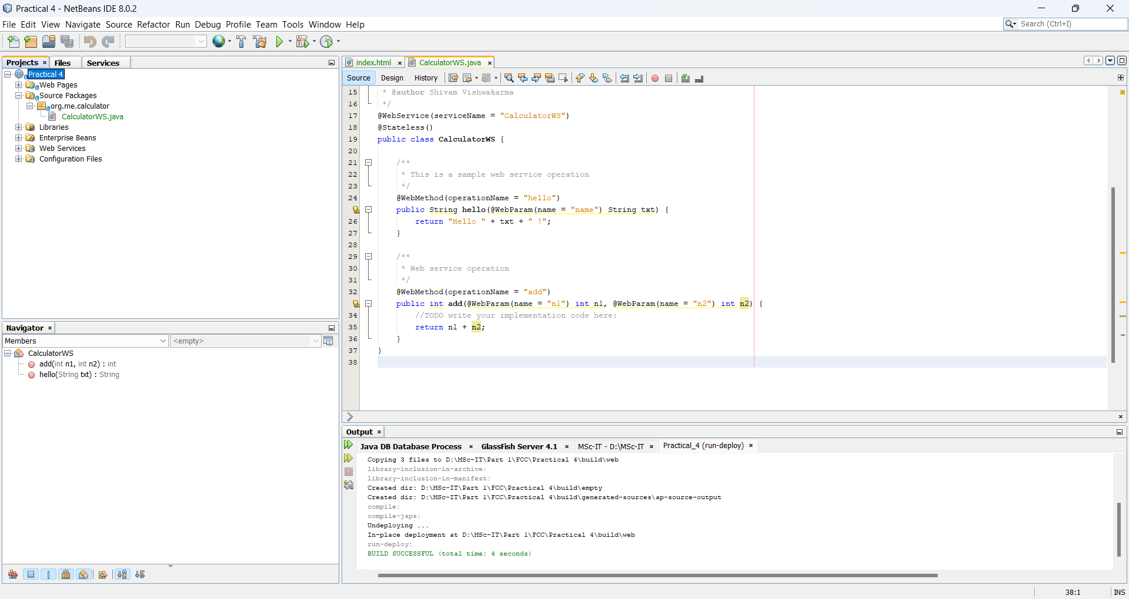

In the IDE's Projects tab, expand the Web Services node of the CalculatorWSApplication project. Right-click the CalculatorWS node, and choose Test Web Service.

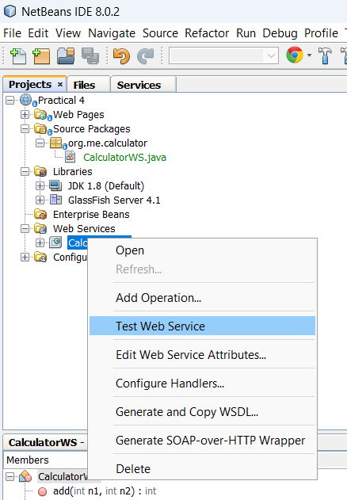

The IDE opens the tester page in your browser, if you deployed a web application to the GlassFish server.

If you deployed to the GlassFish server, type two numbers in the tester page, as shown below:

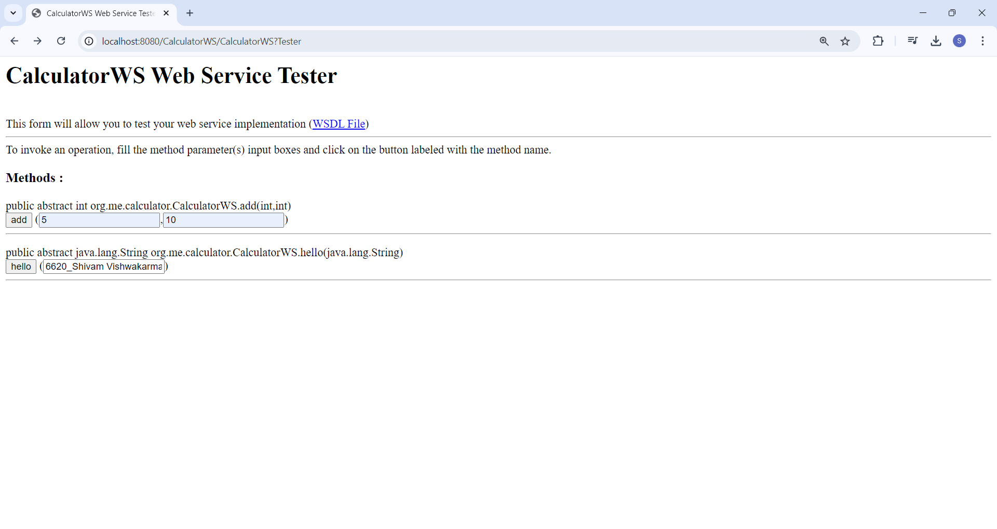

The sum of the two numbers is displayed:

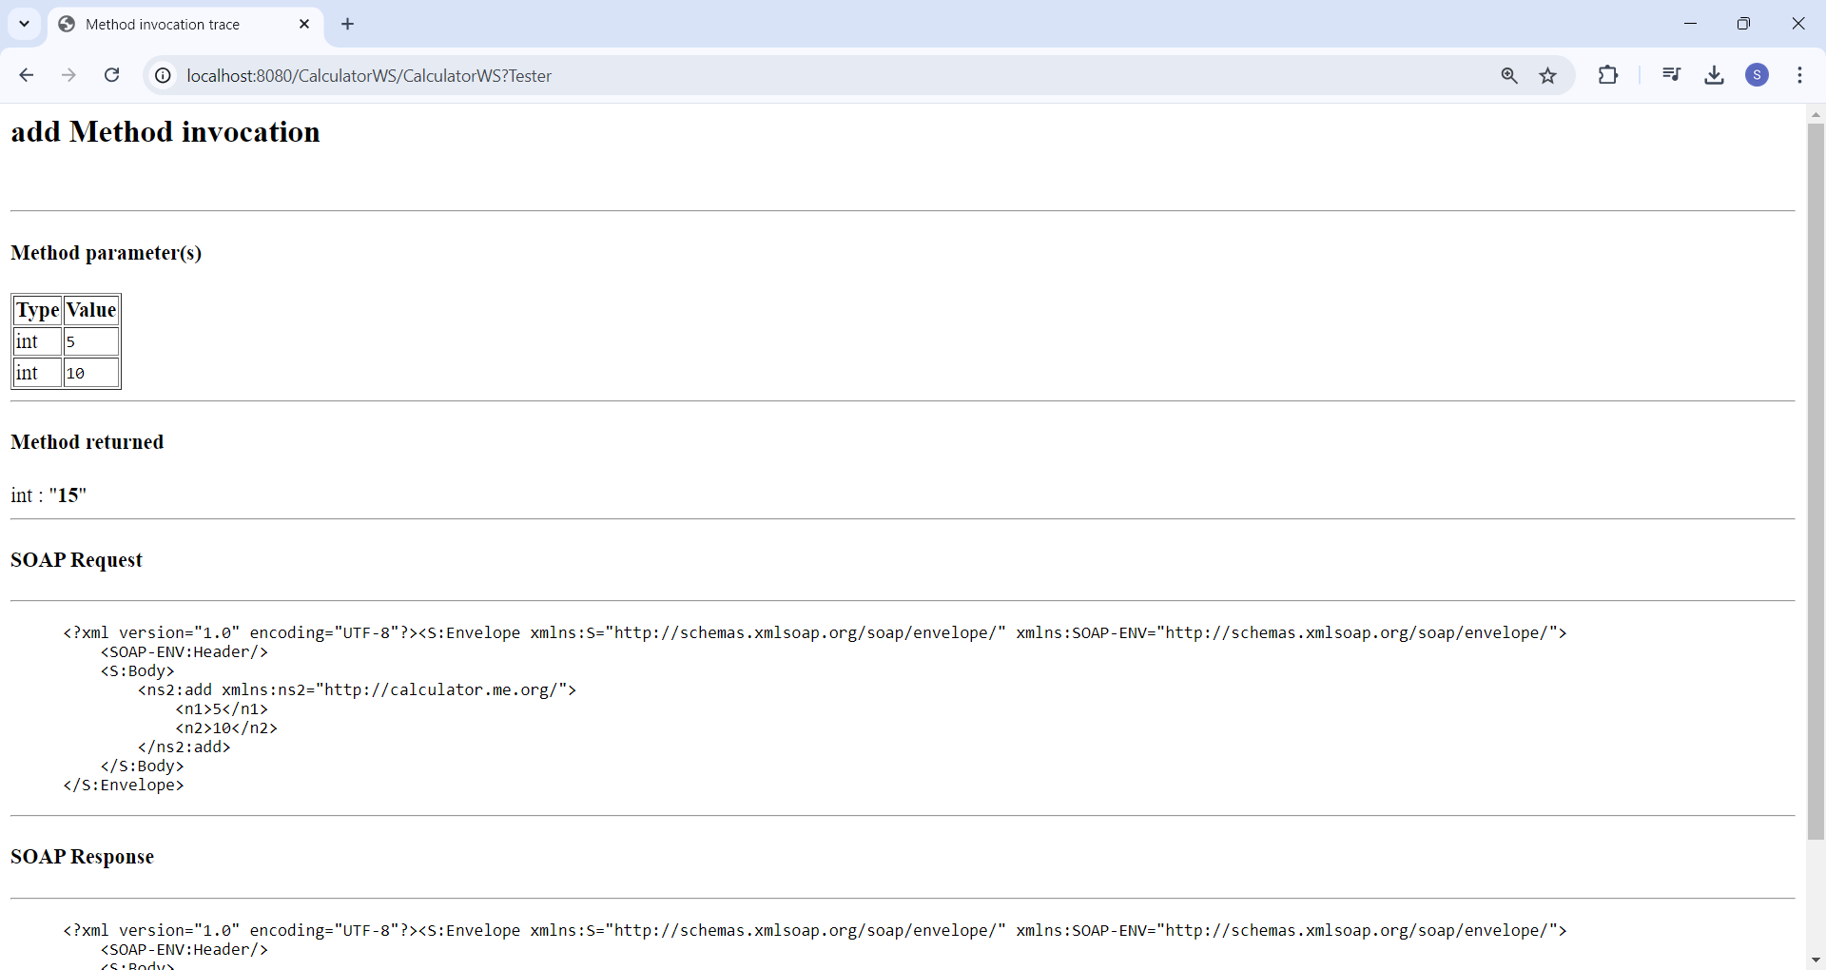

**4. Consuming the Web Service**

need to create a client to make use of the web service's add method.

**Client 1: Java Class in Java SE Application**

New Project → Select Java Application from the Java category.

Name the project “Practical 4 Client App”

Leave Create Main Class selected and accept all other default settings → Click Finish

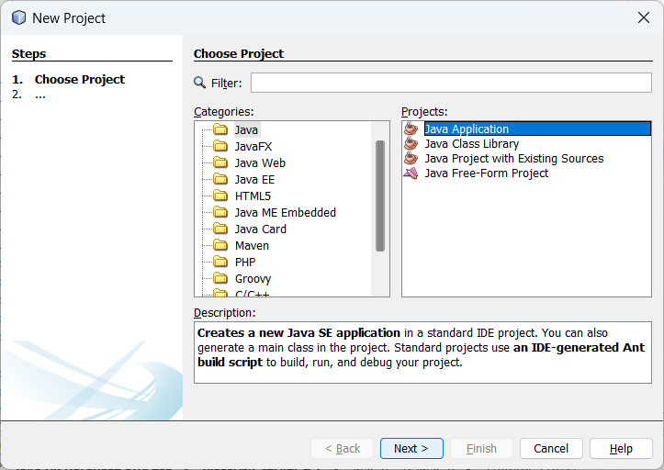

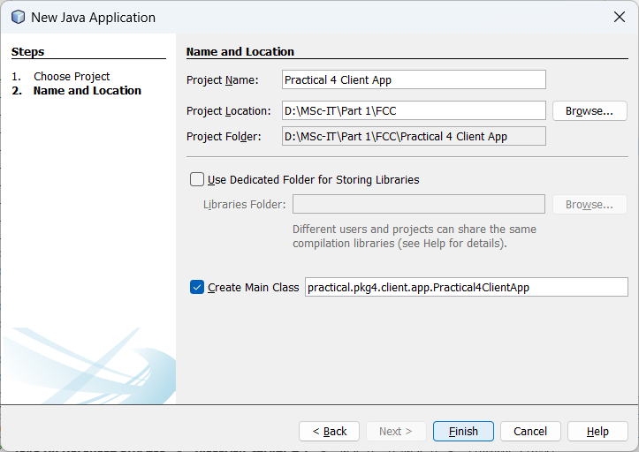

Right-click the “Practical 4 Client App” node and choose New → Web Service Client.

The New Web Service Client wizard opens.

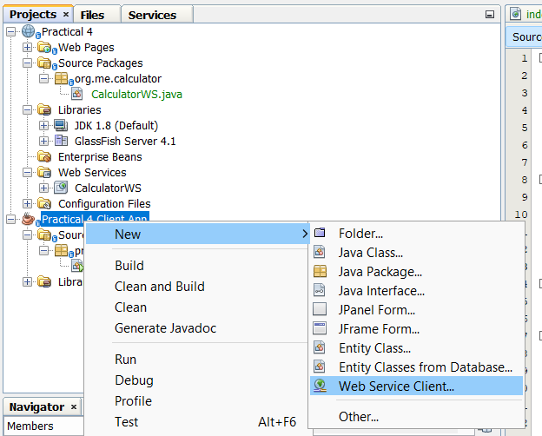

Select Project as the WSDL source. Click Browse. Browse to the “CalculatorWS” web service in the “Practical 4”project. When you have selected the web service, click OK.

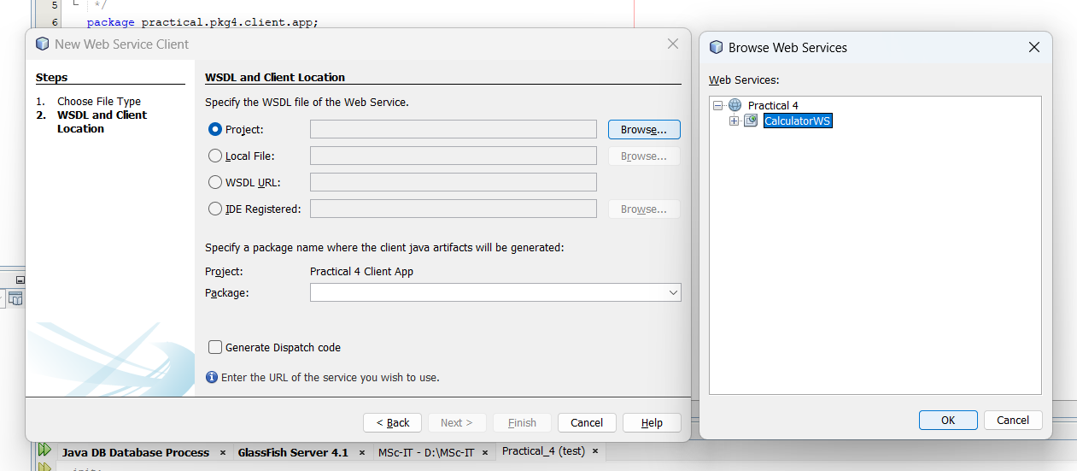

Do not select a package name. Leave this field empty.

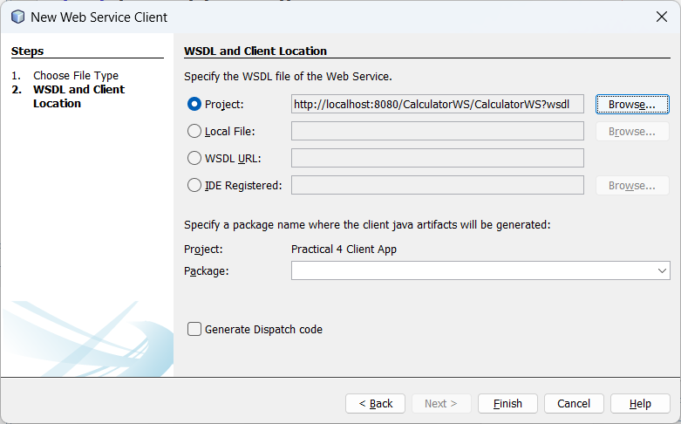

Leave the other settings at default and click Finish. The Projects window displays the new web service client, with a node for the add method that you created:

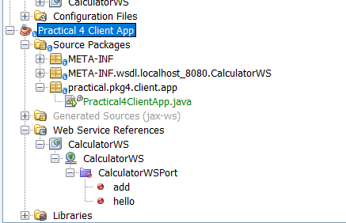

Double-click your main class so that it opens in the Source Editor. Drag the add node below the main() method.

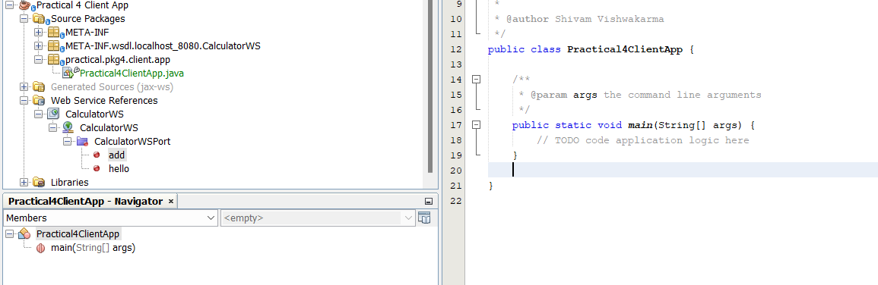

You now see the following:

/*

* To change this license header, choose License Headers in Project Properties.

* To change this template file, choose Tools | Templates

* and open the template in the editor.

*/

package practical.pkg4.client.app;

/**

*

* @author Shivam Vishwakarma

*/

public class Practical4ClientApp {

/**

* @param args the command line arguments

*/

public static void main(String[] args) {

// To do

}

**private static int add(int n1, int n2) {**

**org.me.calculator.CalculatorWS_Service service = new org.me.calculator.CalculatorWS_Service();**

**org.me.calculator.CalculatorWS port = service.getCalculatorWSPort();**

**return port.add(n1, n2);**

**}**

}

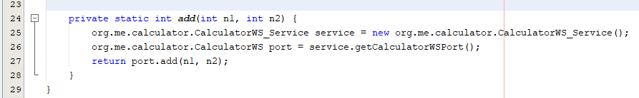

In the main() method body, replace the TODO comment with code that initializes values for i and j, calls add(), and prints the result. Surround the main() method code with a try/catch block that prints an exception.

**public static void main(String[] args) {**

**try {**

**int i = 3;**

**int j = 4;**

**int result = add(i, j);**

**System.out.println("Result = " + result);**

**} catch (Exception ex) {**

**System.out.println("Exception: " + ex);**

**}**

**}**

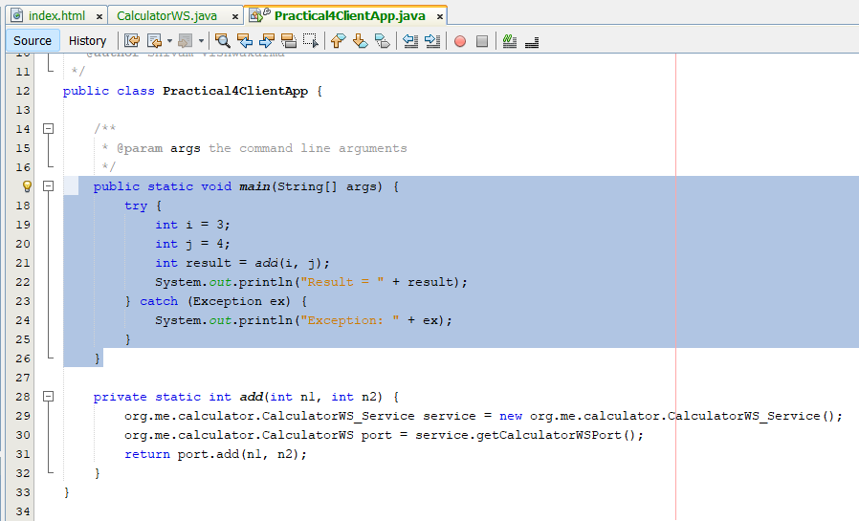

Right-click the project node and choose Run

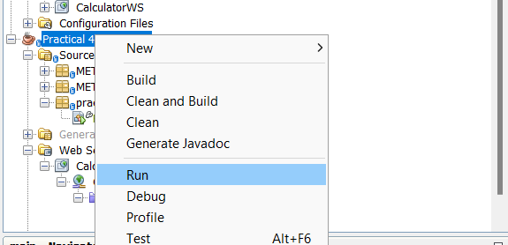

The Output window now shows the sum

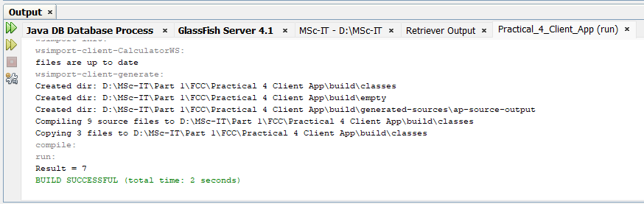

**Client 2: JSP Page in Web Application**

Choose New Project → Select Web Application from the Java Web category.

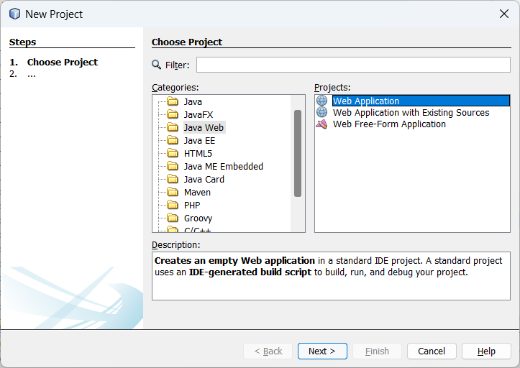

Name the project “Practical 4 JSP Client”

Click Next and then click Finish.

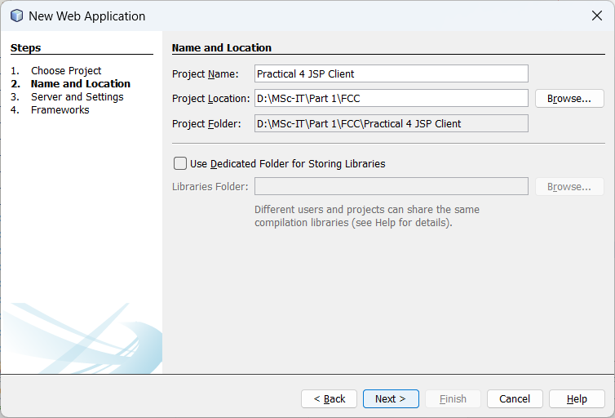

Expand the Web Pages node under the project node and delete index.html .

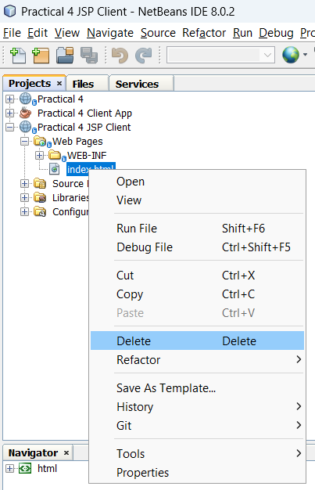

Right-click the Web Pages node and choose New → JSP in the popup menu.

If JSP is not available in the popup menu, choose New → Other and select JSP in the Web category of the New File wizard.

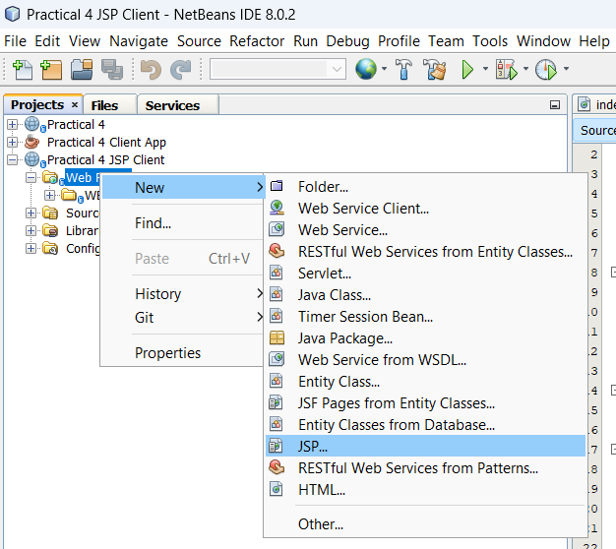

Type index for the name of the JSP file in the New File wizard. Click Finish.

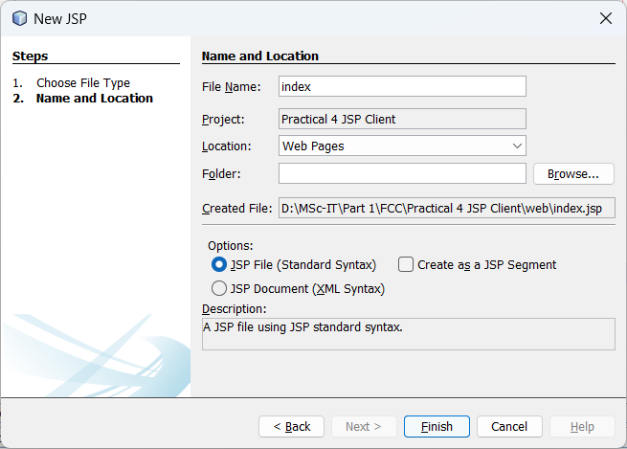

Right-click the “Practical 4 JSP Client” node and choose New → Web Service Client.

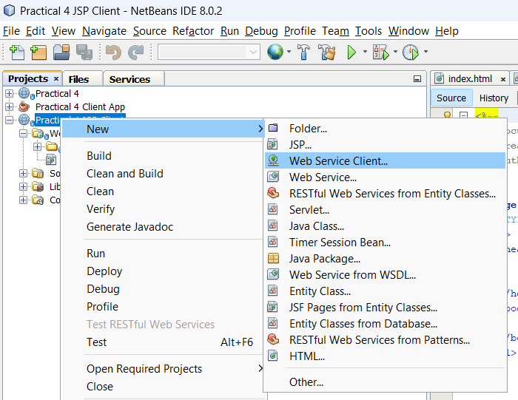

Select Project as the WSDL source.

Click Browse. Browse to the CalculatorWS web service in the “Practical 4” project.

When you have selected the web service, click OK.

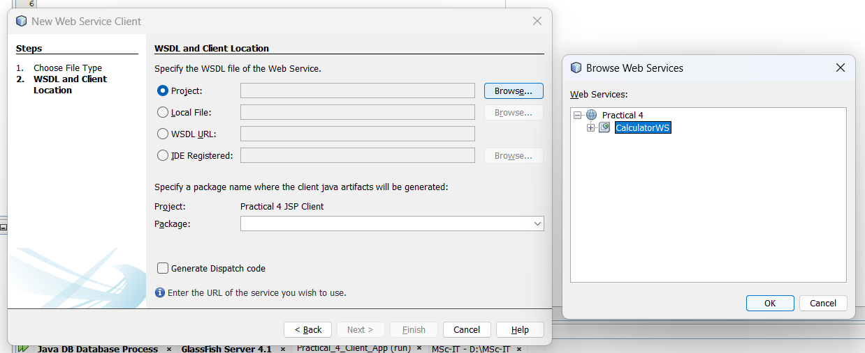

Do not select a package name. Leave this field empty.

Leave the other settings at default and click Finish.

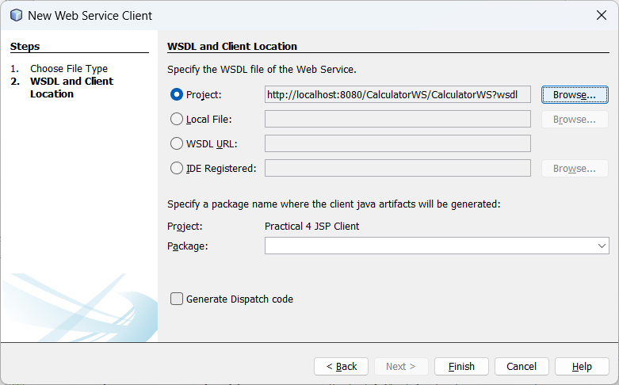

The Projects window displays the new web service client, as shown below:

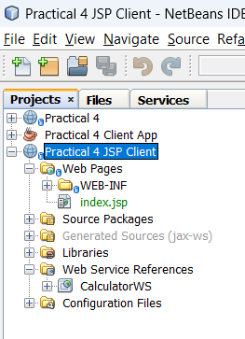

In the Web Service References node, expand the node that represents the web service.

The add operation, which you will invoke from the client, is now exposed.

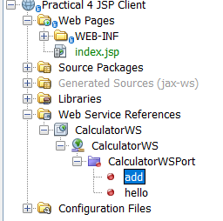

Drag the add operation to the client’s index.jsp page, and drop it below the H1 tags.

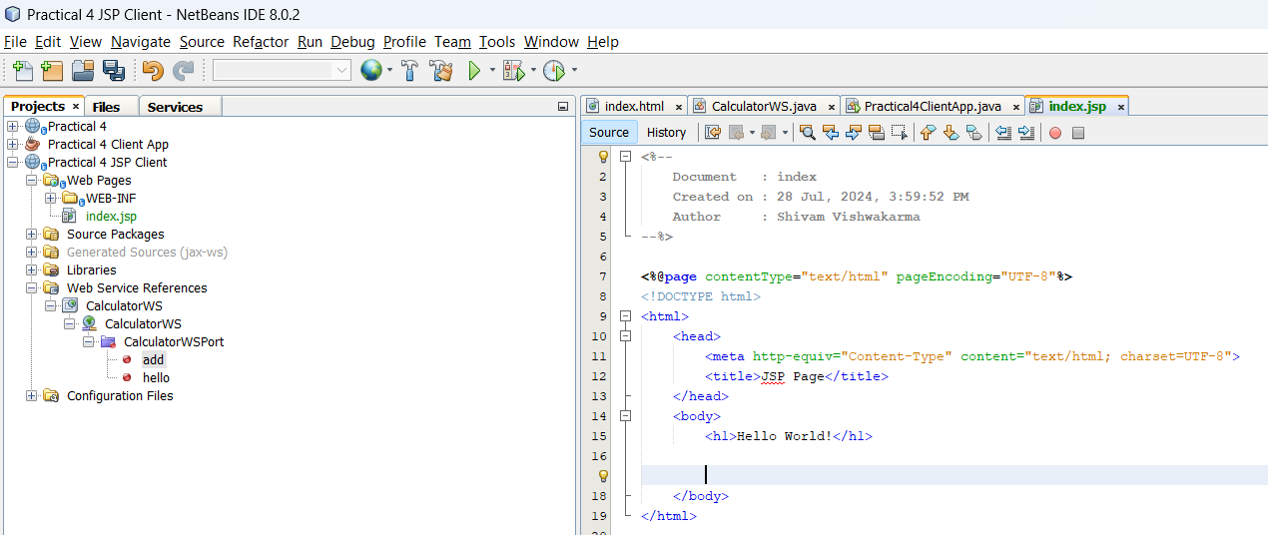

The code for invoking the service’s operation is now generated in the index.jsp page, as you can

see here:

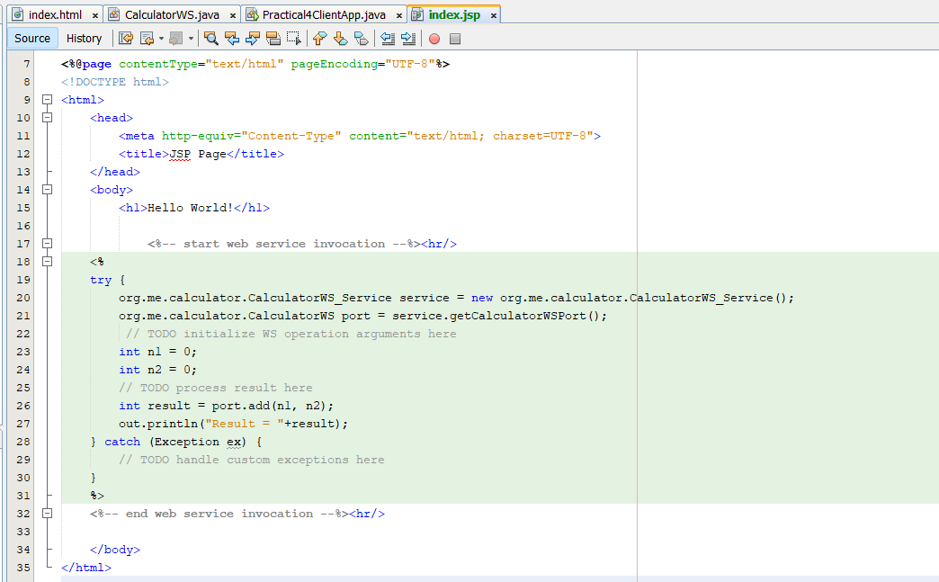

Make the Change the value for n1 and n2 from 0 to other integers, such as 16 and 8.

Replace the commented out TODO line in the catch block with

out.println("exception" + ex); .

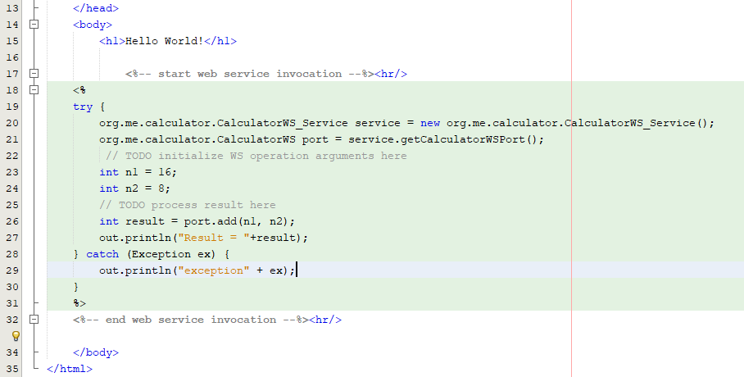

<%-- start web service invocation --%><hr/>

<%

try {

org.me.calculator.CalculatorWS_Service service = new org.me.calculator.CalculatorWS_Service();

org.me.calculator.CalculatorWS port = service.getCalculatorWSPort();

// TODO initialize WS operation arguments here

int n1 = 16;

int n2 = 8;

// TODO process result here

int result = port.add(n1, n2);

out.println("Result = "+result);

} catch (Exception ex) {

out.println("exception" + ex);

}

%>

<%-- end web service invocation --%><hr/>

Right-click the project node and choose Run.

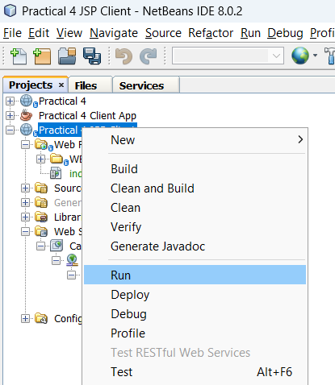

The server starts, if it wasn’t running already. The application is built and deployed, and the browser

opens, displaying the calculation result:

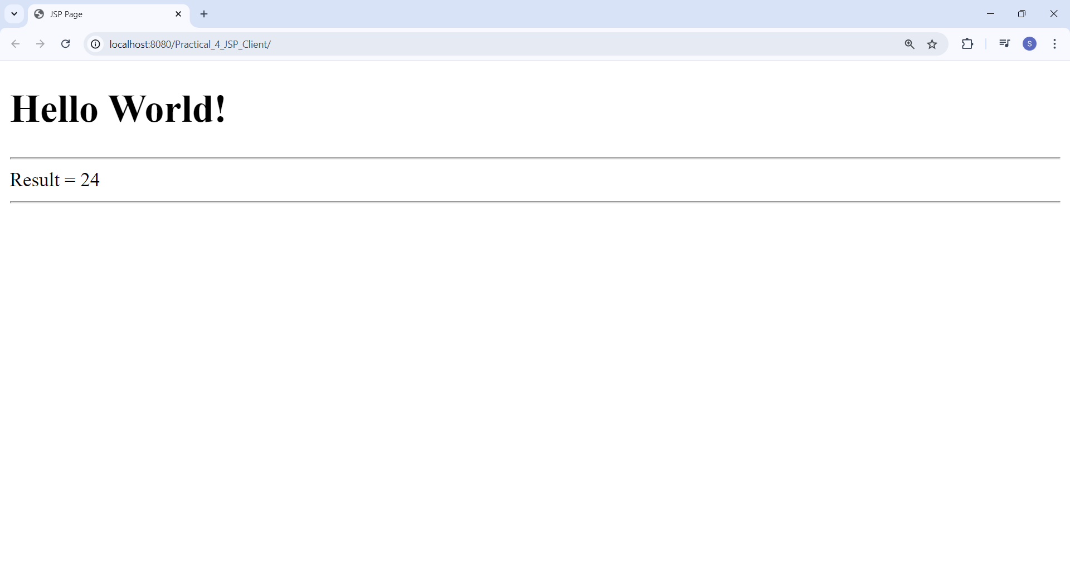

#### **Practical 5 - Implementation of cluster on Windows Server.**

Aug 13, 2024

Ensure you have Windows server 2012 iso file

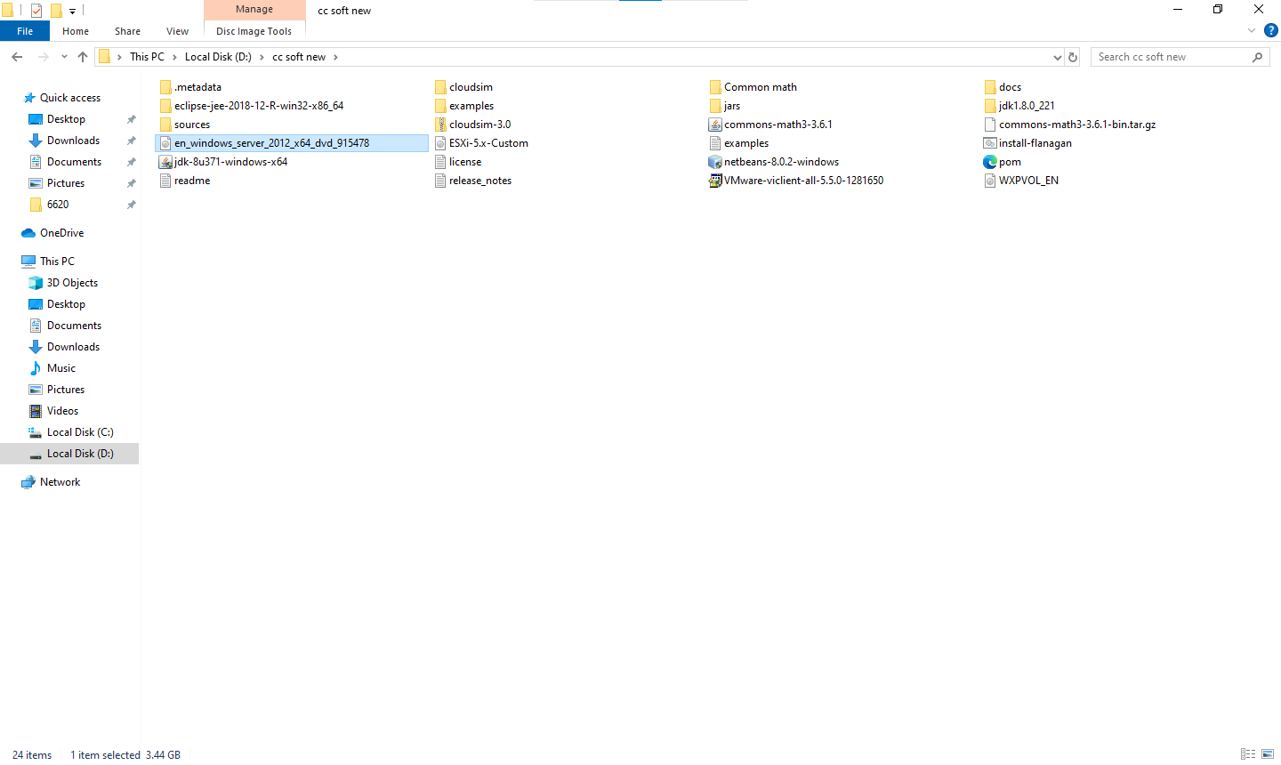

Open VM Ware → File → New Virtual Machine

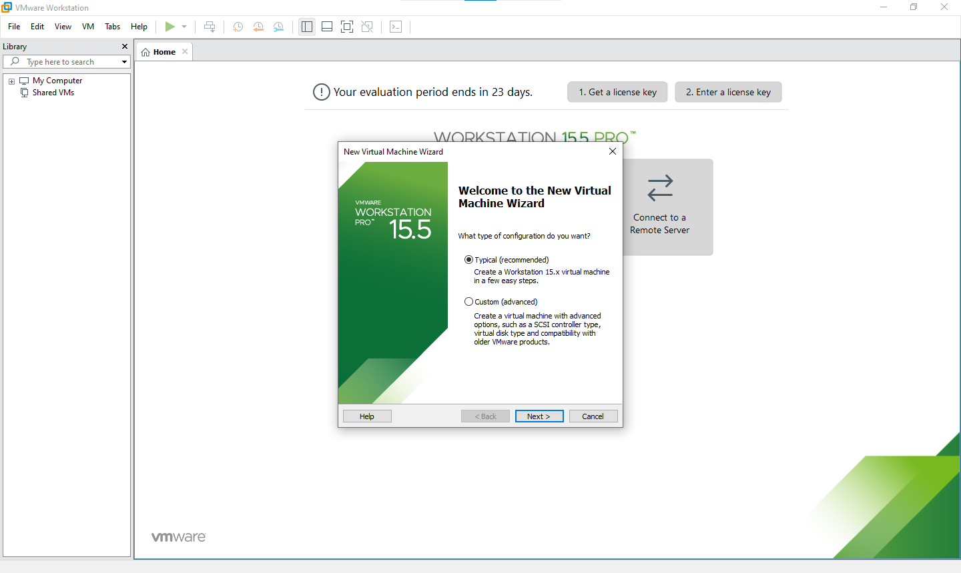

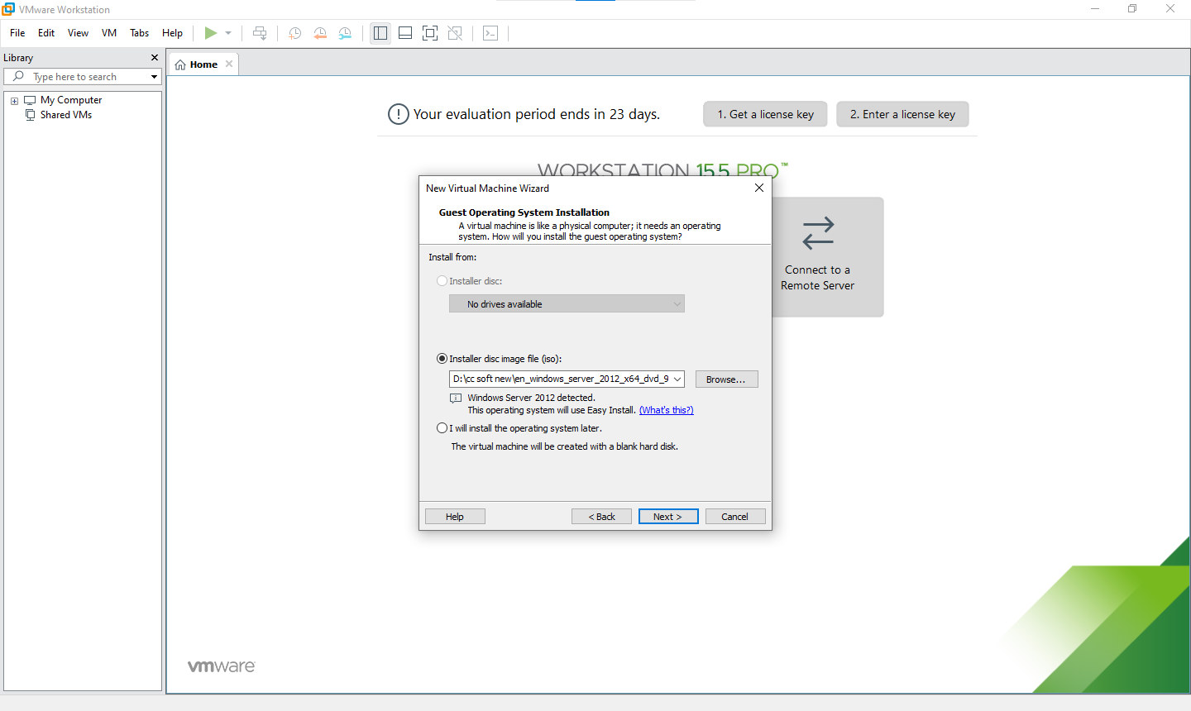

Product Key - 48HP8-DN98B-MYWDG-T2DCC-8W83P

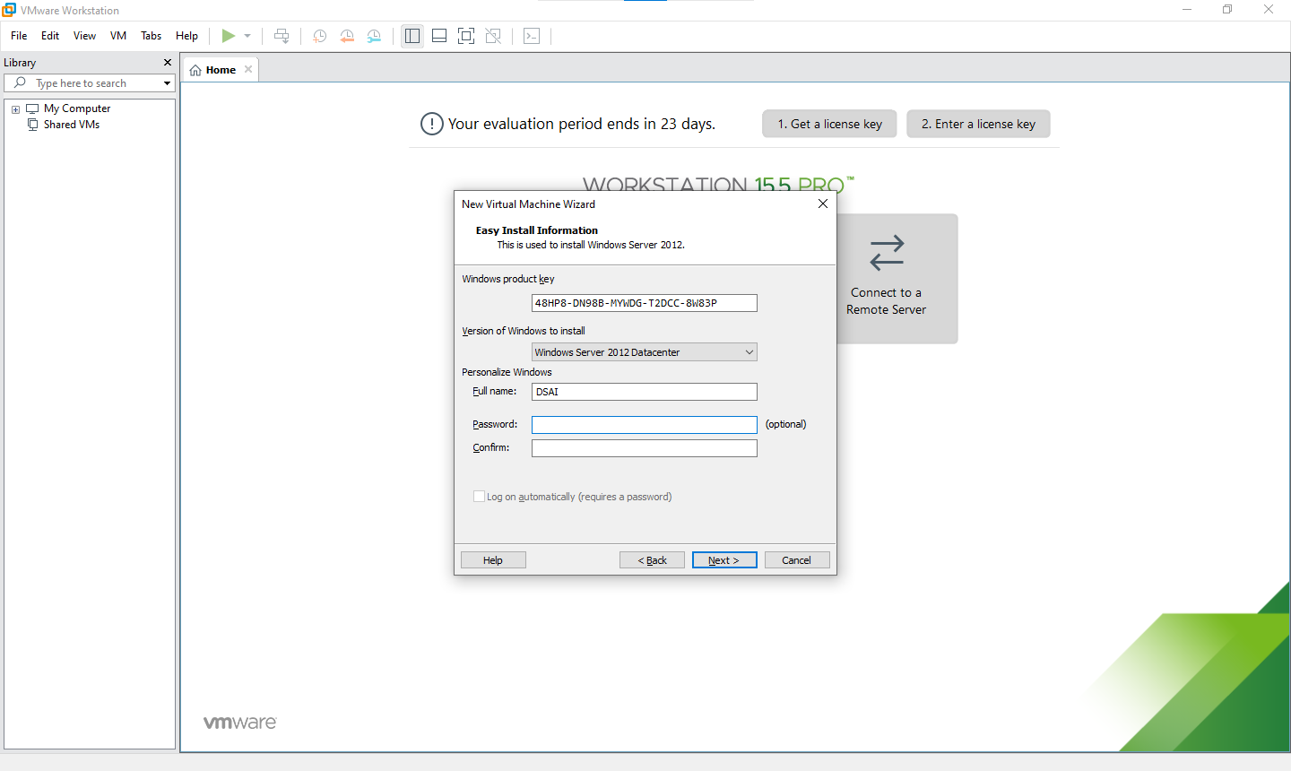

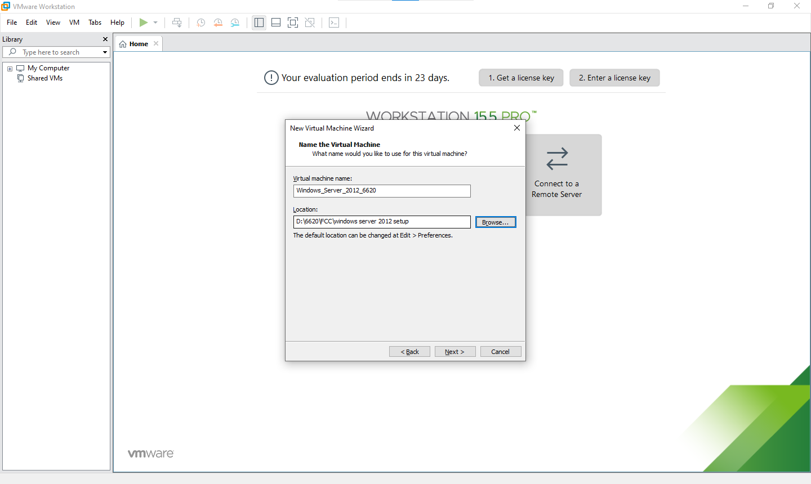

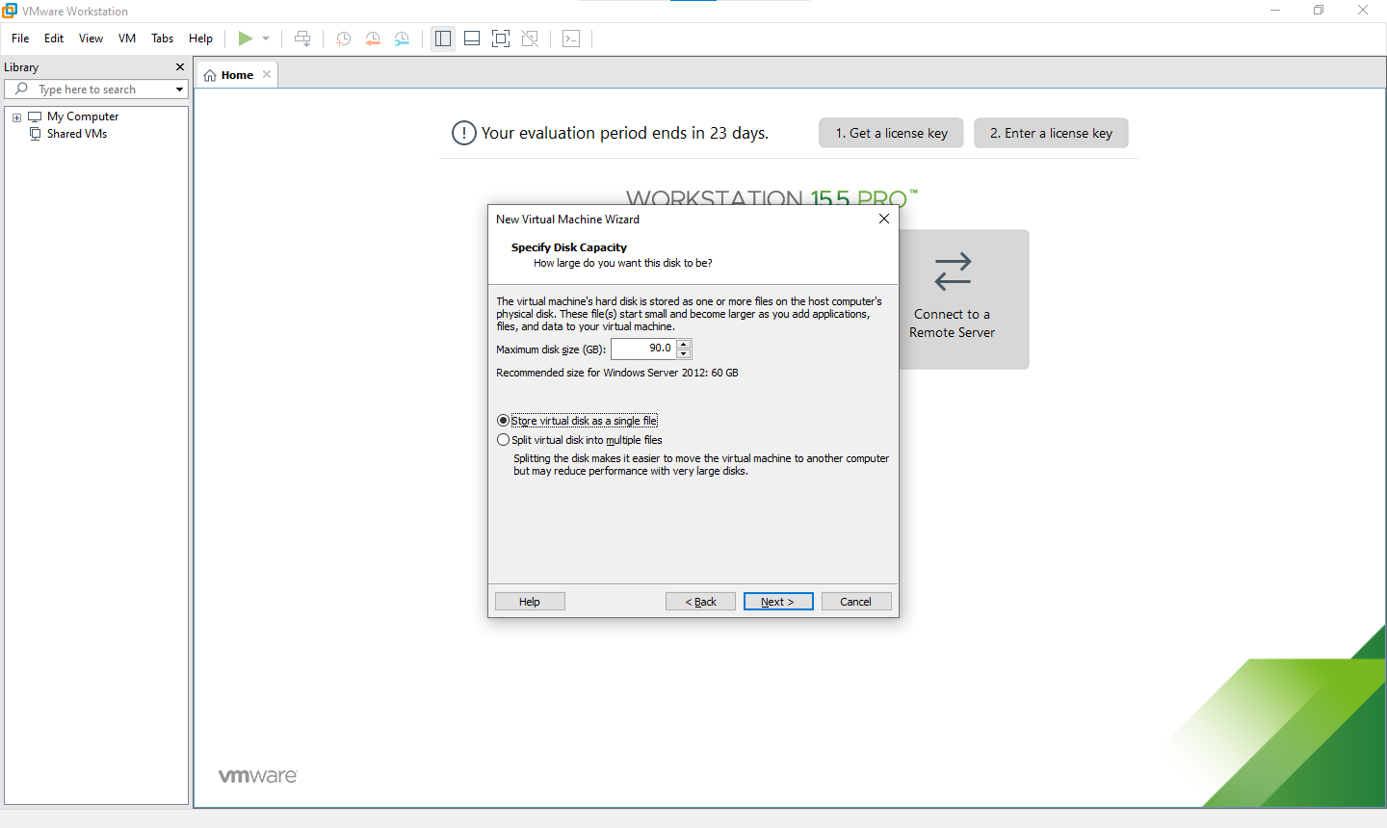

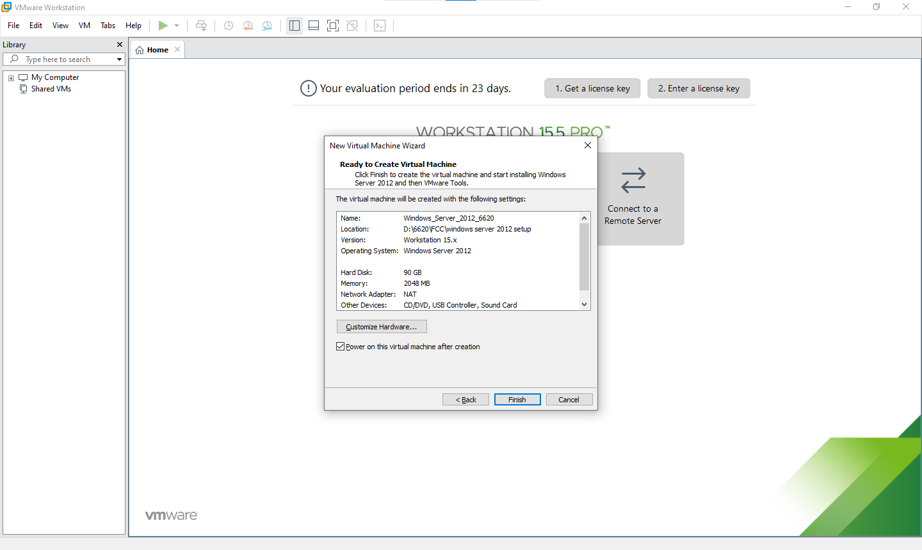

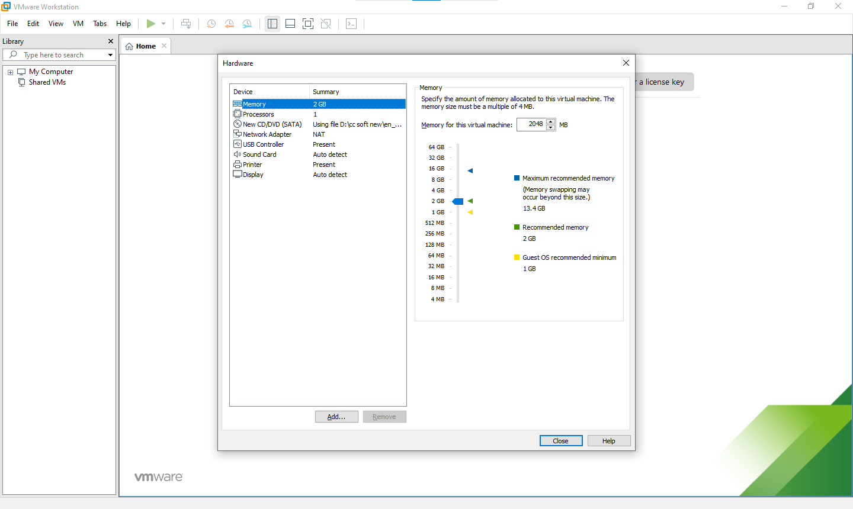

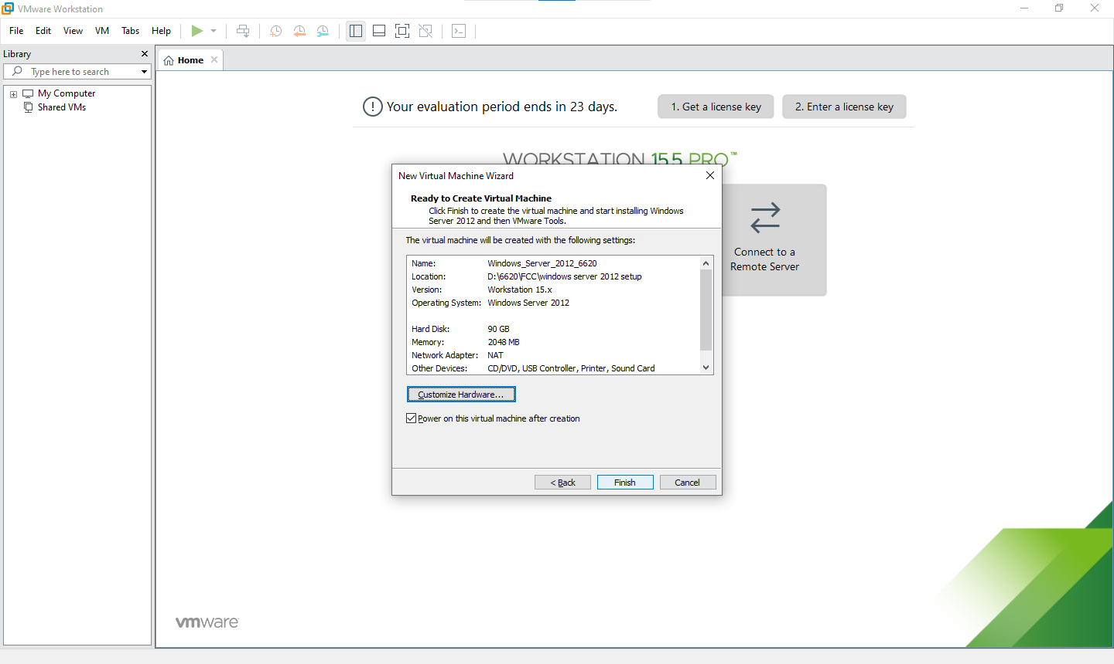

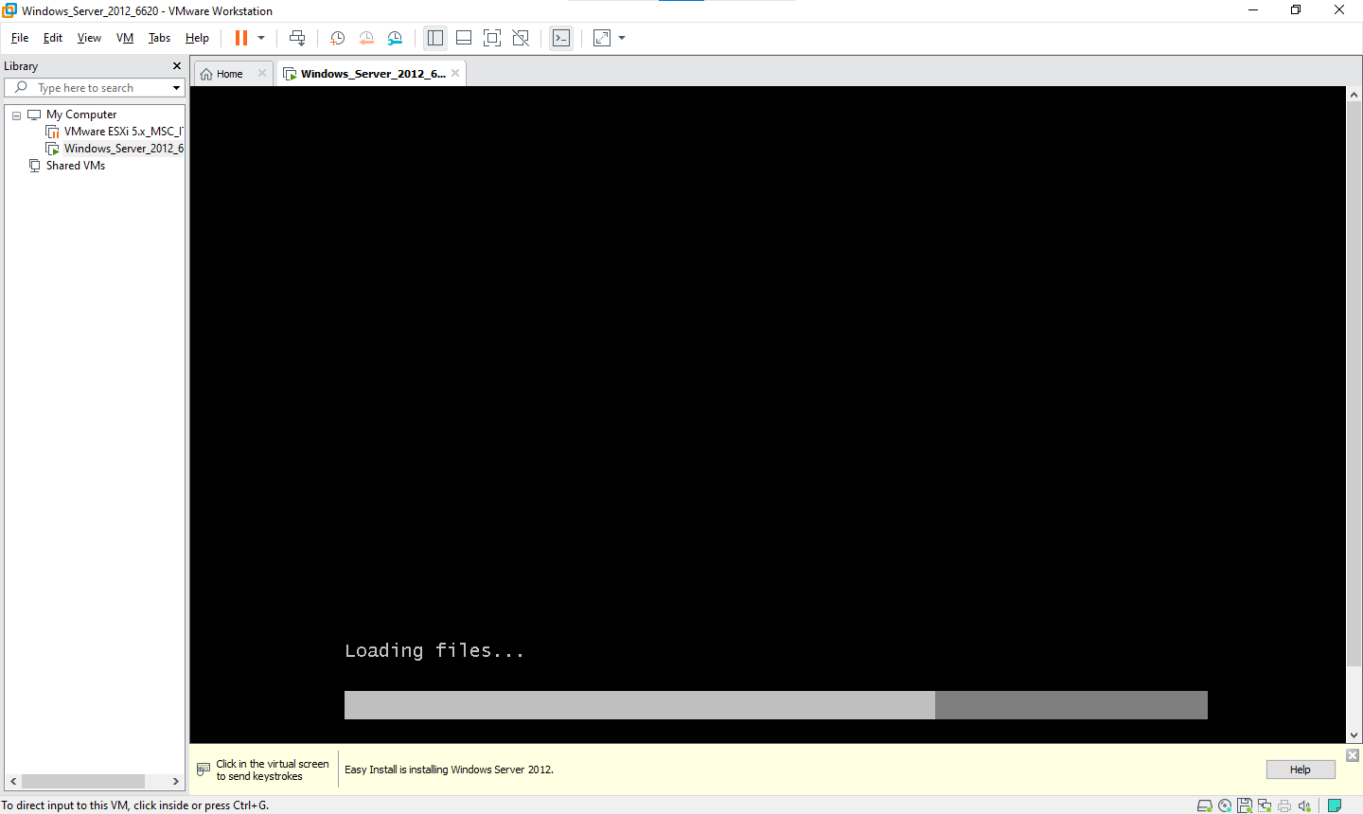

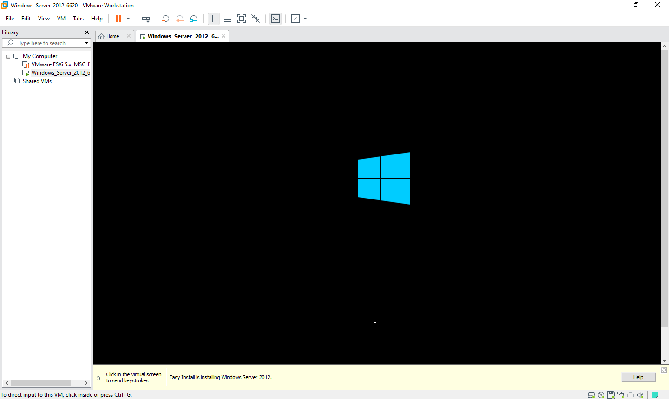

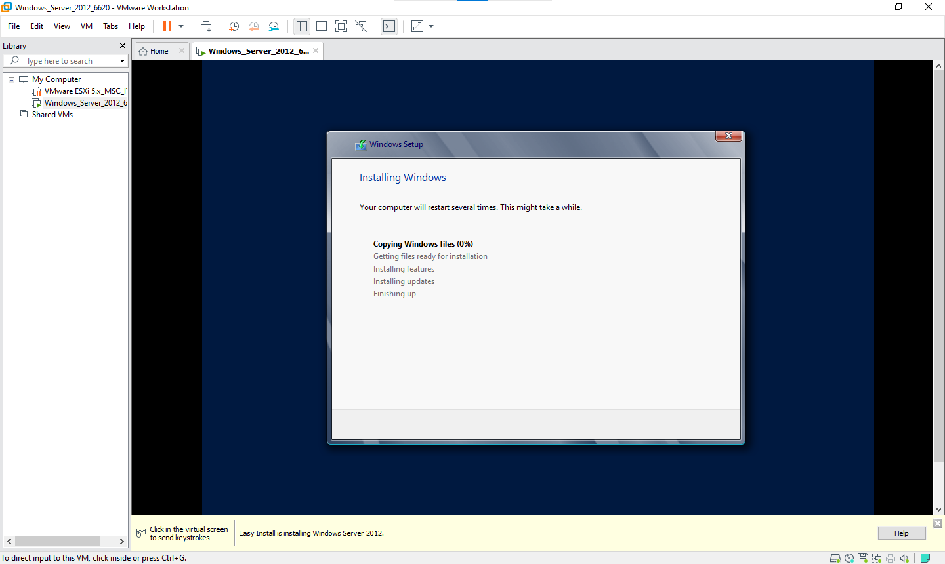

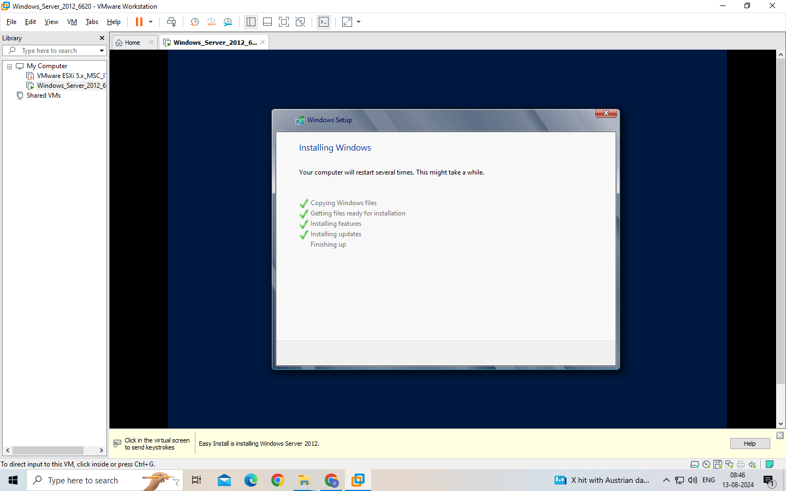

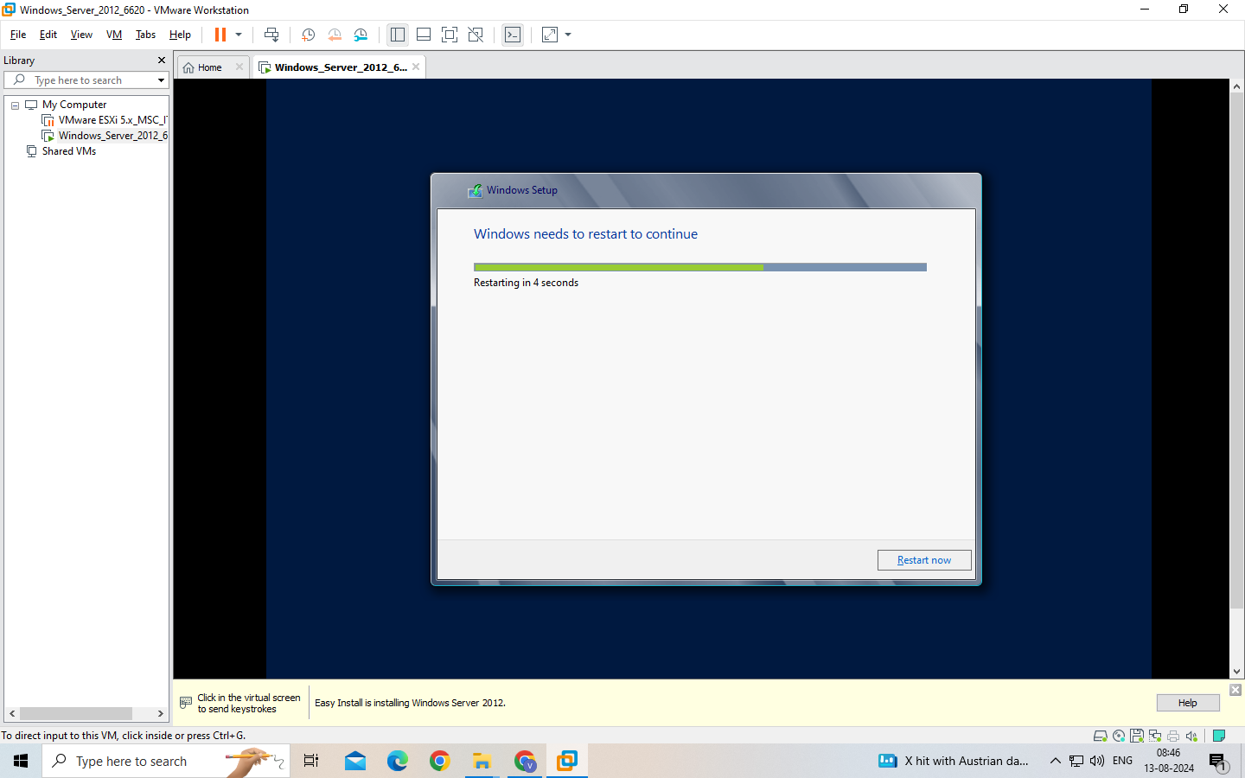

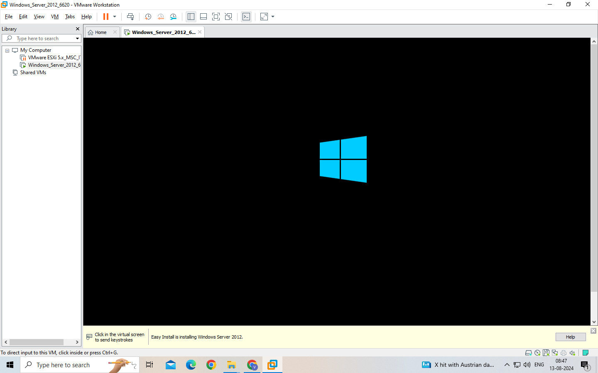

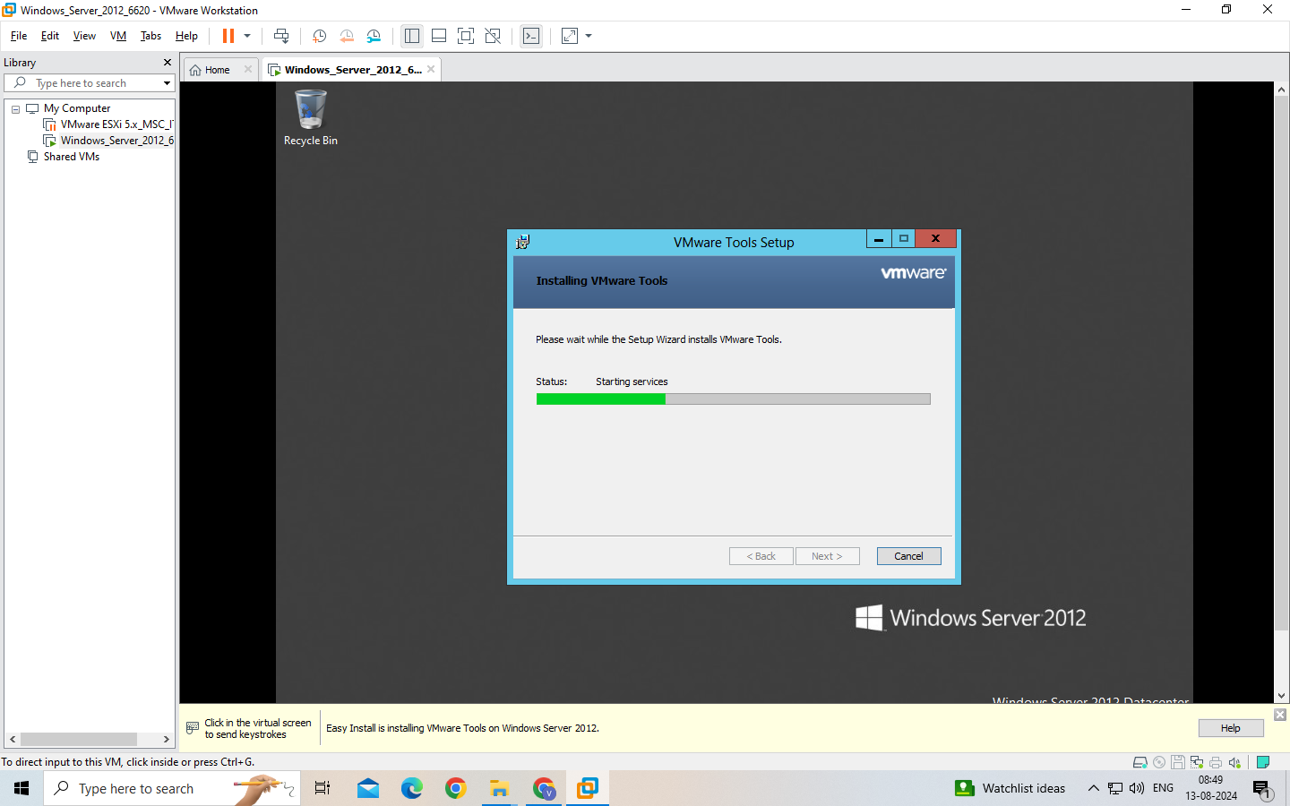

After restart

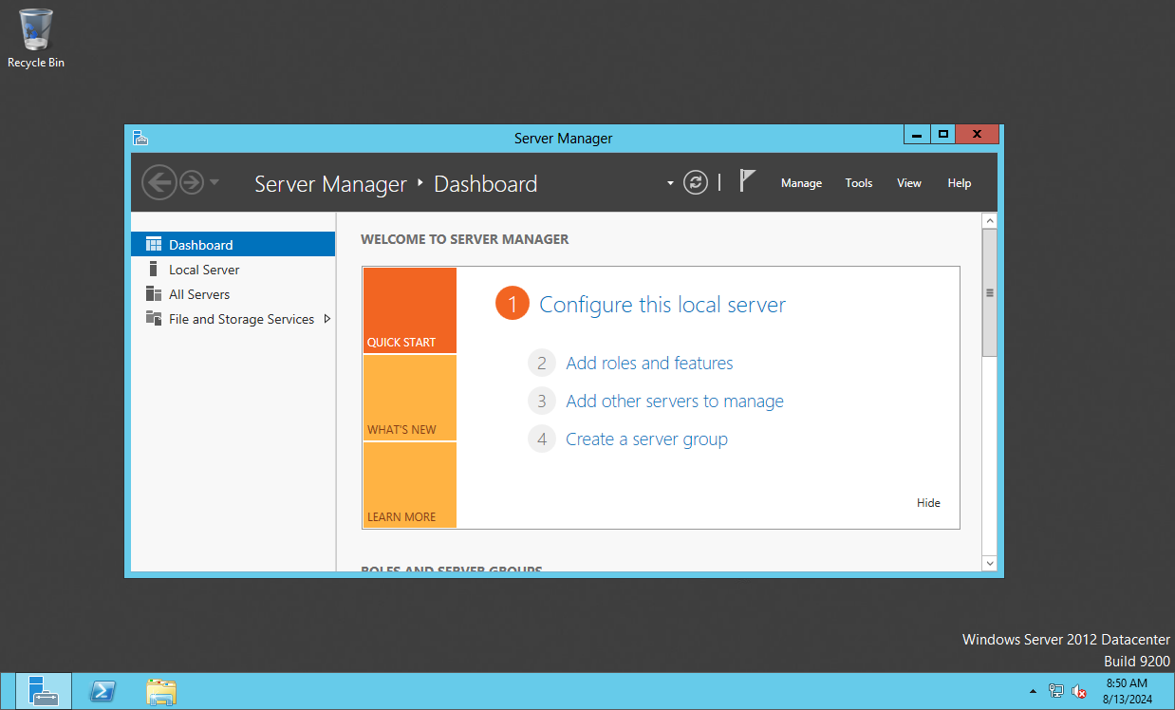

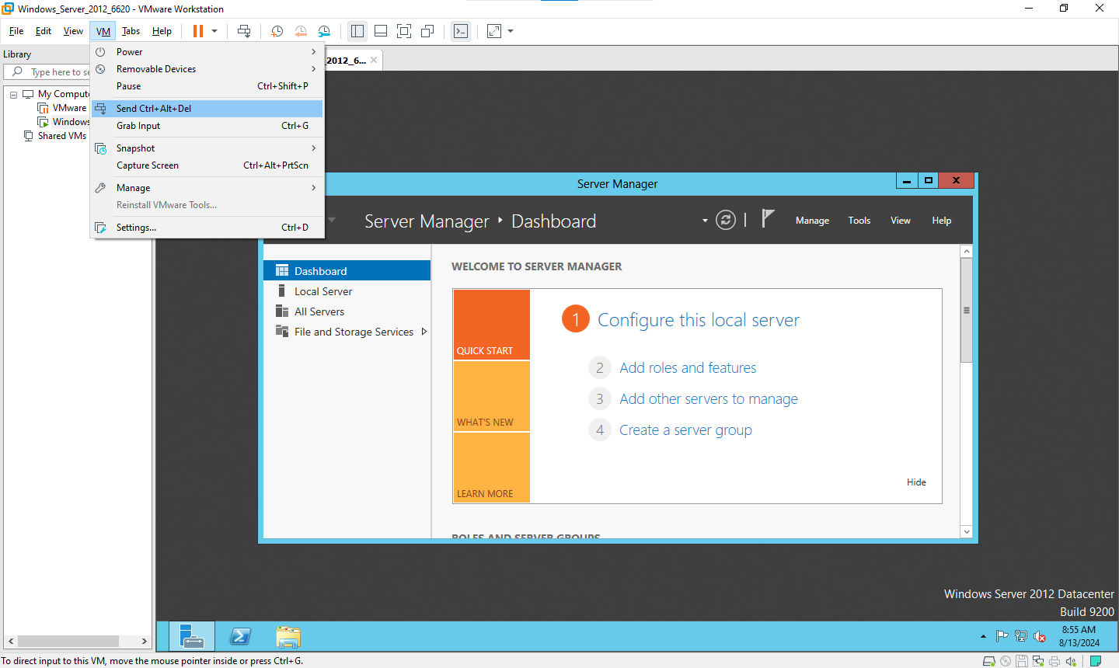

Click on switch user

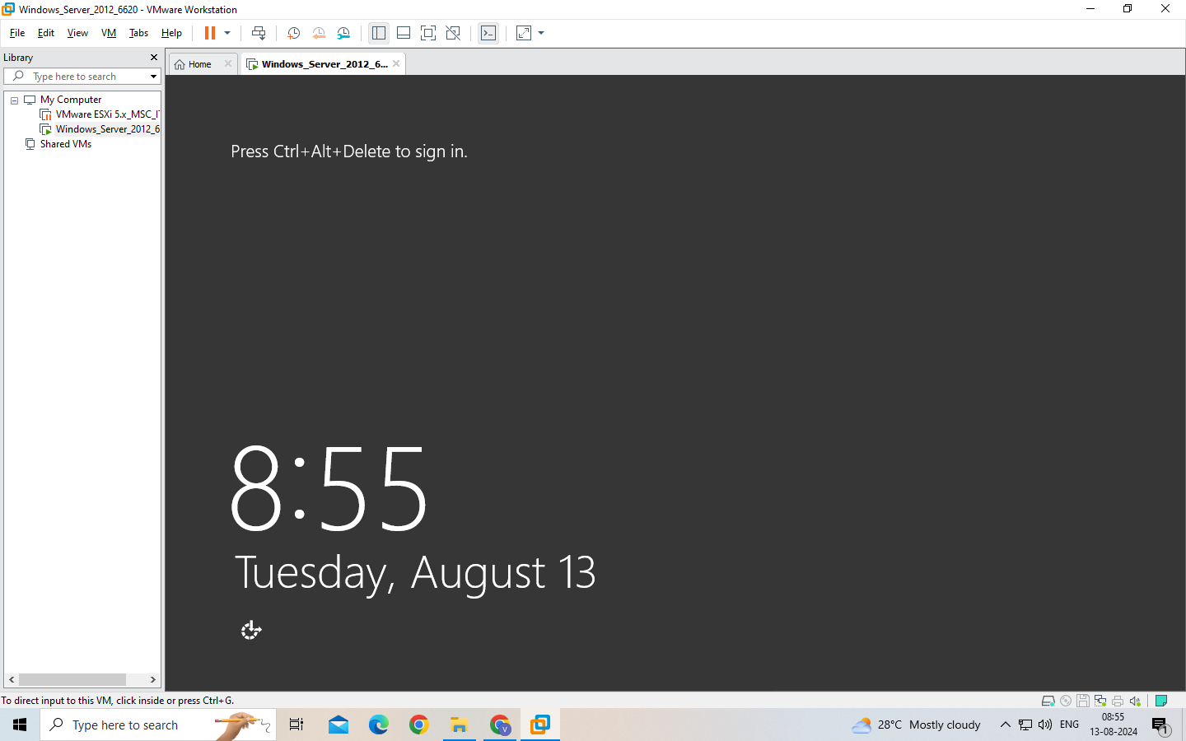



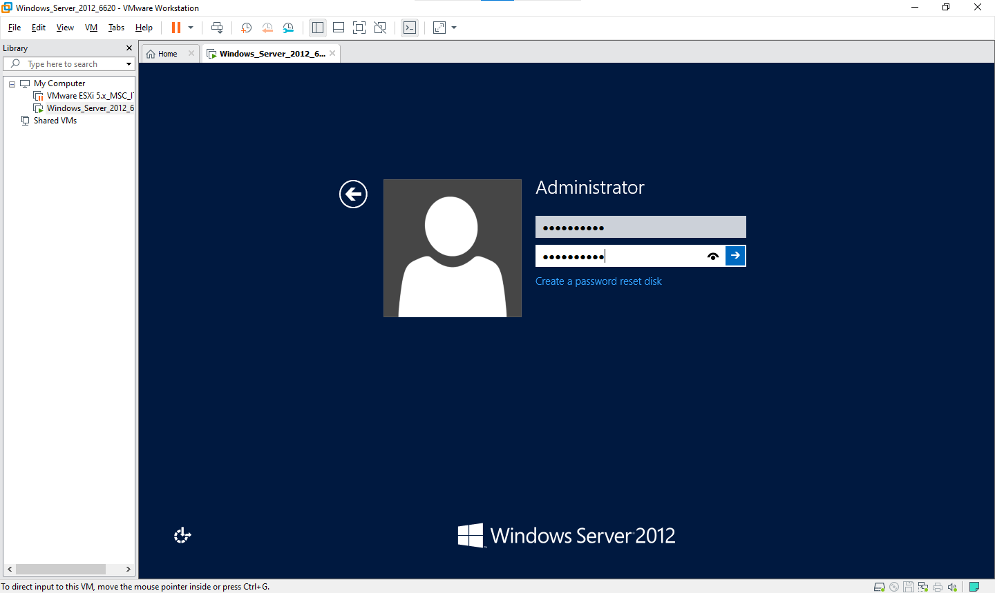

Admin12345

Click on submit

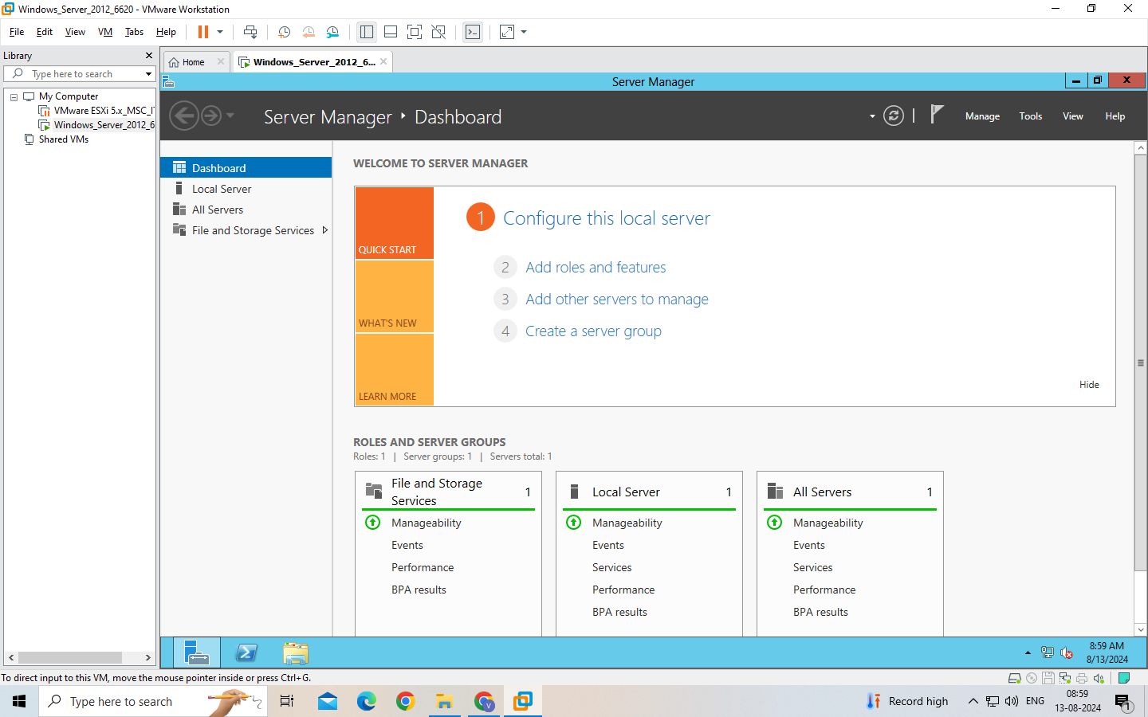

Go to manage →



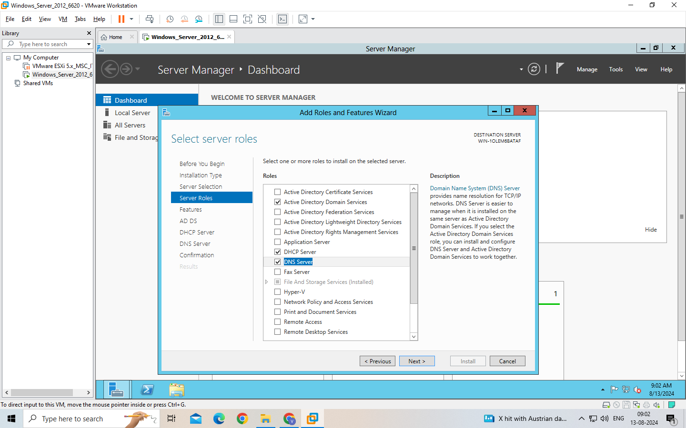

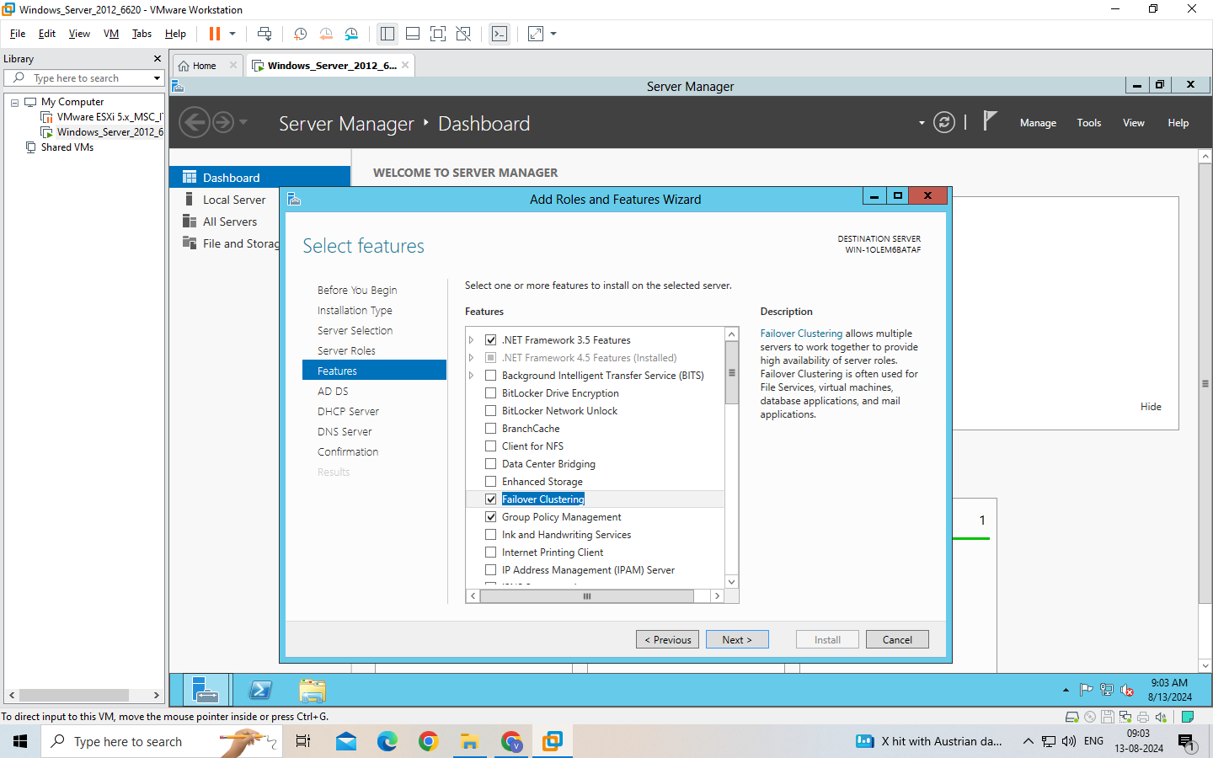

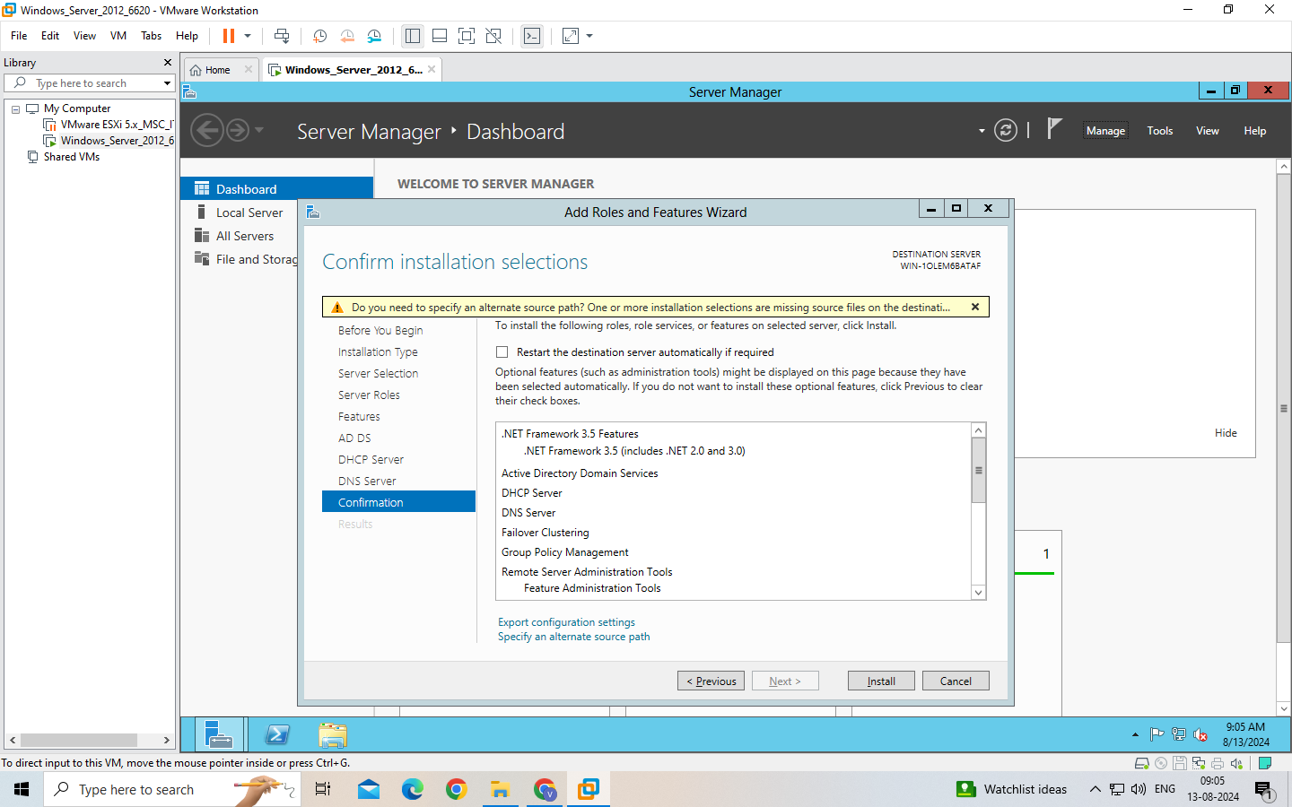

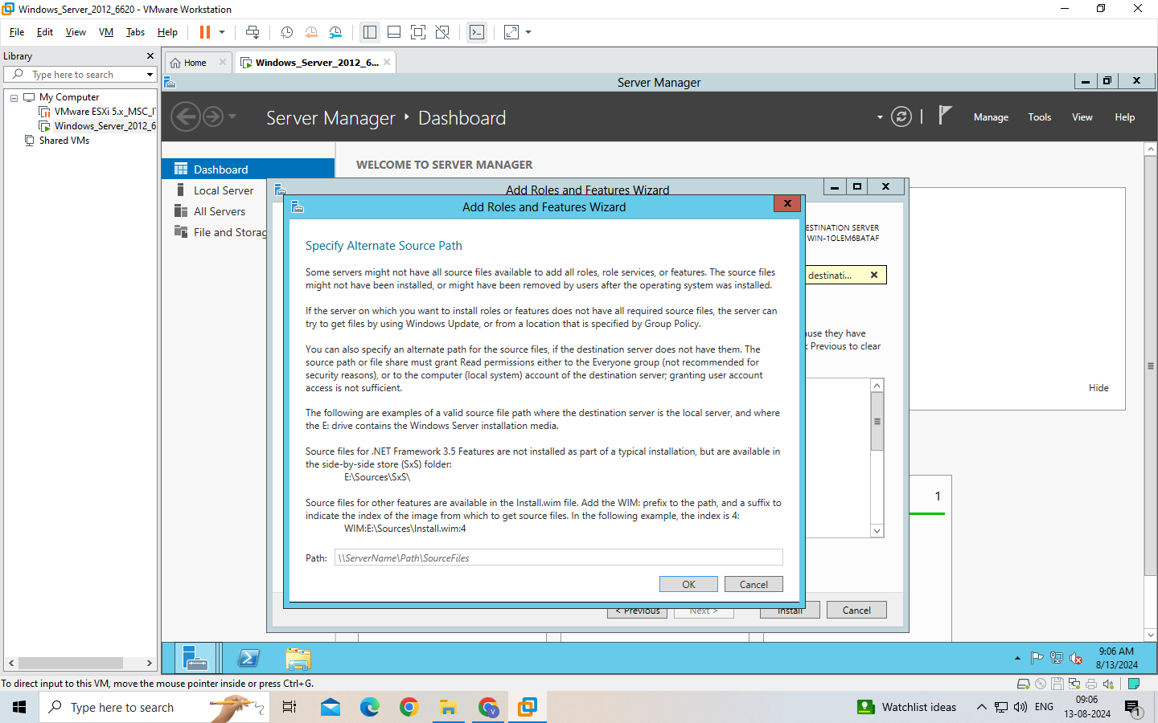

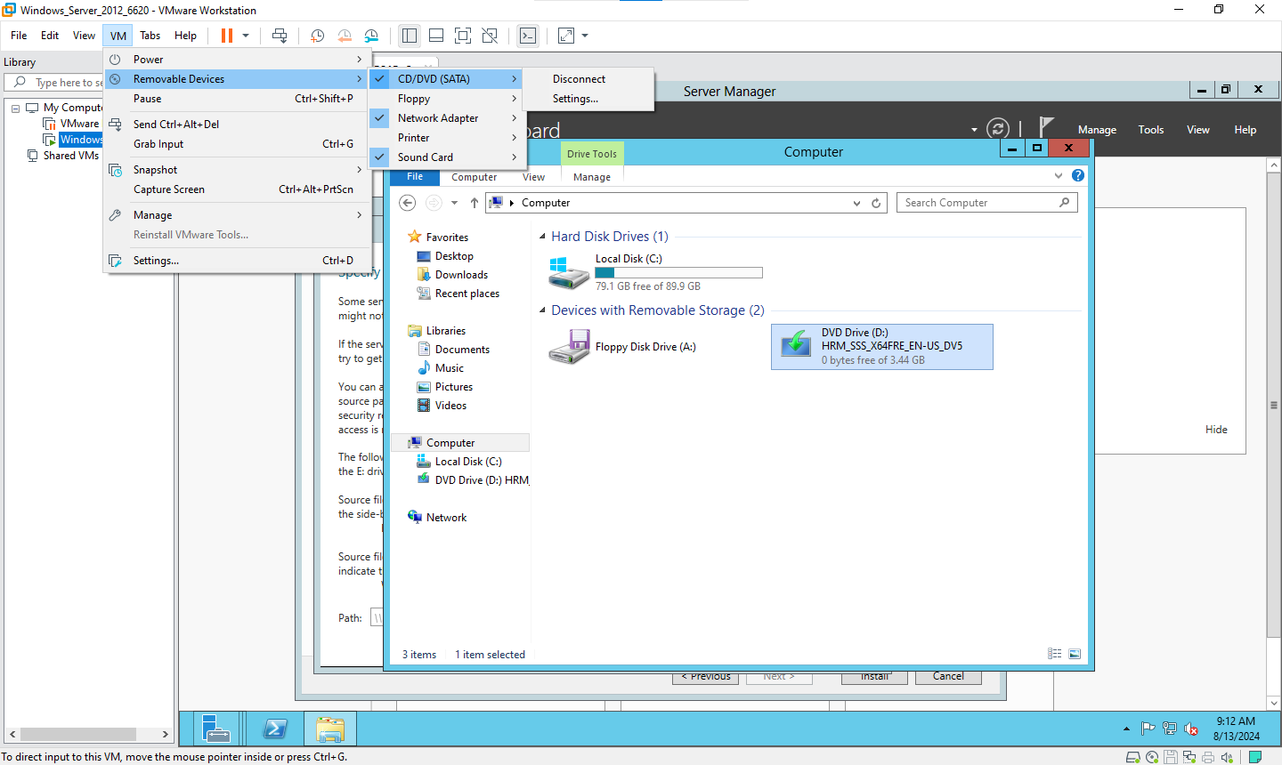

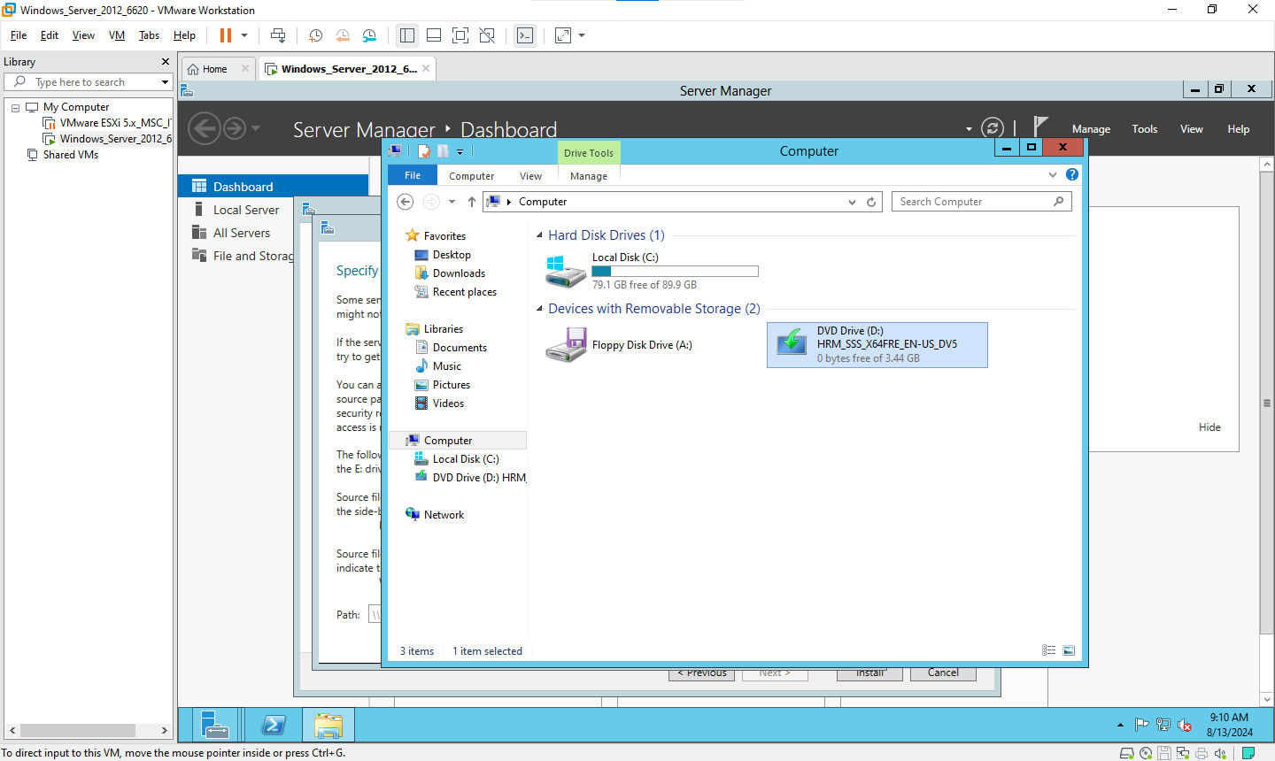

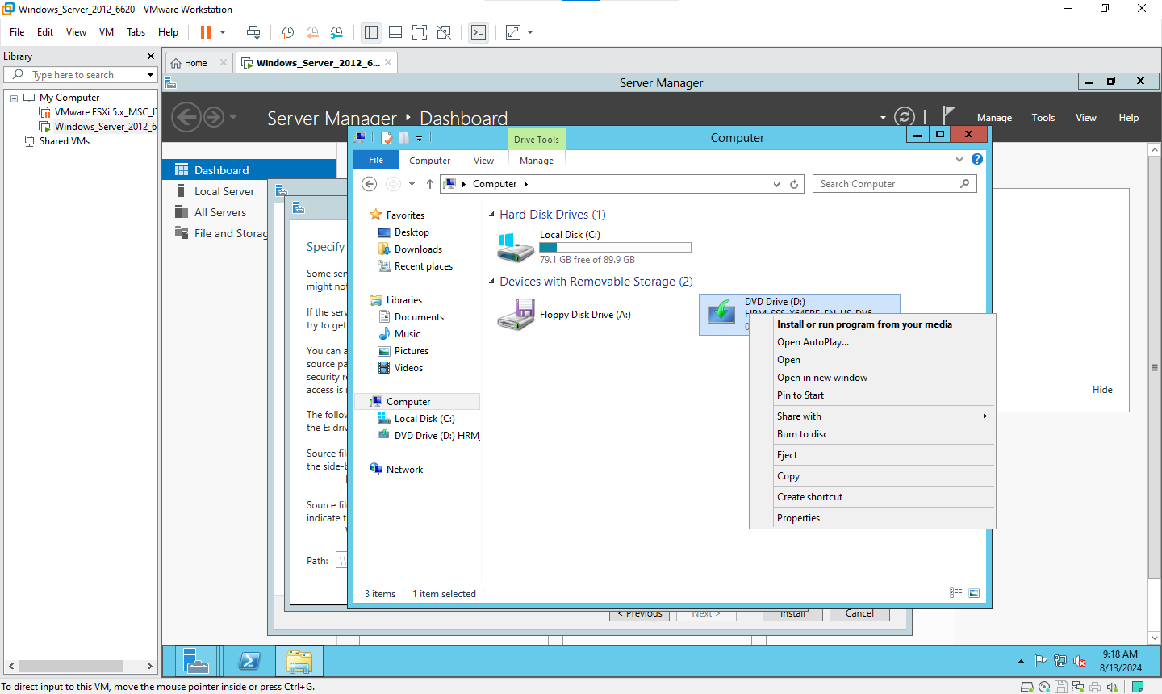

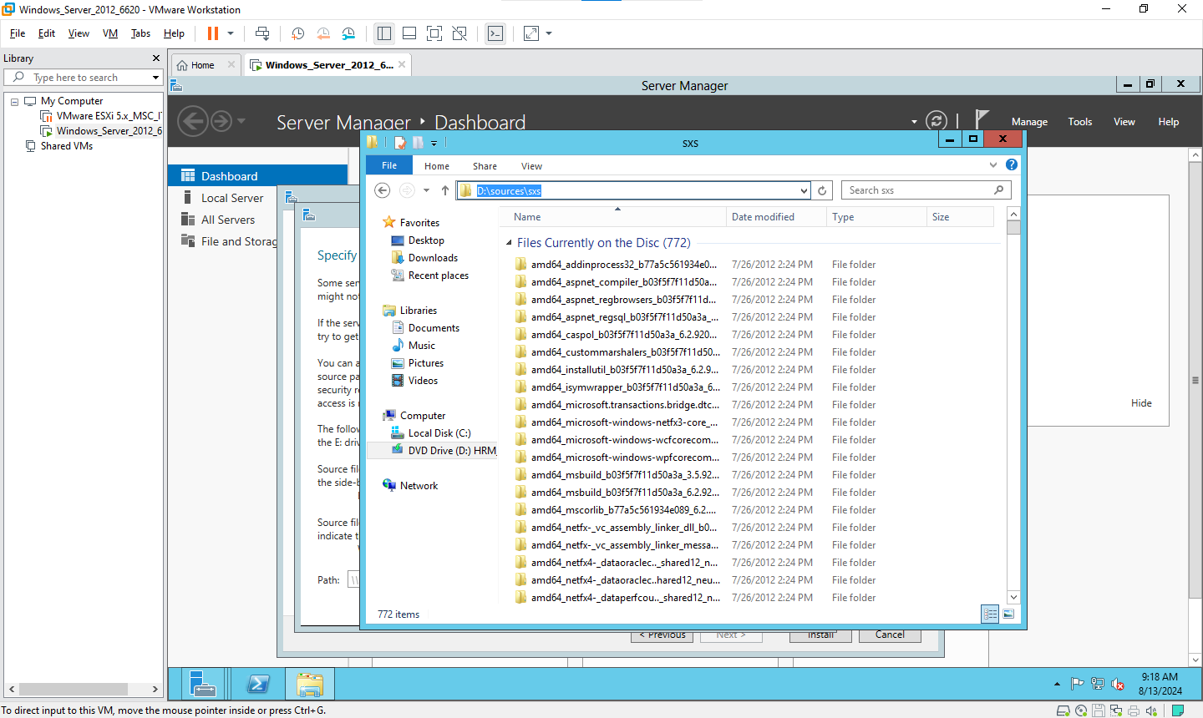

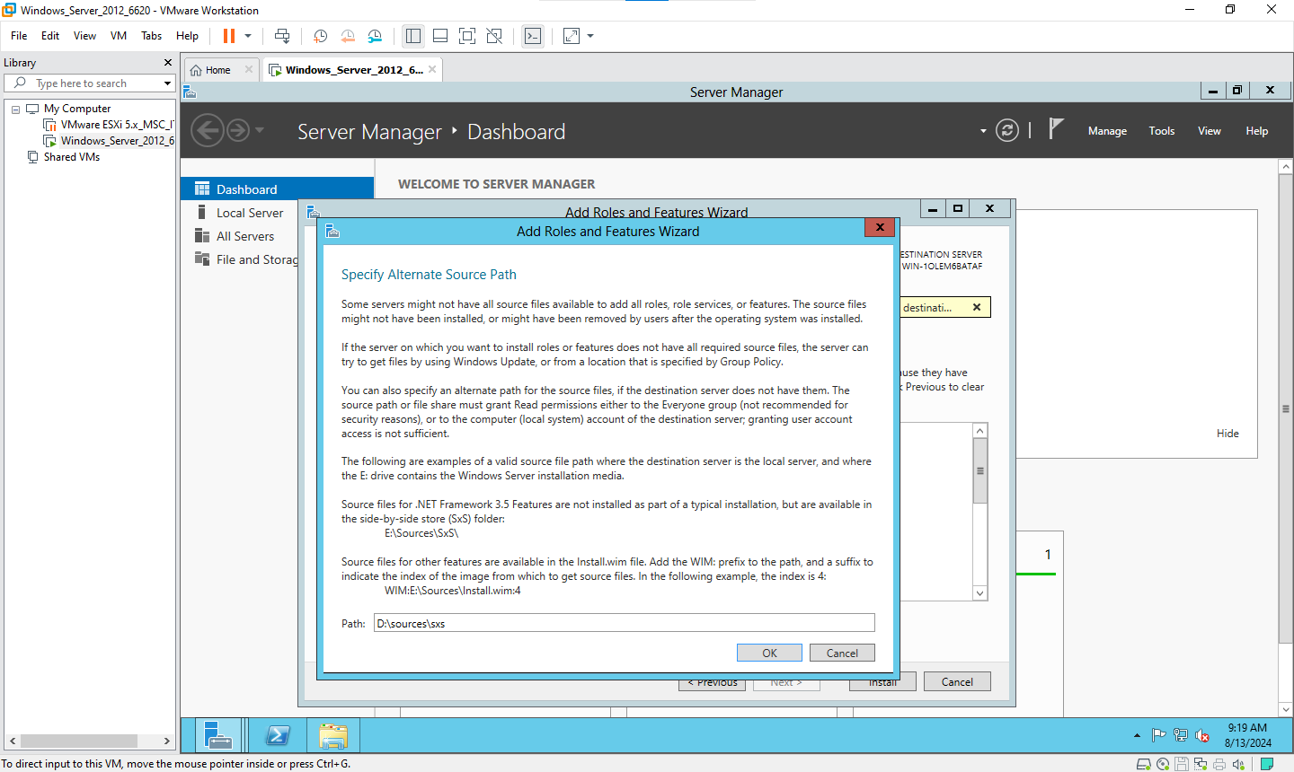

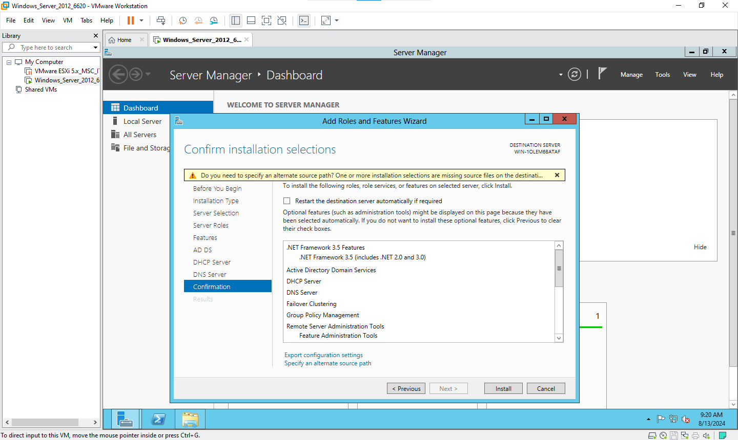

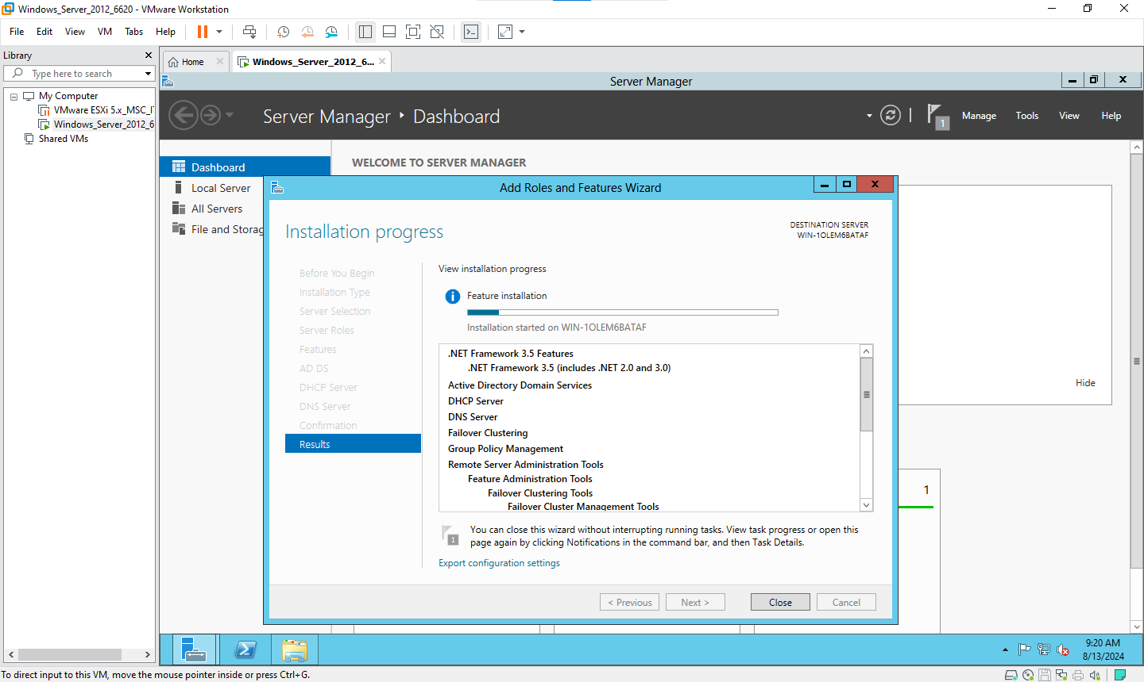

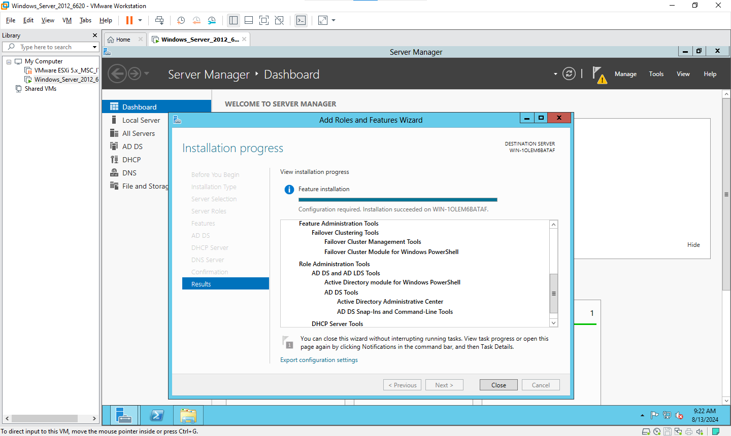

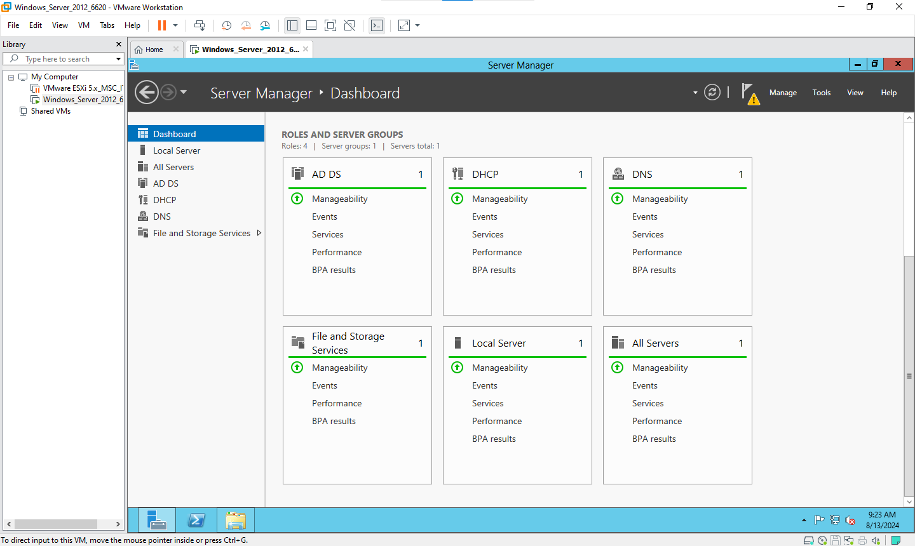

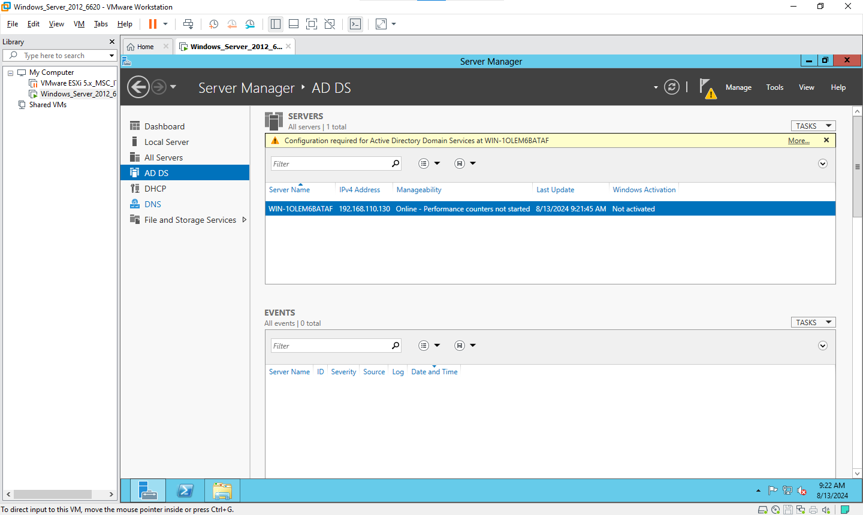

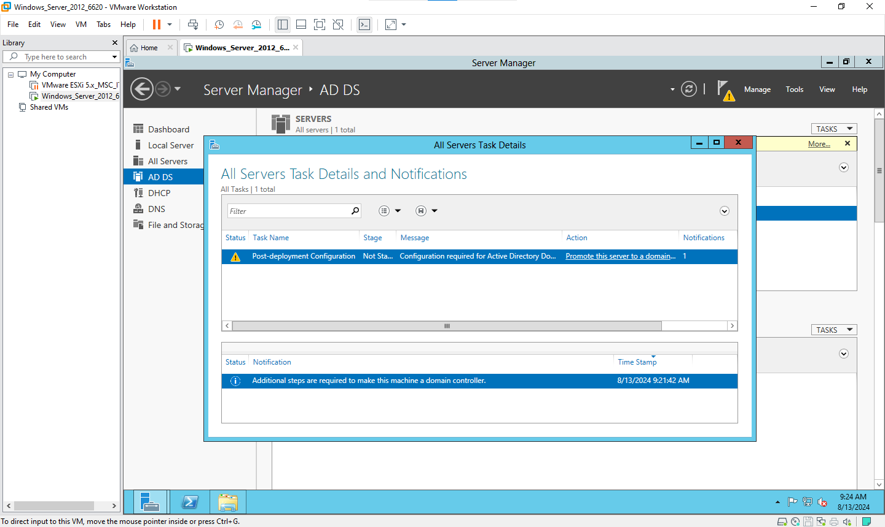

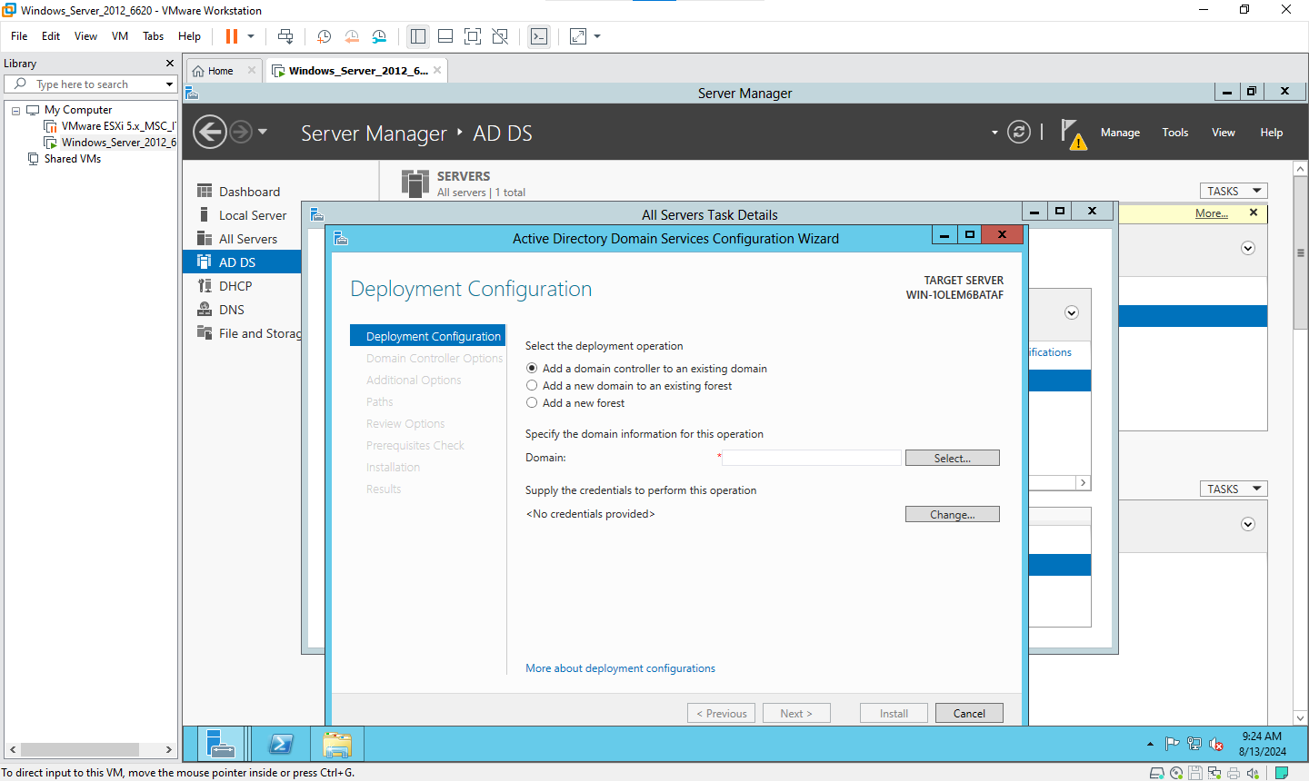

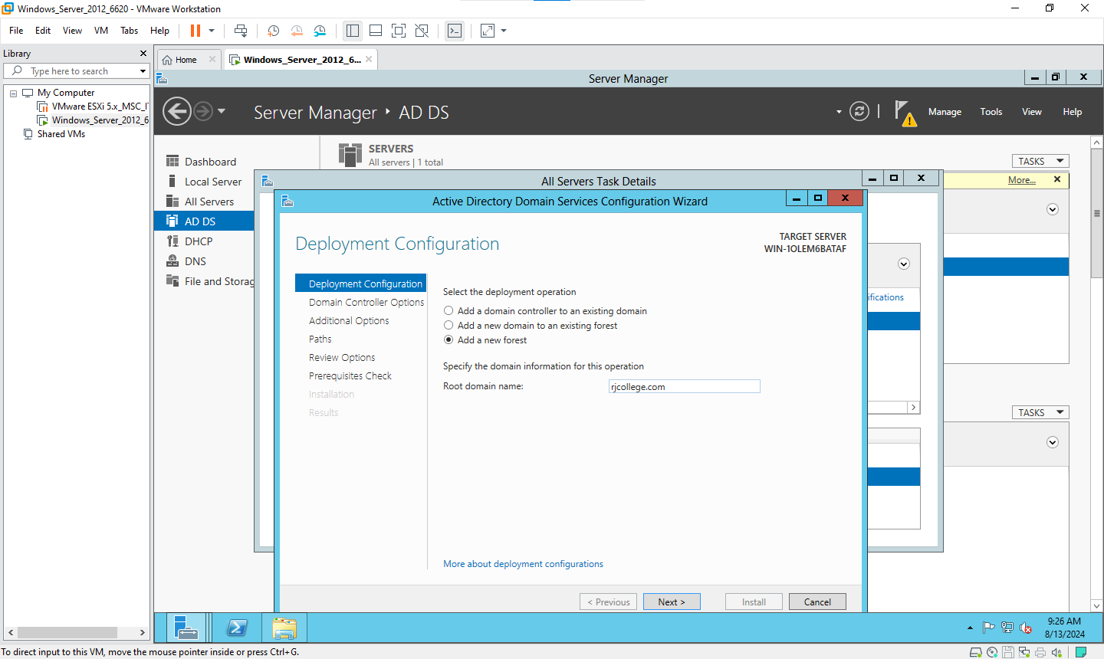

Type same password as admin that is Admin12345

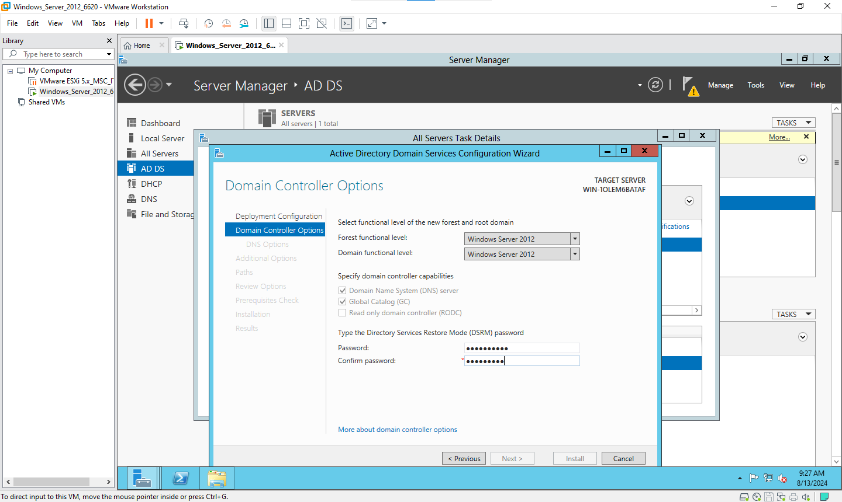

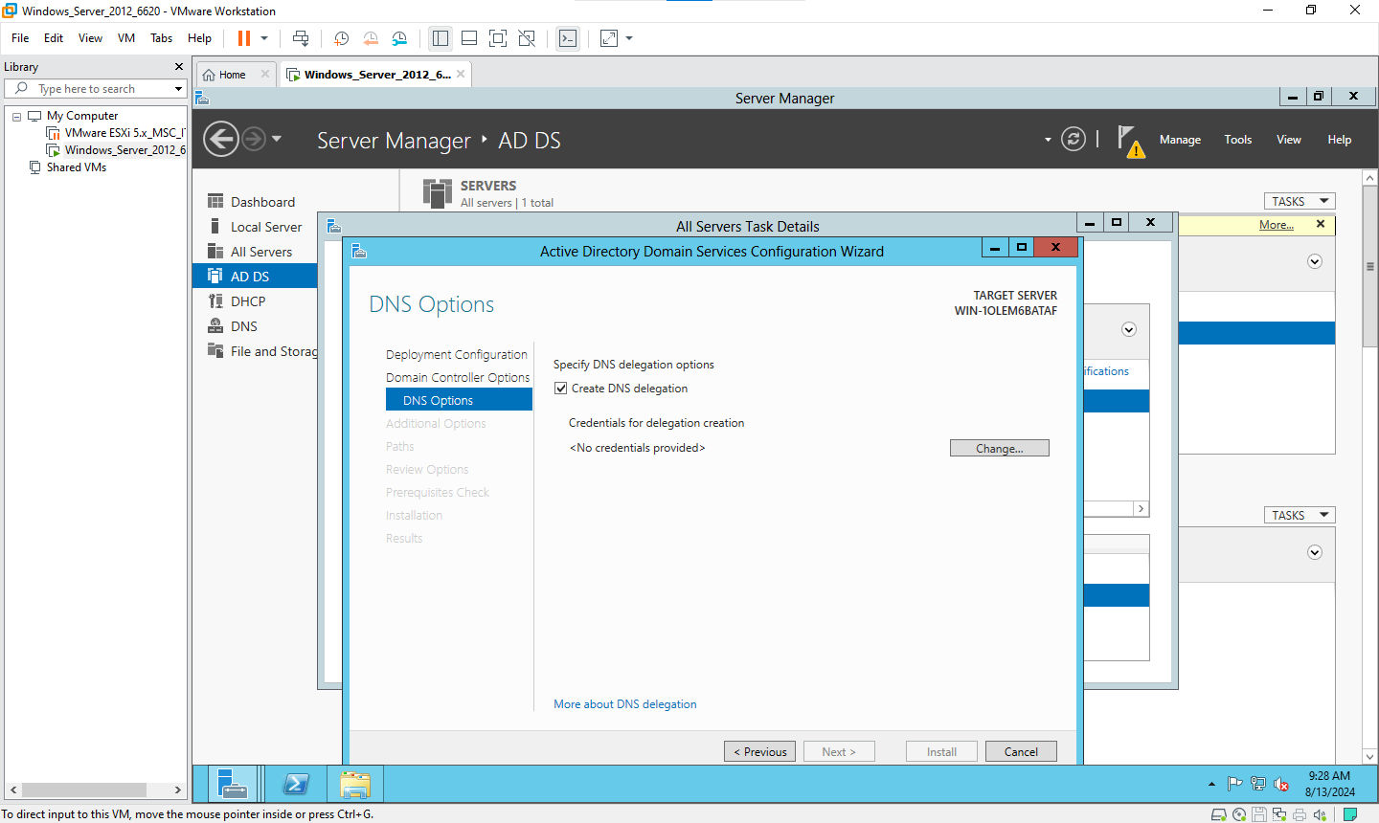

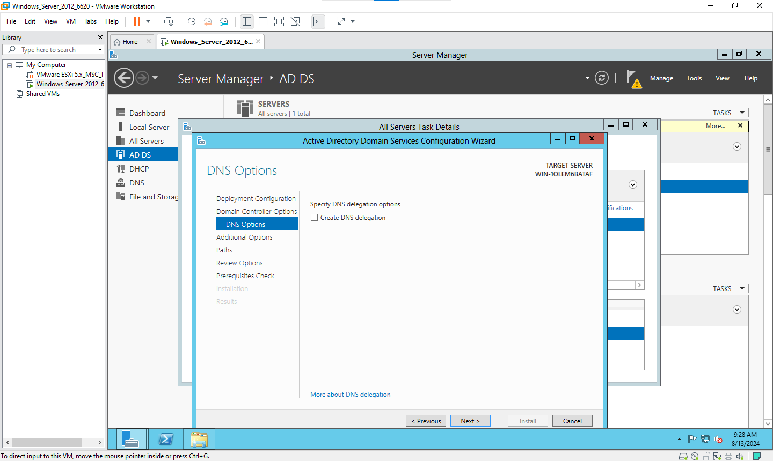

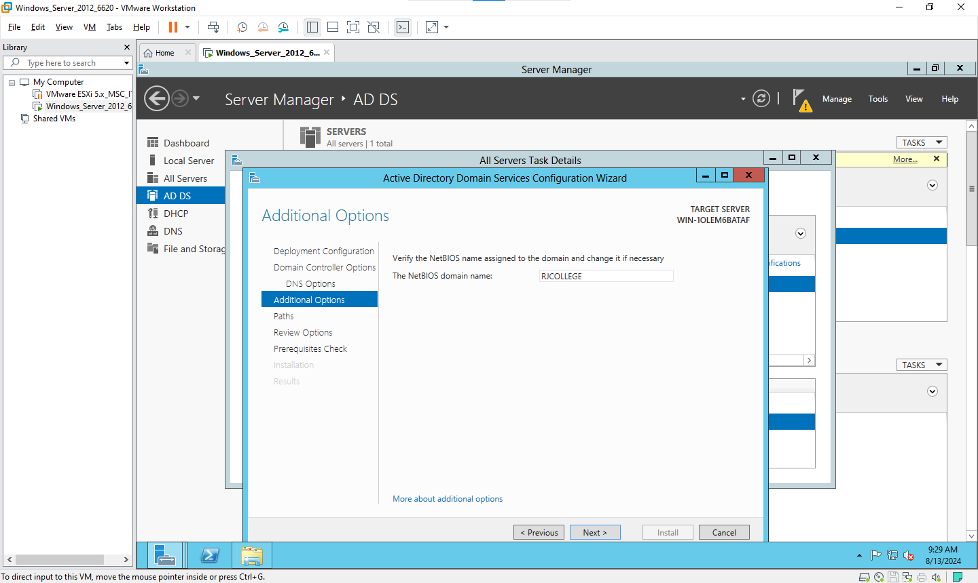

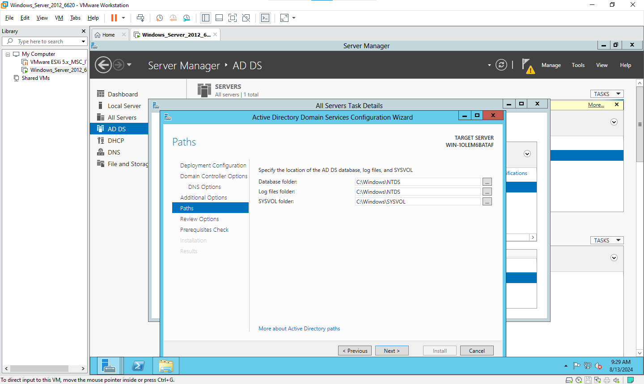

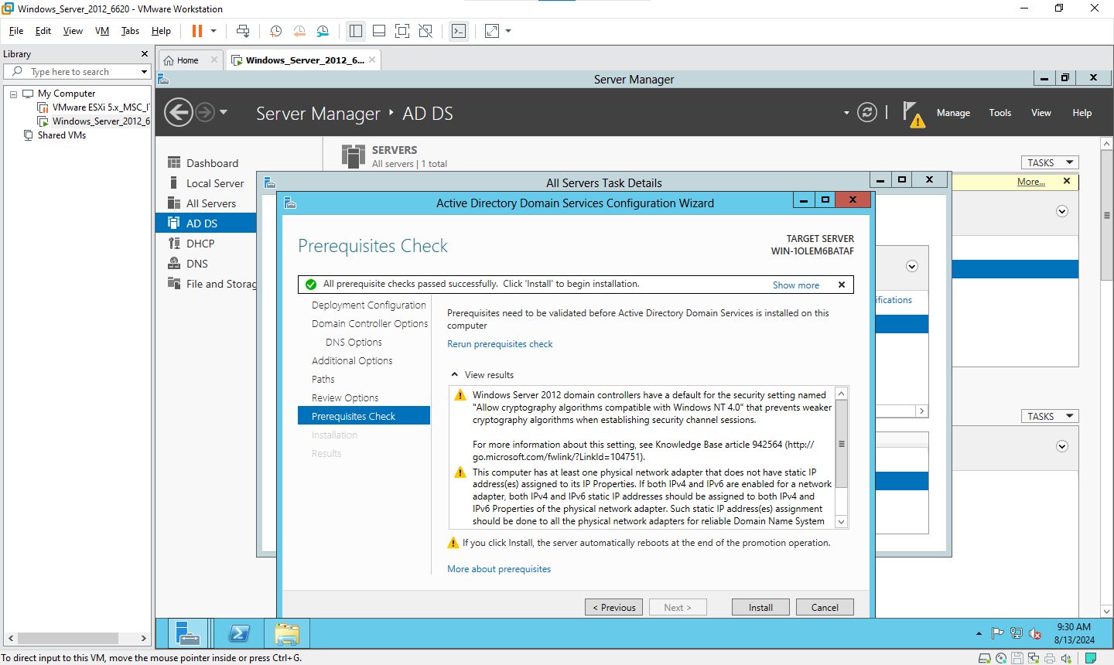

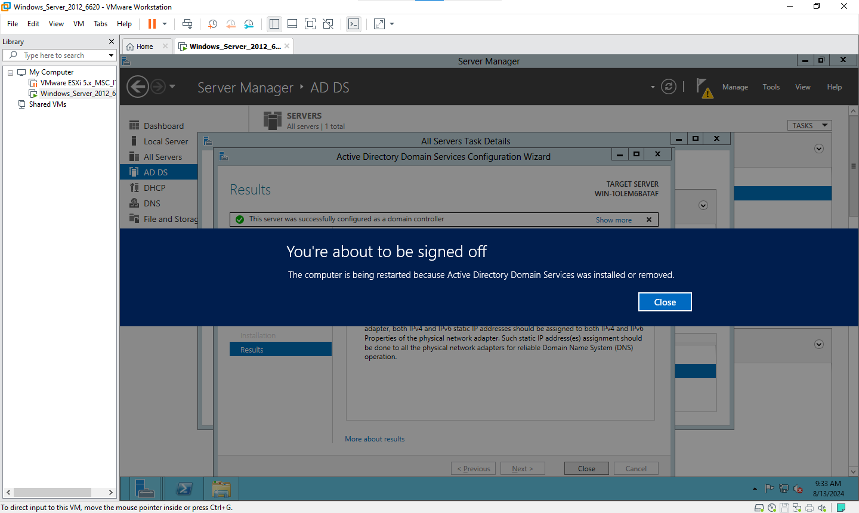

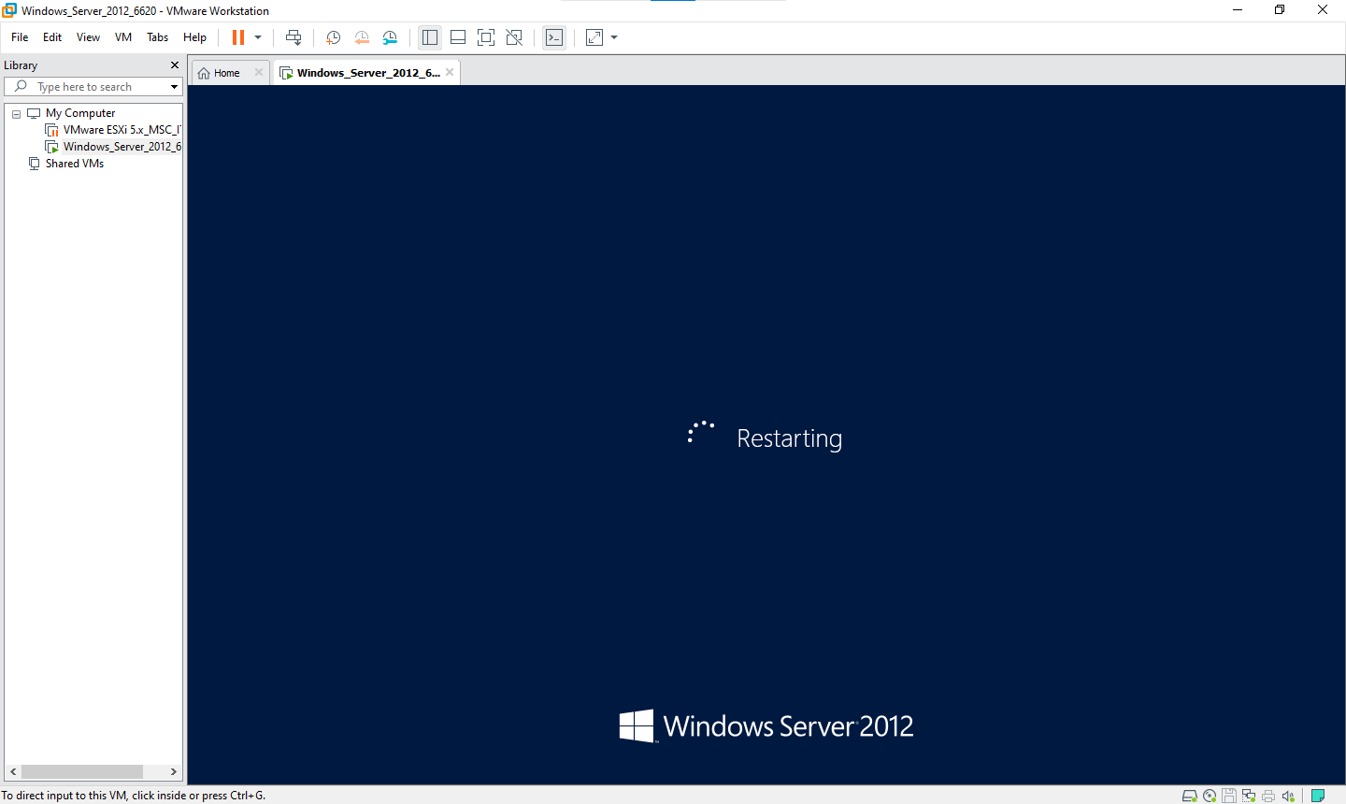

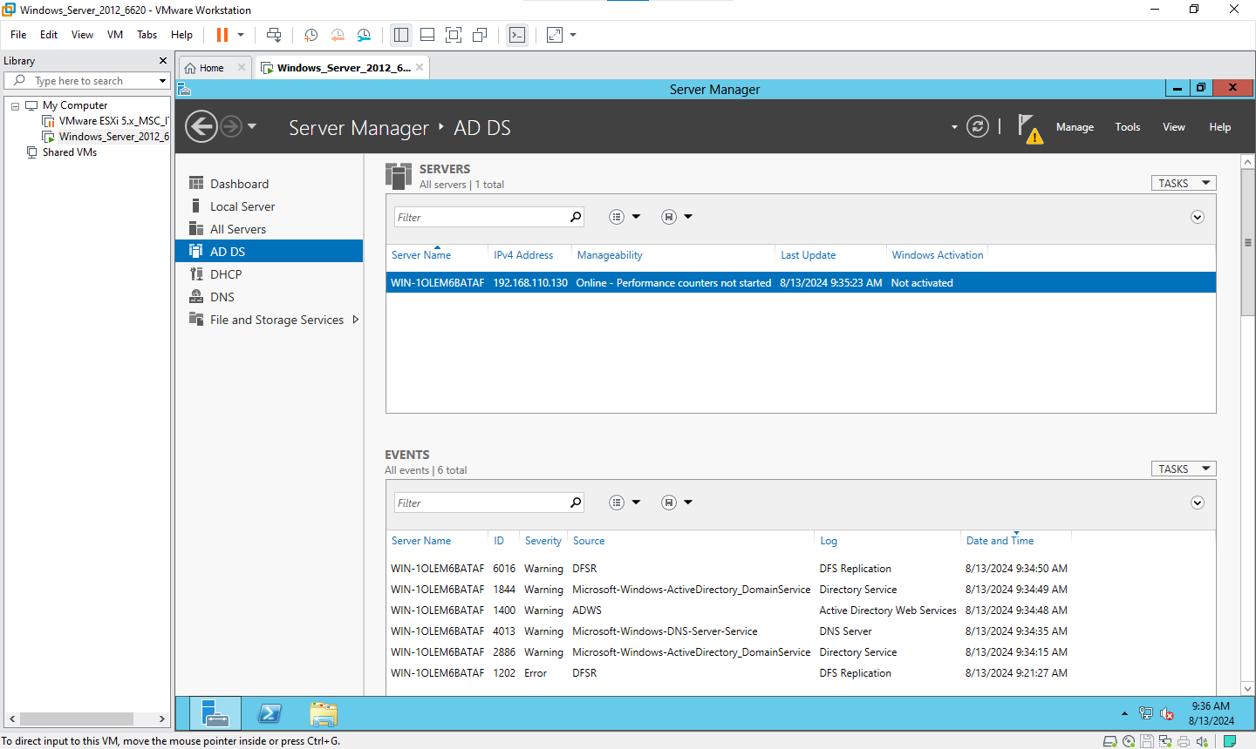

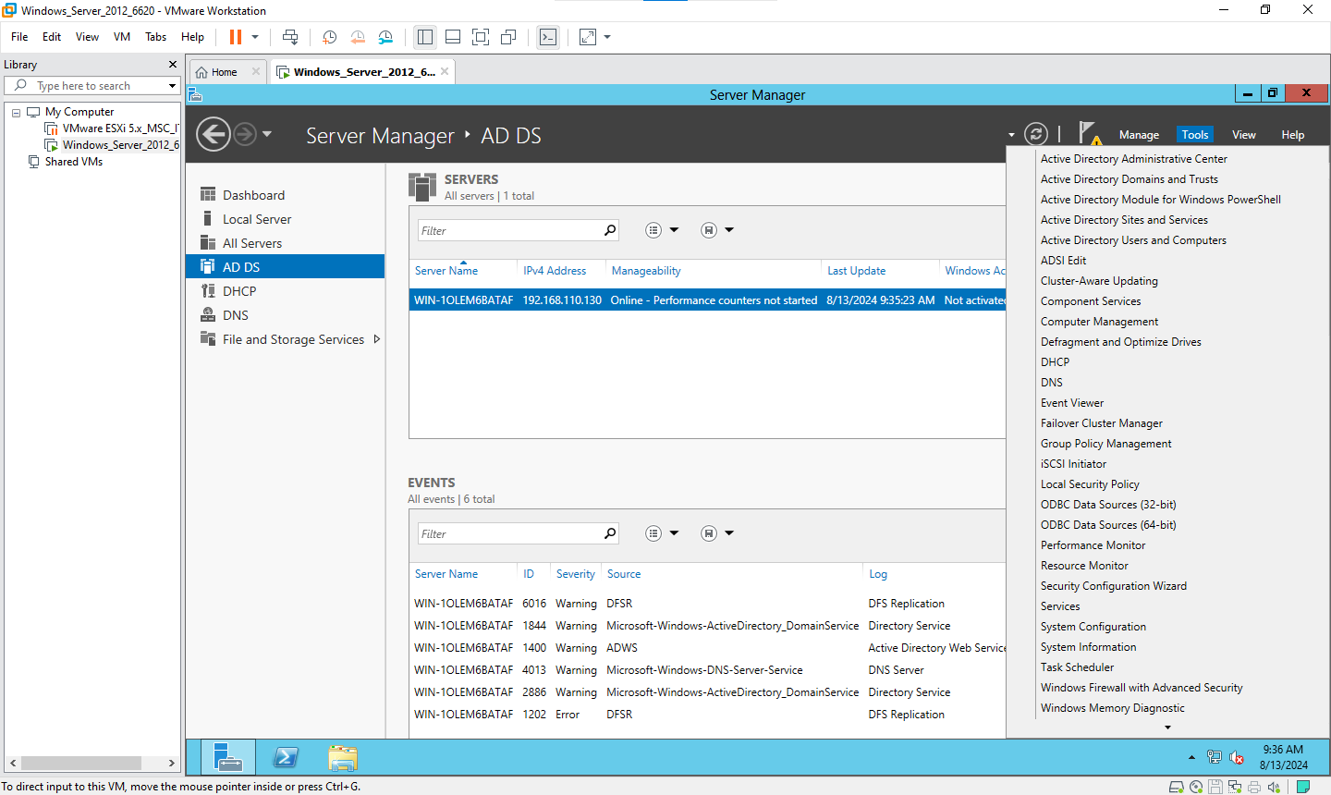

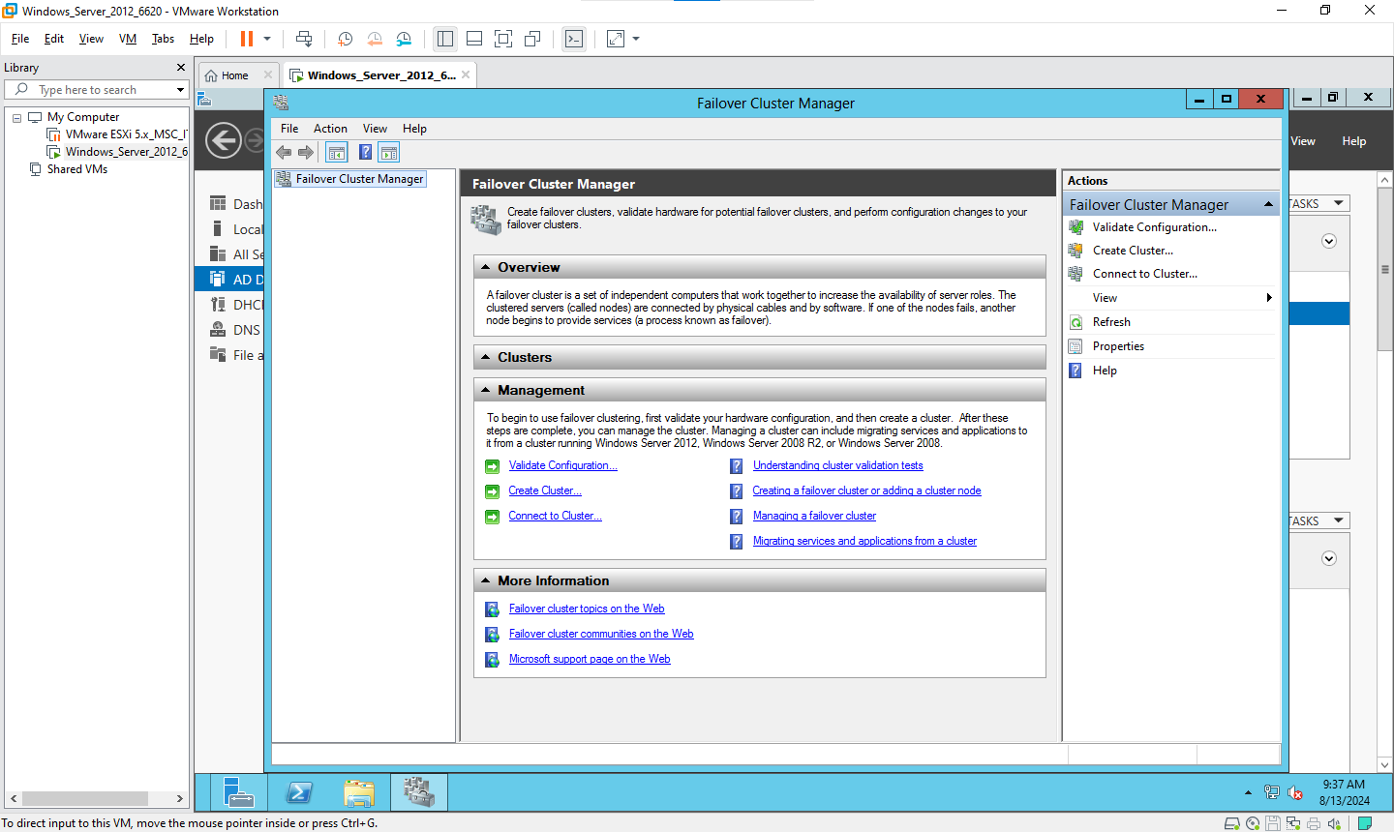

Create cluster

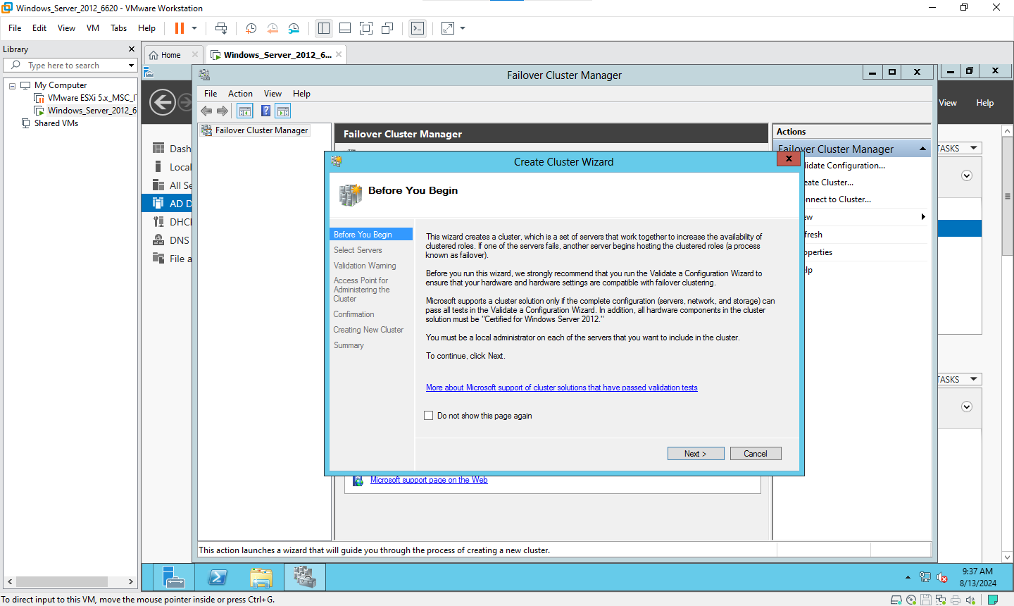

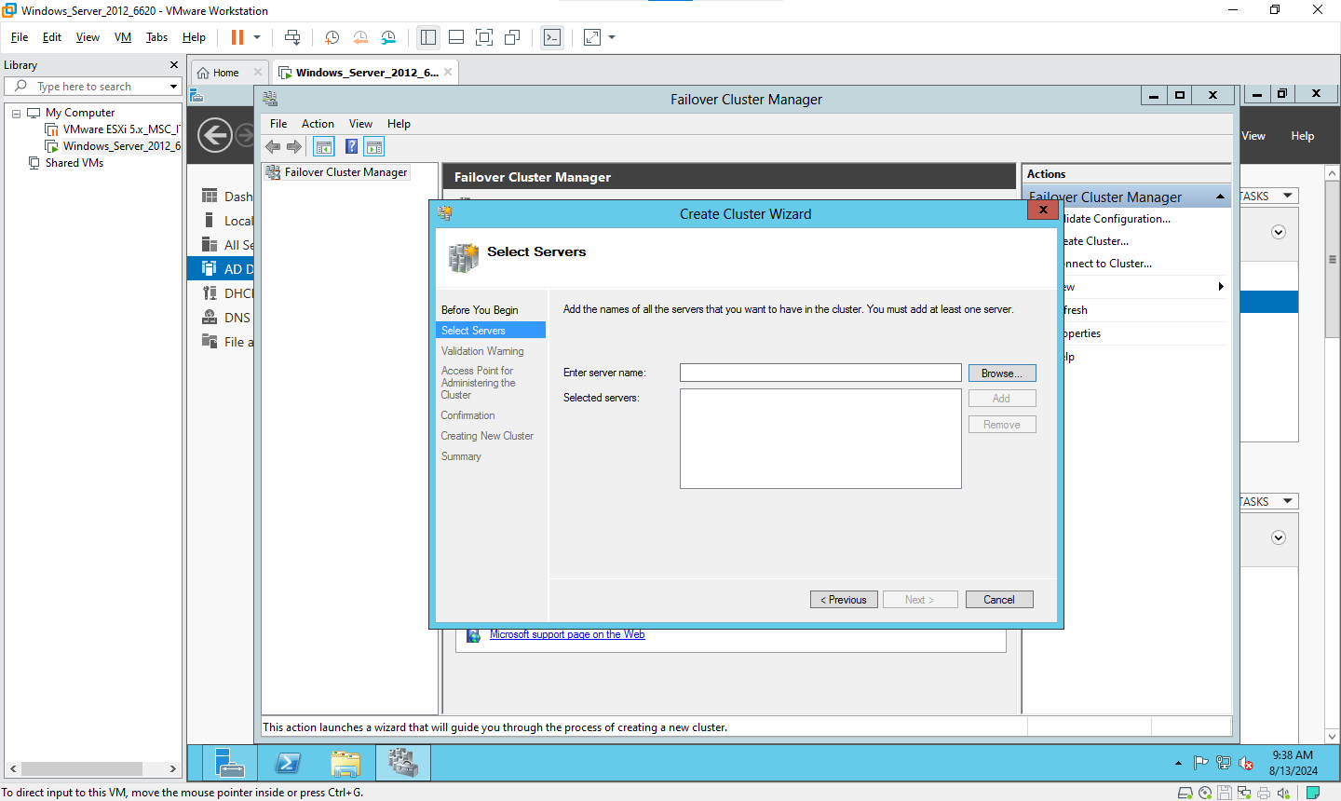

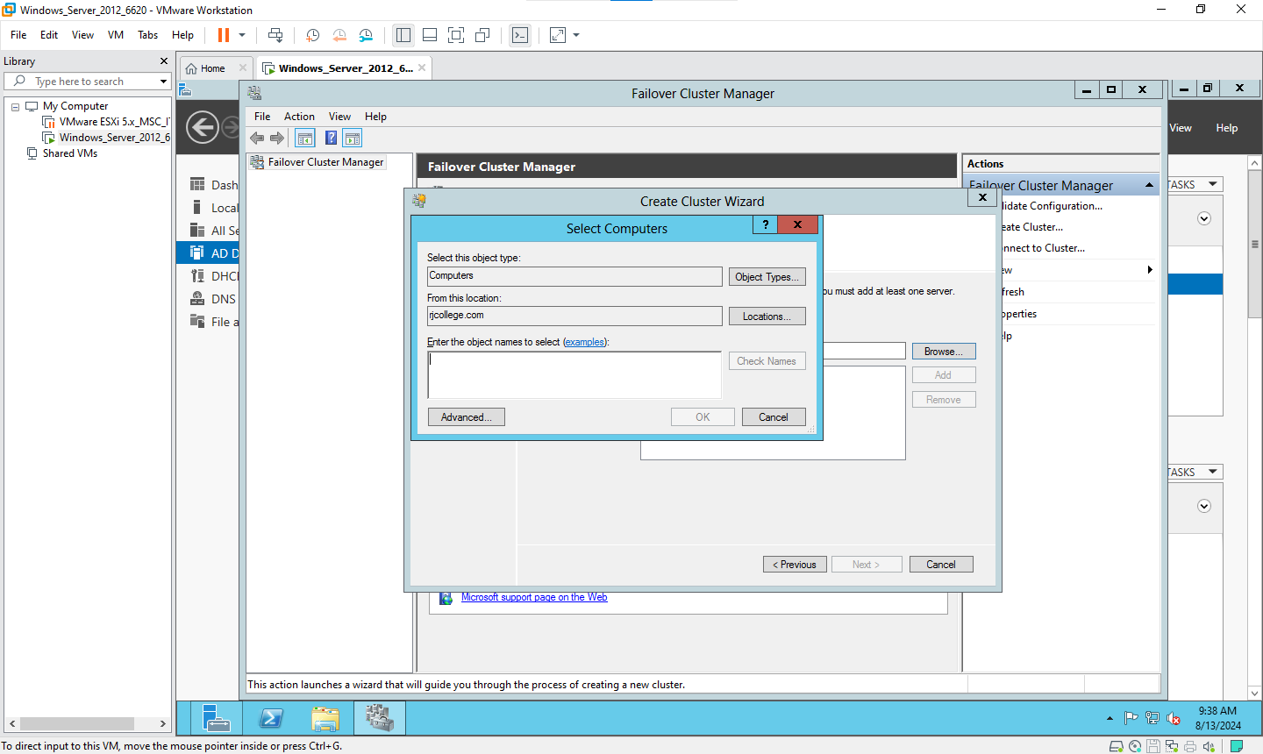

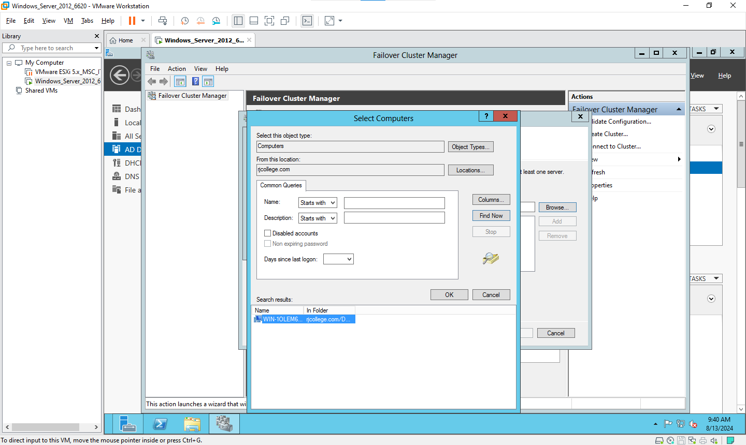

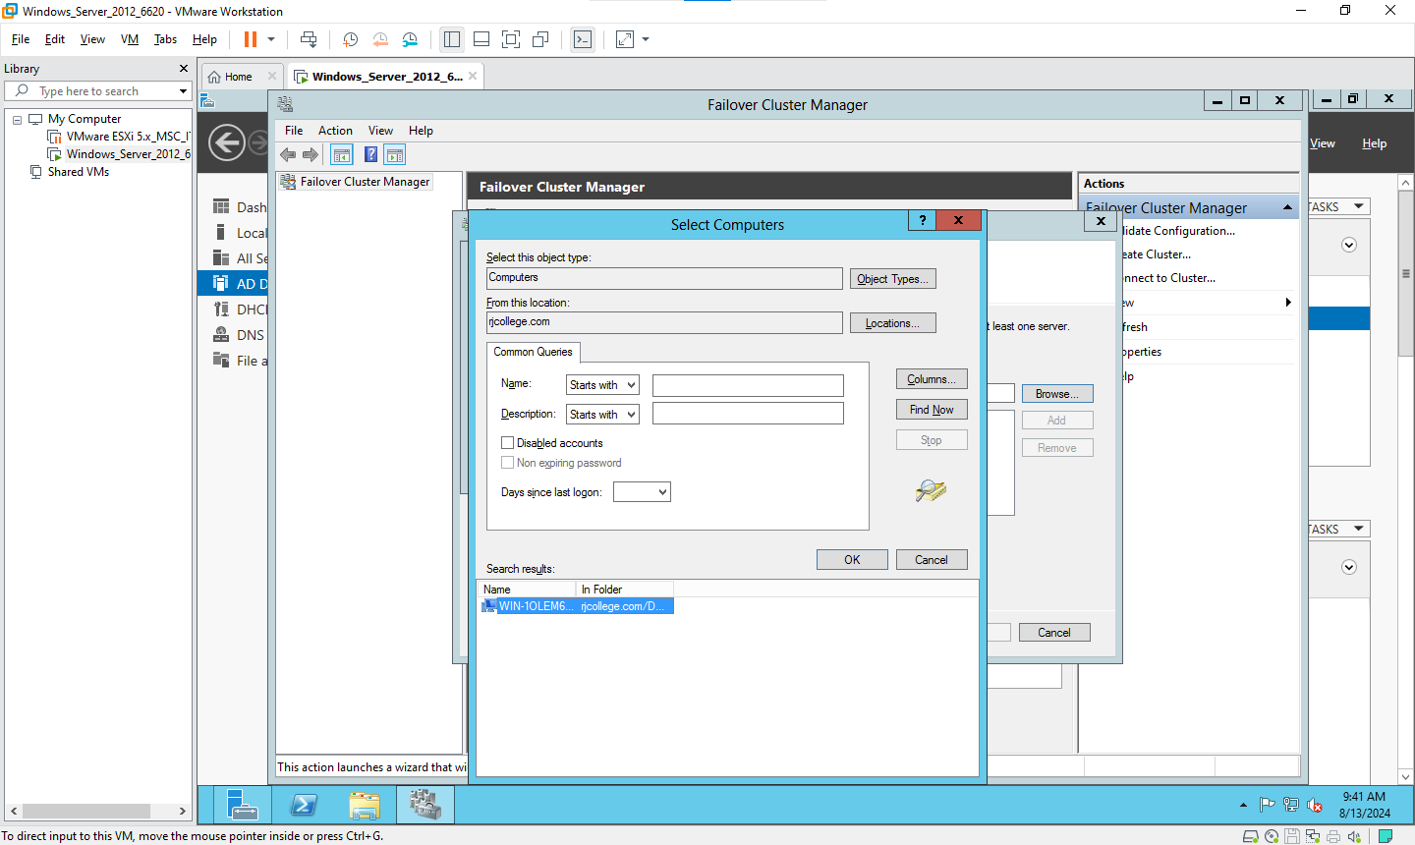

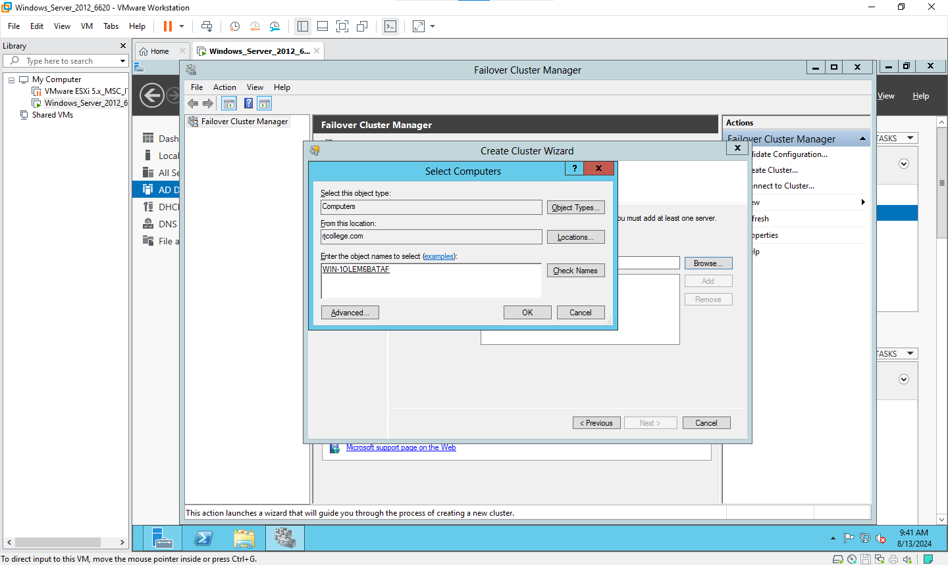

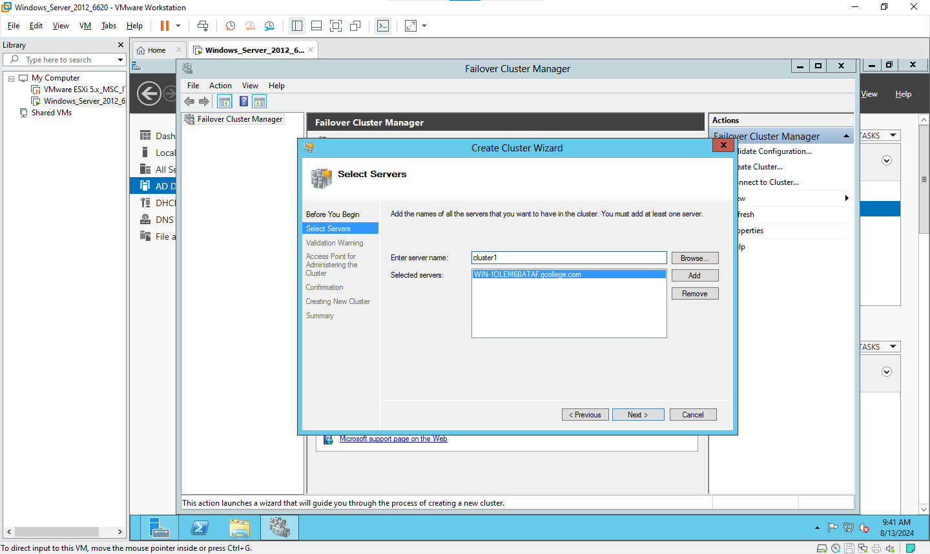

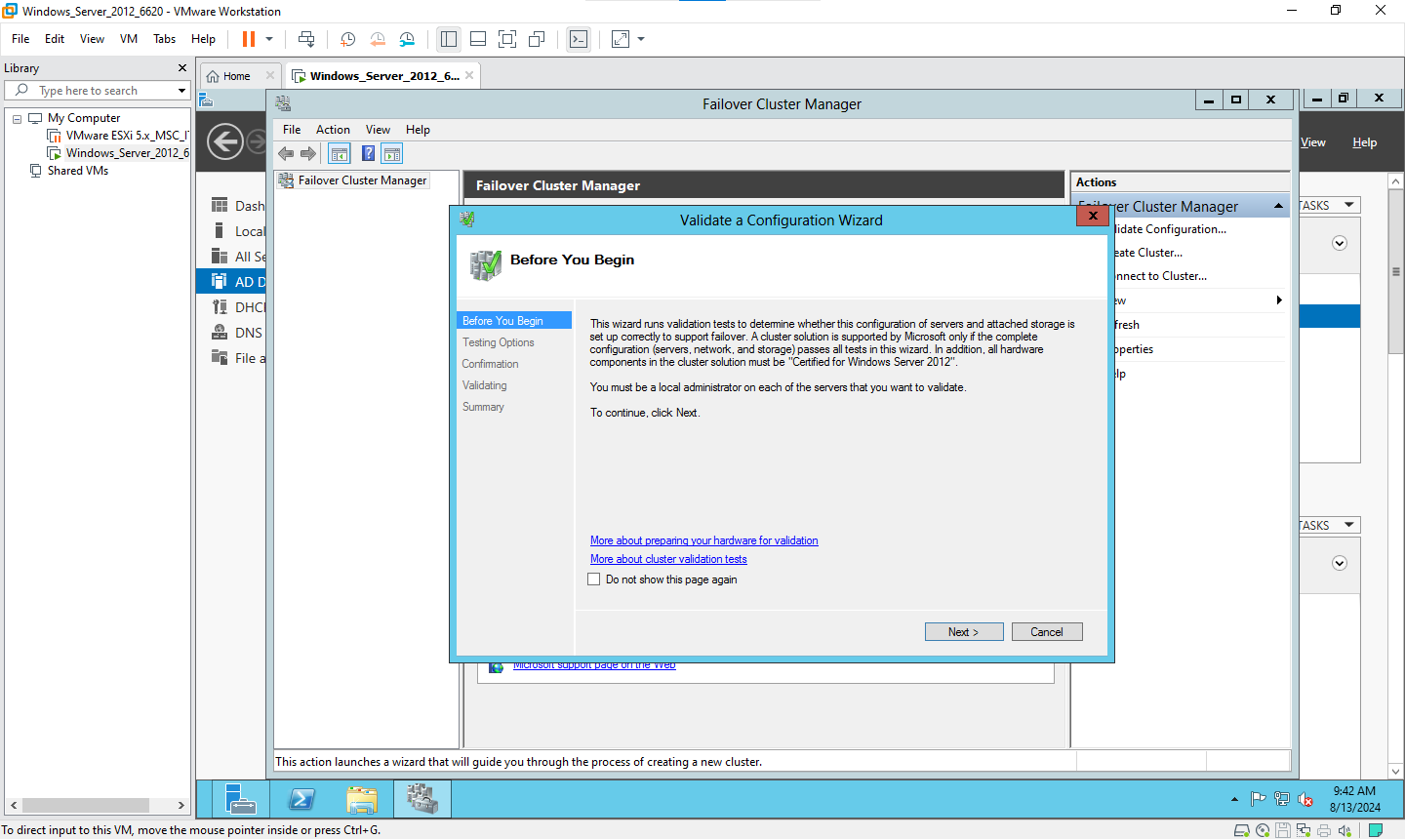

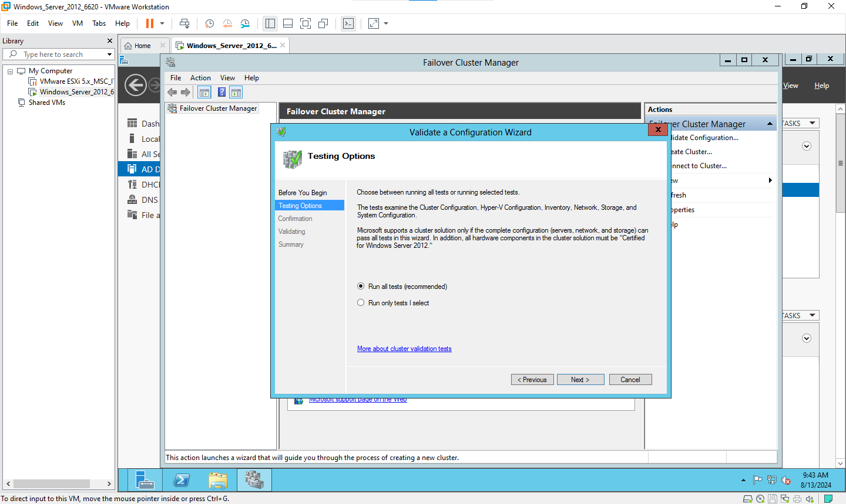

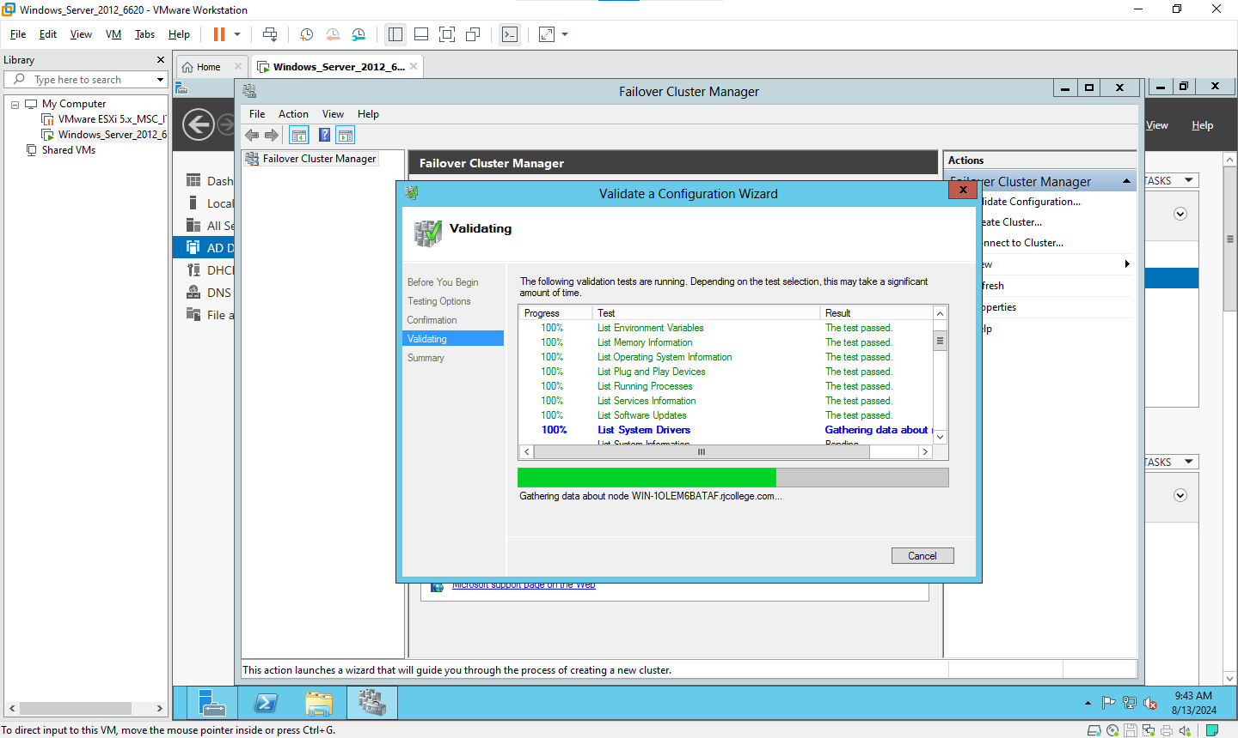

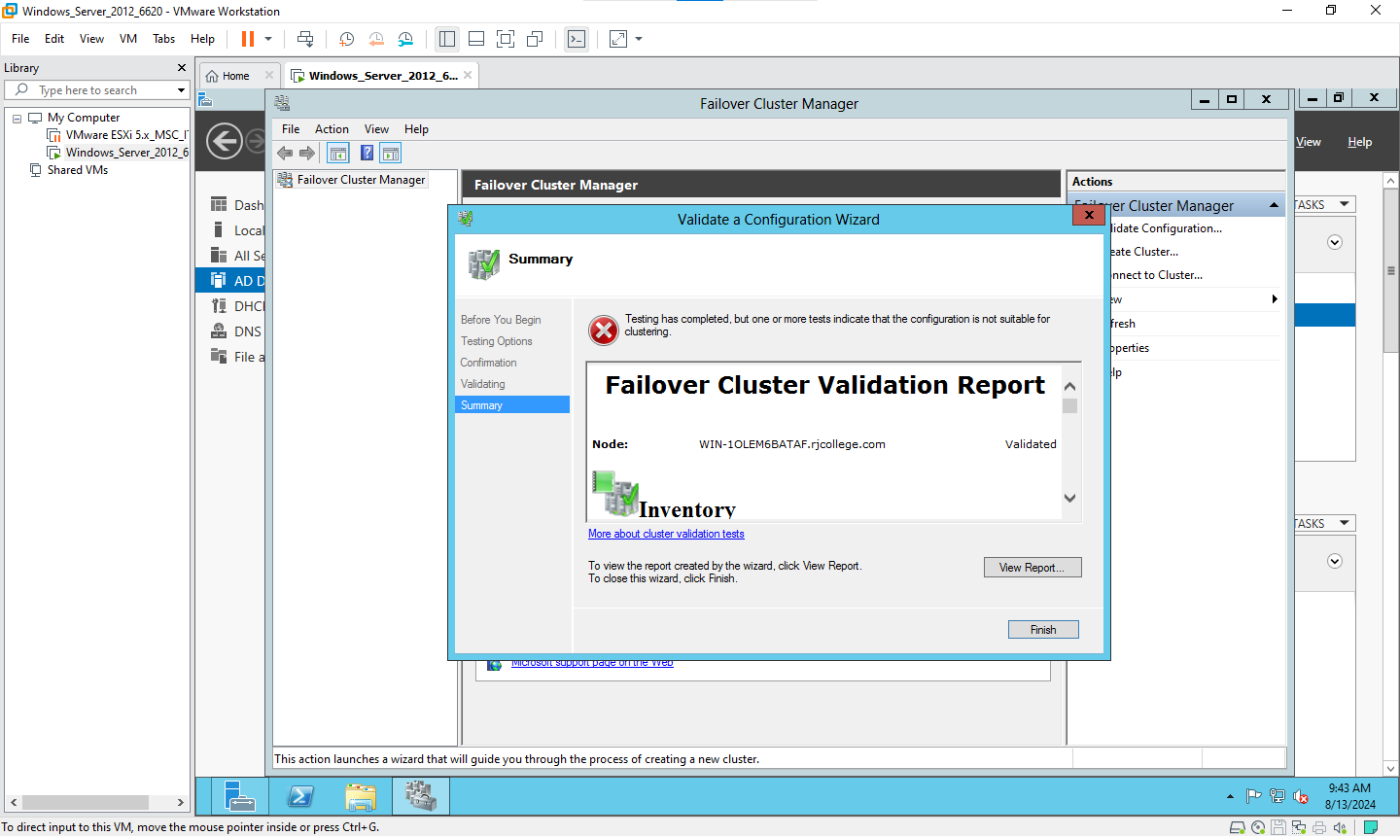

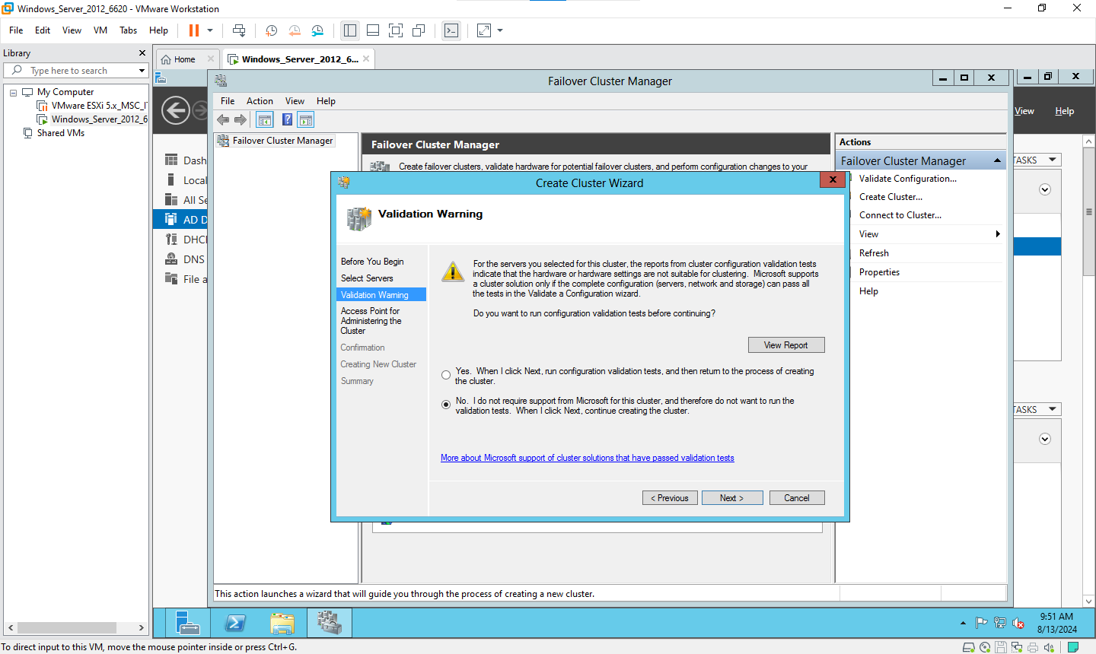

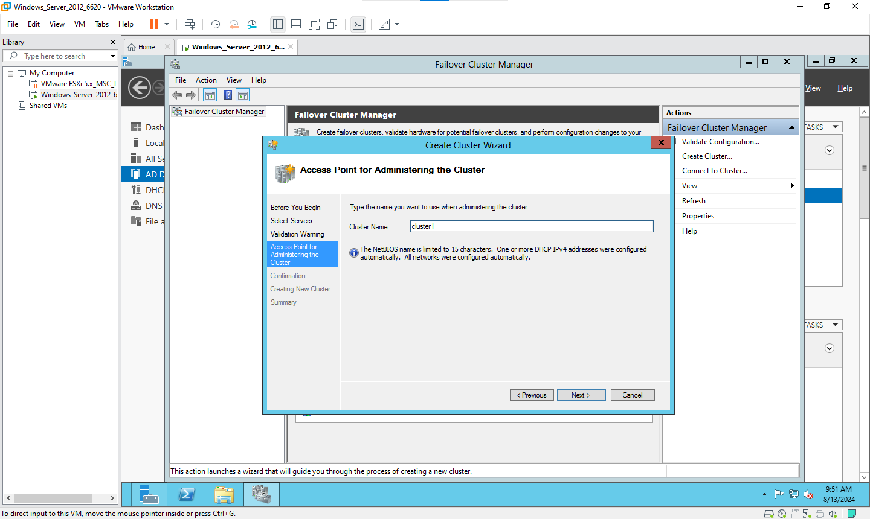

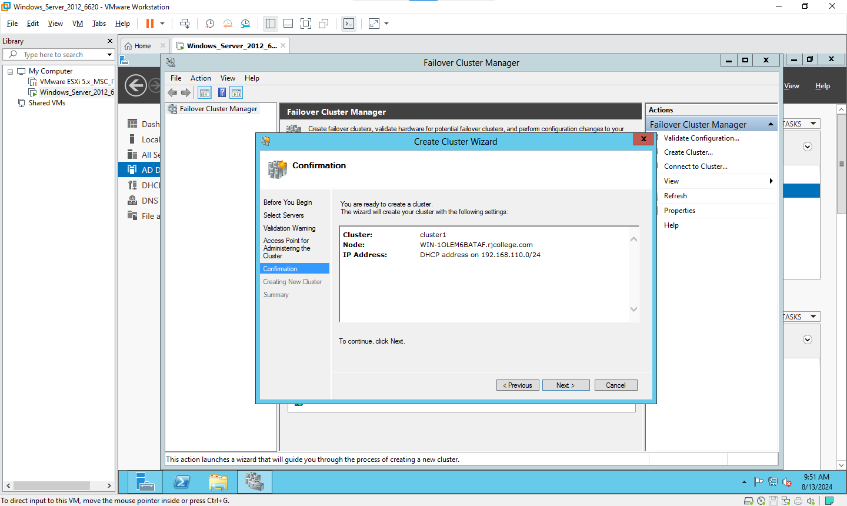

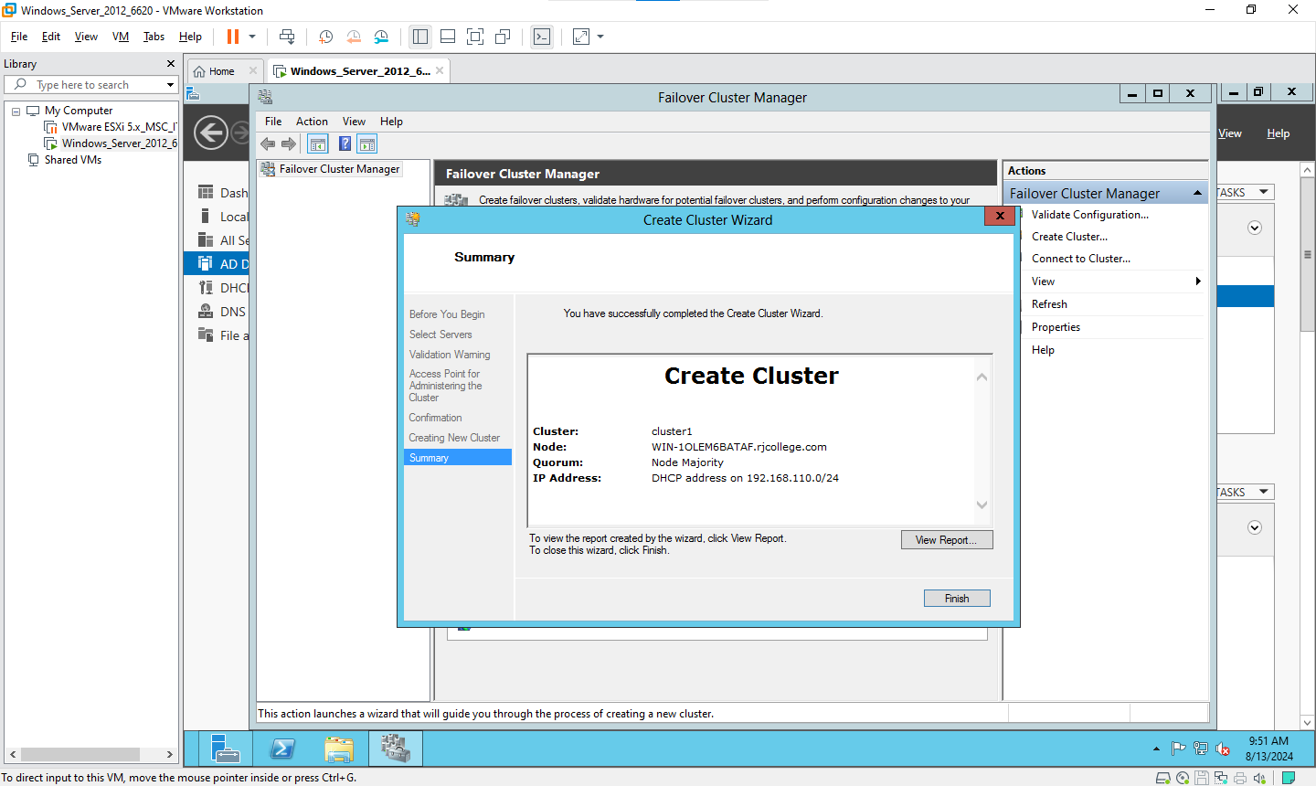

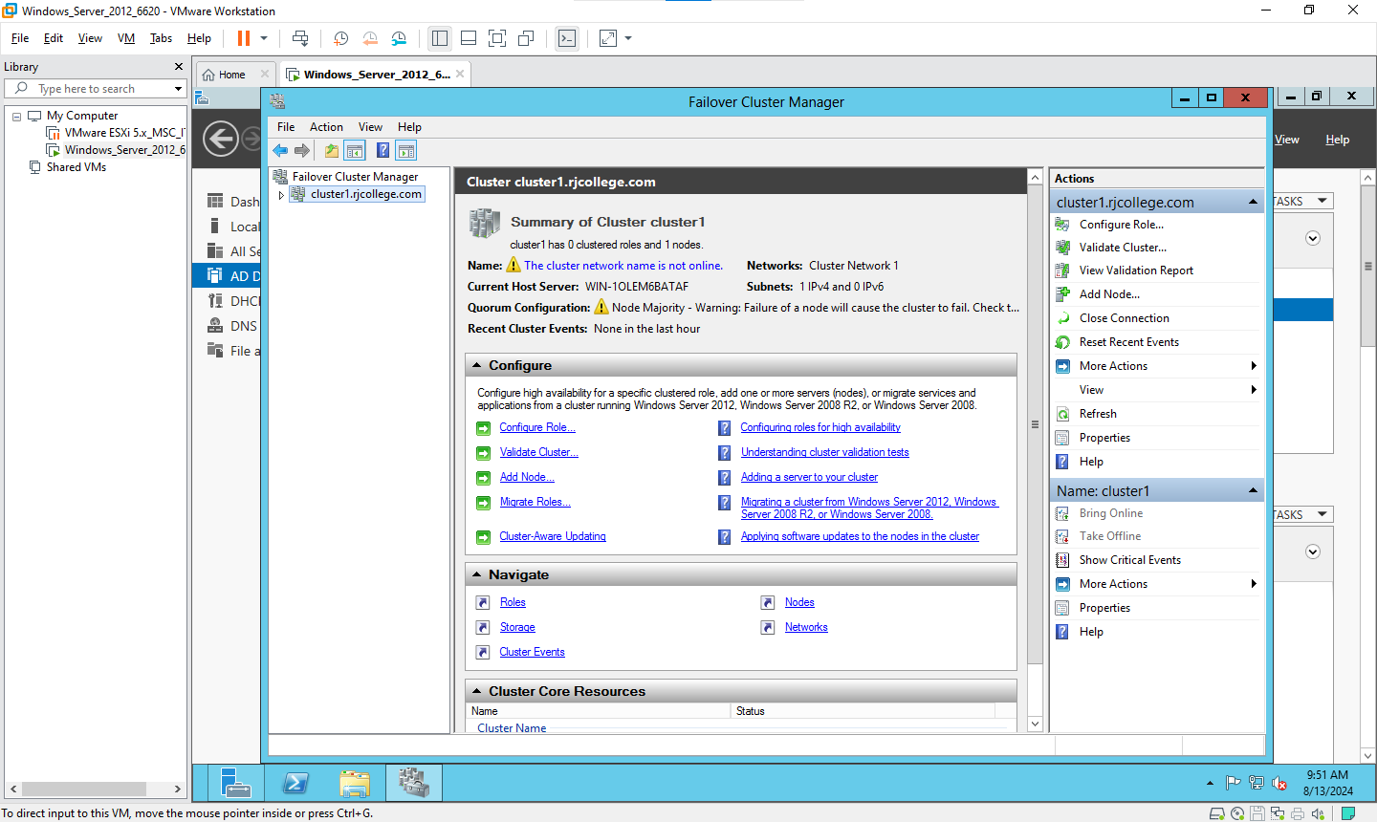

#### **Practical 6 - Developing application for Google App Engine.**

Aug 6, 2024

**Requirements**

* Eclipse IDE

Open Eclipse and go to Help → Eclipse MArketplace

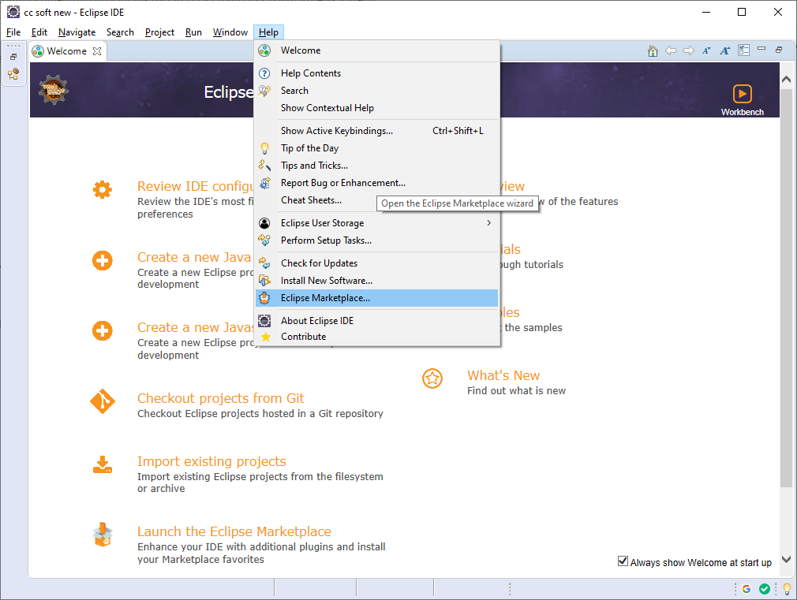

Eclipse Marketplace windows will open the search for google and google cloud tool for eclipse 1.8.4 should be installed amd update

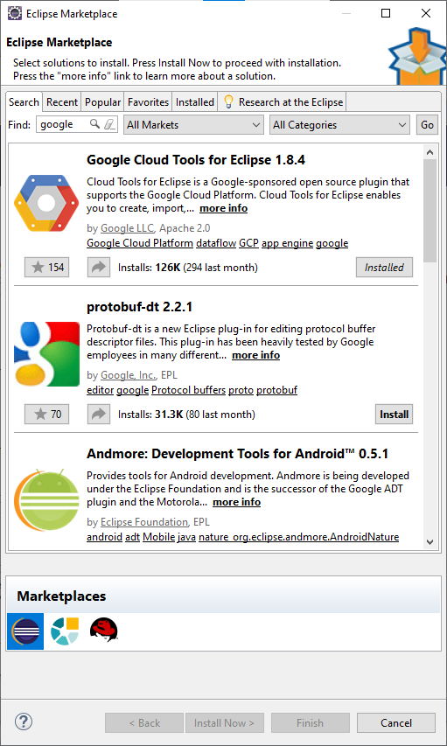

After installation of google cloud tool for eclipse then close that window

Go to New → other.. → Select a wizard windows will pop up

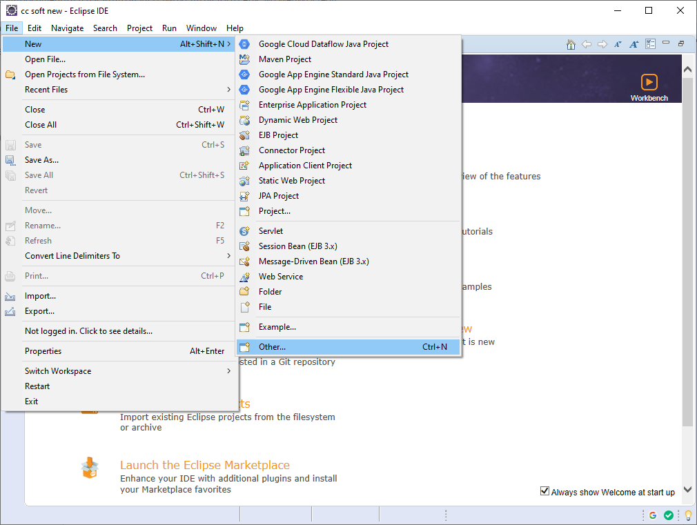

Select Google App Engine Standard Java Project and click on next

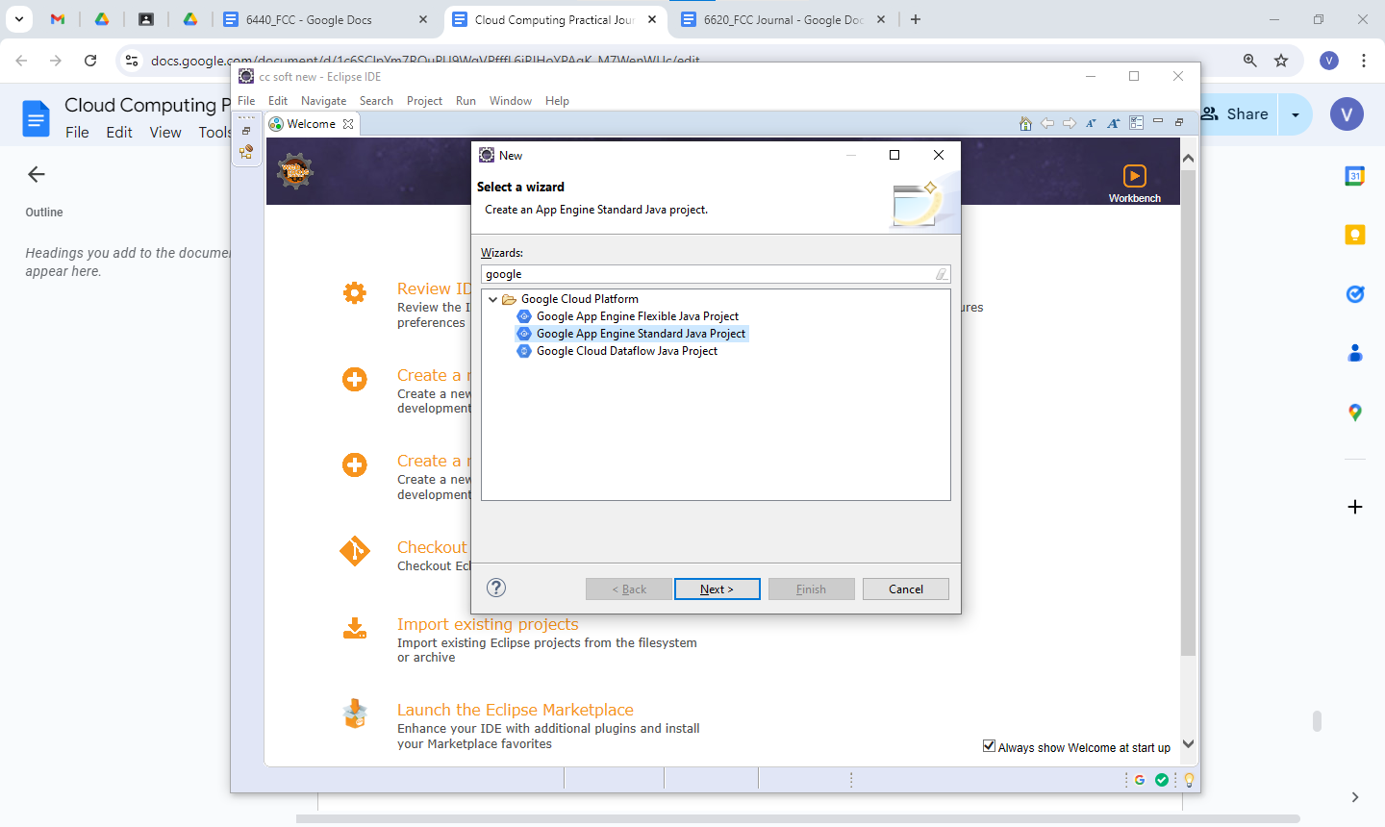

Give name to project

And java package as com.GAE click on finish

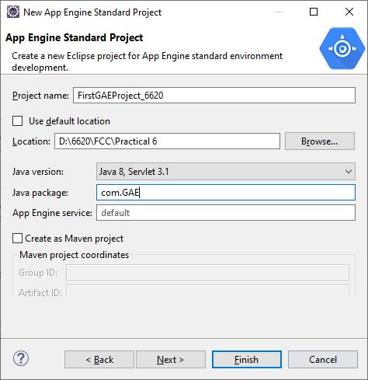

Project will appear like below

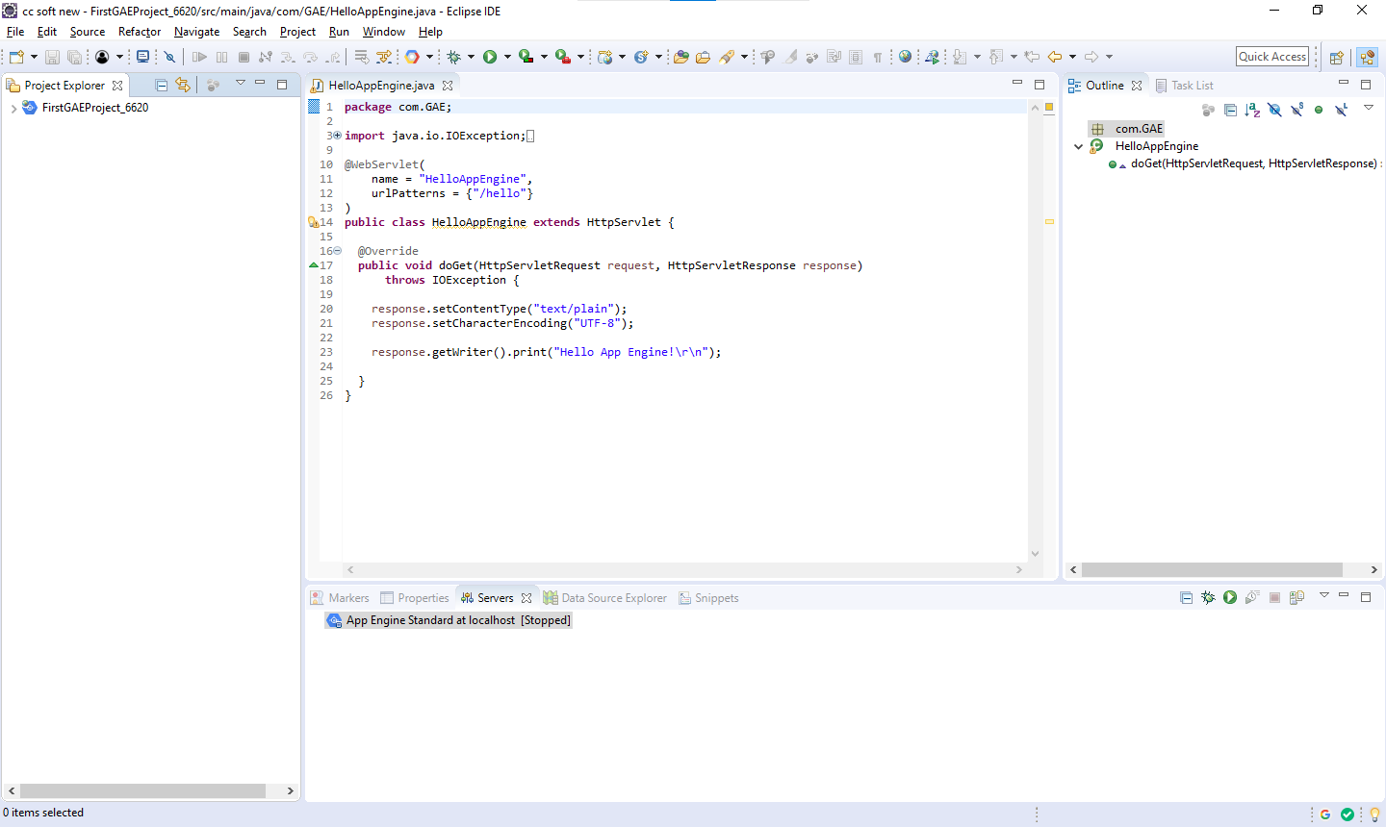

Add the highlighted line in HelloWorldEngine.java file

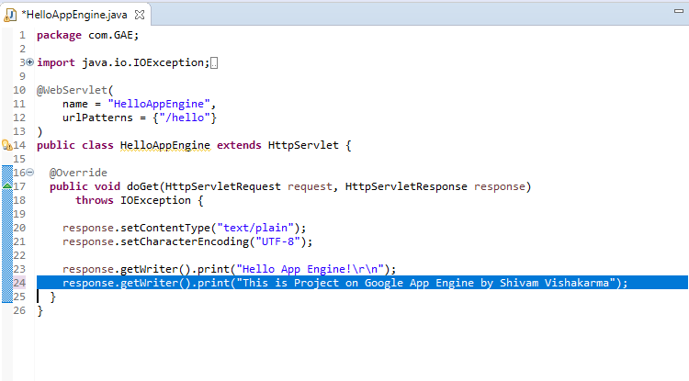

**HelloAppEngine.java**

package com.GAE;

import java.io.IOException;

import javax.servlet.annotation.WebServlet;

import javax.servlet.http.HttpServlet;

import javax.servlet.http.HttpServletRequest;

import javax.servlet.http.HttpServletResponse;

@WebServlet(

name = "HelloAppEngine",

urlPatterns = {"/hello"}

)

public class HelloAppEngine extends HttpServlet {

@Override

public void doGet(HttpServletRequest request, HttpServletResponse response)

throws IOException {

response.setContentType("text/plain");

response.setCharacterEncoding("UTF-8");

response.getWriter().print("Hello App Engine!\r\n");

**response.getWriter().print("This is Project on Google App Engine by Shivam Vishakarma");**

}

}

Go to src – main → webapp → index.html

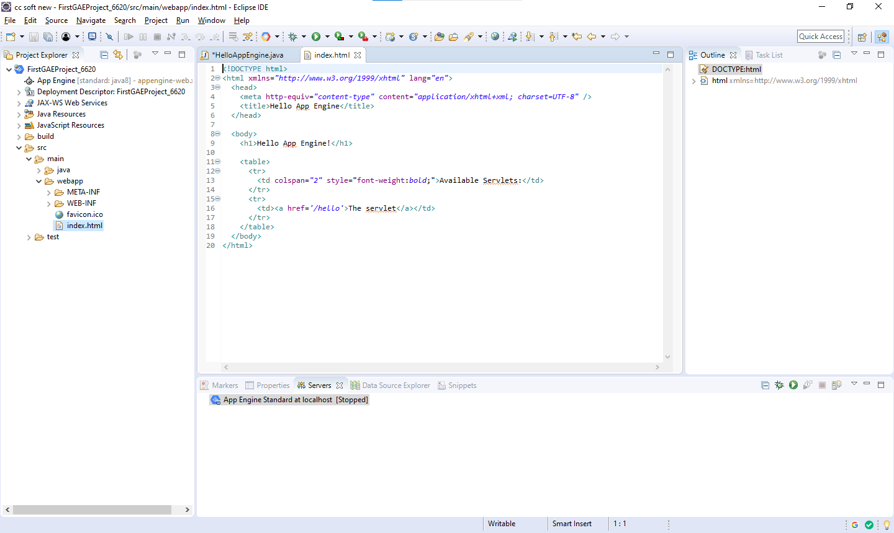

**Change the hyperlink tag as like below**

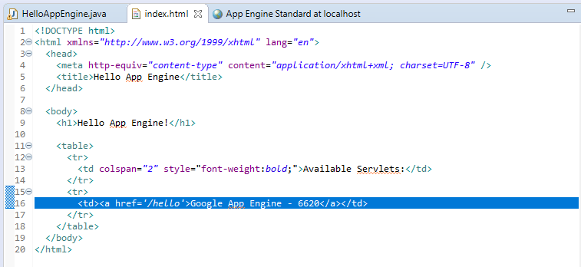

**index.html**

<!DOCTYPE html>

<html xmlns="http://www.w3.org/1999/xhtml" lang="en">

<head>

<meta http-equiv="content-type" content="application/xhtml+xml; charset=UTF-8" />

<title>Hello App Engine</title>

</head>

<body>

<h1>Hello App Engine!</h1>

<table>

<tr>

<td colspan="2" style="font-weight:bold;">Available Servlets:</td>

</tr>

<tr>

**<td><a href='/hello'>Google App Engine - 6620</a></td>**

</tr>

</table>

</body>

</html>

Got to servers which is at below console

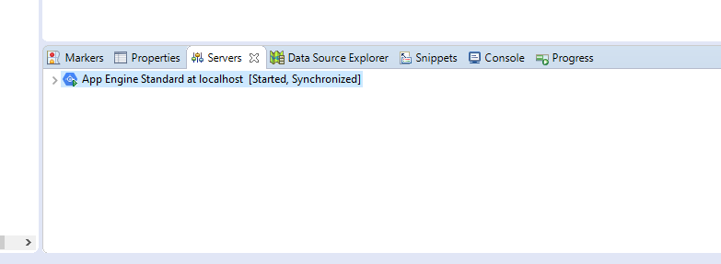

If “App Engine Standard ata localhost exist” then remove it and crate and new one for your project

**Click on Next**

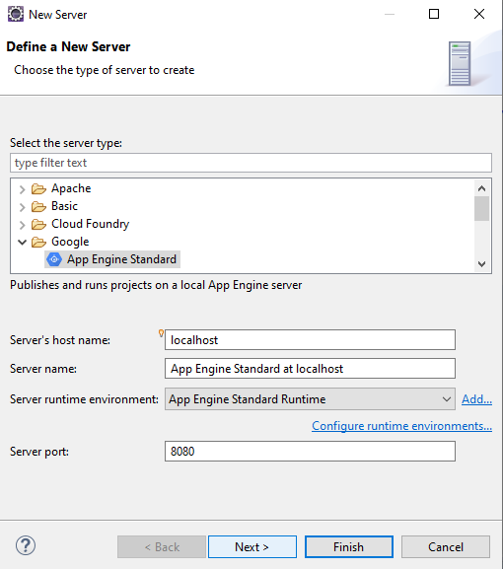

**Move your project from available to configuared**

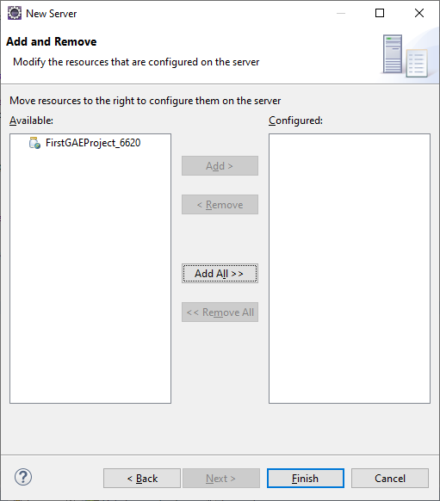

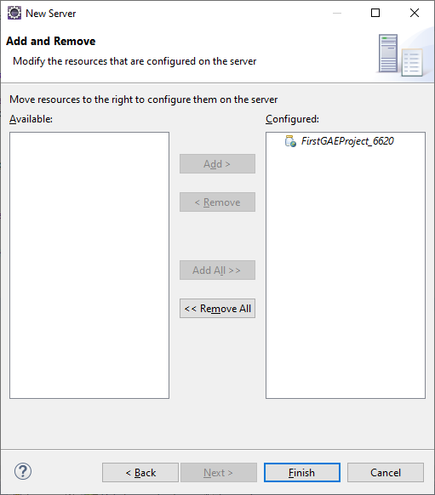

**Now yout app engine standard ata localhost** 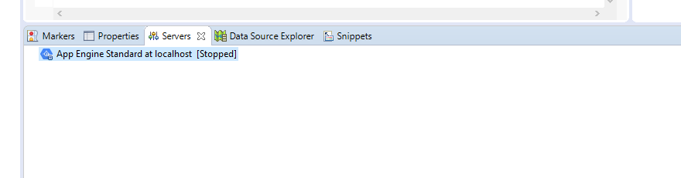

**Right Click on Google app server and click on start**

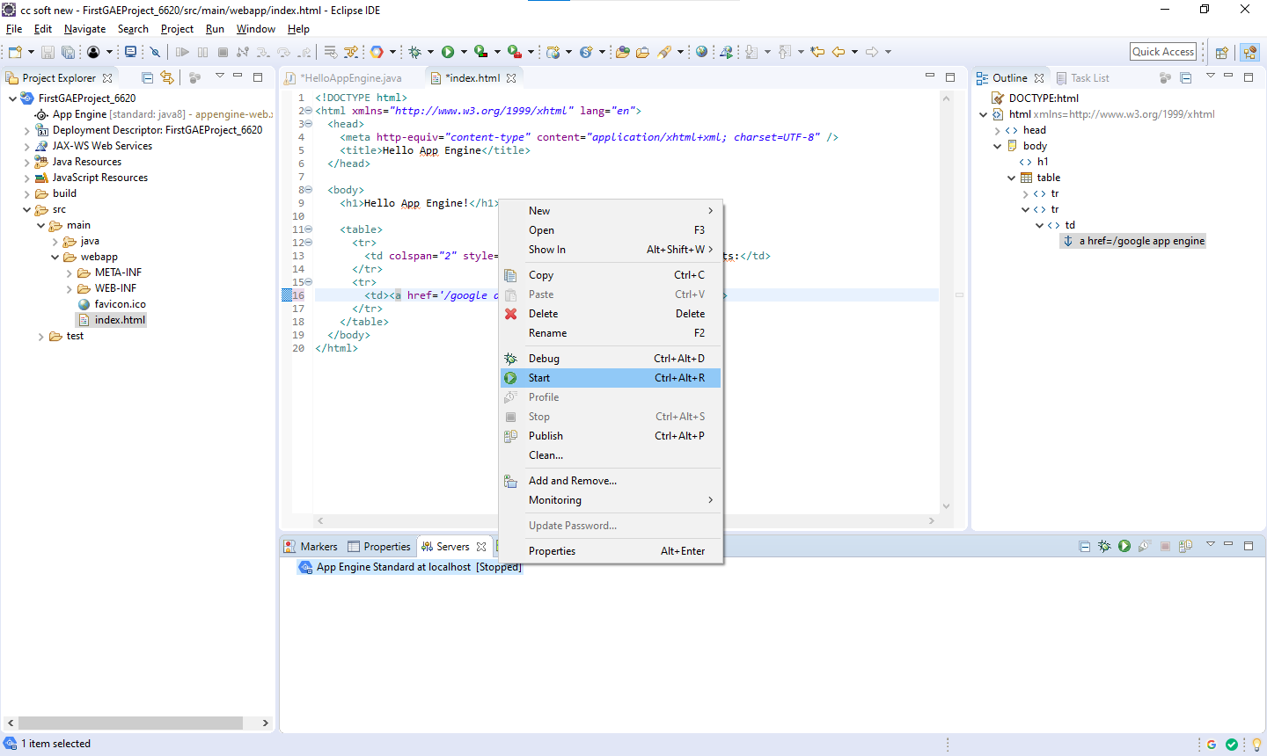

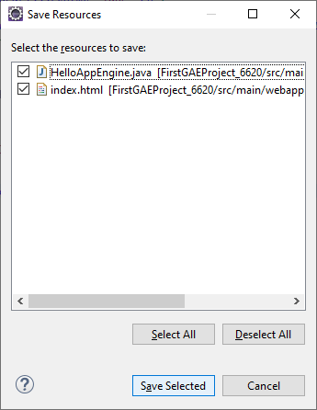

**If port 8080 showing in sin use the open cmd**

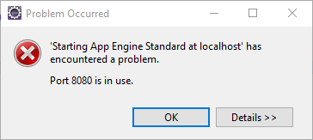

**Run below following cmd**

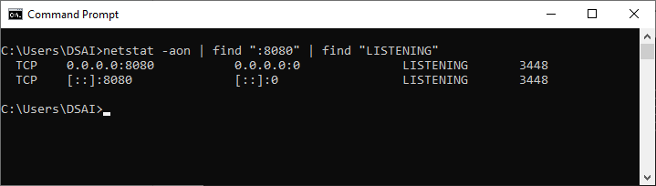

**go to task manager and go to services and look for the port that is listening to 8080 in my case is 3448 and stopt that service**

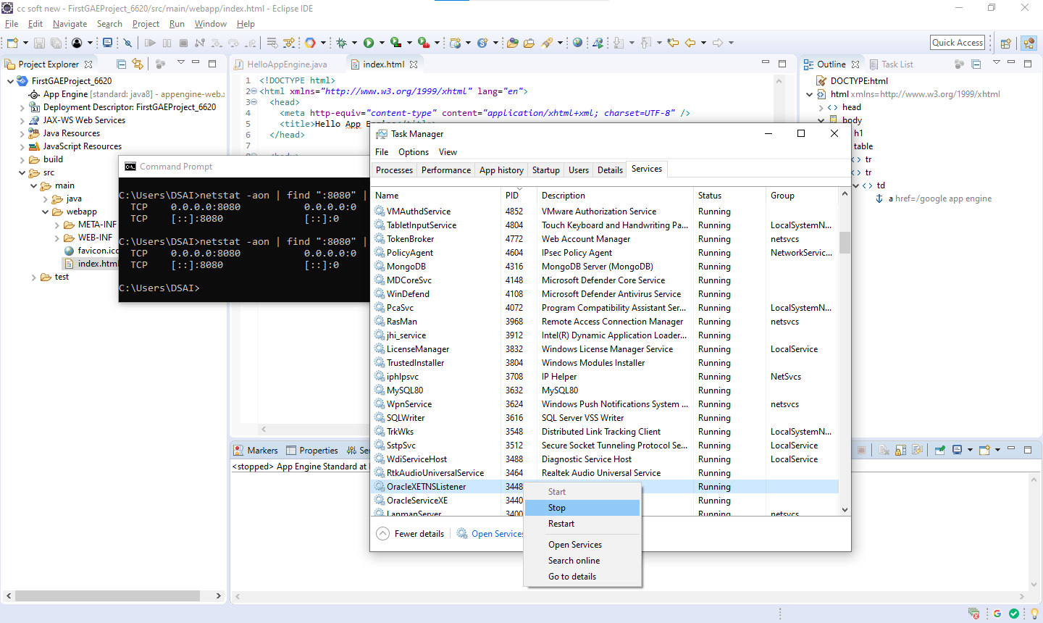

**And run the project again from servers**

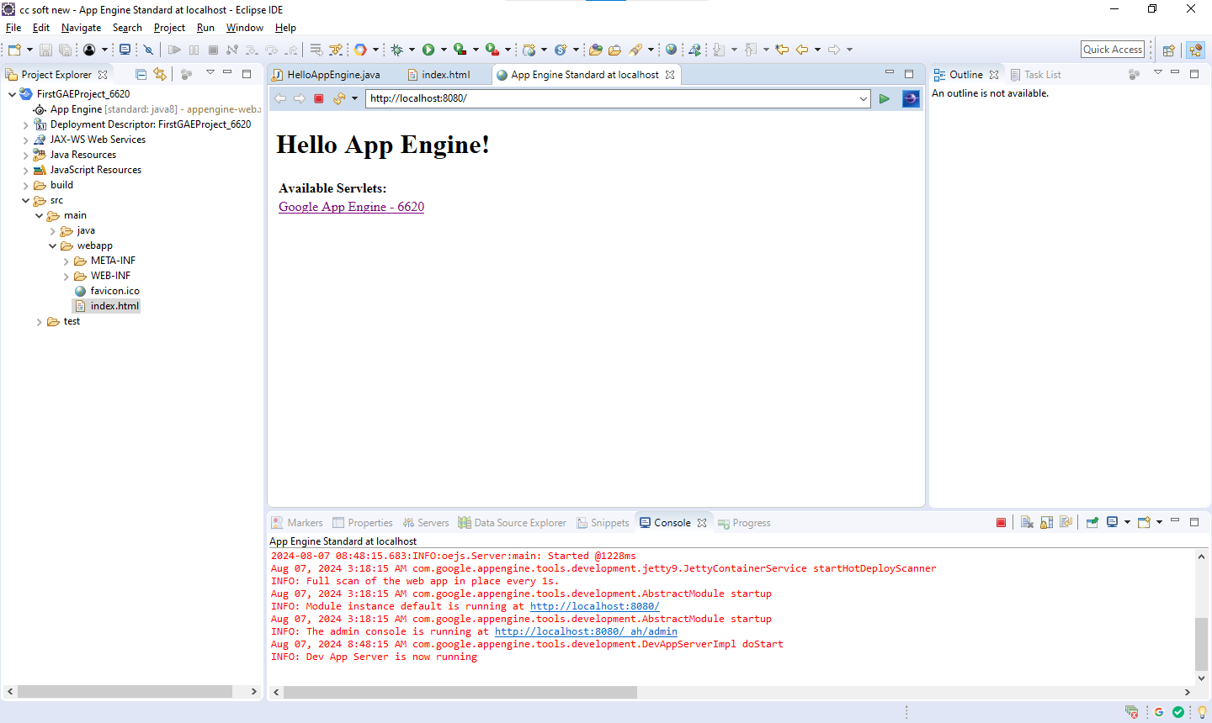

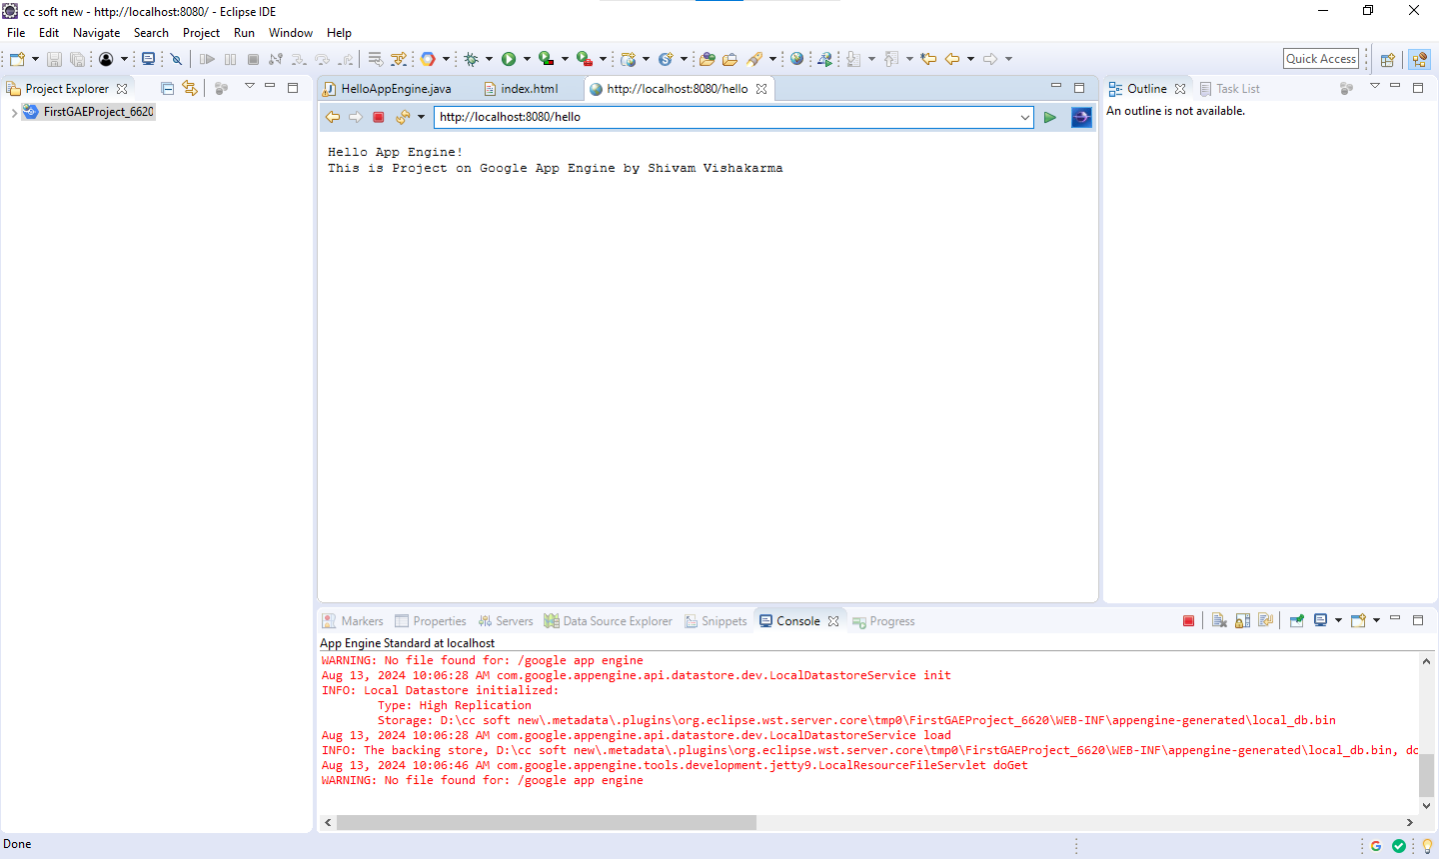

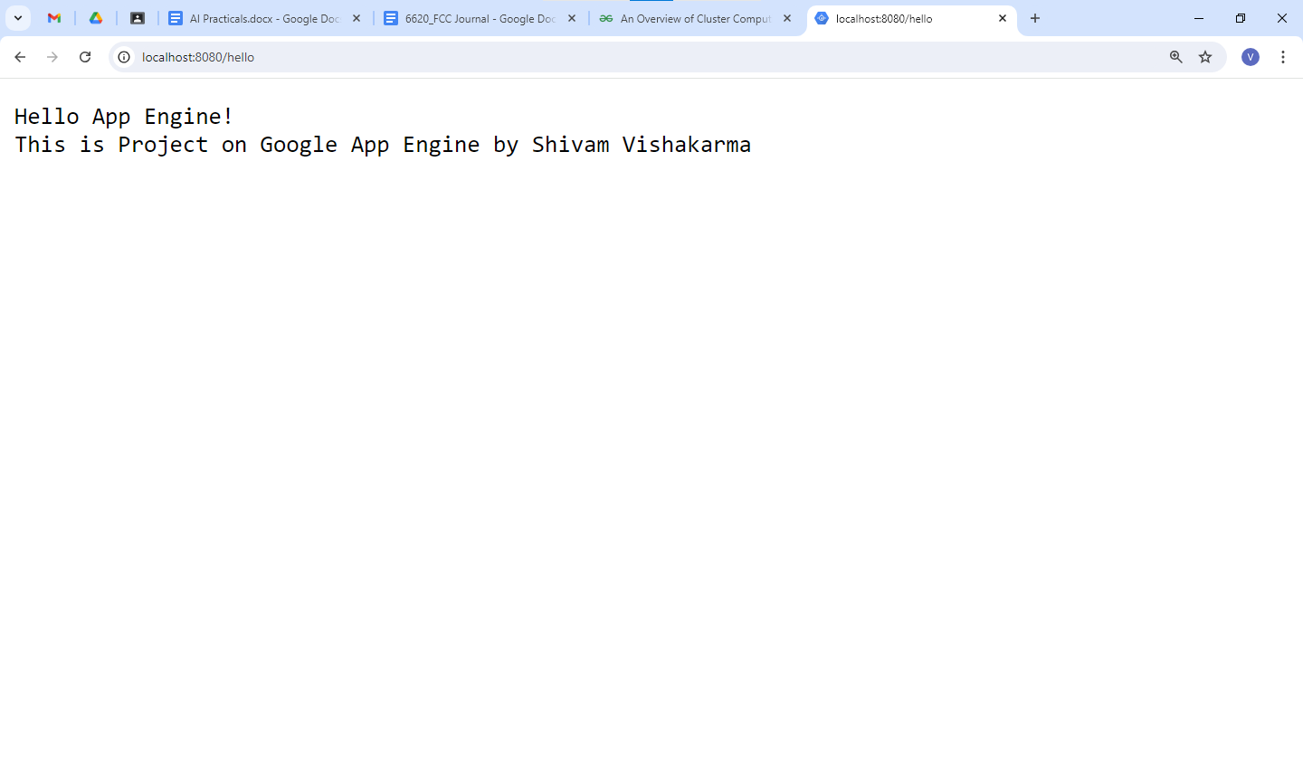

**Now, Let make a simple calculator**

**index.html**

<!DOCTYPE html>

<html xmlns="http://www.w3.org/1999/xhtml" lang="en">

<head>

<meta http-equiv="content-type" content="application/xhtml+xml; charset=UTF-8" />

<title>Hello App Engine</title>

</head>

<body>

<h1>Google App Engine!</h1>

<h3>Calculator</h3>

**<form method="post" action="/calculate">**

**<div>Enter 1<sup>st</sup> Number : <input type="number" name="num1"></div>**

**<div>Enter 2<sup>nd</sup> Number : <input type="number" name="num2"></div>**

**<div>**

**<input type="submit" name="operation" value="ADD">**

**<input type="submit" name="operation" value="SUBTRACT">**

**<input type="submit" name="operation" value="MULTIPLY">**

**<input type="submit" name="operation" value="DIVIDE">**

**</div>**

**</form>**

<br/> <br/> <br/>

<h3>Factorial</h3>

**<form method="post" action="/factorial">**

**<div>Enter Number : <input type="number" name="factNum"></div>**

**<div>**

**<input type="submit" name="factorial" value="Calculate Factorial">**

**</div>**

**</form>**

</body>

</html>

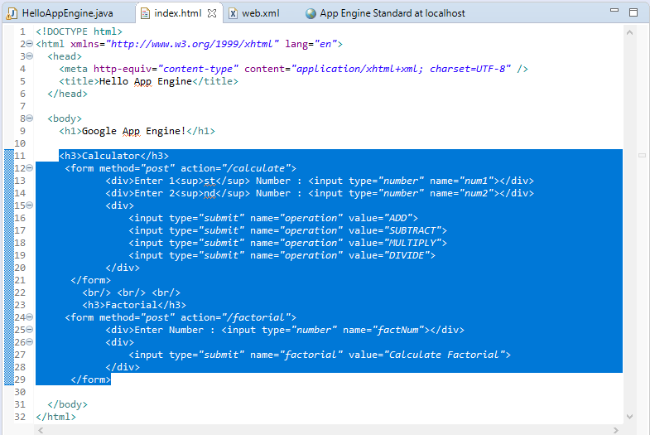

**HelloAppEngine.java**

package com.GAE;

import java.io.IOException;

import javax.servlet.annotation.WebServlet;

import javax.servlet.http.HttpServlet;

import javax.servlet.http.HttpServletRequest;

import javax.servlet.http.HttpServletResponse;

@WebServlet(

name = "HelloAppEngine",

**urlPatterns = {"/calculate", "/factorial"}**

)

public class HelloAppEngine extends HttpServlet {

@Override

public void **doPost**(HttpServletRequest request, HttpServletResponse response)

throws IOException {

response.setContentType("text/plain");

response.setCharacterEncoding("UTF-8");

response.getWriter().print("6620_Shivam Vishwakarma\n");

**String path = request.getServletPath();**

**response.getWriter().print("path : " + path + "\n\n");**

**if ("/calculate".equals(path)) {**

**calculator(request, response);**

**} else if ("/factorial".equals(path)) {**

**factorial(request, response);**

**} else {**

**response.getWriter().print("Error: Invalid URL pattern.");**

**}**

}

**private void calculator(HttpServletRequest request, HttpServletResponse response)**

**throws IOException {**

**String num1Str = request.getParameter("num1");**

**String num2Str = request.getParameter("num2");**

**String operation = request.getParameter("operation");**

**if (num1Str == null || num2Str == null || operation == null) {**

**response.getWriter().print("Error: Missing parameters.");**

**return;**

**}**

**double num1 = 0;**

**double num2 = 0;**

**try {**

**num1 = Double.parseDouble(num1Str);**

**num2 = Double.parseDouble(num2Str);**

**} catch (NumberFormatException e) {**

**response.getWriter().print("Error: Invalid number format.");**

**return;**

**}**

**String result = "";**

**switch (operation.toUpperCase()) {**

**case "ADD":**

**result = num1 + " + " + num2 + " = " + (num1 + num2);**

**break;**

**case "SUBTRACT":**

**result = num1 + " - " + num2 + " = " + (num1 - num2);**

**break;**

**case "MULTIPLY":**

**result = num1 + " x " + num2 + " = " + (num1 * num2);**

**break;**

**case "DIVIDE":**

**if (num2 != 0) {**

**result = num1 + " / " + num2 + " = " + (num1 / num2);**

**} else {**

**result = "Error: Division by zero is not allowed.";**

**}**

**break;**

**default:**

**result = "Error: Invalid operation.";**

**break;**

**}**

**response.getWriter().print(result);**

**}**

**private void factorial(HttpServletRequest request, HttpServletResponse response)**

**throws IOException {**

**String numStr = request.getParameter("factNum");**

**if (numStr == null) {**

**response.getWriter().print("Error: Missing parameter.");**

**return;**

**}**

**int num;**

**try {**

**num = Integer.parseInt(numStr);**

**} catch (NumberFormatException e) {**

**response.getWriter().print("Error: Invalid number format.");**

**return;**

**}**

**if (num < 0) {**

**response.getWriter().print("Factorial is not defined for negative numbers.");**

**return;**

**}**

**long factorial = calculateFactorial(num);**

**response.getWriter().print(num + "! = " + factorial);**

**}**

**public long calculateFactorial(int num) {**

**if (num == 0 || num == 1) {**

**return 1;**

**}**

**return num * calculateFactorial(num - 1);**

**}**

}

**Output**

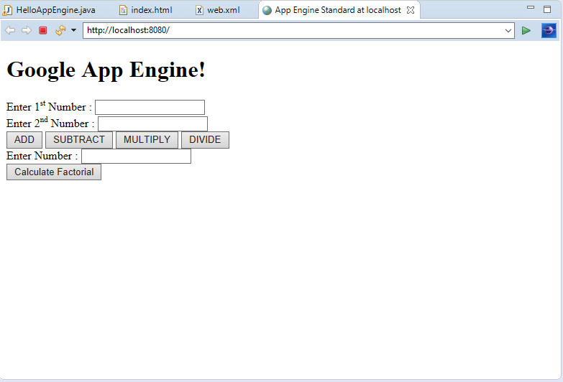

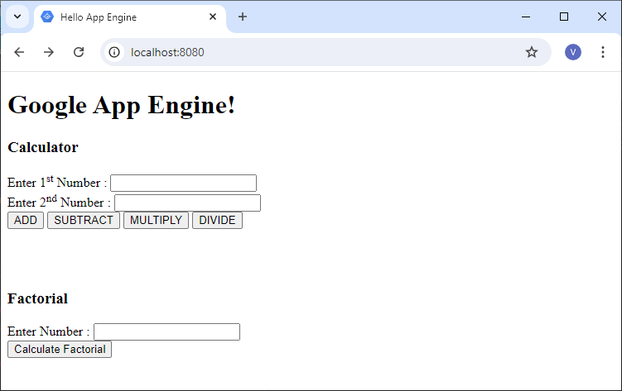

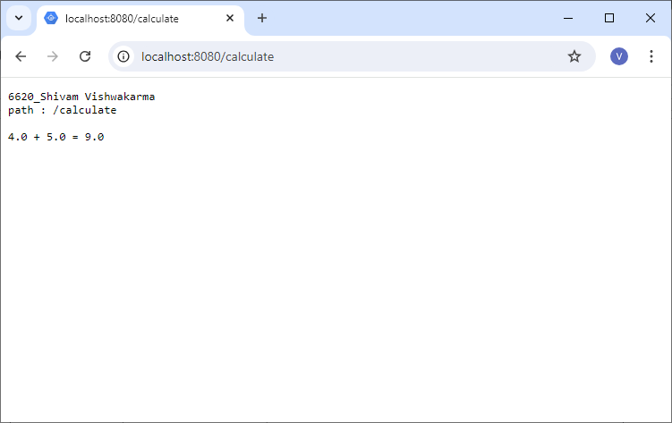

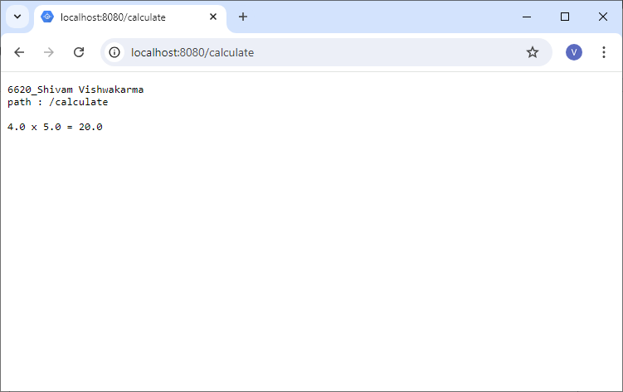

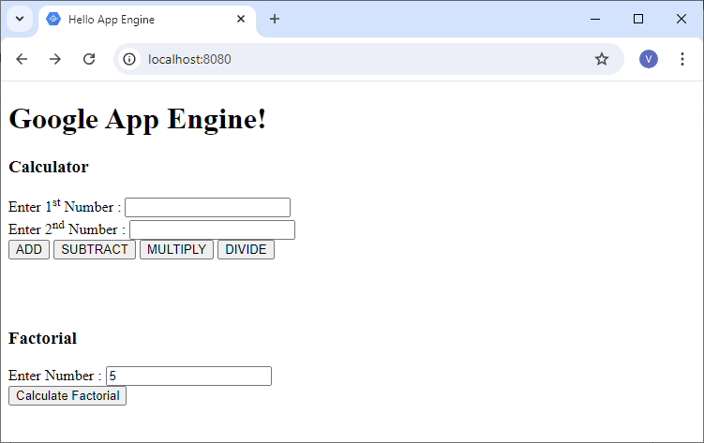

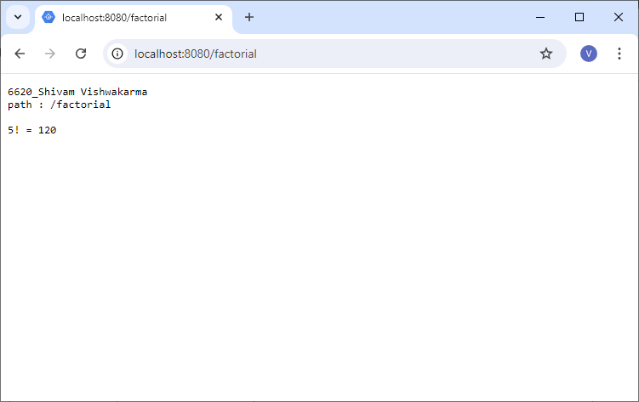

#### **Practical 7 - Implement virtualization using VMWare ESXi Server and managing with vSphere Client.**

Aug 6, 2024

Open VM Ware → go to File → New Virtual Machine

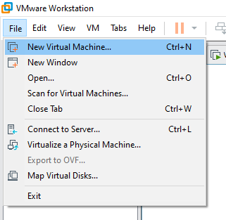

Click on NEXT

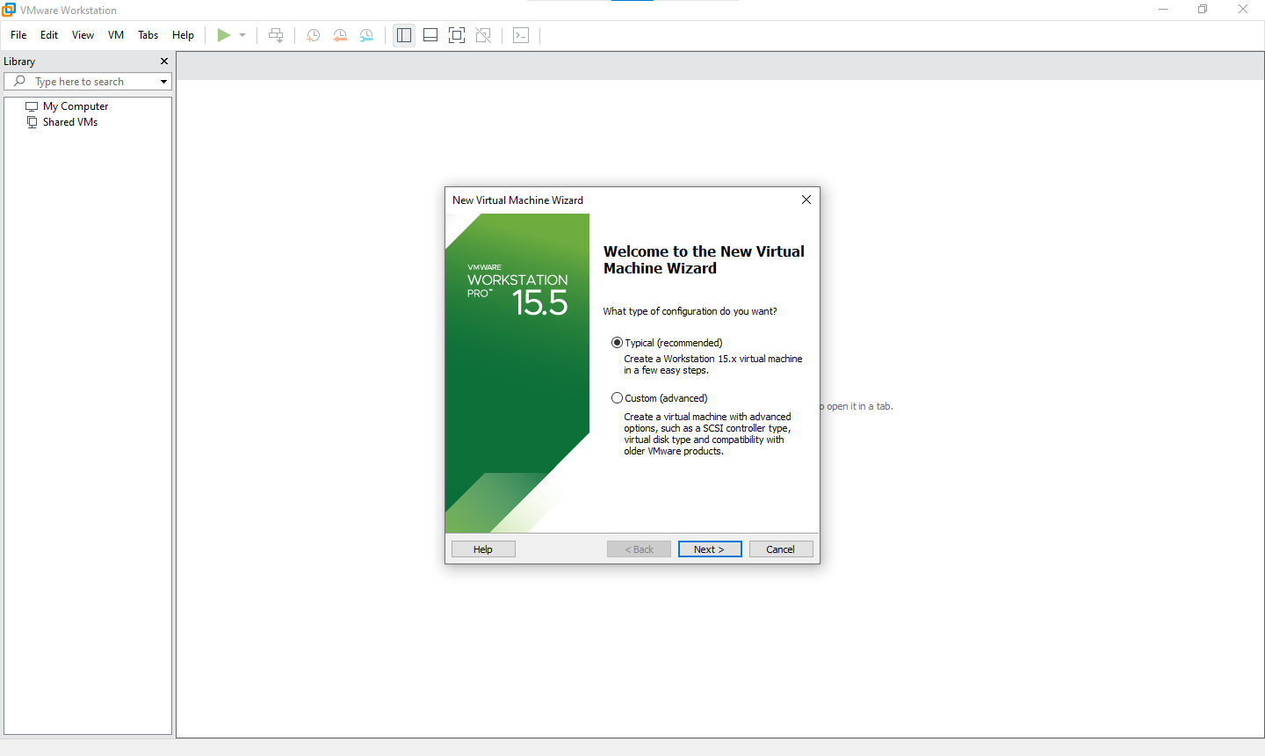

Select “Installer disc image file (iso)” and select EXSI iso file from file explorer and click on NEXT

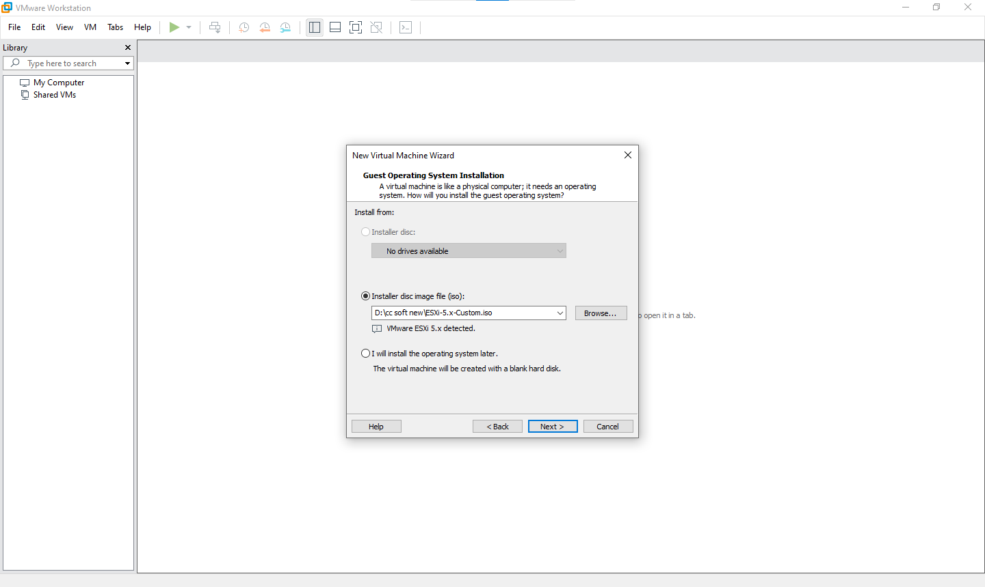

Name your Virtual machine and select location for your visual machine and click on NEXT

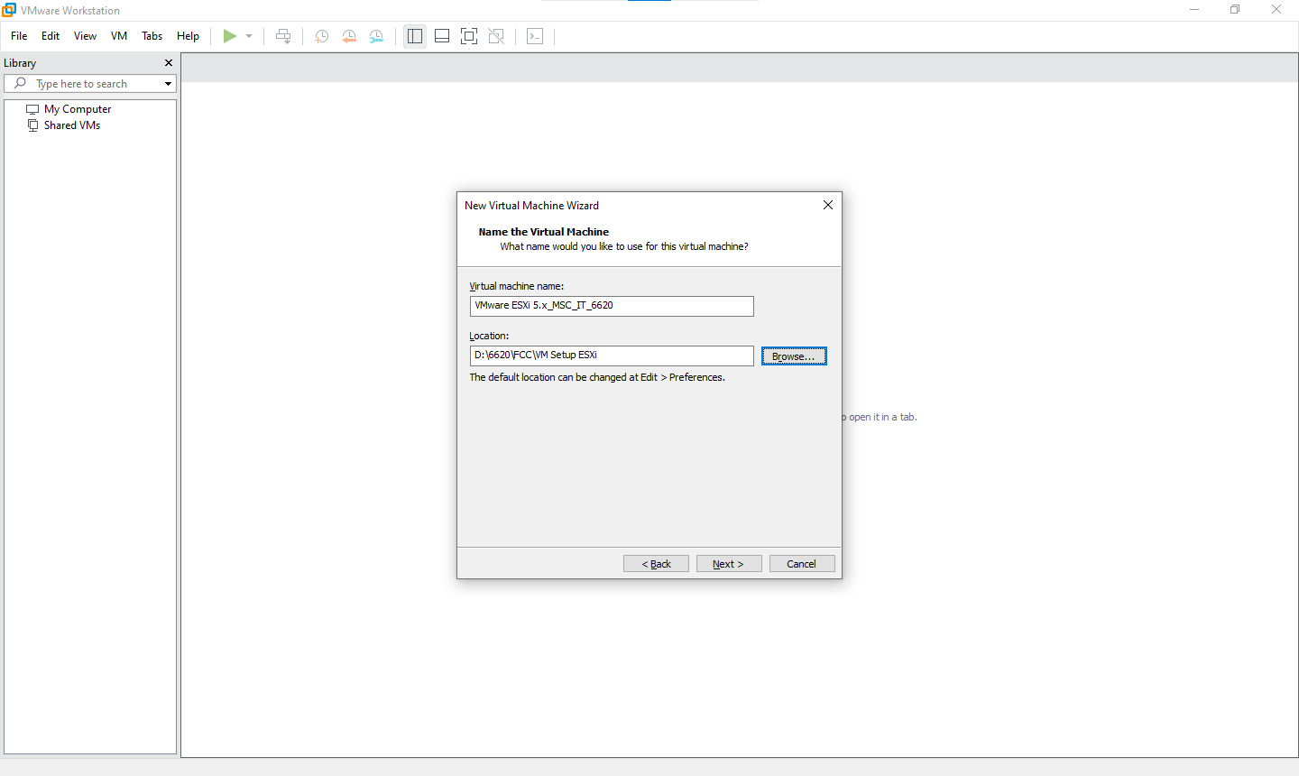

Select “Maximum Disc size” as 60 GB and select option “Store virtual disc as single file” and click on NEXT

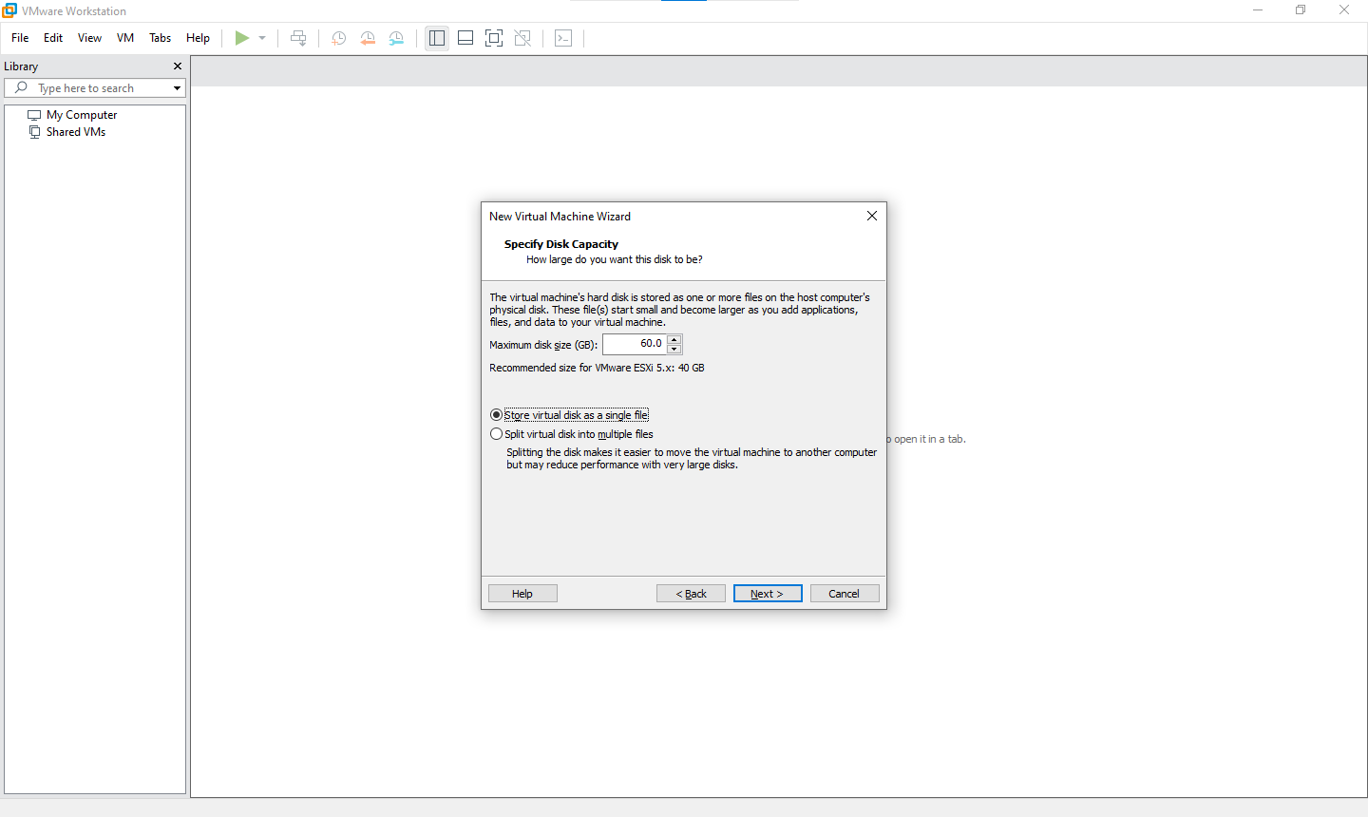

Click on Customize hardware

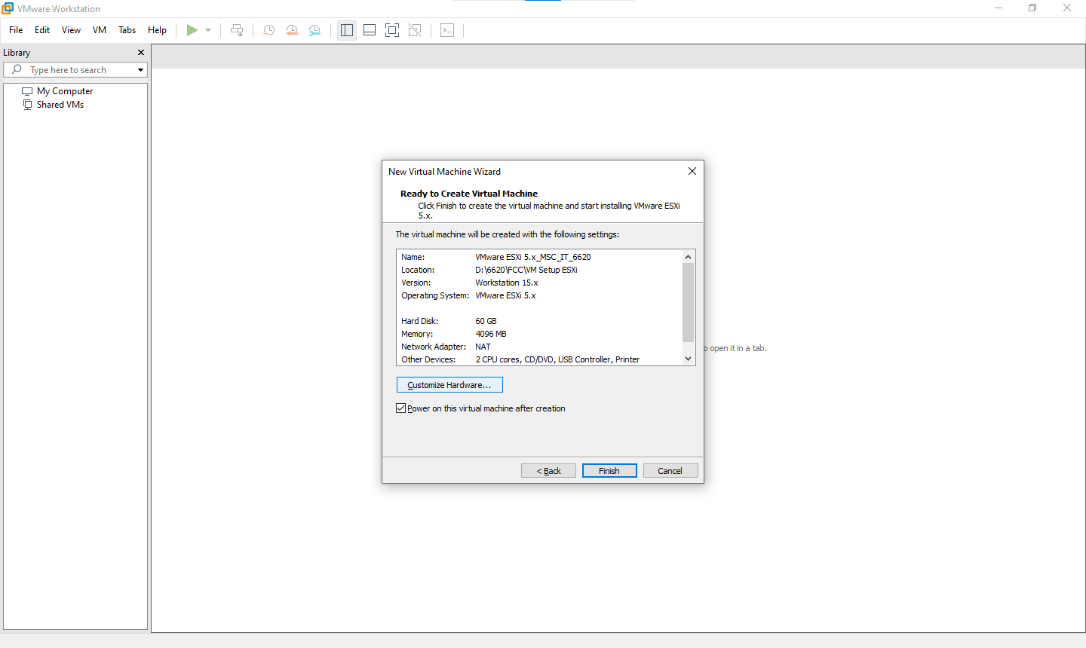

Got to “New CD/DVD (IDE)” option make sure option of “use ISO Image file” is select with ESXI iso file selected and the close that window

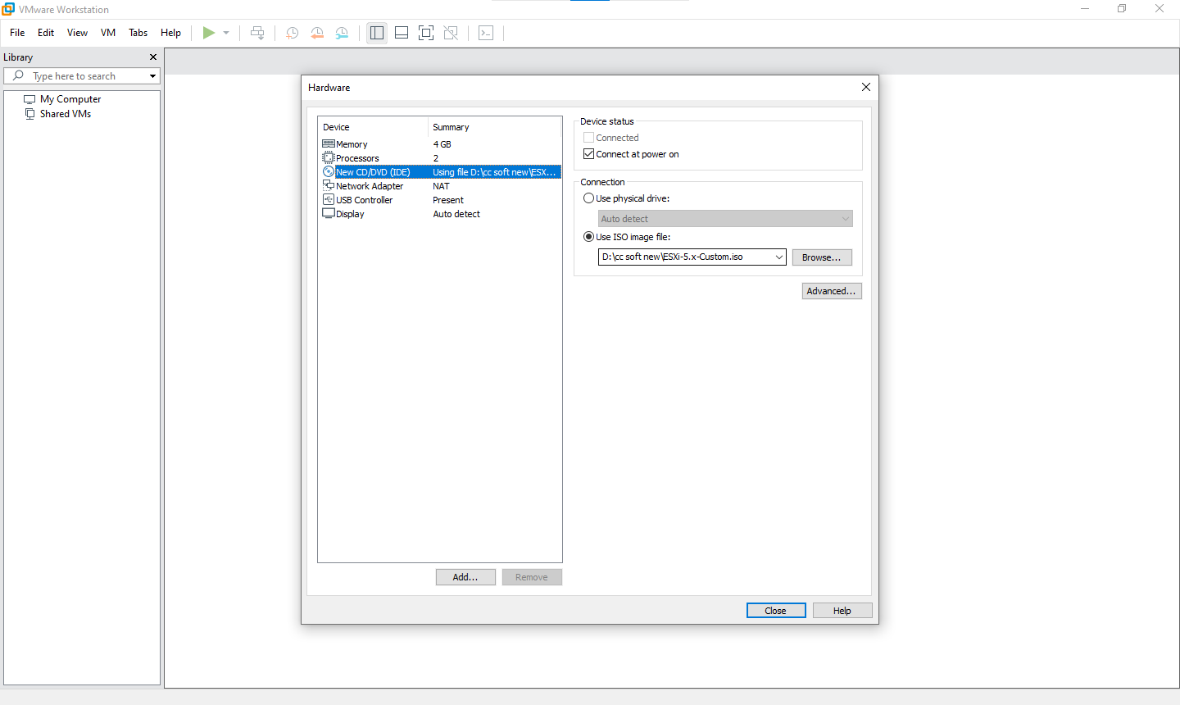

And click on finish



Your Virtual machine will booted up

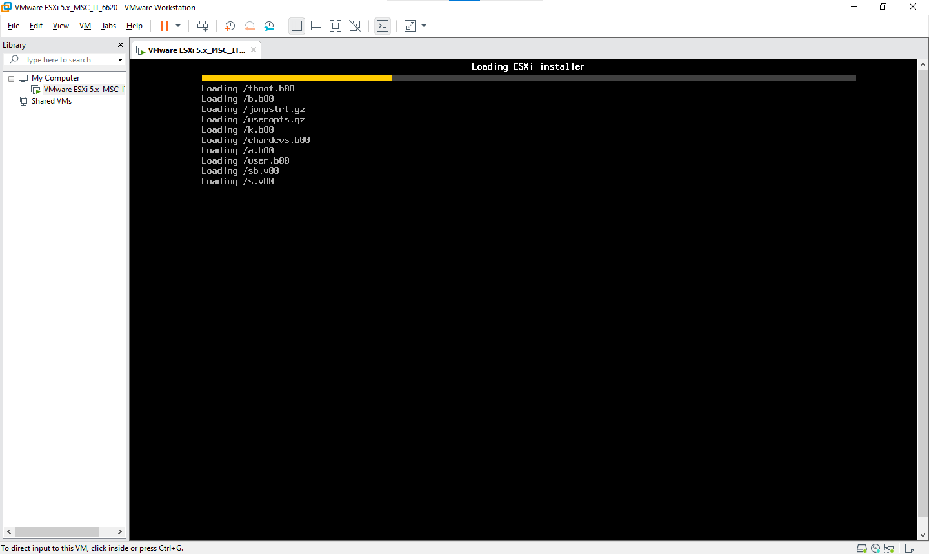

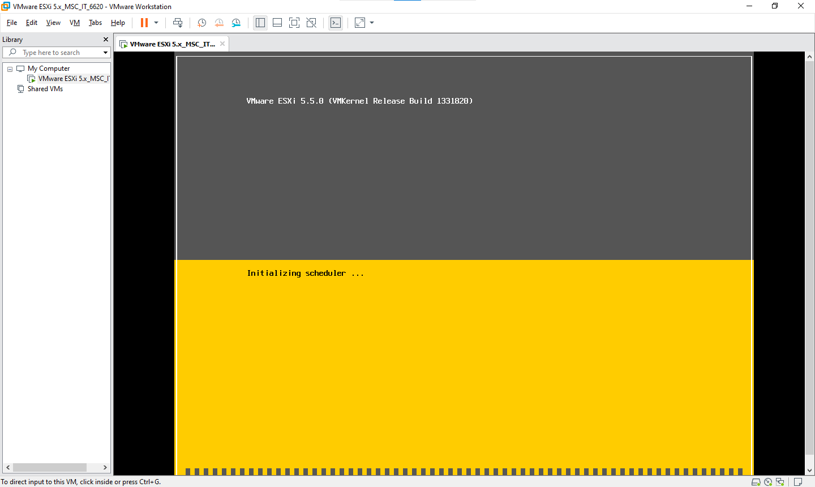

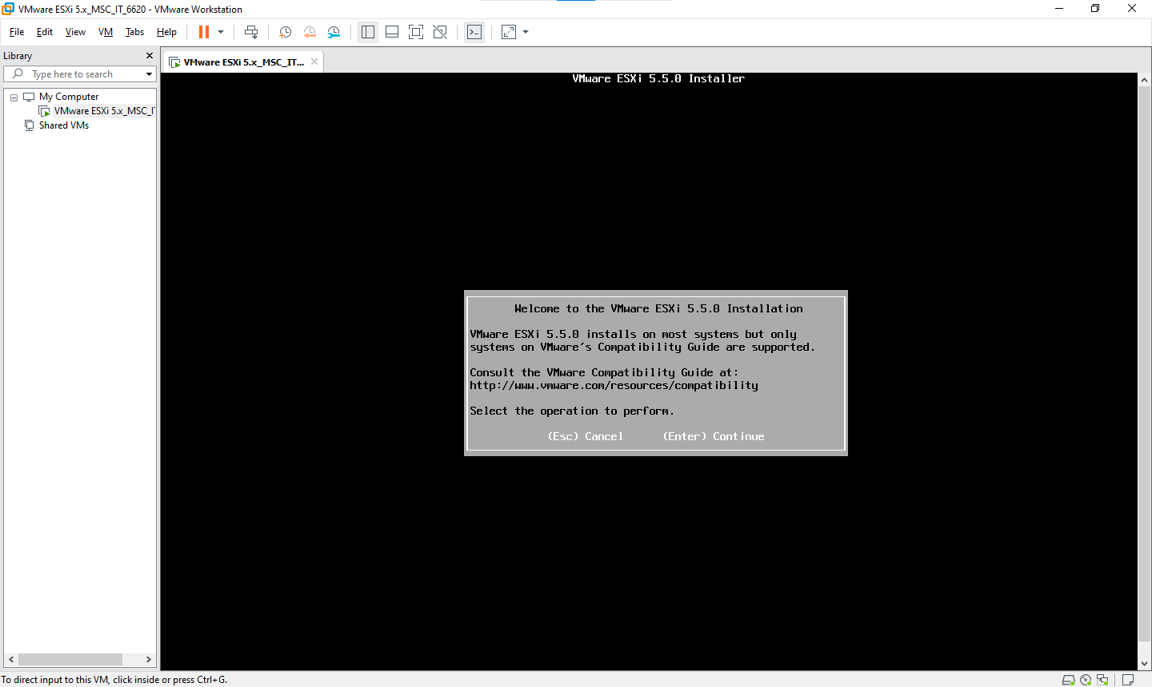

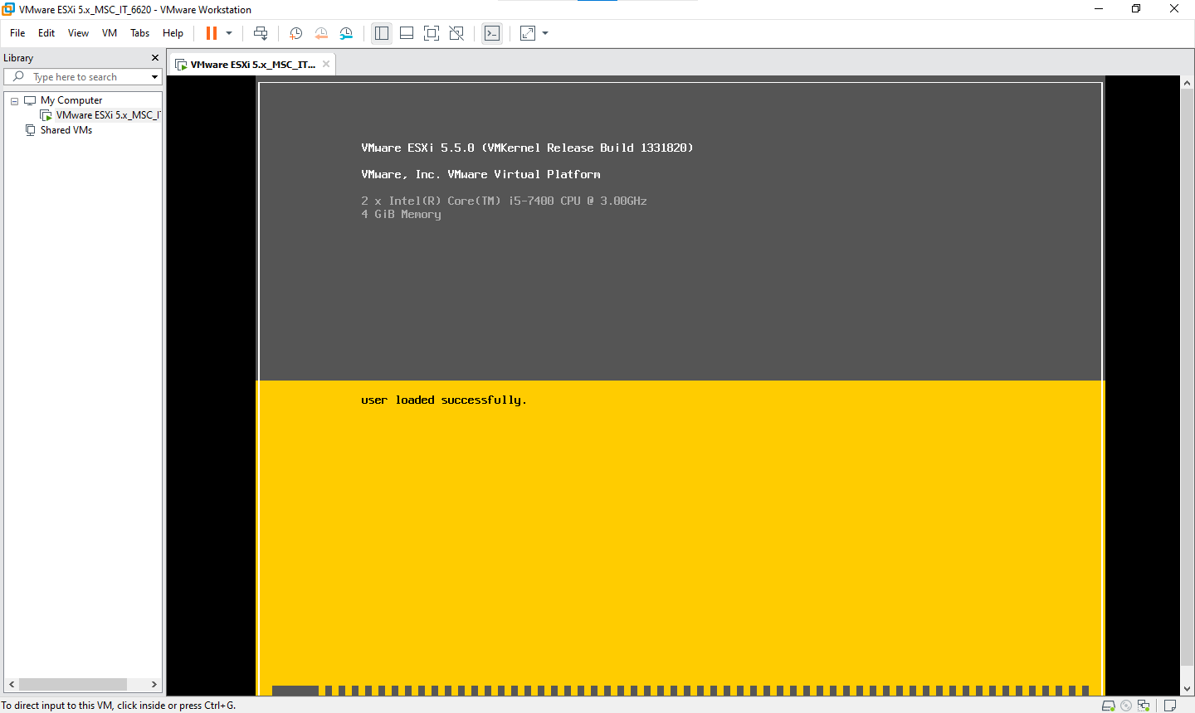

Note this IP address and leave the Virtual machine ON only don't let it be down for while your are performing

<http://192.168.110.128/>

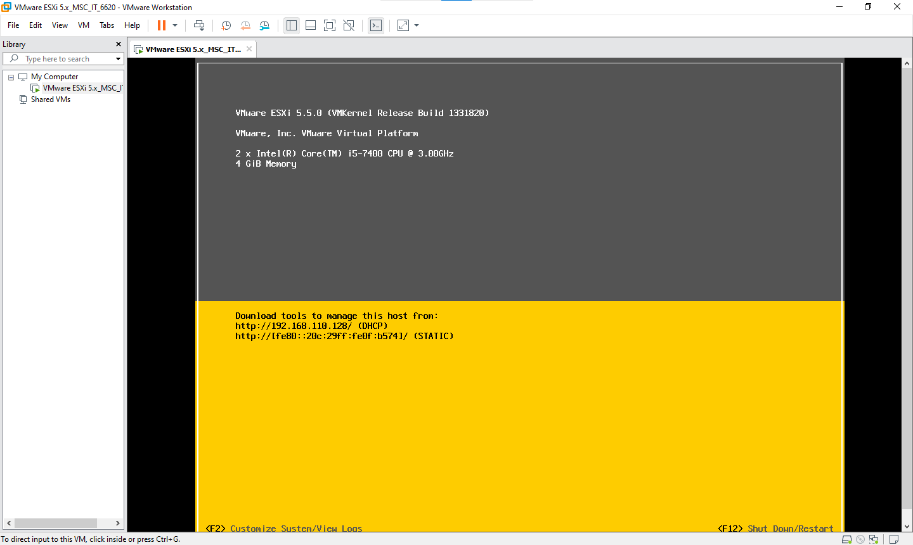

Install vSphere Client

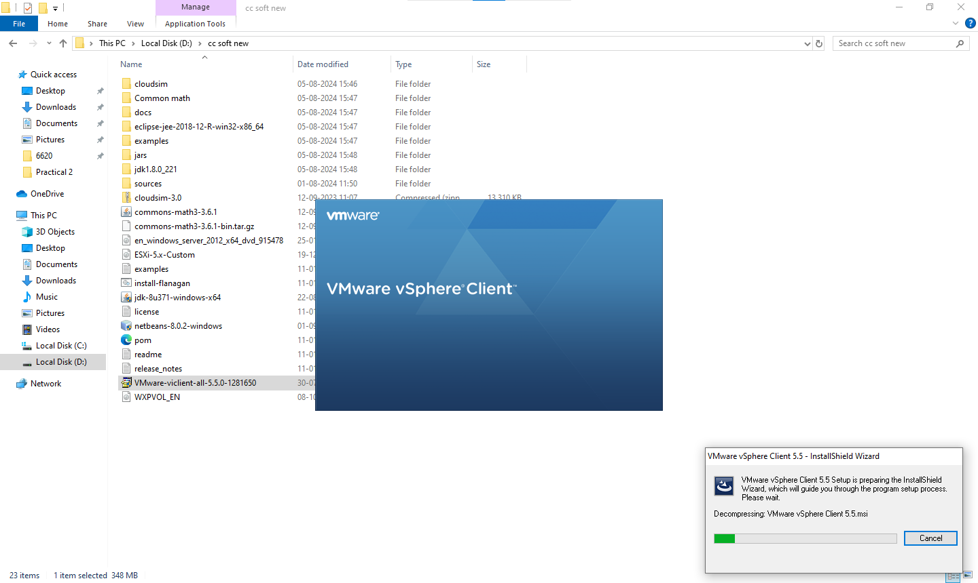

Change setup location as your desired location

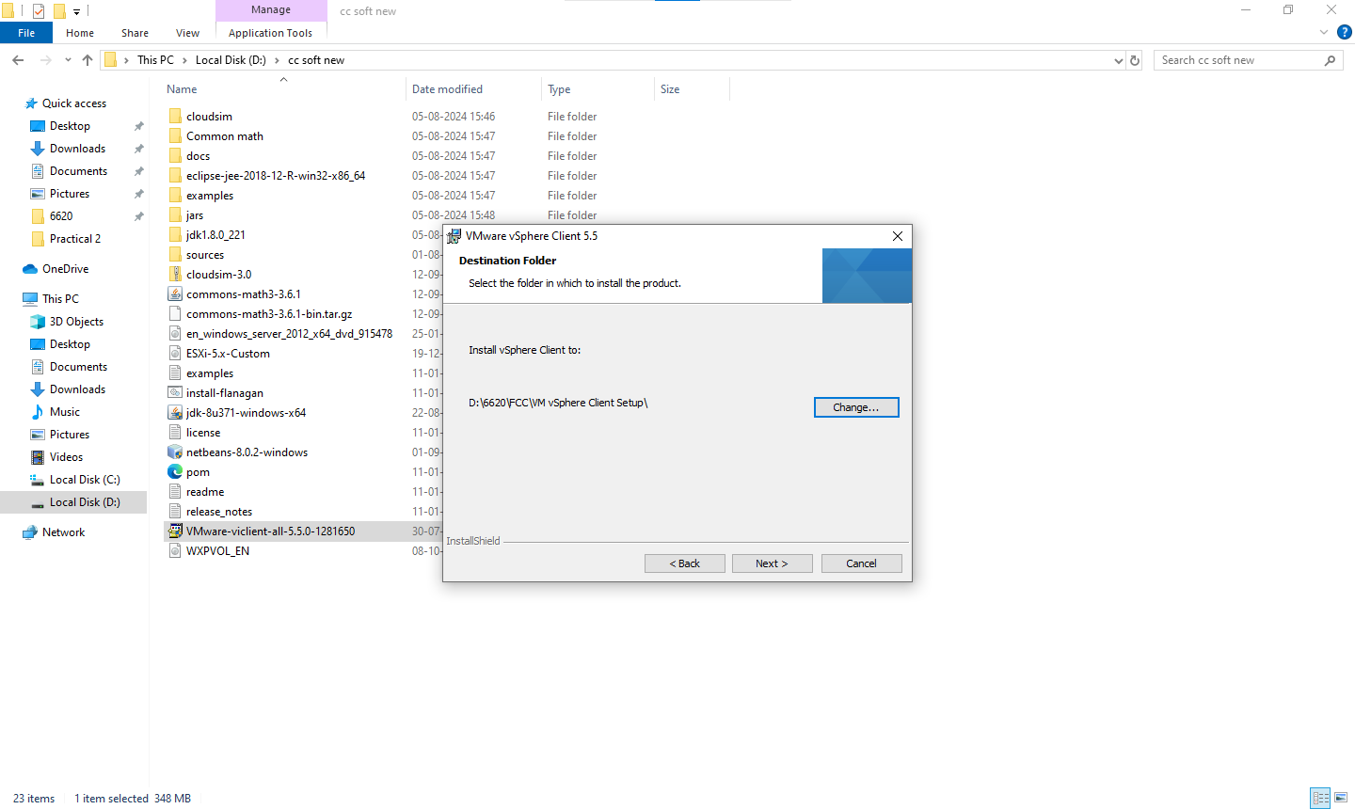

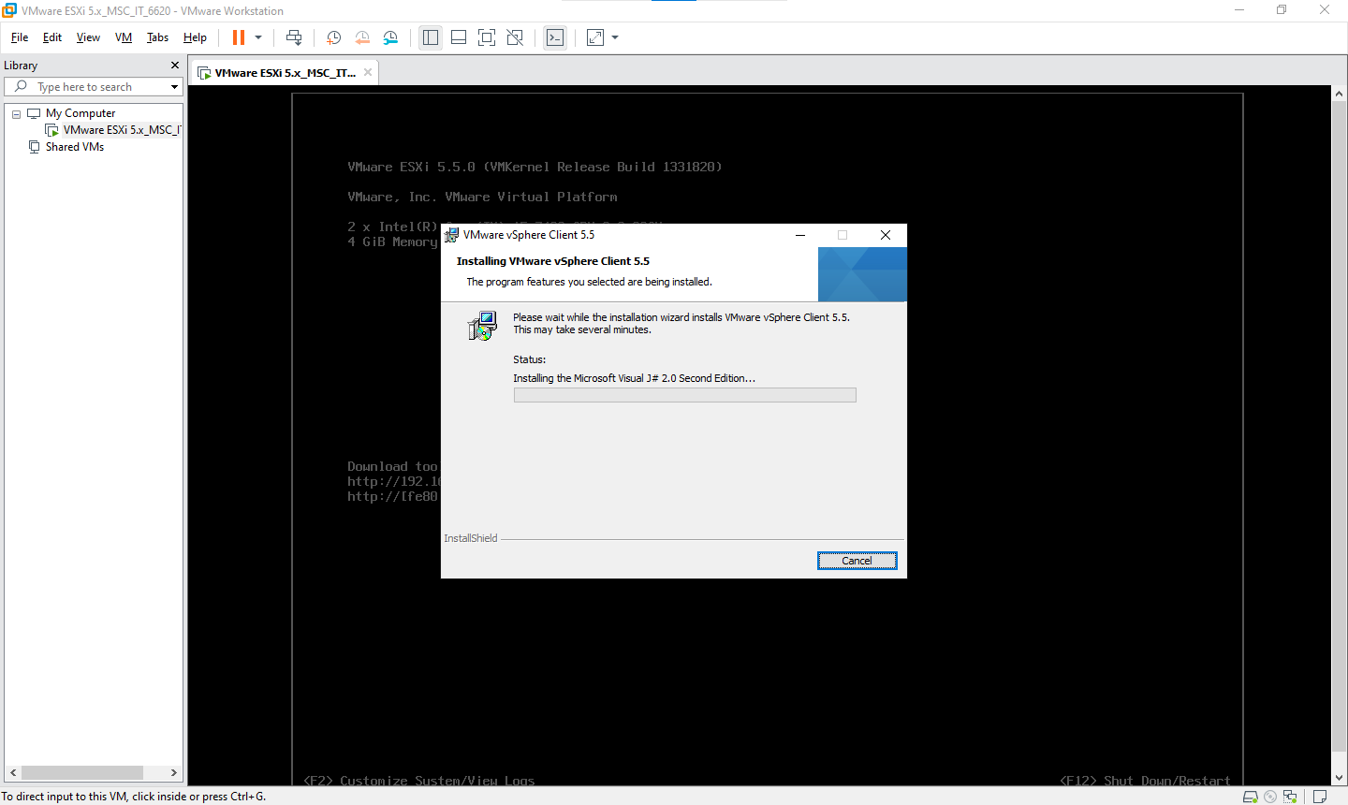

After successful Installation of vSphere open vSphere client

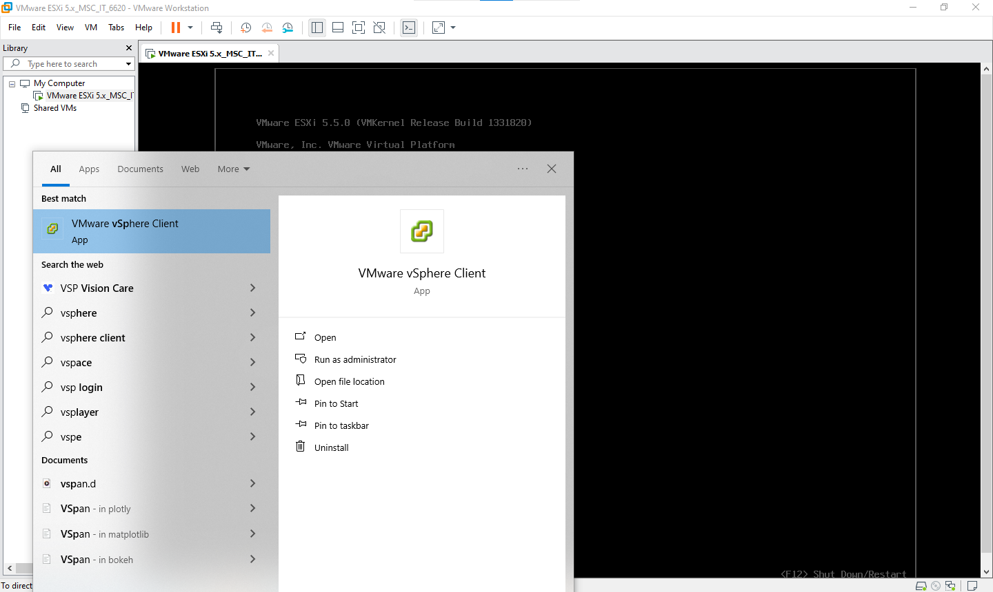

Login with noted down IP Address with username root and password root123

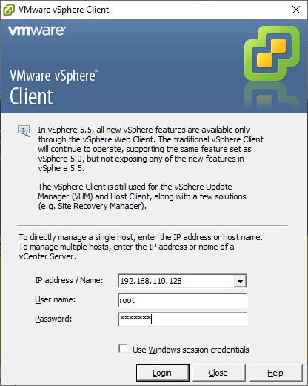

Click the install checkbox and then view certificate

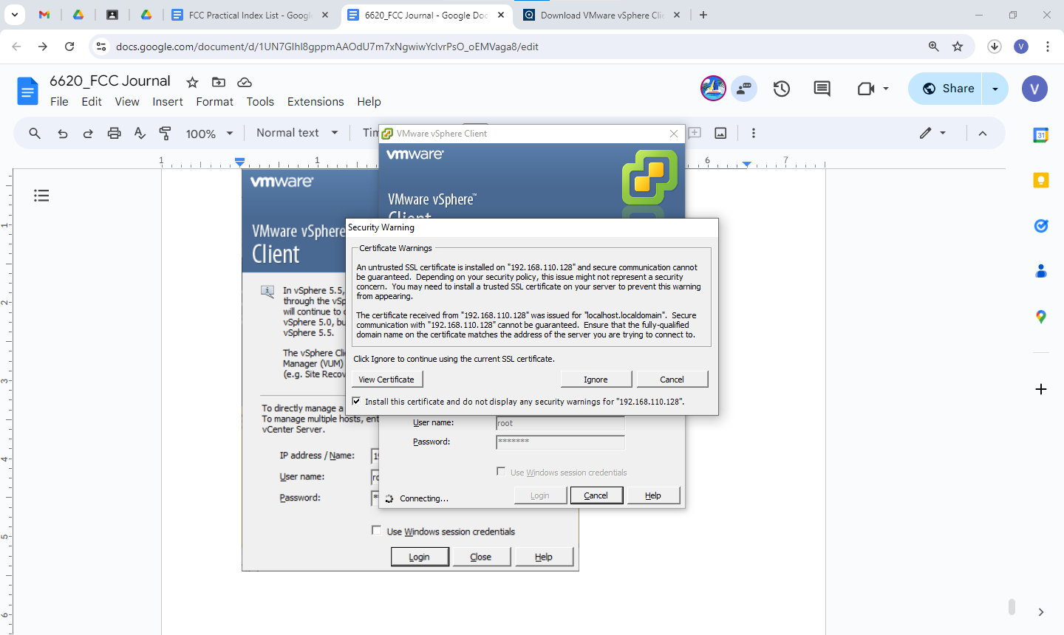

User name - root

Password - root123

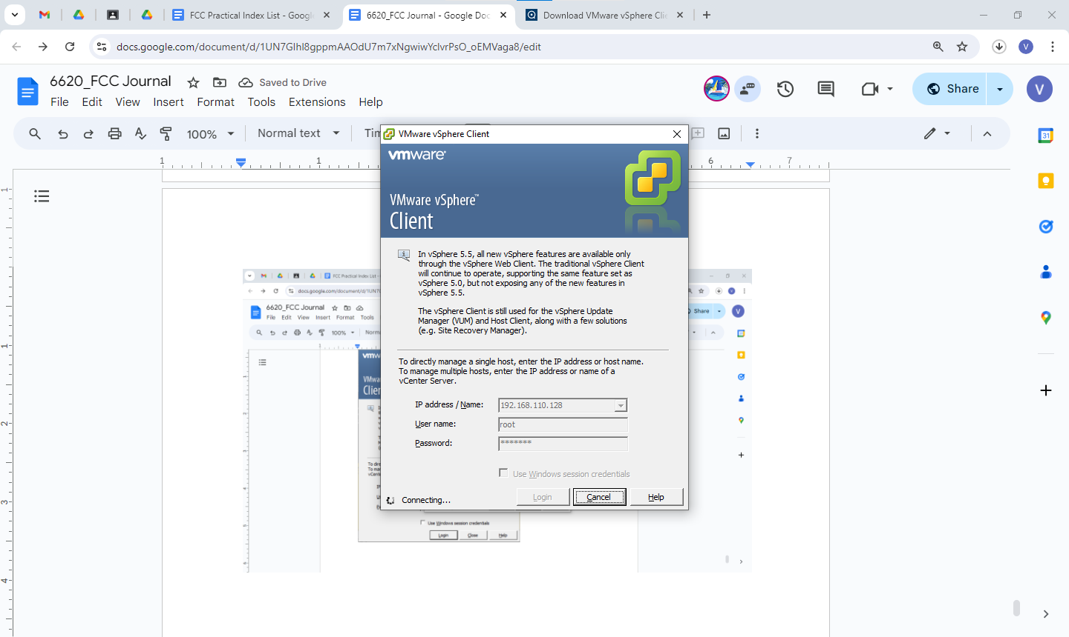

Click on inventory

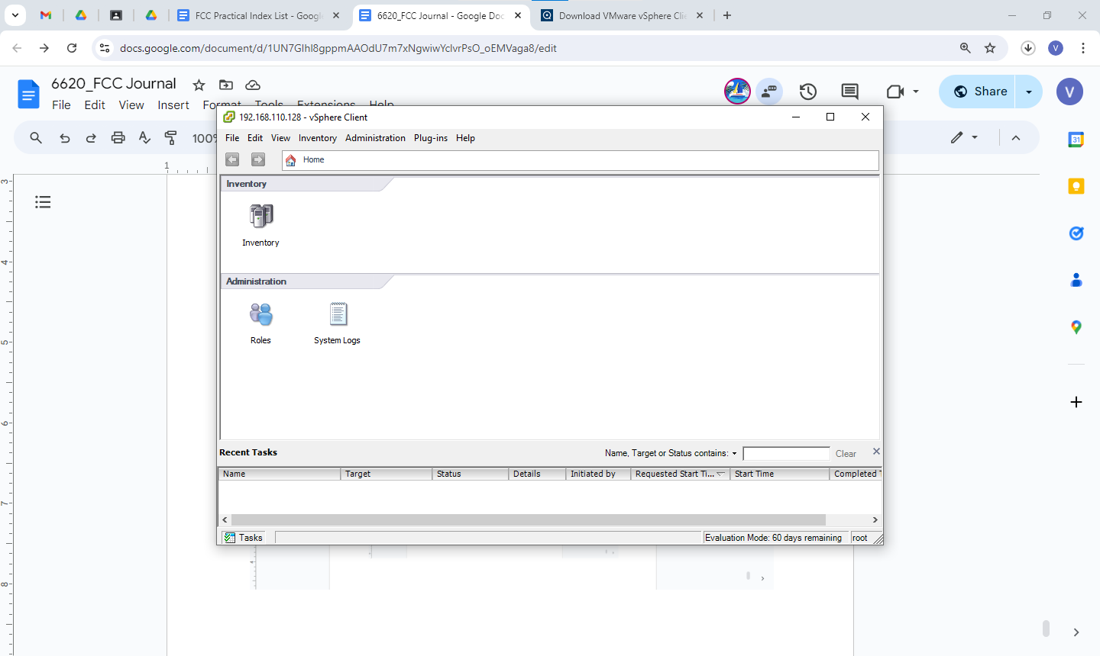

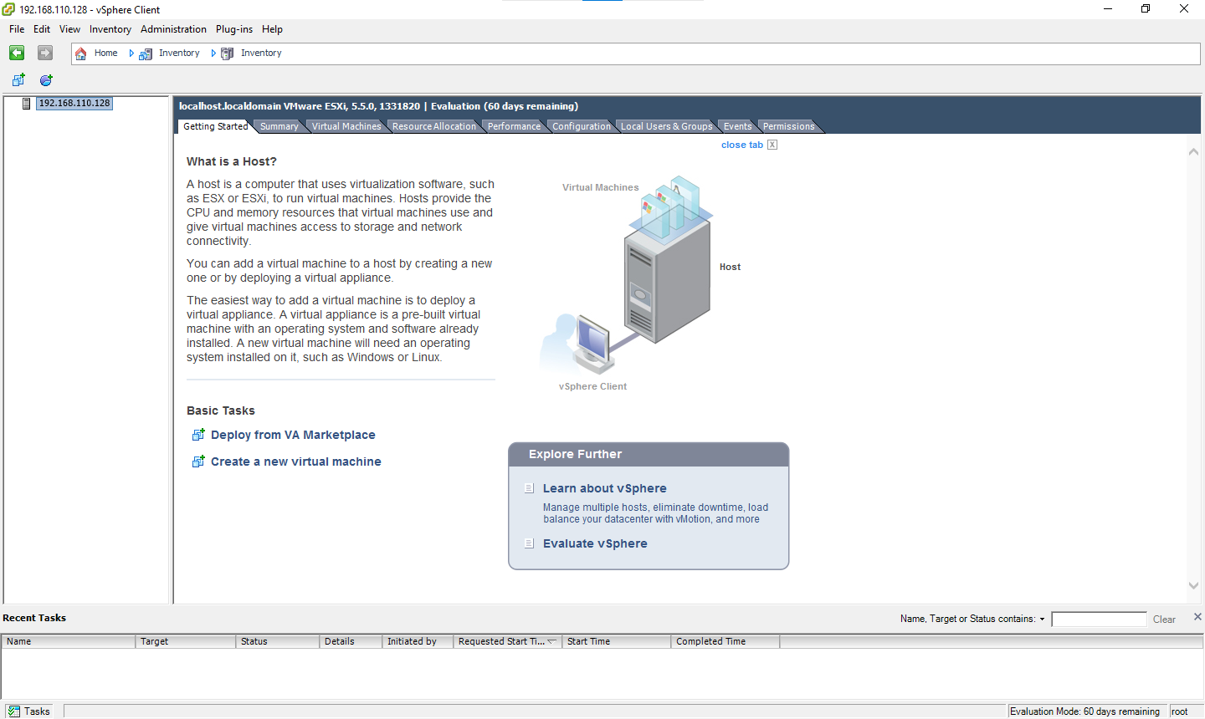

Go to Configuration → right click go to Browse Database

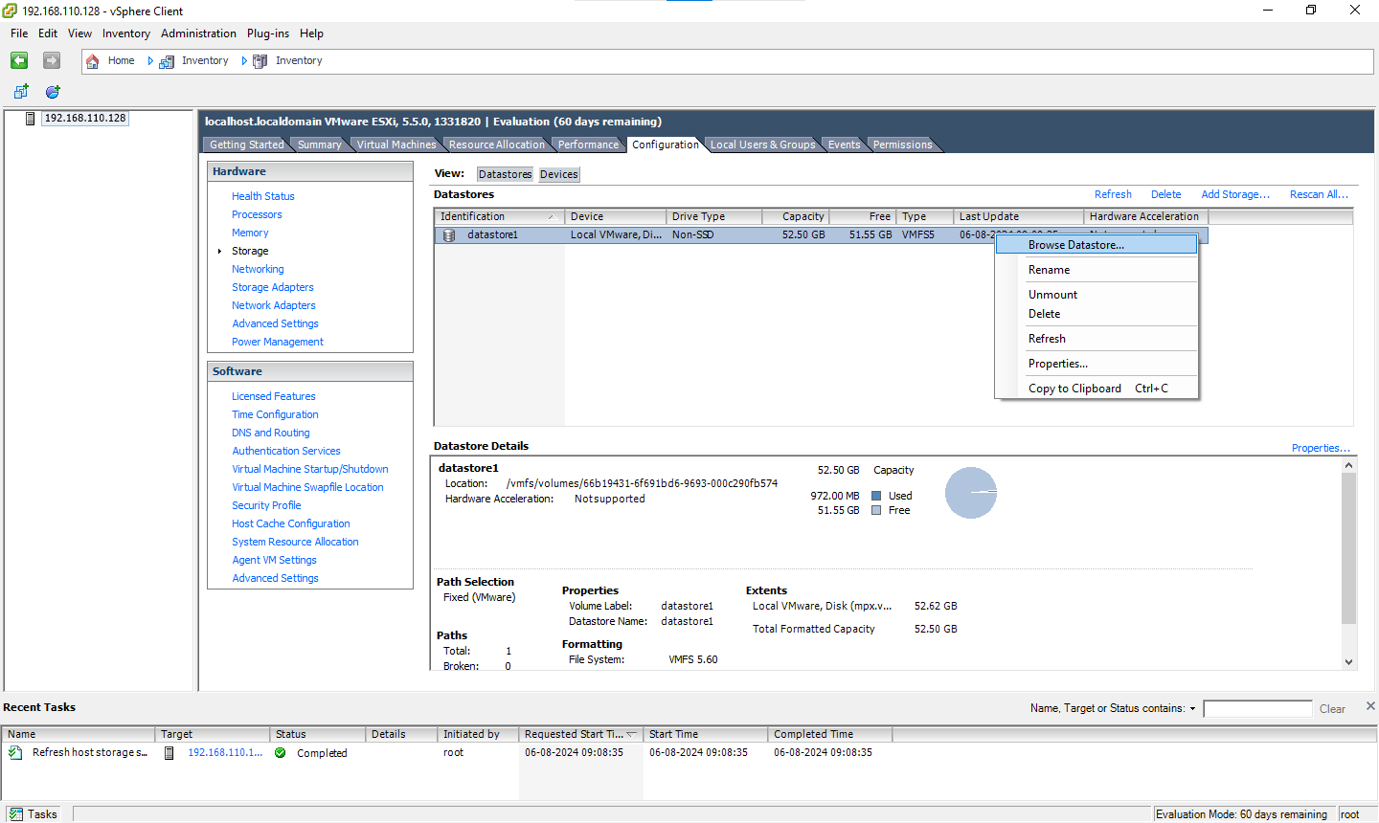

Upload WXPVOL Disc image file

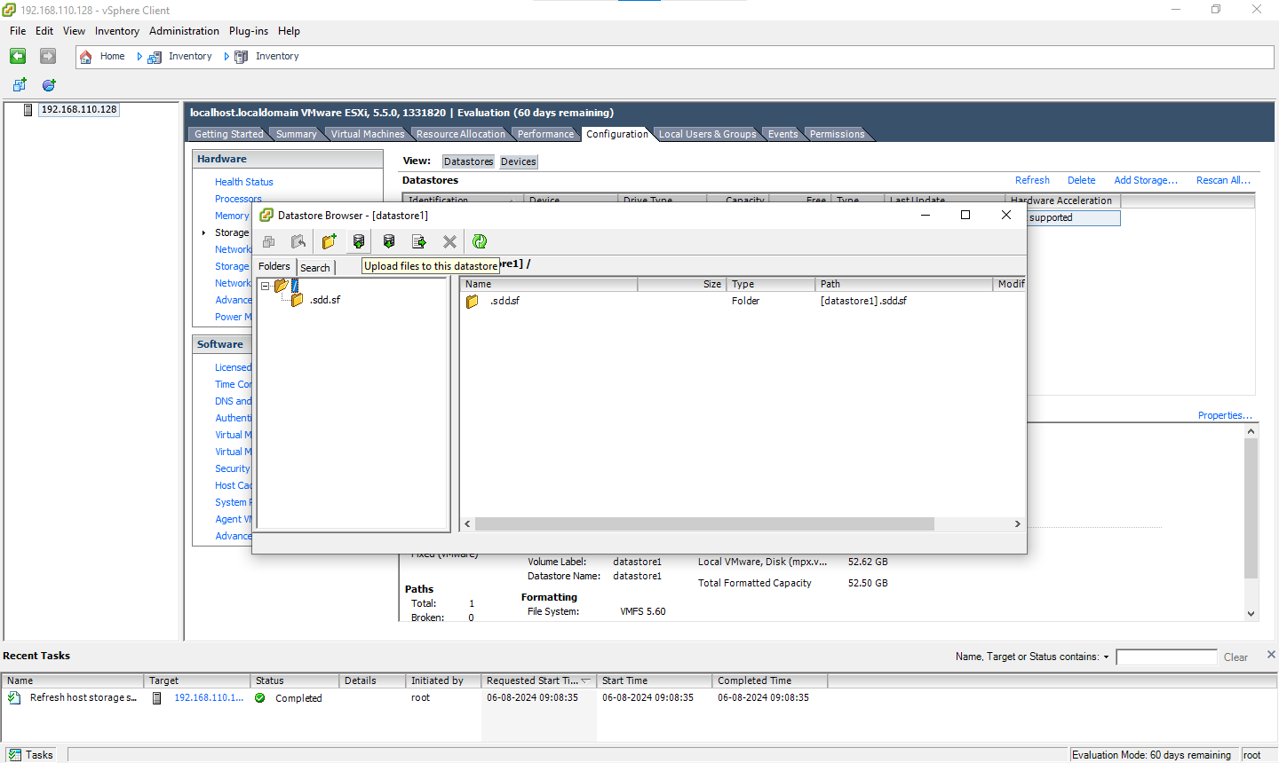

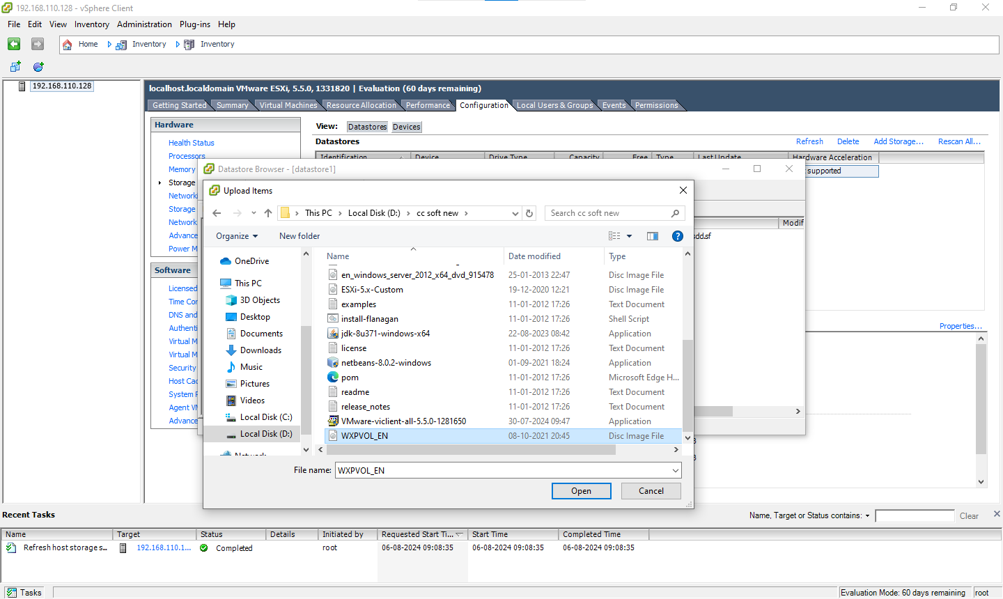

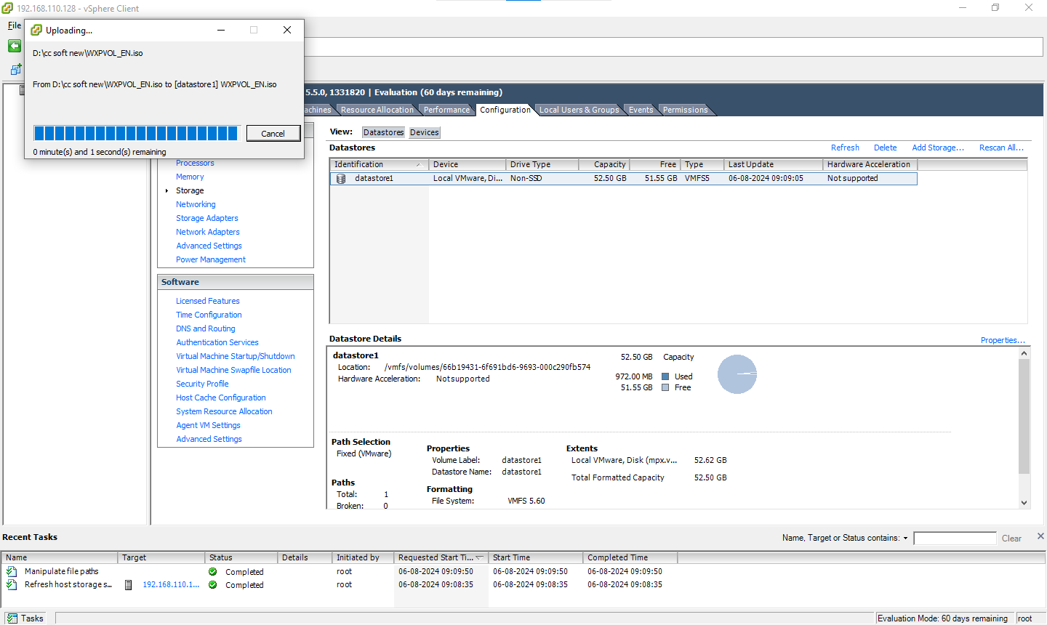

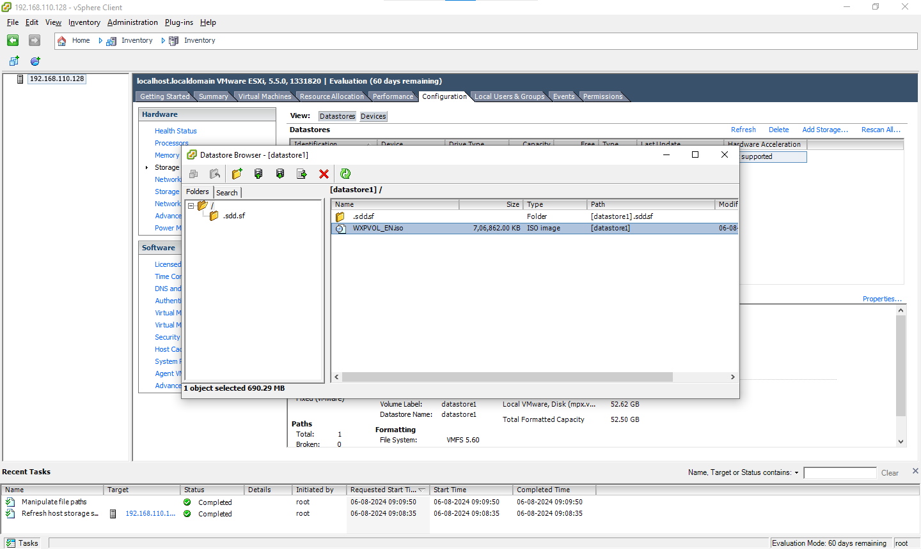

—-------------------------------

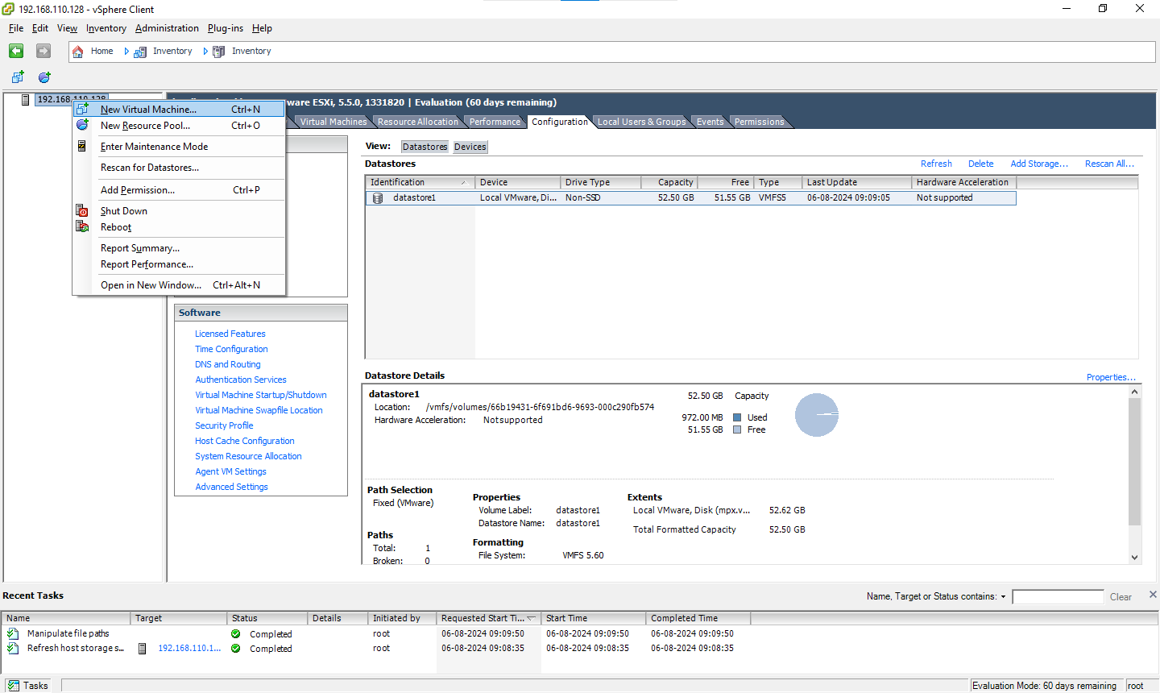

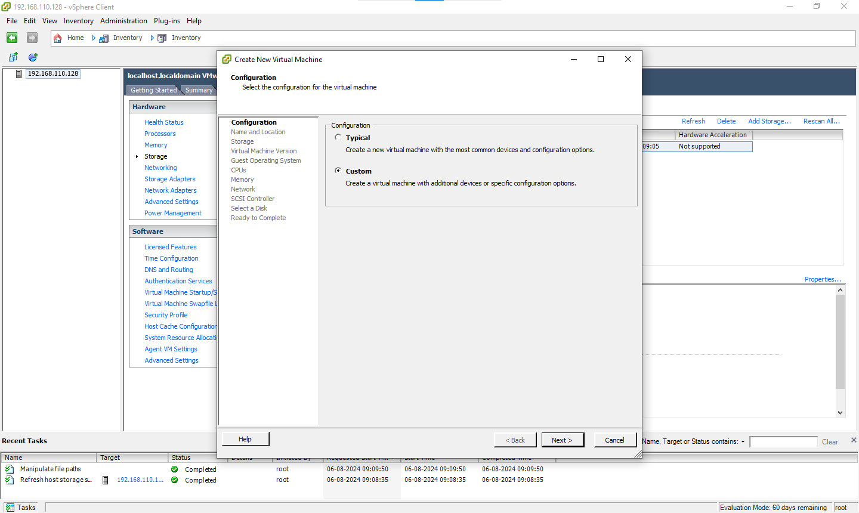

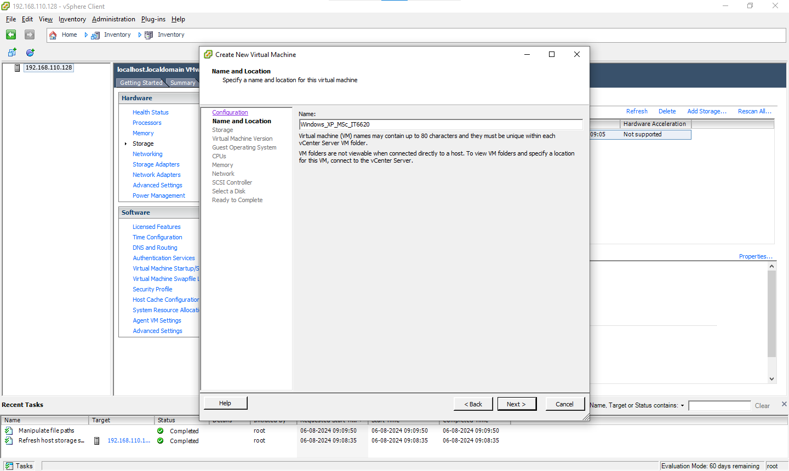

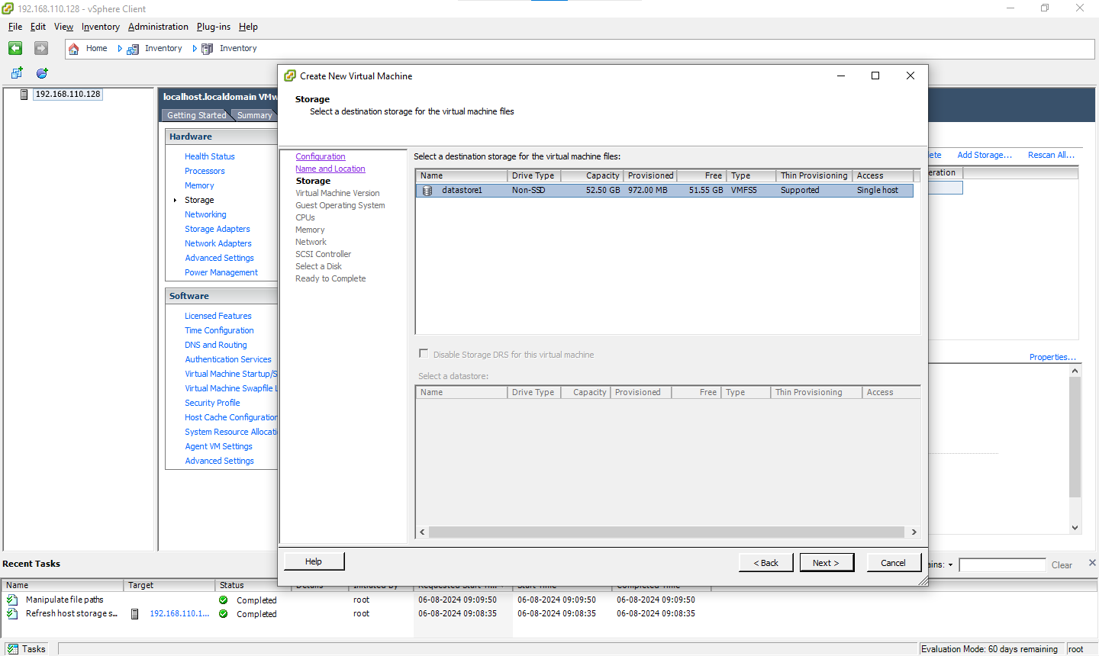

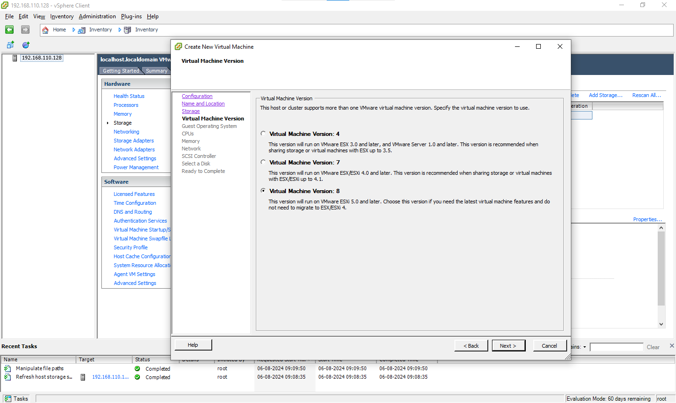

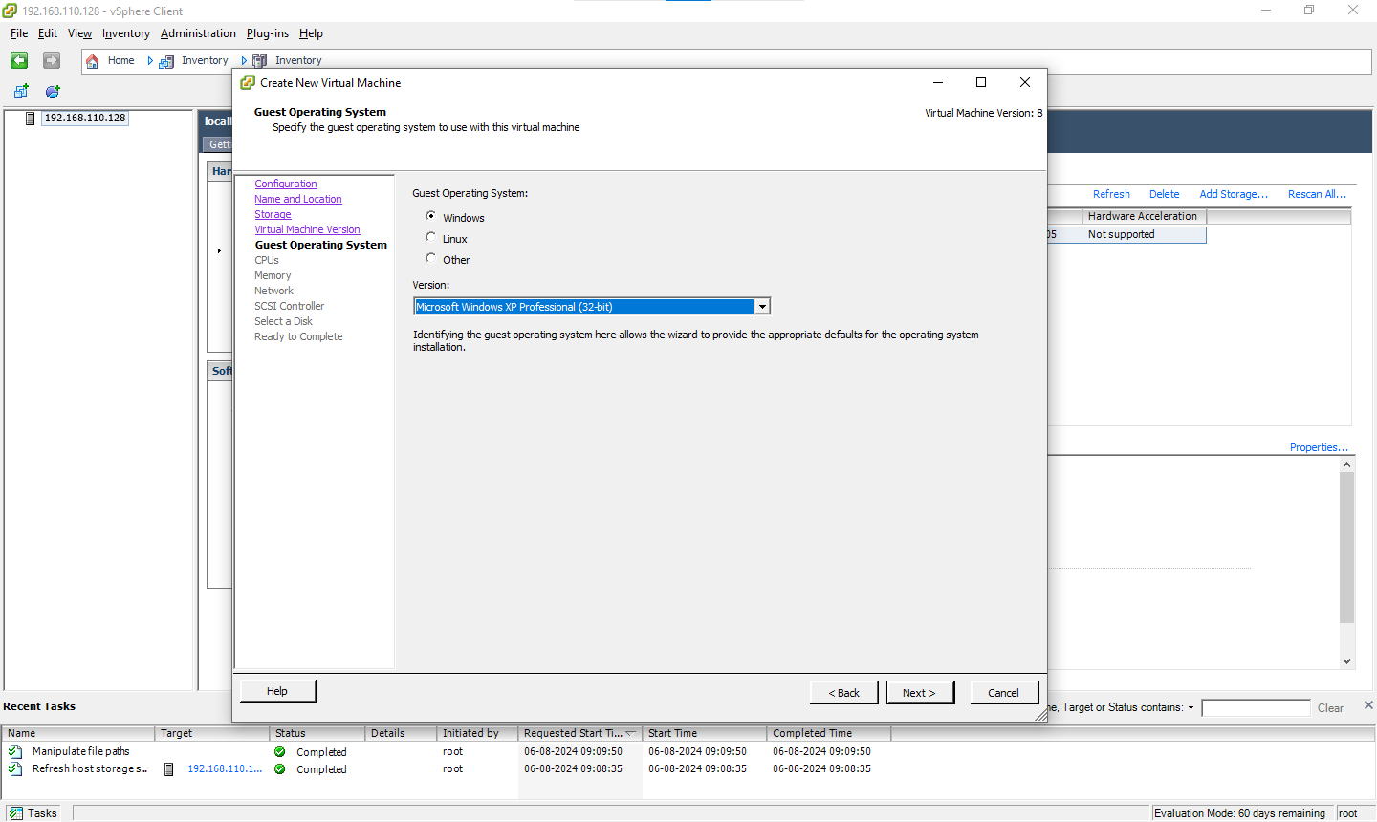

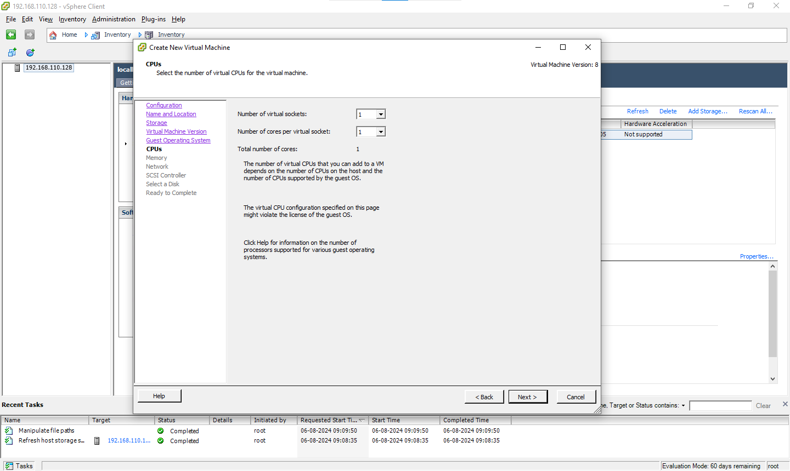

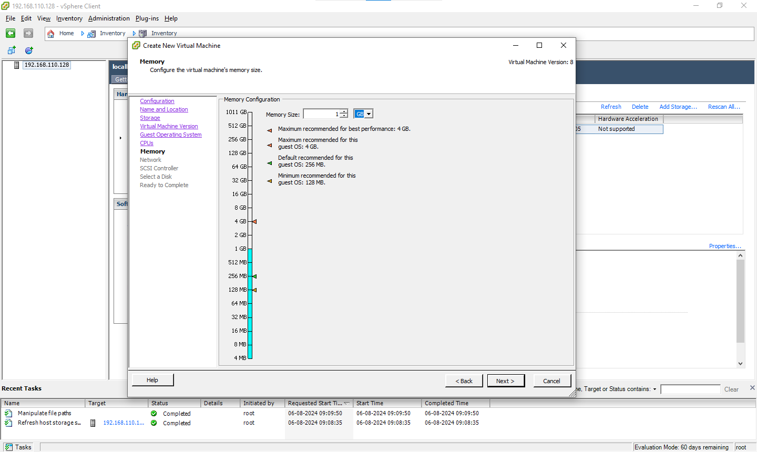

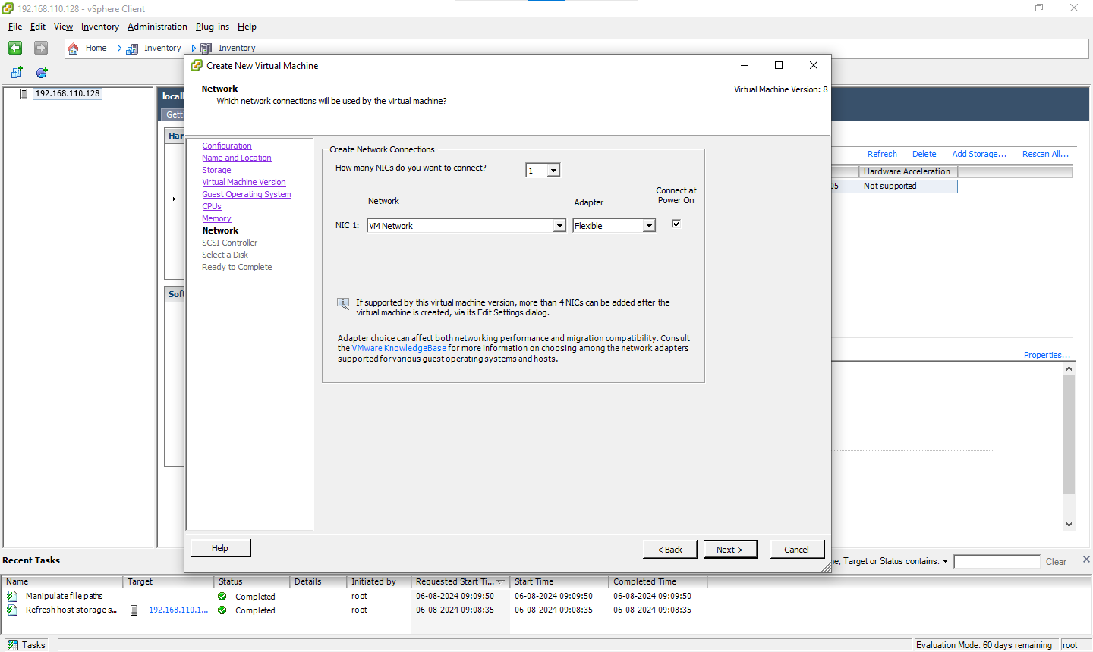

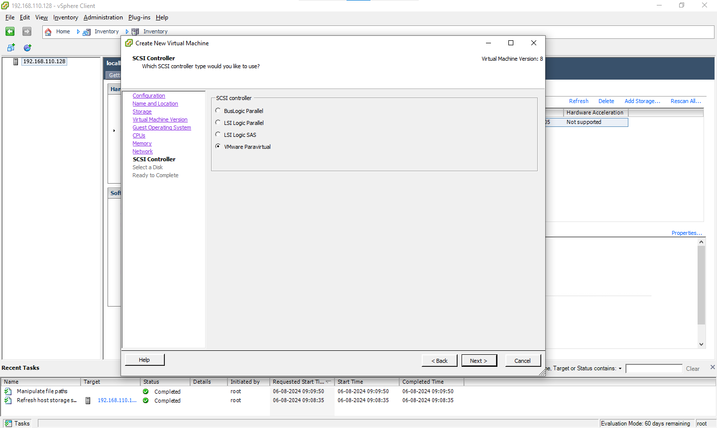

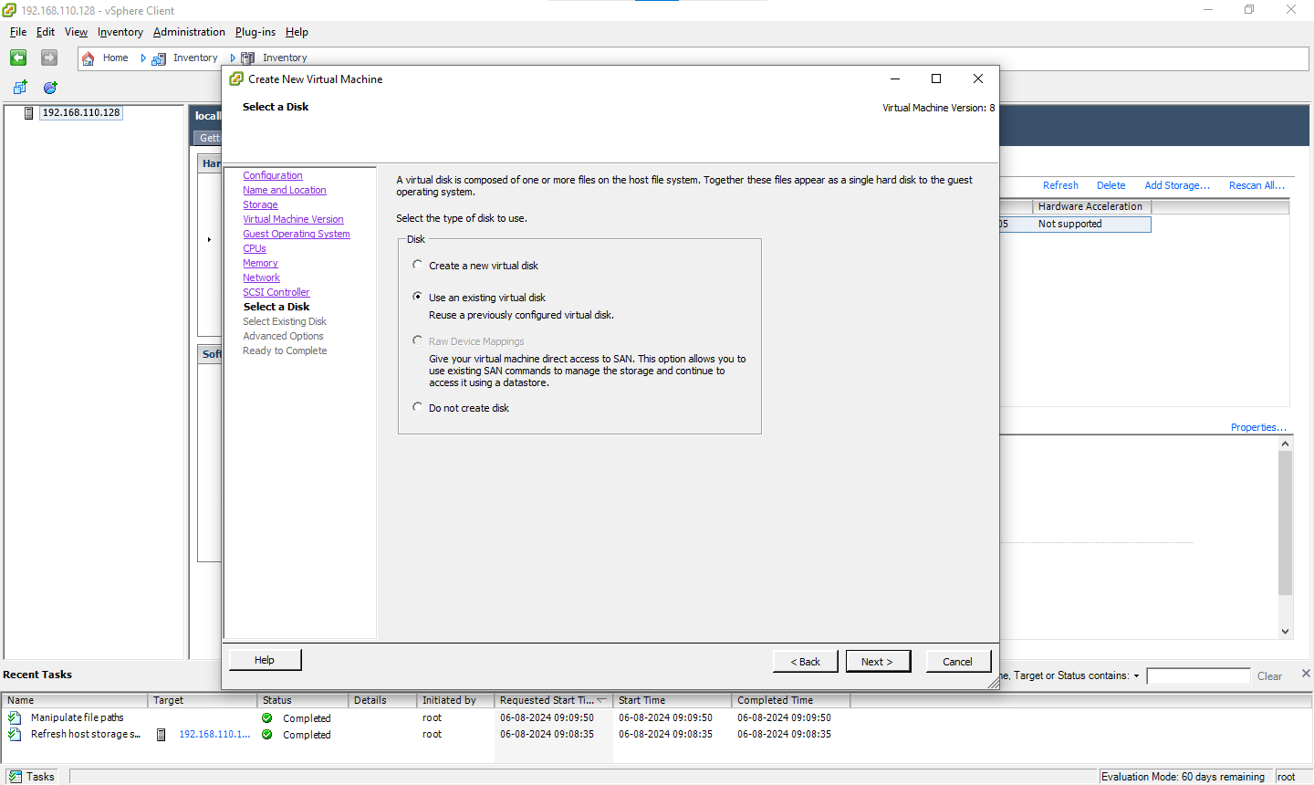

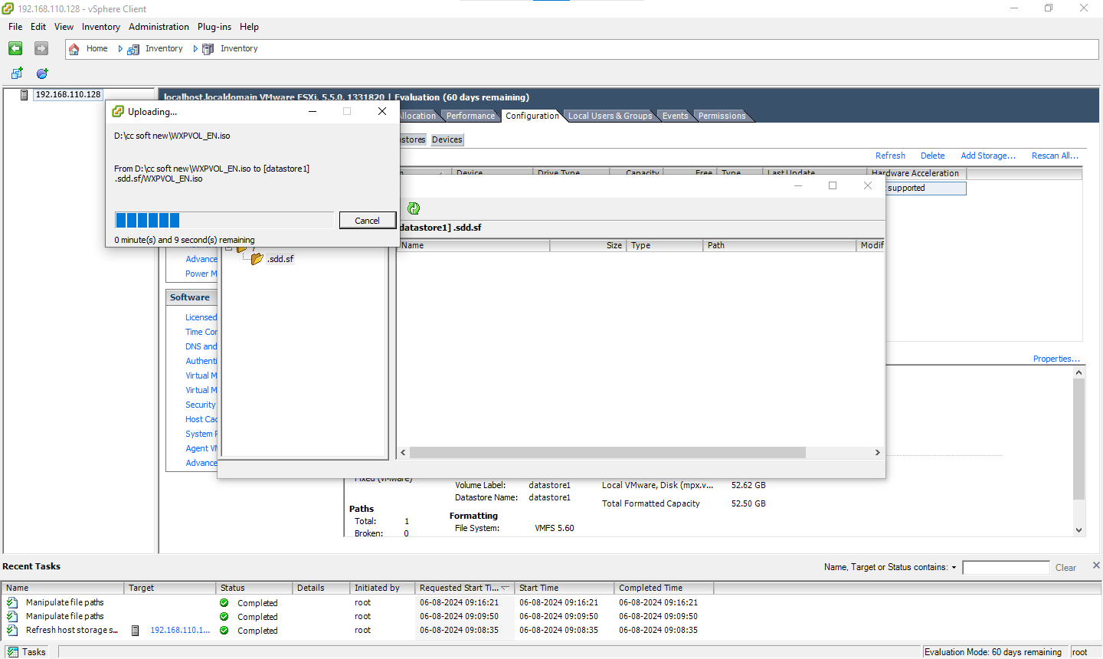

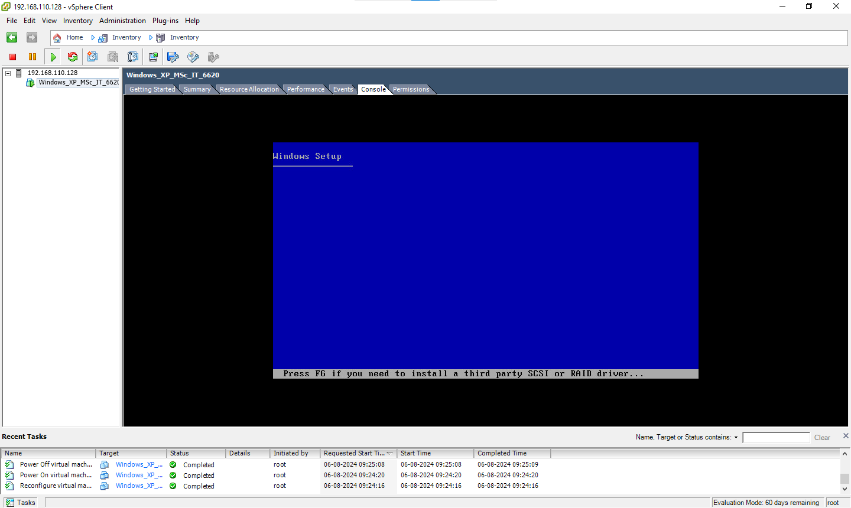

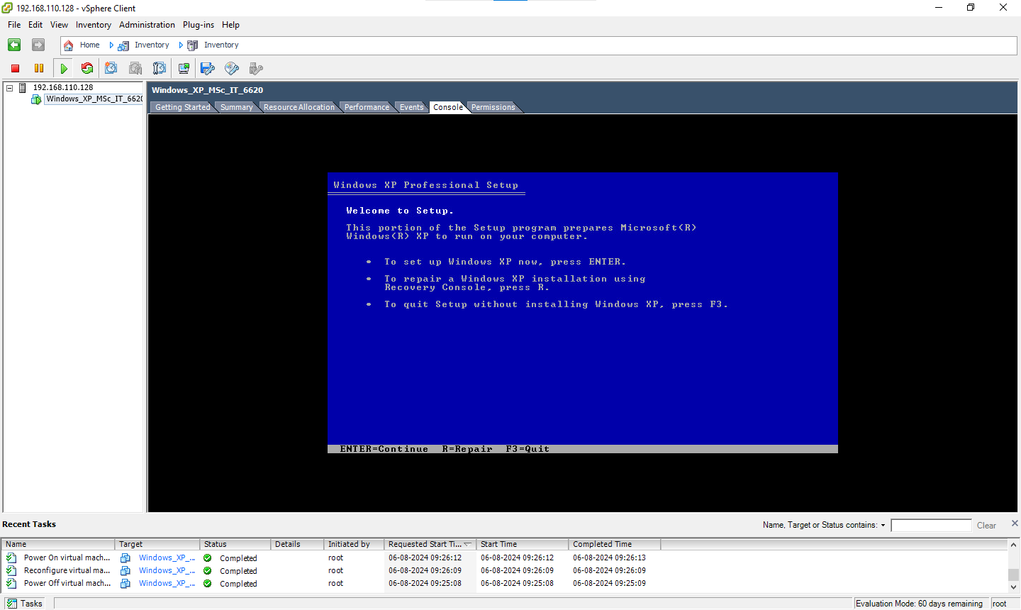

Aug 13, 2024 - new

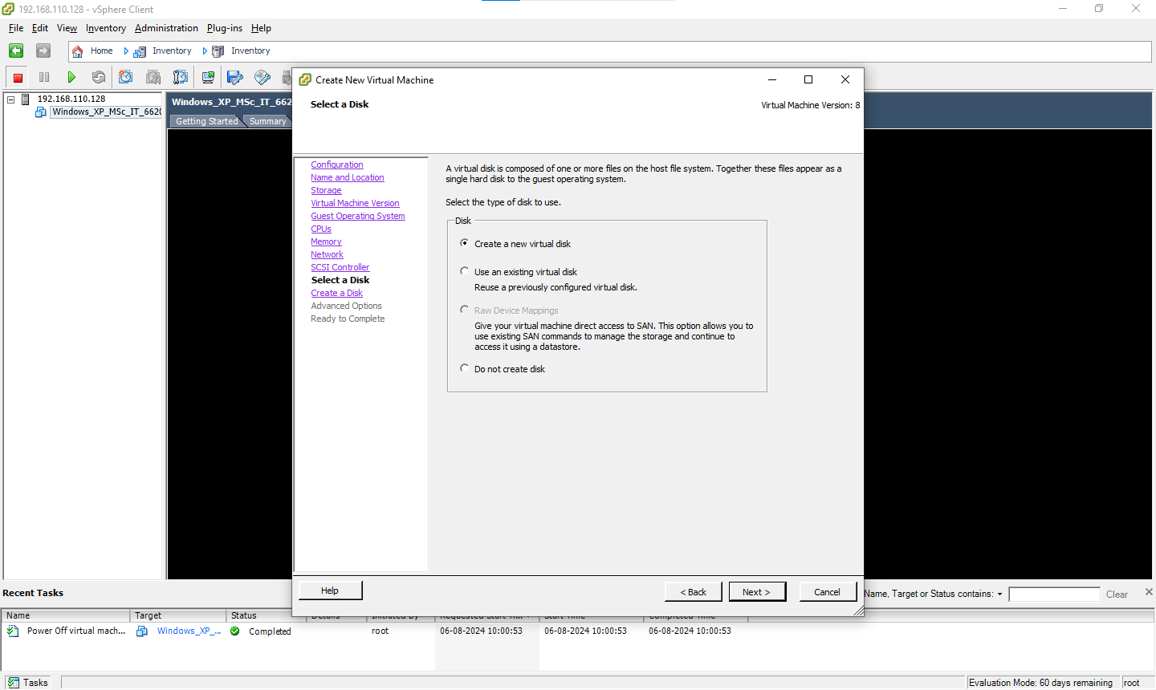

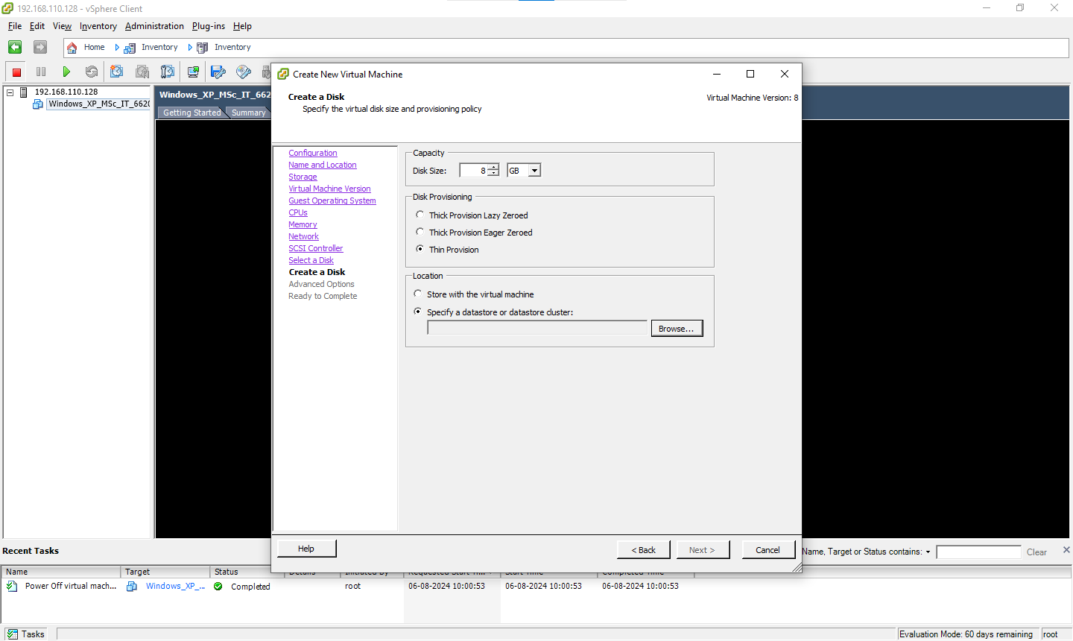

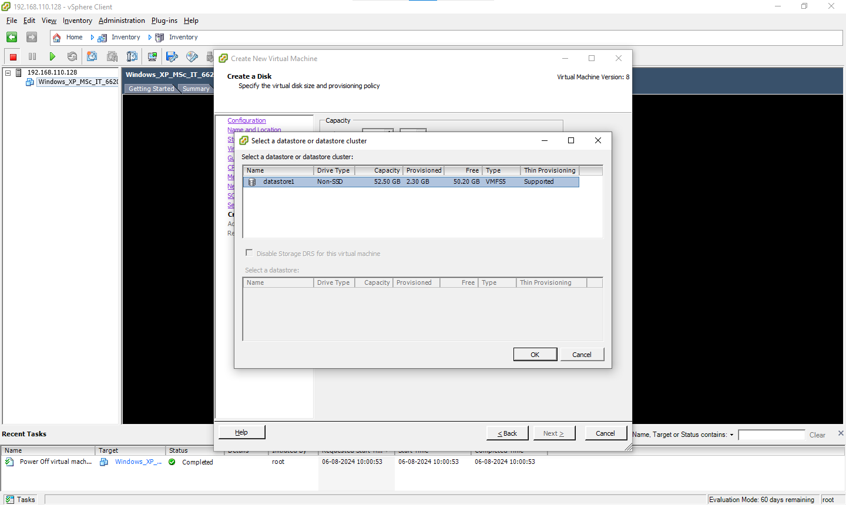

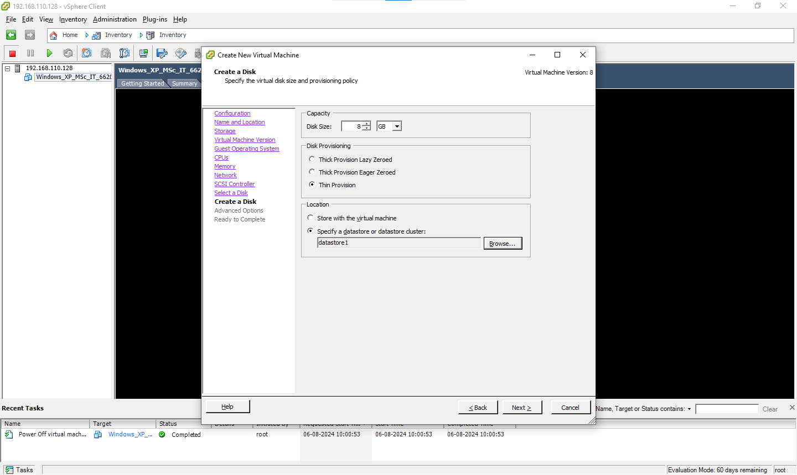

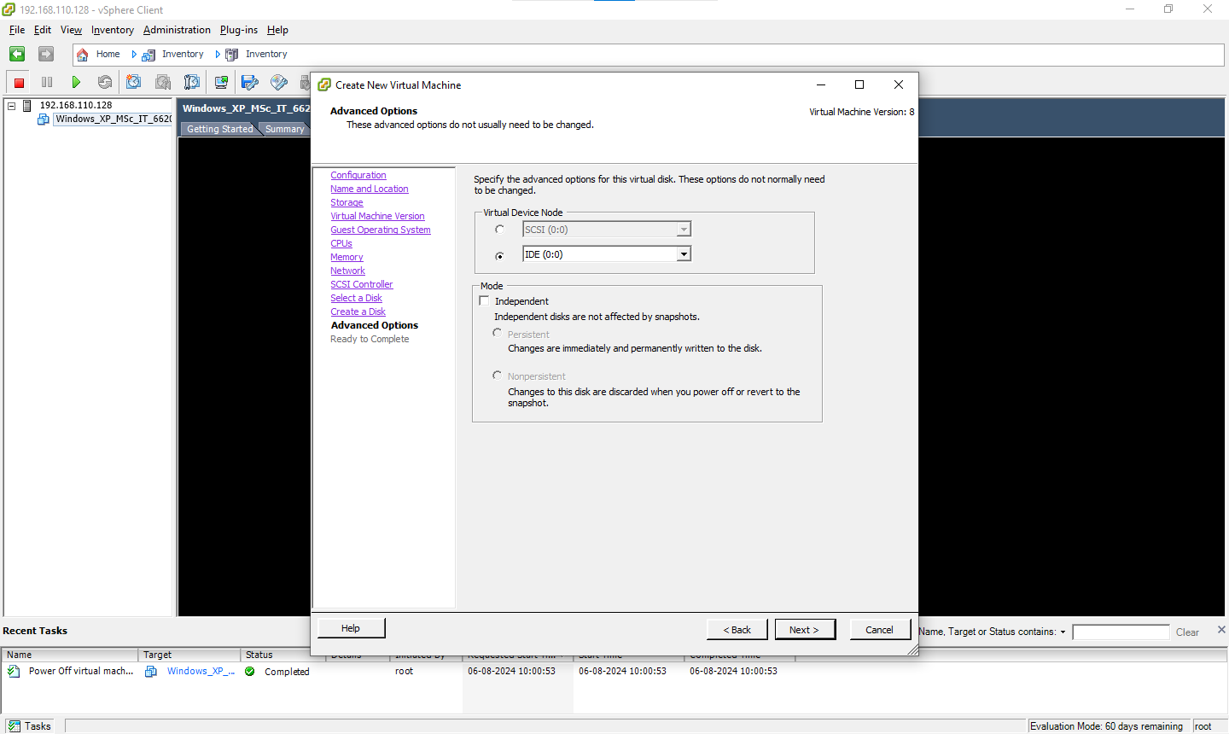

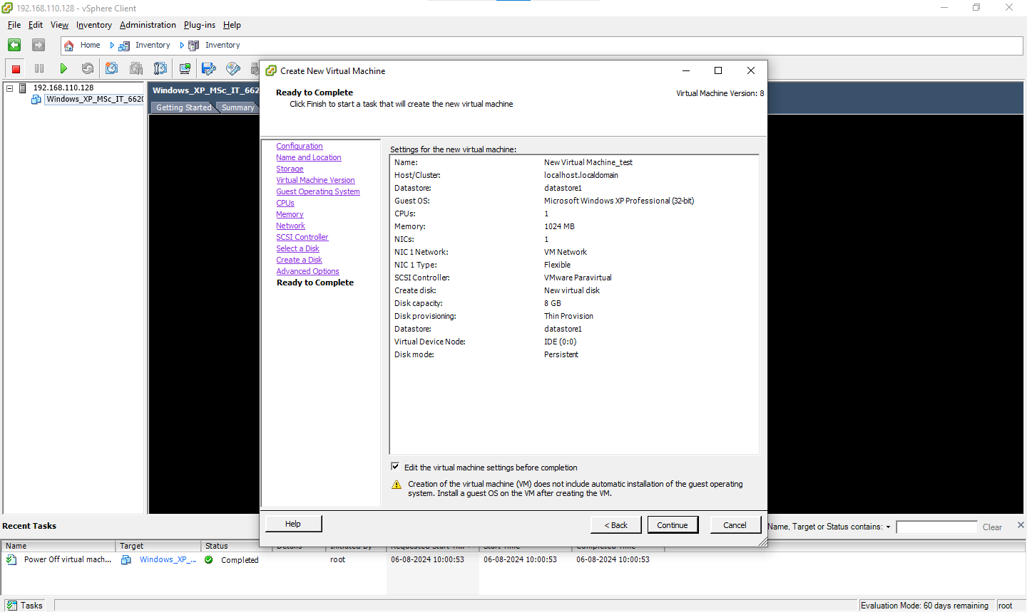

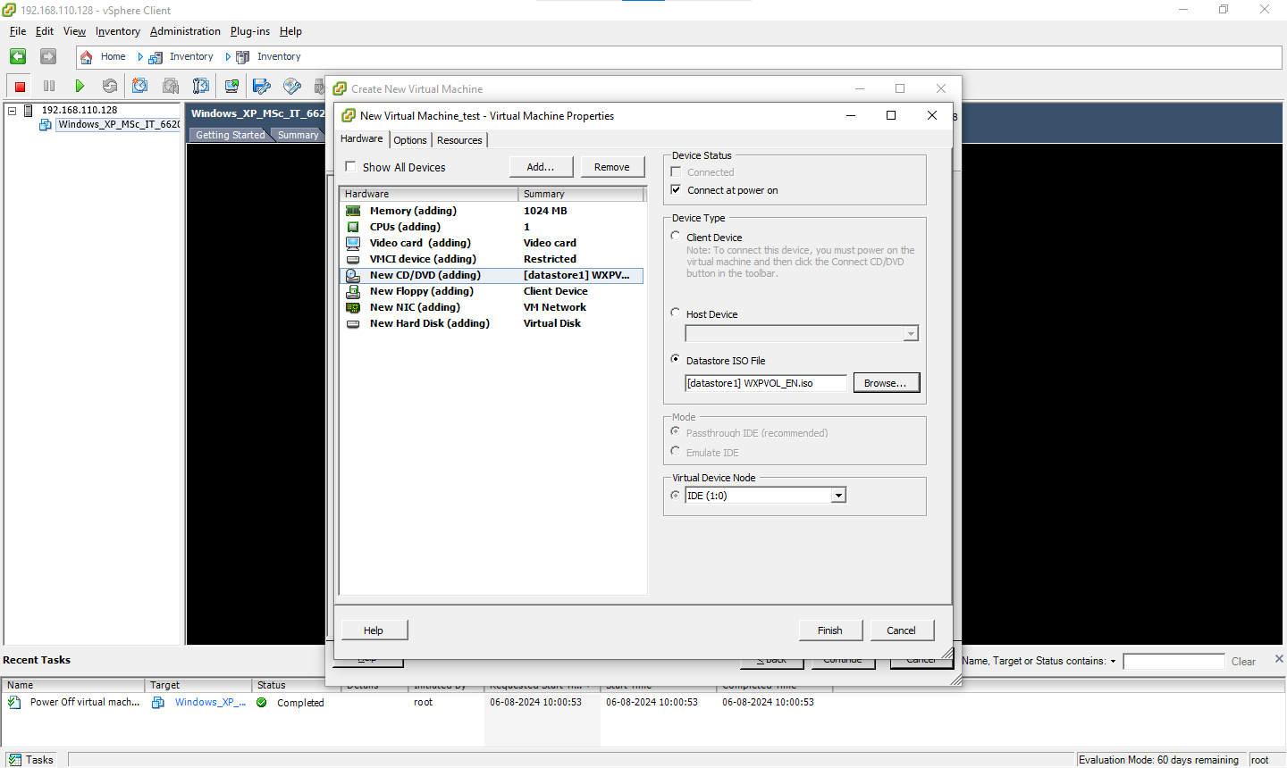



#### 

#### **Practical 8 - Implement simple cloud simulation in cloudsim.**

Sep 3, 2024

CloudSim is an open-source framework, which is used to simulate cloud computing infrastructure and services. It is developed by the CLOUDS Lab organization and is written entirely in Java. It is used for modeling and simulating a cloud computing environment as a means for evaluating a hypothesis prior to software development in order to reproduce tests and results.

For example, if you were to deploy an application or a website on the cloud and wanted to test the services and load that your product can handle and also tune its performance to overcome bottlenecks before risking deployment, then such evaluations could be performed by simply coding a simulation of that environment with the help of various flexible and scalable classes provided by the CloudSim package, free of cost.

**STEP 1:** Open eclipse

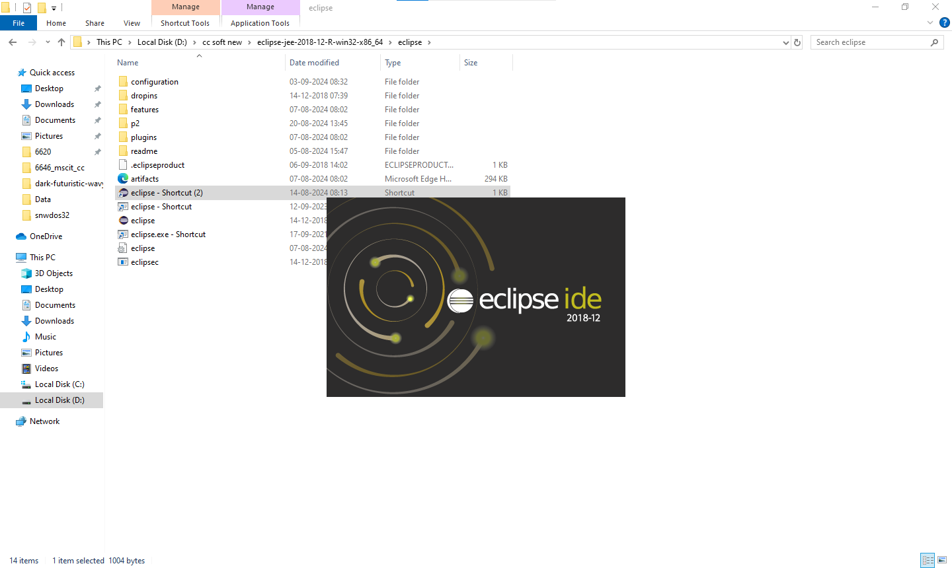

**STEP 2:** New → Project → Java Project

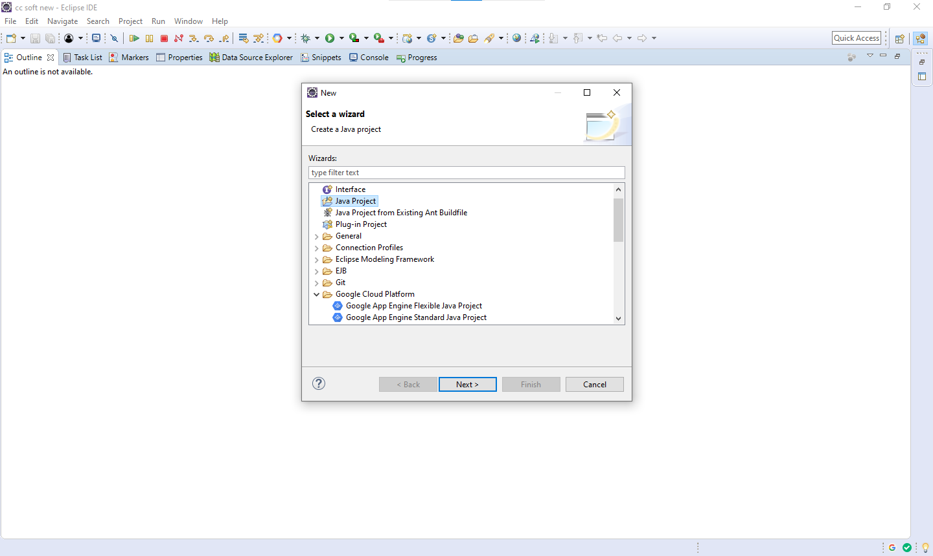

**STEP 3:** Uncheck use default location checkmark and browse cloudsim dir in cc soft and click on next

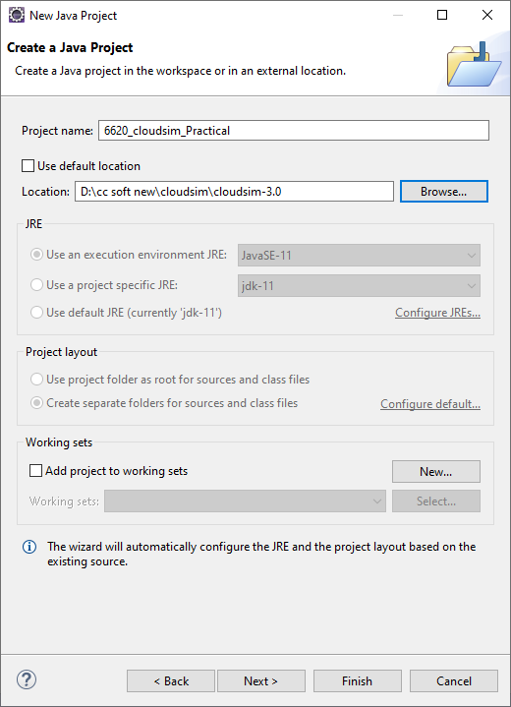

**STEP 4:** Click on Add External jar and browser common math jar from cc soft new dir

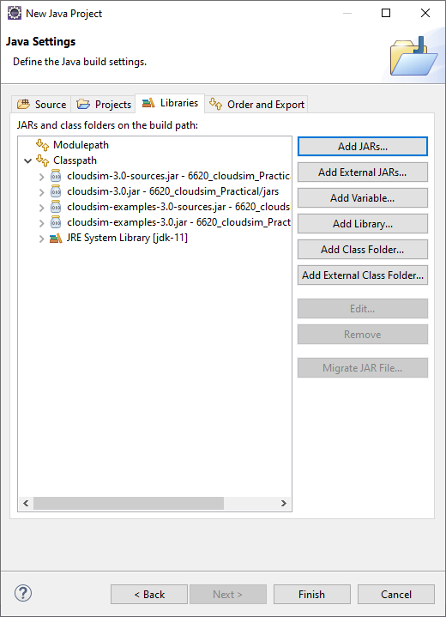

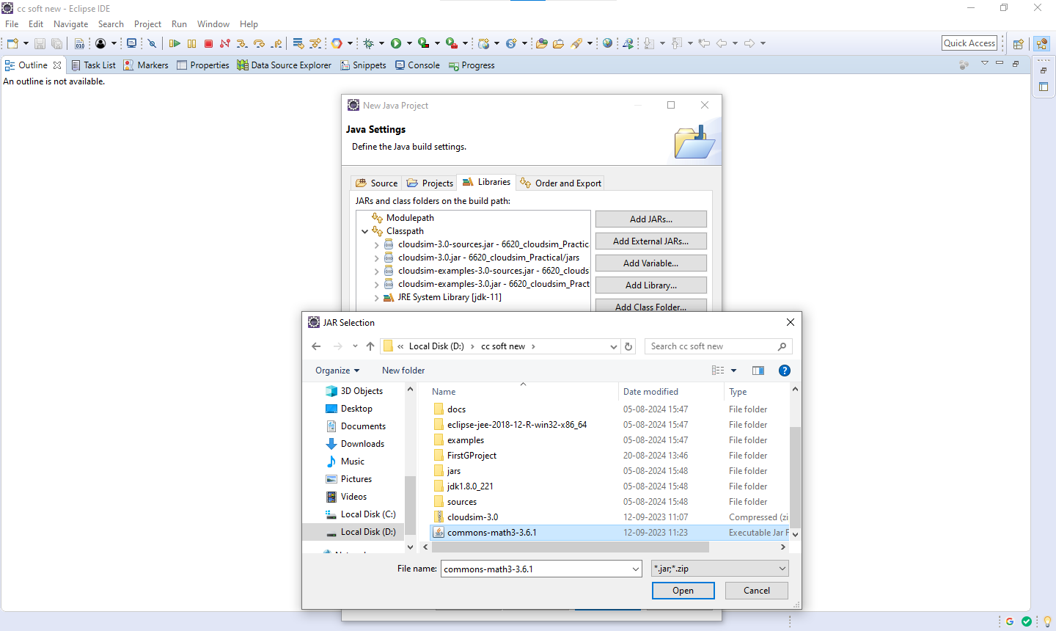

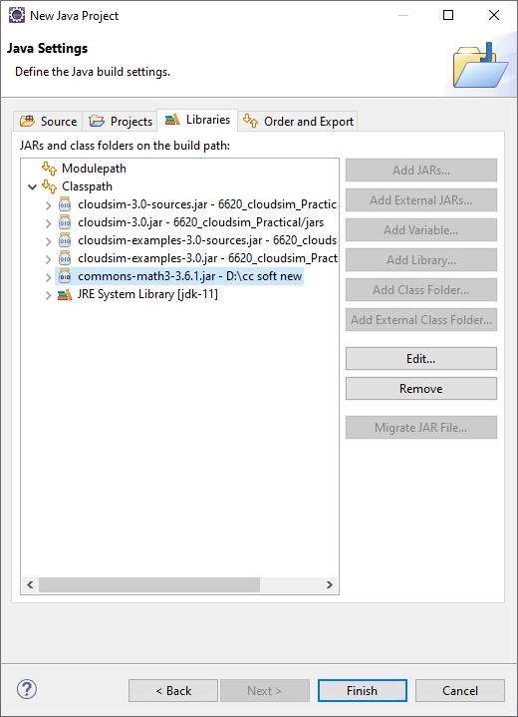

Go to project → examples → org.cloudbus.cloudsim.examples → CloudSimExample1.java and run that file

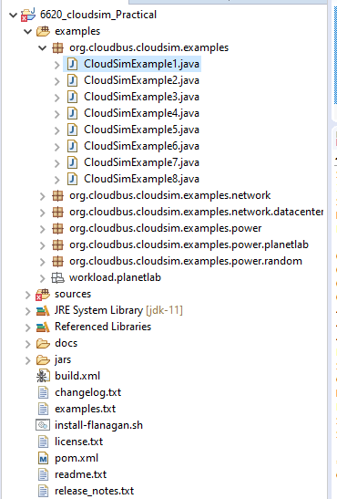

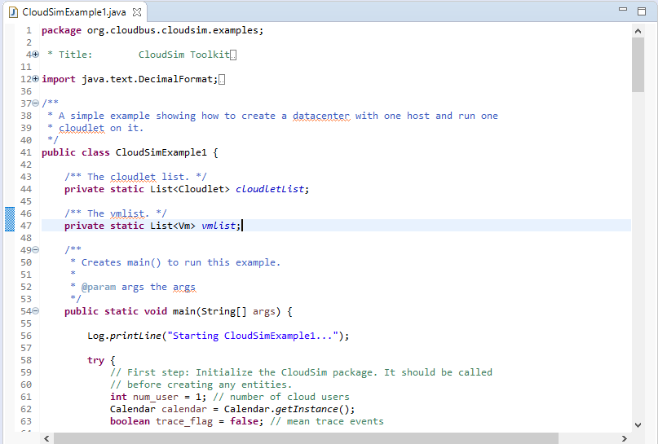

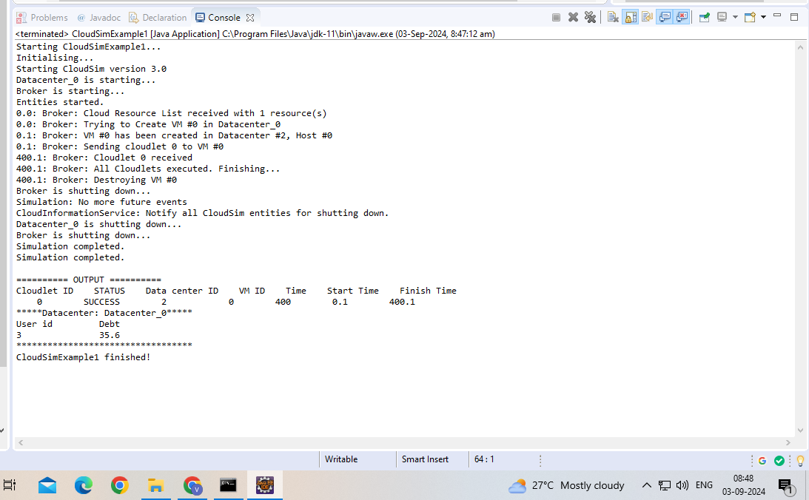

Example 1

package org.cloudbus.cloudsim.examples;

/*

* Title: CloudSim Toolkit

* Description: CloudSim (Cloud Simulation) Toolkit for Modeling and Simulation

* of Clouds

* Licence: GPL - http://www.gnu.org/copyleft/gpl.html

*

* Copyright (c) 2009, The University of Melbourne, Australia

*/

import java.text.DecimalFormat;

import java.util.ArrayList;

import java.util.Calendar;

import java.util.LinkedList;

import java.util.List;

import org.cloudbus.cloudsim.Cloudlet;

import org.cloudbus.cloudsim.CloudletSchedulerTimeShared;

import org.cloudbus.cloudsim.Datacenter;

import org.cloudbus.cloudsim.DatacenterBroker;

import org.cloudbus.cloudsim.DatacenterCharacteristics;

import org.cloudbus.cloudsim.Host;

import org.cloudbus.cloudsim.Log;

import org.cloudbus.cloudsim.Pe;

import org.cloudbus.cloudsim.Storage;

import org.cloudbus.cloudsim.UtilizationModel;

import org.cloudbus.cloudsim.UtilizationModelFull;

import org.cloudbus.cloudsim.Vm;

import org.cloudbus.cloudsim.VmAllocationPolicySimple;

import org.cloudbus.cloudsim.VmSchedulerTimeShared;

import org.cloudbus.cloudsim.core.CloudSim;

import org.cloudbus.cloudsim.provisioners.BwProvisionerSimple;

import org.cloudbus.cloudsim.provisioners.PeProvisionerSimple;

import org.cloudbus.cloudsim.provisioners.RamProvisionerSimple;

/**

* A simple example showing how to create a datacenter with one host and run one

* cloudlet on it.

*/

public class CloudSimExample1 {

/** The cloudlet list. */

private static List<Cloudlet> cloudletList;

/** The vmlist. */

private static List<Vm> vmlist;

/**

* Creates main() to run this example.

*

* @param args the args

*/

public static void main(String[] args) {

Log.printLine("Starting CloudSimExample1...");

try {

// First step: Initialize the CloudSim package. It should be called

// before creating any entities.

int num_user = 1; // number of cloud users

Calendar calendar = Calendar.getInstance();

boolean trace_flag = false; // mean trace events

// Initialize the CloudSim library

CloudSim.init(num_user, calendar, trace_flag);

// Second step: Create Datacenters

// Datacenters are the resource providers in CloudSim. We need at

// list one of them to run a CloudSim simulation

Datacenter datacenter0 = createDatacenter("Datacenter_0");

// Third step: Create Broker

DatacenterBroker broker = createBroker();

int brokerId = broker.getId();

// Fourth step: Create one virtual machine

vmlist = new ArrayList<Vm>();

// VM description

int vmid = 0;

int mips = 250;

long size = 10000; // image size (MB)

int ram = 512; // vm memory (MB)

long bw = 1000;

int pesNumber = 1; // number of cpus

String vmm = "Xen"; // VMM name

// create VM

Vm vm1 = new Vm(vmid, brokerId, mips, pesNumber, ram, bw, size, vmm, new CloudletSchedulerTimeShared());

vmid++;

Vm vm2 = new Vm(vmid, brokerId, mips, pesNumber, ram, bw, size, vmm, new CloudletSchedulerTimeShared());

vmid++;

Vm vm3 = new Vm(vmid, brokerId, mips, pesNumber, ram, bw, size, vmm, new CloudletSchedulerTimeShared());

vmid++;

Vm vm4 = new Vm(vmid, brokerId, mips, pesNumber, ram, bw, size, vmm, new CloudletSchedulerTimeShared());

// add the VM to the vmList

vmlist.add(vm1);

vmlist.add(vm2);

vmlist.add(vm3);

vmlist.add(vm4);

// submit vm list to the broker

broker.submitVmList(vmlist);

// Fifth step: Create one Cloudlet

cloudletList = new ArrayList<Cloudlet>();

// Cloudlet properties

int id = 0;

long length = 400000;

long fileSize = 300;

long outputSize = 300;

UtilizationModel utilizationModel = new UtilizationModelFull();

Cloudlet cloudlet1 = new Cloudlet(id, length, pesNumber, fileSize, outputSize, utilizationModel, utilizationModel, utilizationModel);

cloudlet1.setUserId(brokerId);

id++;

Cloudlet cloudlet2 = new Cloudlet(id, length, pesNumber, fileSize, outputSize, utilizationModel, utilizationModel, utilizationModel);

cloudlet2.setUserId(brokerId);

id++;

Cloudlet cloudlet3 = new Cloudlet(id, length, pesNumber, fileSize, outputSize, utilizationModel, utilizationModel, utilizationModel);

cloudlet3.setUserId(brokerId);

id++;

Cloudlet cloudlet4 = new Cloudlet(id, length, pesNumber, fileSize, outputSize, utilizationModel, utilizationModel, utilizationModel);

cloudlet4.setUserId(brokerId);

//cloudlet.setVmId(vmid);

// add the cloudlet to the list

cloudletList.add(cloudlet1);

cloudletList.add(cloudlet2);

cloudletList.add(cloudlet3);

cloudletList.add(cloudlet4);

// submit cloudlet list to the broker

broker.submitCloudletList(cloudletList);

broker.bindCloudletToVm(cloudlet1.getCloudletId(),vm1.getId());

broker.bindCloudletToVm(cloudlet2.getCloudletId(),vm2.getId());

broker.bindCloudletToVm(cloudlet3.getCloudletId(),vm3.getId());

broker.bindCloudletToVm(cloudlet4.getCloudletId(),vm4.getId());

// Sixth step: Starts the simulation

CloudSim.startSimulation();

CloudSim.stopSimulation();

//Final step: Print results when simulation is over

List<Cloudlet> newList = broker.getCloudletReceivedList();

printCloudletList(newList);

// Print the debt of each user to each datacenter

datacenter0.printDebts();

Log.printLine("CloudSimExample1 finished!");

} catch (Exception e) {

e.printStackTrace();

Log.printLine("Unwanted errors happen");

}

}

/**

* Creates the datacenter.

*

* @param name the name

*

* @return the datacenter

*/

private static Datacenter createDatacenter(String name) {

// Here are the steps needed to create a PowerDatacenter:

// 1. We need to create a list to store

// our machine

List<Host> hostList = new ArrayList<Host>();

// 2. A Machine contains one or more PEs or CPUs/Cores.

// In this example, it will have only one core.

List<Pe> peList = new ArrayList<Pe>();

int mips = 1000;

// 3. Create PEs and add these into a list.

peList.add(new Pe(0, new PeProvisionerSimple(mips))); // need to store Pe id and MIPS Rating

// 4. Create Host with its id and list of PEs and add them to the list

// of machines

int hostId = 0;

int ram = 2048; // host memory (MB)

long storage = 1000000; // host storage

int bw = 10000;

hostList.add(

new Host(

hostId,

new RamProvisionerSimple(ram),

new BwProvisionerSimple(bw),

storage,

peList,

new VmSchedulerTimeShared(peList)

)

); // This is our machine

// 5. Create a DatacenterCharacteristics object that stores the

// properties of a data center: architecture, OS, list of

// Machines, allocation policy: time- or space-shared, time zone

// and its price (G$/Pe time unit).

String arch = "x86"; // system architecture

String os = "Linux"; // operating system

String vmm = "Xen";

double time_zone = 10.0; // time zone this resource located

double cost = 3.0; // the cost of using processing in this resource

double costPerMem = 0.05; // the cost of using memory in this resource

double costPerStorage = 0.001; // the cost of using storage in this

// resource

double costPerBw = 0.0; // the cost of using bw in this resource

LinkedList<Storage> storageList = new LinkedList<Storage>(); // we are not adding SAN

// devices by now

DatacenterCharacteristics characteristics = new DatacenterCharacteristics(

arch, os, vmm, hostList, time_zone, cost, costPerMem,

costPerStorage, costPerBw);

// 6. Finally, we need to create a PowerDatacenter object.

Datacenter datacenter = null;

try {

datacenter = new Datacenter(name, characteristics, new VmAllocationPolicySimple(hostList), storageList, 0);

} catch (Exception e) {

e.printStackTrace();

}

return datacenter;

}

// We strongly encourage users to develop their own broker policies, to

// submit vms and cloudlets according

// to the specific rules of the simulated scenario

/**

* Creates the broker.

*

* @return the datacenter broker

*/

private static DatacenterBroker createBroker() {

DatacenterBroker broker = null;

try {

broker = new DatacenterBroker("Broker");

} catch (Exception e) {

e.printStackTrace();

return null;

}

return broker;

}

/**

* Prints the Cloudlet objects.

*

* @param list list of Cloudlets

*/

private static void printCloudletList(List<Cloudlet> list) {

int size = list.size();

Cloudlet cloudlet;

String indent = " ";

Log.printLine();

Log.printLine("========== OUTPUT ==========");

Log.printLine("Cloudlet ID" + indent + "STATUS" + indent

+ "Data center ID" + indent + "VM ID" + indent + "Time" + indent

+ "Start Time" + indent + "Finish Time");

DecimalFormat dft = new DecimalFormat("###.##");

for (int i = 0; i < size; i++) {

cloudlet = list.get(i);

Log.print(indent + cloudlet.getCloudletId() + indent + indent);

if (cloudlet.getCloudletStatus() == Cloudlet.SUCCESS) {

Log.print("SUCCESS");

Log.printLine(indent + indent + cloudlet.getResourceId()

+ indent + indent + indent + cloudlet.getVmId()

+ indent + indent

+ dft.format(cloudlet.getActualCPUTime()) + indent

+ indent + dft.format(cloudlet.getExecStartTime())

+ indent + indent

+ dft.format(cloudlet.getFinishTime()));

}

}

}

}

Output

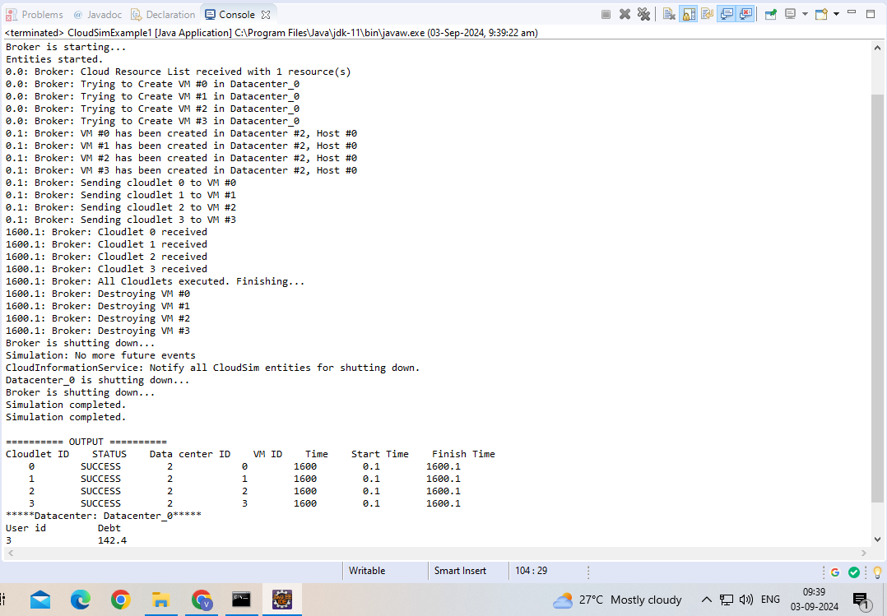

#### **Practical 9 - Implement virtualization using Hyper-V.**

Aug 20, 2024

First we have to uninstall vmware software if already installed on the computer because the VMware Workstation installer does not support running on a Hyper-V virtual machine.

After uninstalling VMware, we can proceed to next step - go to control panel and click on uninstall a program

If Hyper V is not installed and if you couldn’t find it then follow the link to do installation

<https://www.how2shout.com/how-to/how-to-download-and-install-hyper-v-on-windows-11-home.html>

After then Restart your system

And Search for hyper-v manager in Windows search box and click on that

for creating virtual machine, first we have to create virtual switch click on virtual switch manager option

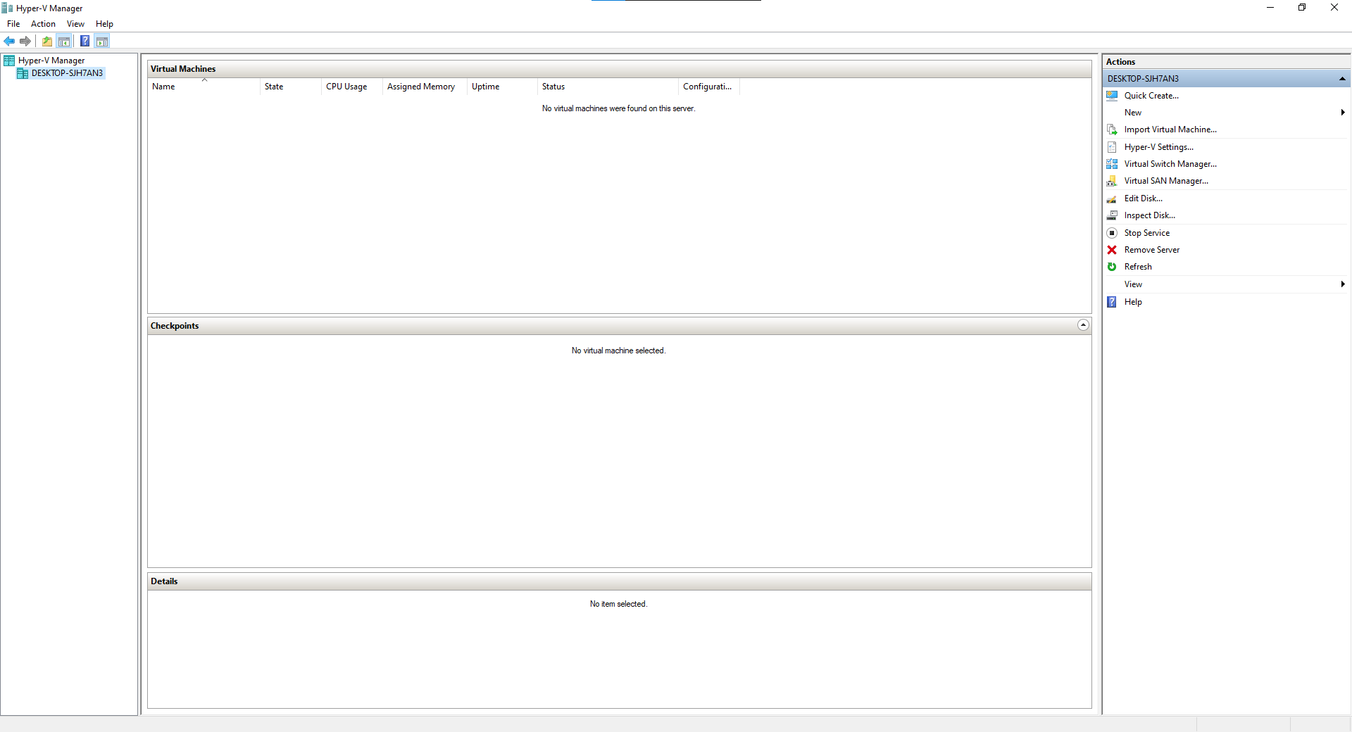

Select External as a connection type and then click on create virtual switch

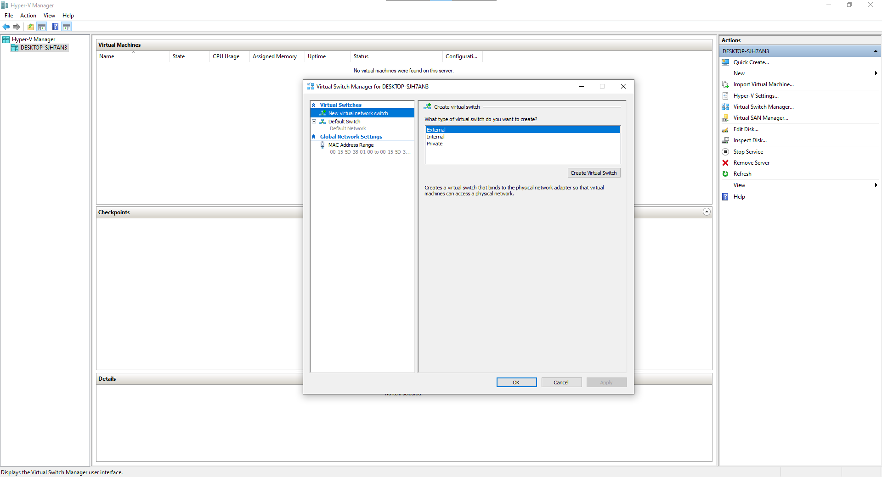

Give name to your virtual switch then click on apply button

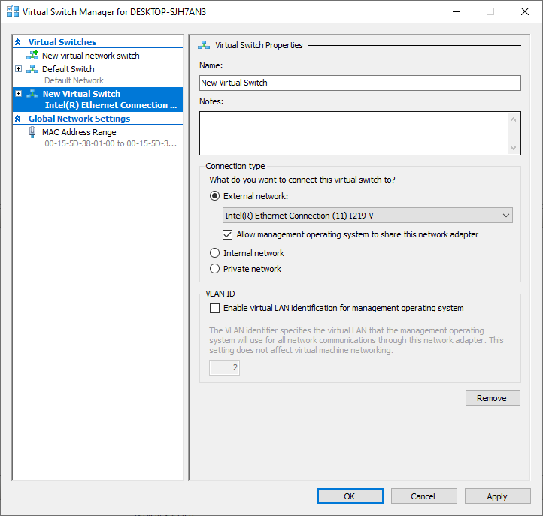

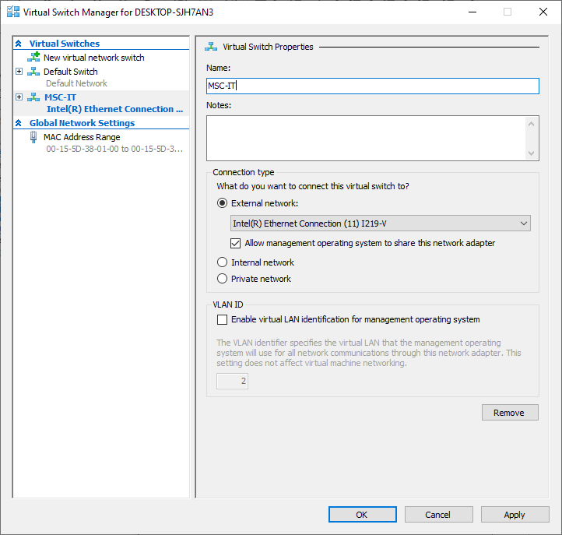

after click on Apply button it will show warning about our connection click on yes

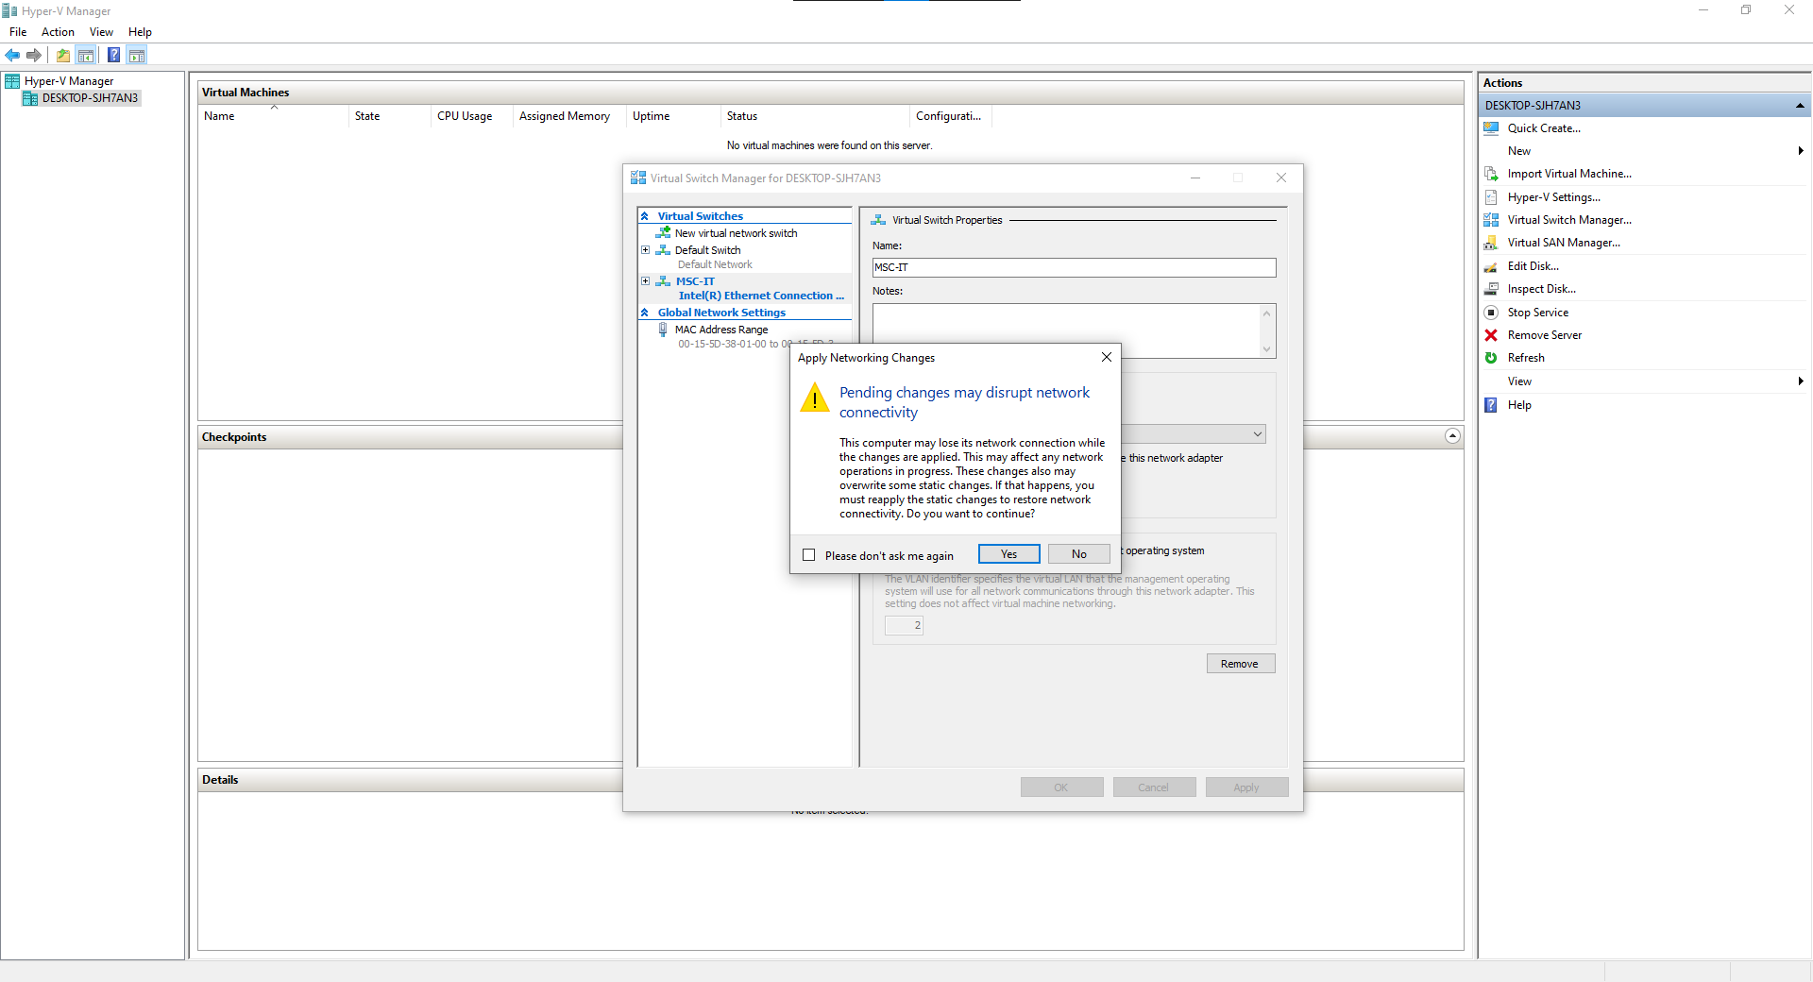

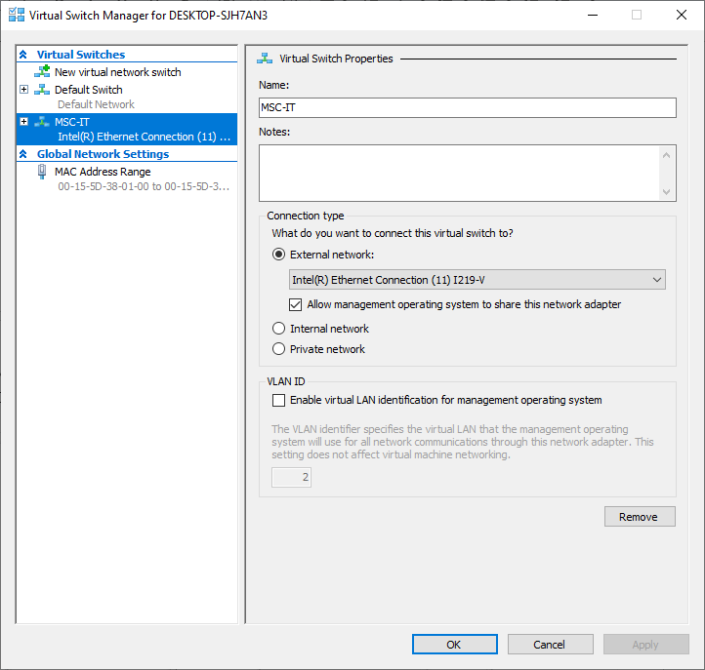

Now right click on server and select new virtual machine

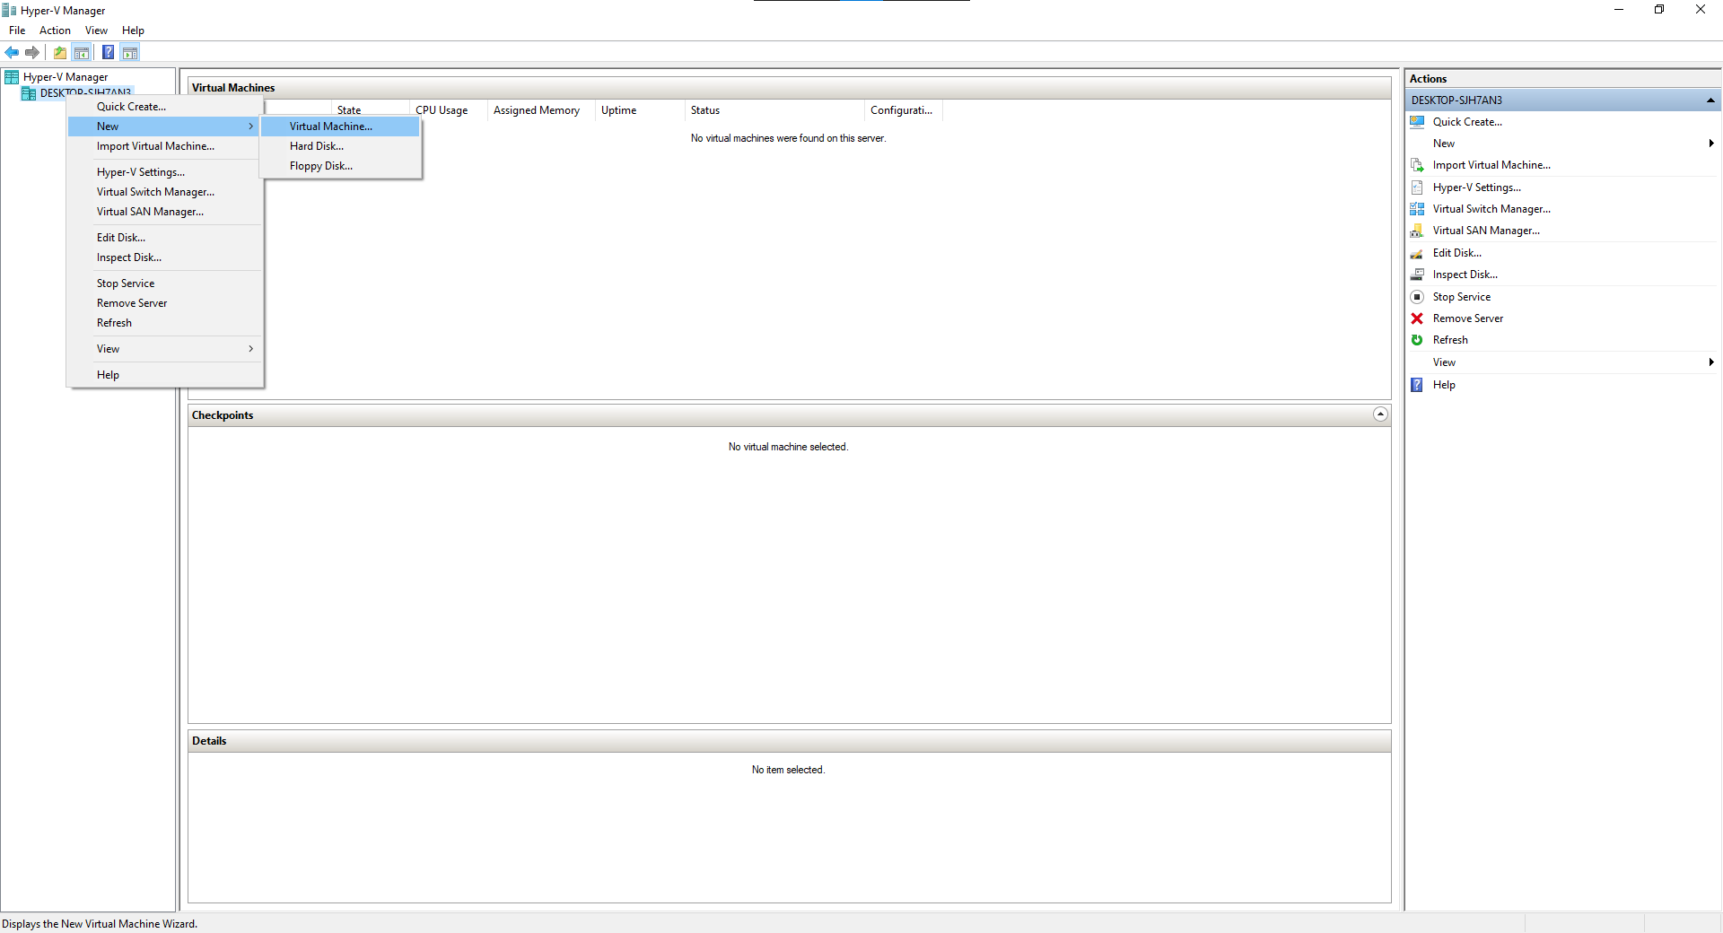

click on next button

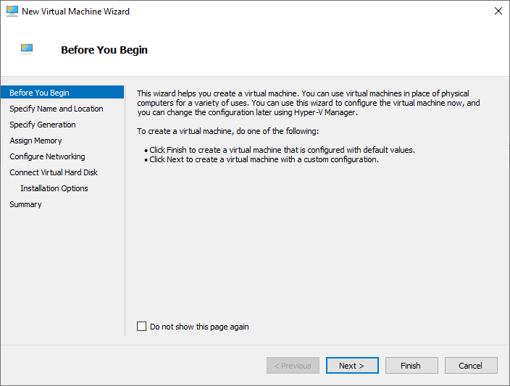

Provide name to virtual machine then click on Next button

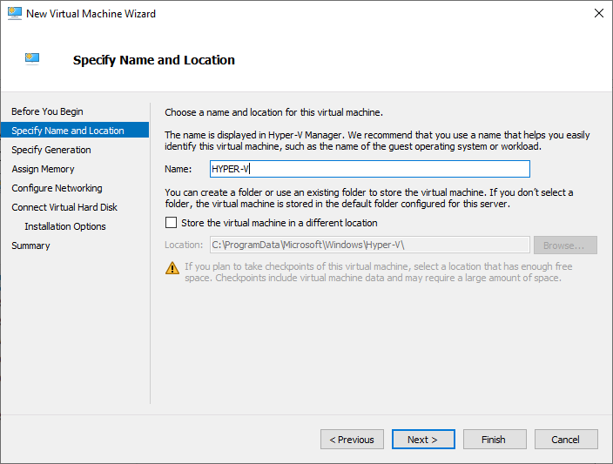

Specify generation : generation 1

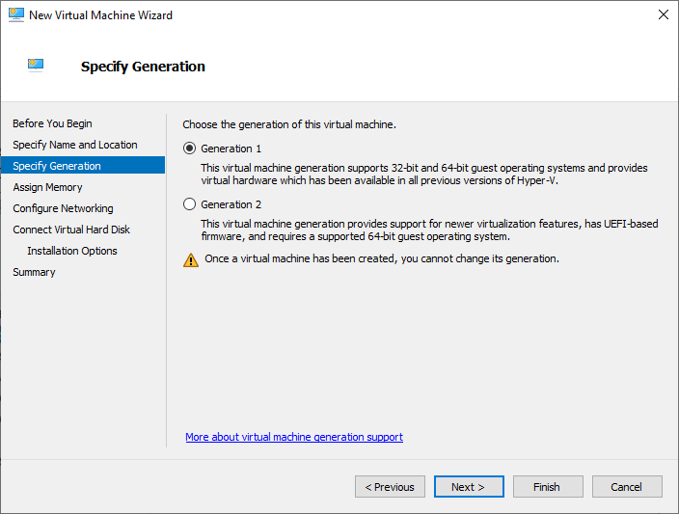

tick on use dynamic memory for this virtual machine

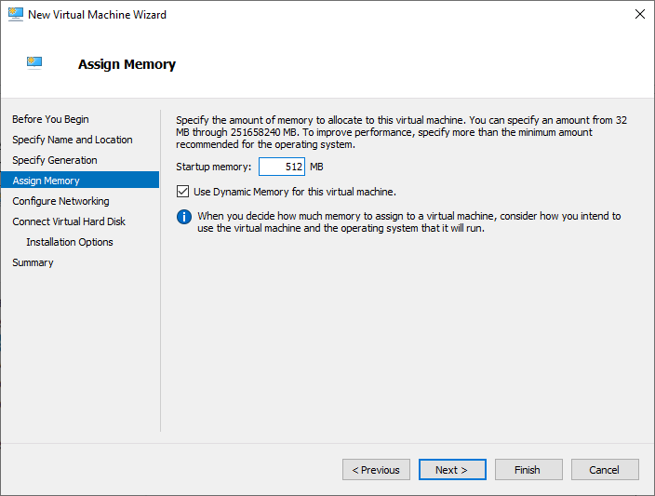

Select switch which we created earlier for our virtual machine from drop-down

list and then click on next

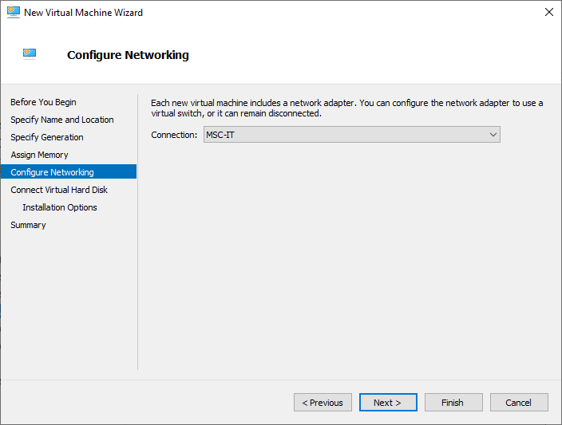

Description of virtual machine and location where it will store virtual machine

related files and size require for this machine click on next

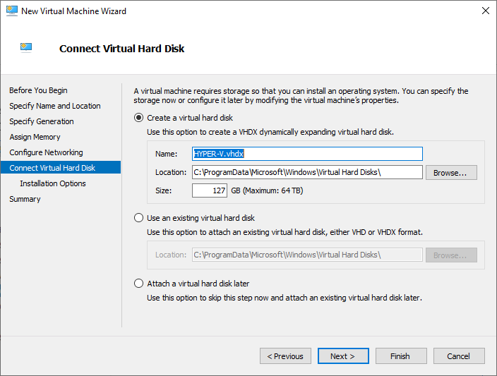

New virtual machine wizard panel will appear, where we will choose operating system which

we want to install on virtual machine

select install an operating system from boot CD/DVD-ROM and then select Image file(.iso)

and browse your OS iso file then click on next button

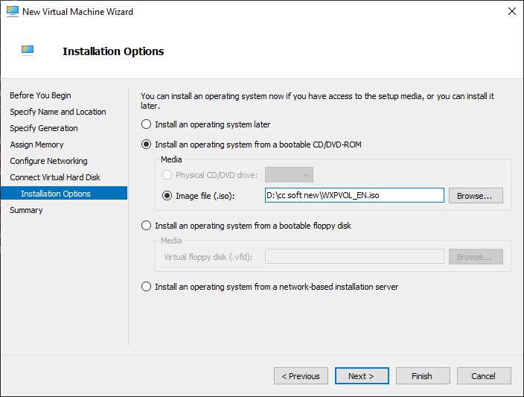

Summary report will be generated about virtual machine then click on

Finish button

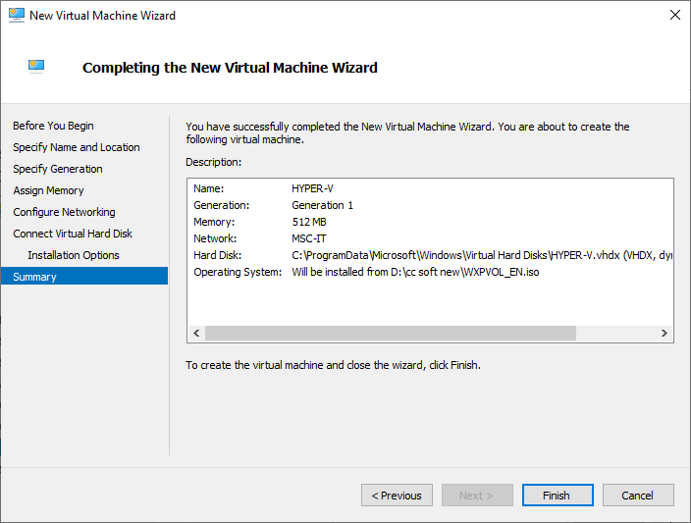

In virtual machine panel your virtual machine will appear which has off state

Click finish

And go to Virtual machine and right click and then Connect

